MATHEMATICS

- There were 4678 elephants in a park. What is the place value of digit 4 in the number?
  - Hundreds

  - Tens

  - Thousands

  - Ten thousands

- A bucket has 20 litres. How much milk is in 4 such buckets?

  - 40L

  - 60L

  - 100L

  - 80L.

- There were nine thousand nine hundred and ninety people in a meeting. What is the number of the people written in symbols?
  - 9990

  - 9000990

  - 9999

  - 99999

- Take away 48 from 372.

  - 336

  - 334

  - 324

  - 420

- In a test five learners had their scores as follows;

Kamene - 412 Kamau - 399 Damaris - 400 Anyango - 199 Pius - 386

Kamau was in the ________ position.

A. first B. fourth

C. third D. second
- In farm a farmer has 56401 animals. What is the total value of digit 6 in the number of animals?
G4

  - 60000

  - 600

  - 60

  - 6000

- Henry has 24 sheep and 42 goats. How

many animals does he have?

A. 68 | B. 66
C. 64 | D. 60

- Kioko bought a bag for Sh.450 and a pair of shoes for sh.170. How much did he pay?
  - Sh. 620

  - Sh. 520

  - Sh. 720

  - Sh. 280

- Complete: 5 x 7 = _________

  - 35

  - 45

  - 63

  - 70

- Juma had the note shown below.
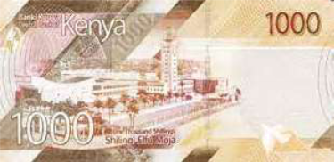

How many sh.100 notes does the note have?

A. 100 | B. 2
C. 5 | D. 10

- Halima had 30 sweets. She shared the sweets equally among her 6 friends. How many sweets did each of them get?
  - 36

  - 5

  - 24

  - 6

ASSESSMENT 2 ^{MATHS/GR .4}

- Complete;

4+4+4+4+4+4=

____ x ____ = ___

  - 7 x 4 = 28

  - 4 x 6 = 24

  - 4 x 5 = 20

  - 4 x 4 = 16

- There are 15 pencils in a packet. How

many pencils are there in 5 such packets?

A. 20 | B. 10
C. 75 | D. 65

14. | The mass of a goat is 47kg. What is the
 | mass of the goat to the nearest 10?
 | A. 40kg | B. 30kg
 | C. 45kg | D. 50kg
15. | A teacher had 64 exercise books. He
 | shared them equally among 8 learners.
 | How many books did each learner get?
 | A. 7 | B. 8
 | C. 9 | D. 6

16. What fraction is shaded?
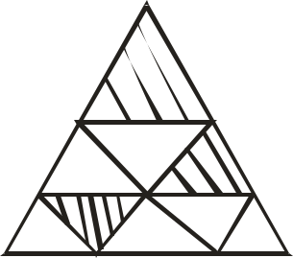
- Work out;

23m -17m =

  - 40m

  - 16m

  - 6m

  - 14m

- In a park there were 362 lions, 403 hyenas, 215 antelopes and 652 elephants.
Arrange their numbers from the smallest to the largest.

  - 652, 403, 362, 215

  - 362, 652, 403, 215

  - 215, 362, 403, 652

  - 652, 215, 403, 362

1
20. How many ₂ kg are there in 4kg?
A. 8

B. 9

C. 2

D. 6

21. Joy had the containers below.
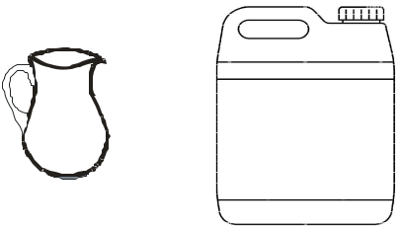

^{2L} 10L

A. |  | 3 |  | B. | 5
 |  | 9 |  | B. | 9
C. | 4 |  |  | D. |  | 2
C. | 9 |  |  |  |  | 9

- Kalelei had 875 sheep. What is the number in words?

  - Eight hundred and seven five.

  - Eight hundred and seventy five.

  - Eighty hundred and seven fifty.

  - Eight seven five.

How many jugs did she use to fill the container?

A. 4 | B. 5
C. 20 | D. 40
22. Work out;
Hrs | min
2 | 27
+ 3 | 14

A. 5hrs 41 min B. 5hrs 31 min

C. 5 hrs 51 min D. 5hrs 01 min

ASSESSMENT 3 ^{MATHS/GR .4}

- Rehema had a wire mesh 39m 70cm long. She used 13m 40cm of the wire. What length of the wire remained?
  - 26m 30cm

  - 42cm 110cm

  - 43m 10cm

  - 16m 30cm

- Write down the next number in the sequence.

5, 10, 15, 20, ____

  - 30

  - 25

  - 40

  - 35

- Which of the following is an odd number?

  - 40

  - 36

  - 38

  - 43

- Add: 3a + 4a =

  - 3a

  - 5a

  - 7a

  - 7 + a

- Which of the following is not a multiple of 5?

  - 45

  - 20

  - 55

  - 36
- Name the shapes below.

A.
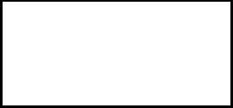
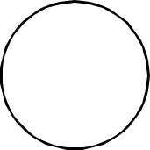

B.
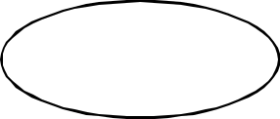

C.

A | B | C
A. Oval | Rectangle | Circle
B. Circle | Square | Oval
C. Circle | Rectangle | Oval
D. Circle | Triangle | Oval

- What is the time shown in the clockface below?
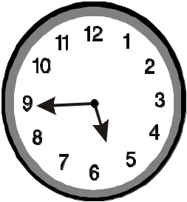

A. Quarter to six o’clock.

B. Six o’clock.

C. Half past nine O’clock.

D. Quarter past five o’clock.

2
30. Write 1₃ as an improper fraction.

A. | 6 |  |  | B. | 5
A. | 3 |  |  | B. | 3
C. | 5 |  | D. |  |  | 12
C. | 2 |  |  |  |  | 8

CBCASSESSMENT 4 ^{MATHS/GR .4}

