GRADE 4 - 2025
^{COMPETENCE BASED CURRICULUM}

CBC ASSESSMENT

FIRST TRIAL

KENYA PRIMARY SCHOOL EDUCATION ASSESSMENT

MATHEMATICS
TIME: 2 HOURS

INSTRUCTIONS TO LEARNER’S (Please read these instructions carefully)

- You have been given this question booklet and a separate answer sheet. The question booklet contains 30 questions.

Answer all the questions.

- Do any necessary rough work in this booklet.

- When you have chosen your answer, mark it on the ANSWER SHEET, not in this question booklet.

HOW TO USE THE ANSWER SHEET

- Use ordinary pencil.

- Confirm that the answer sheet that you have been provided with has the following:

YOURASSESSMENT NUMBER YOURNAME

NAME OFYOURSCHOOL NAMEOFSUBJECT
- Do not make any marks outside the boxes.

- Keep the sheet as clean as possible and do not fold it.

- For each of the question 1 - 30, four answers are given. The choices are lettered A, B, C, D. In each case only ONE of the four choices is correct. Choose the correct answer.

- On the answer sheet, show the correct answer by drawing a dark line inside the box in which the letter you have chosen is written.

Example:

In the question booklet:

11. Work out: 335 x 24

- 8004

- 8400

- 8040

- 80040

The correct answer is C (8040)

On the answer sheet:

In the set of boxes numbered 11, draw a dark line inside the box with letter C printed as indicated below.


  - [A] [B] [C] [D]

- Your dark line MUST be within the box.

- For each question, ONLY ONE box is to be marked in each set of four boxes.

This paper consists of 4 printed pages.

CBCASSESSMENT

Turn over

MATHS/GR .4

- A kitchen has 1762 spoons. What is the

place value of digit 6 in the number?

A. 60 B. Tens

C. Ones D. Hundreds

- What is the next number in the pattern below?

730, 720, 710, _________

A. 700 | B. 690
C. 680 | D. 740

- There are four thousand two hundred and

seven chairs in a hall. Write the number of chairs in symbols.

A. 4270 | B. 4207
C. 4200 | D. 4720

- Leah shaded the figure below. What fraction did she shade?
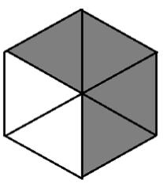

A. | 2 |  |  | B. | 2
A. | 4 |  |  | B. | 6
C. |  | 4 |  | D. |  | 5
 |  | 6 |  |  |  | 6

- Gael had 24 counters. What is a quarter of 24?

A. 96 | B. 12
C. 4 | D. 6

- What number is represented on the abacus below?
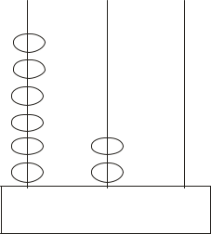

A. 600 | B. 62
C. 620 | D. 260

- During the Elnino rains, families that were displaced were given 326 blankets and 204 mattresses. How many items

were the families given altogether?

A. 530 | B. 630
C. 520 | D. 630

- Which number can be subtracted from 426 to get 321?

A. 747 | B. 105
C. 205 | D. 613

- A driver used sh. 525 to buy petrol. If he had sh. 900, how much balance was he
given?
A. Sh. 485 | B. Sh. 375
C. Sh. 885 | D. Sh. 985

10. What is the name of the figure below?
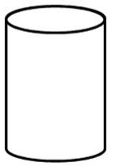

A. Circle B. Cube

C. Cylinder D. Cuboid

11. Cherop had 325 cows. He sold 124 cows. How many cows did he remain with?

A. 201 | B. 449
C. 241 | D. 249

H T O

CBCASSESSMENT

2 MATHS/GR .4

- A car has four wheels. How many wheels do 7 cars have?
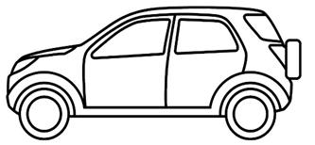

A. 11 | B. 3
C. 28 | D. 30

- Njeri shared the following pens among four learners.
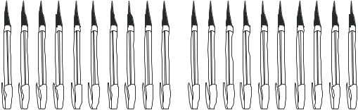
- A cartwheel caried 67kg of maize and 124kg of beans. How many kilograms
did it carry altogether?

A. 181kg B. 57kg

C. 67kg D. 191kg

- Muli harvested 650kg of wheat. He gave 325kg to a school. How many kilograms did he remain with?
  - 335kg

  - 325kg

  - 425kg

  - 125kg

- A chef had four containers which had the

following capacity. Which one holds more water?
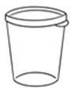
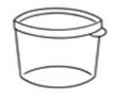

How many pens did each learner get?

A. 10 pens B. 4 pens

C. 5 pens D. 8 pens

A. B.

18L
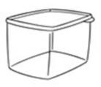

12L

- There were 64 people in a seminar. They were grouped into groups of

8. How many groups were there?

A. 7 | B. 8
C. 11 | D. 12

- A class has 234 learners. Write the number of learners in words.

  - Two hundred and three four

  - Two hundred and thirty four

  - Two thousand and thirty four

  - Two thirty four.

- What is 411m + 223m?

A. 634m | B. 212m
C. 614m | D. 234m

C. D.
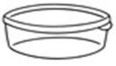

24L
14L

- Liza has 76 litres of milk. She used 35 litres to cook tea. How many litres
remained?
A. 41L | B. 111L
C. 101L | D. 51L

- Hannah had 224 mangoes. She was given 104 more mangoes. How many mangoes did she have altogether?
  - 328

  - 120

  - 320

  - 228

CBCASSESSMENT 3 ^{MATHS/GR .4}

- Jane woke up at the time shown below. What was the time?
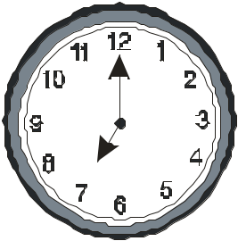

A. 12 o’clock

B. 7 o’clock

C. 35 minutes to 6 o’clock

D.12 o’clock

- An athlete ran for 3 hours 21 minutes to the market. He then used 1 hour

42 minutes to go back home. How long did he take to run?

  - 6 hours 50 minutes

  - 5 hours 3 minutes

  - 6 hours 3 minutes

  - 4 hours 24minutes

- Ali had the following notes. How much money did he have?
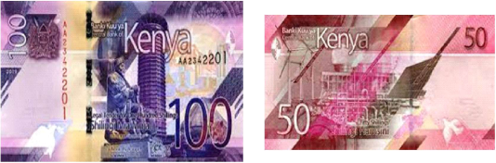

A. Sh. 100 | B. Sh. 50
C. Sh. 150 | D. Sh. 200

- Harima had sh. 720. He bought a toy car for sh. 510. How much did he
remain with?
A. Sh. 1230 | B. Sh. 210
C. Sh. 1200 | D. Sh. 320
- A tuktuk can carry 6 people. How many people can 8 tuktuk carry?
A. 14 | B. 26
C. 72 | D. 54

- What is the next shape in the pattern below?
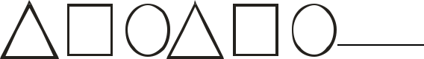



A. B.


C. D. 

28. Which one of the following numbers is an even number?

A. 23 | B. 48
C. 71 | D. 101

29. What is the total value of digit 6 in the number 761?

A. 6 | B. 600
C. 6000 | D. 60

- Juma went for a holiday for three weeks. How many days did he go for the holiday?

A. 21 days B. 18 days

C. 15 days D. 12 days

CBCASSESSMENT 4 ^{MATHS/GR .4}

