COMPETECE BASED CURRICULUM
HOMEWORKK ENGAGEMENT ACTIVITY
DECEMBER HOLIDAY
GRADE 4

MATHEMATICS

- What is the place value of 9 in 1928 (1mk)

- Write the total value of each of the digit below (4mks)

9 -

5 -

4 -

8 -

- Write in words 4004 (1mk)

- Round off the numbers below to the nearest ten. (3mks)

  - 998 -

  - 269 -

  - 141 -

- Add by breaking apart (4mks)

  - 14+9=

  - 25+7=

- Divide using repeated subtraction. (4mks)

  - 36÷9=

  - 24+8=

- Write the numbers below from the largest to the smallest (2mks)

485, 854, 458, 584, 845, 548 (1mk)
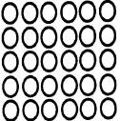

8.

(2mks)

6 x ___ =___ +___ +___ +___ +___ = ___

- Write two pairs of factors of 14. (2mks)

- List all the divisors of 10 (1mk)

- Represent the following in an abacus.

3,504 (1mk)

- Subtract 49 from 344 (1mk)

- Write the next multiple of 7 after 49 (1mk)

- Complete the pattern (1mk) 1,3,9, 27,___

- Circle all the odd numbers (1mk) 40, 47, 49, 54, 63,50, 29

- Write the number 8 in roman numbers.(1mk)

- Work out (2mks)

  - ___ x 5 = 25

  - 30 ÷ ___ =6

- How many legs do 9 dogs have? (1mk)

- Shade the fractions below (2mks)
  - ½

  - ¹/₈

- Add 9872 and 114 1mk)
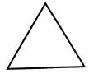
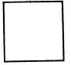

MEASUREMENT

- How many days are there in 4 weeks? (1mk)

- Juma bought 623kg of sugar while Musa bought 529kg of sugar. How much sugar did they buy altogether. (2mks)

- What is the time? (2mks)

- Work out (2mks) a. Sh Cts
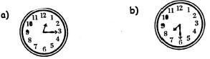
    - 32

+1 40

  - Sh Cts

    - 50 -8 35

- Convert 2 hours 30 minutes into minutes (1mk)

Price list

- Jane bought 2 loaves of bread and one packet of milk. How much did she pay for the items? (1mk)

- Moran gave out sh 100 after buying a bar of soap. How much balance did she get?(1mk)

- How much is the price of two packet of milk? (1mk)
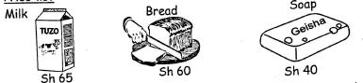

GEOMETRY

29. Count the shapes (4mks)
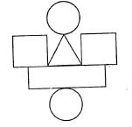

- Rectangles

- Squres

- Circles

d. Triangles

MARKING SCHEME
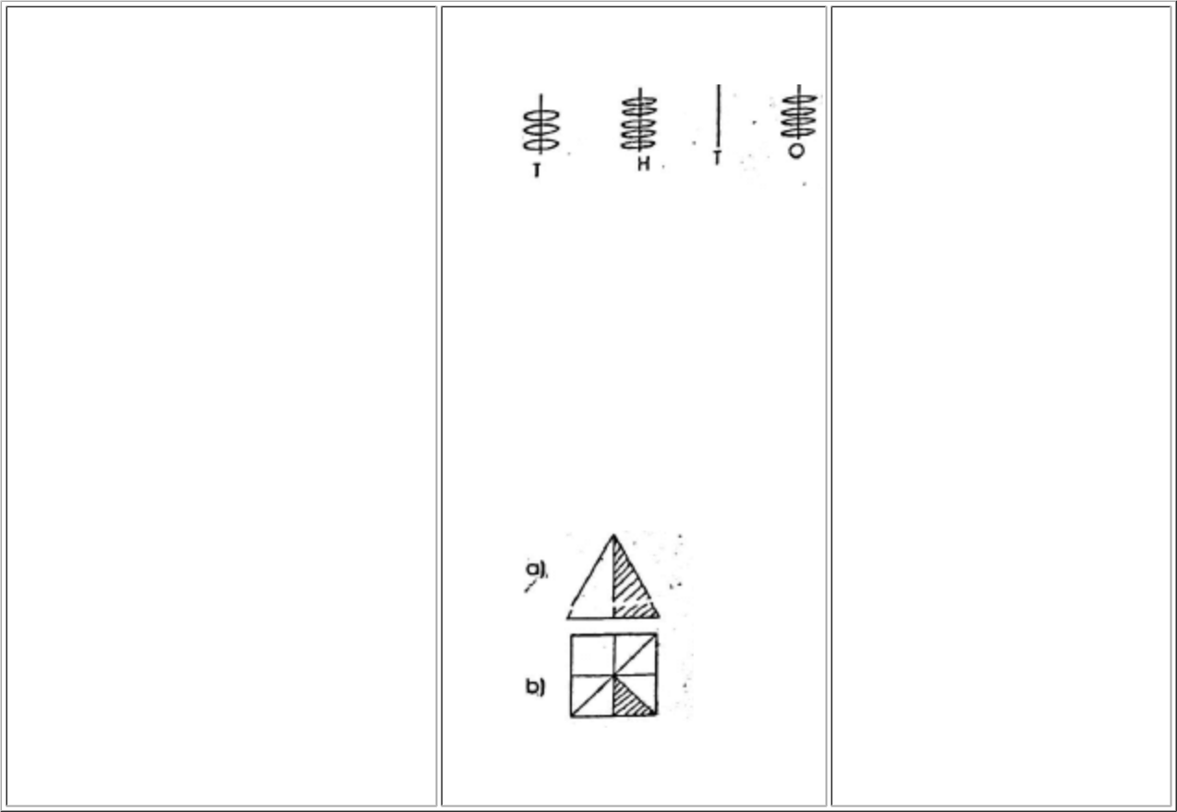

- hundreds

- 9-9000

5-500

4-40

8-8

- four thousand and 4

  - 1000

  - 270

  - 140

- 14+6+3

20+3

= 23

6.

  - 4

  - 3

- 854, 845, 584, 548, 485, 458

- 6 x 5 = 6 + 6 + 6 + 6 + 6 = 30

  - 7 and 2

  - 1 and 14

10. 2, 5, 10

11.

- 295

- 56

- 81

- 47, 49, 63, 29

- viii

17.

  - 5

  - 5

- 36 legs

20. 9,986

- 28

- 1152kg

  - quarter past one

  - half past 7

24.

a. 3 72

b. 7 15

- 150mins

- sh185

- sh60

- sh130

  - 1

  - 2

  - 2

  - 1

