^{COMPETENCE BASED CURRICULUM}
 |  | GRADE 4 - 2025
CBC ASSESSMENT |  | CODE 001
FIRST TRIAL | KENYA PRIMARY SCHOOL EDUCATION ASSESSMENT
 | ENGLISH COMPOSITION | Time: 40 minutes
Learner’s name:...................................................................................................... | Grade | ...................................
School’s Name: ....................................................................................... | Assessment No......................................
Date: .............................................................................


You have 40 minutes to write your composition.

Write a composition about;

OUR COW
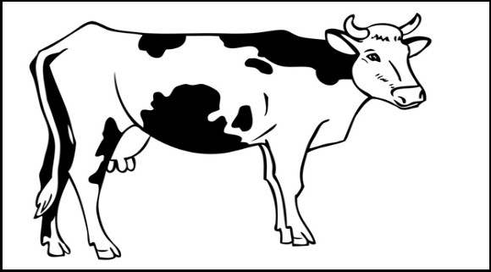

________________________________________________________________________________

COMP/ GR. 4

CBC ASSESSMENT

CBC ASSESSMENT | COMP/ GR. 4

