
COMPETENCE BASED CURRICULUM
G2
GRADE 2
END TERM ASSESSMENT
TERM 1 2025
MATHEMATICS ACTIVITIES

Name:_________________________________________________
School:________________________________________________
Grade:________________________________________________
Gender: Boy _______________ Girl ______________

Exceeding Expectation | Meeting Expectation | Approaching Expectation | Below Expectation
18-20 (90% +) | 17-15 (88% +) | 14-12 (60%+) | 11 and below (56%+)

1. Write in words and figures
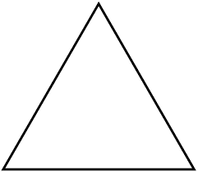 | 
2. Write the missing numbers
5, 10, 15, ____, _____ 30, _____, 40
40, 30, _____, ______, 0
31, 32, 33, ____, _____, 36, _____, 38
3. Jane has thirteen books. Peter has nine books. How many books do they have together?__________________________________________________

4. A farmer has ten eggs and five eggs broke. How many eggs was he left with?_____________________________________

5. Fill in the missing numbers

___________ + 6 = 13

6. Write the time shown on the clock
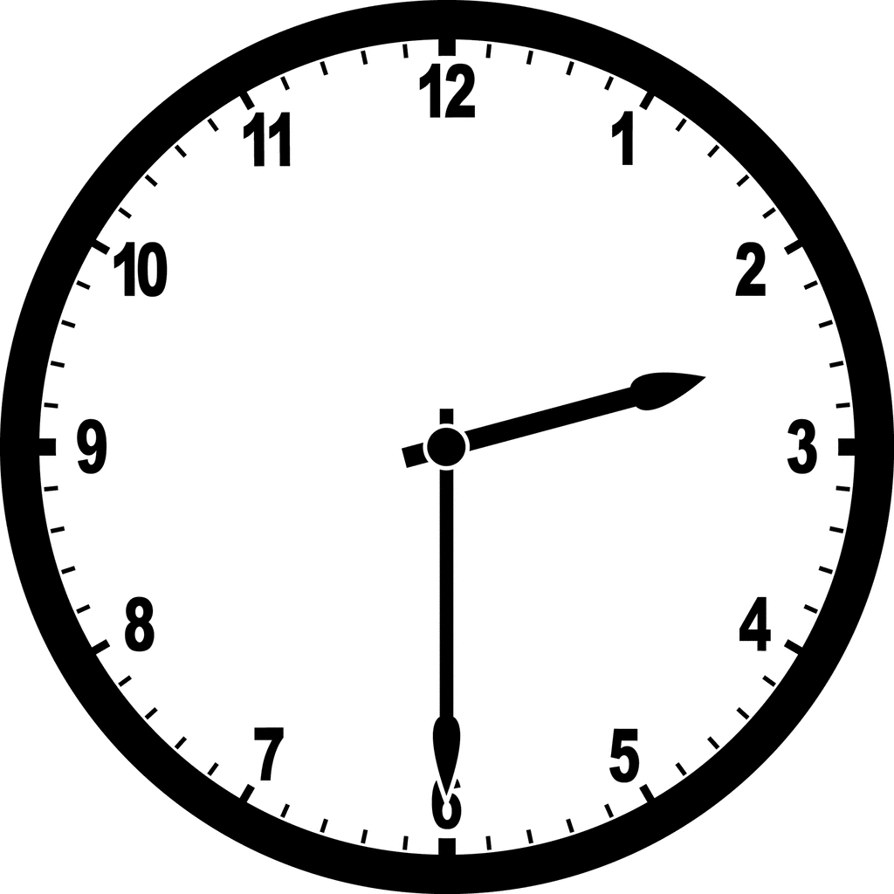___________________________________________
7. A Grade 2 class has a total of thirty pupils. Twenty pupils are boys. How many girls are there in the class?___________________________________________

8. Three cows have ______________________ legs?
9. How many months are there in a year?_________________________________
10. John had nine mangoes. He divided the mangoes among three boys. How many mangoes did each boy get?_________________________________

11. Fill in the gap
January ________________________ February ___________________ April
12. A tailor had 39 shirts. He sold 11 shirts. How many shirts was he left with?________

13. Order from smallest to biggest
22, 30, 19, 10, 33, 7
_________________________________________________________________
14. Subtract 7 from 12

15. Daniel had a hundred shilling note. He bought a loaf of bread at Ksh. 50. How much change was he given back by the shopkeeper?

16. Which object is heavier?


A
B
_____________________________________________

17. Draw the next shape.
___________

