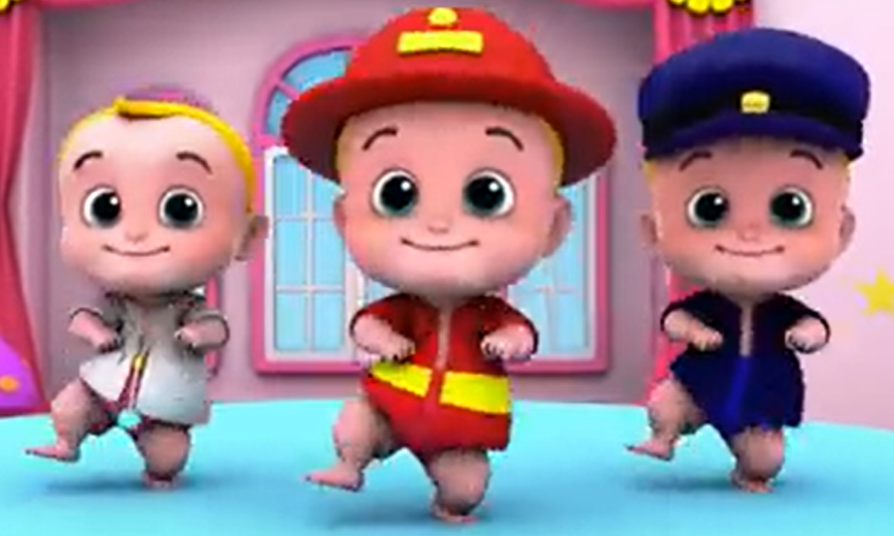
COMPETENCE BASED CURRICULUM
G2
GRADE 2
END TERM ASSESSMENT
TERM 1 2024
INTEGRATED ASSESSMENT
Name:_________________________________________________
School:________________________________________________
Grade:________________________________________________
Gender: Boy _______________ Girl ______________
For official use only
TASK | Exceeding Expectation | Meeting Expectation | Approaching Expectation | Below Expectation
 | 13-15 | 10-12 | 7-9 | 0-6
Environmental
CRE activities

ENVIRONMENTAL ACTIVITIES
1. Write two ways of responding to weather conditions below: (2marks)
a) Rainy conditions
_____________________________________________________________________________
_____________________________________________________________________________
b) Sunny conditions
_____________________________________________________________________________
_____________________________________________________________________________
2. List down three small animals that you know
____________________, ____________________, ____________________ (3 marks)
3. Sandy soil is best for ________________ (modelling, building, farming) (1 mark)
4. Draw the following containers used to store water (3 marks)
pot | bucket | tank
5. _________________soil makes the longest ribbons. (1 mark)
6. Name three sources of light.
_____________________, _____________________, _____________________ (3 marks)
7.______________________ is a dangerous animal. ( hen, fish, snake ). (1 mark)
8. Bright light can affect our ______________________ (ears, eyes, mind).(1 mark)
9. The main source of water is ____________________ (river, rain, tap).(1 mark)
10. Draw and colour the following parts of a plant. (4 marks)
flower | leaf | fruit | roots
11. List three ways of showing care to domestic animals (3 marks)
______________________________________________________
______________________________________________________
______________________________________________________
12. Name three good oral habits. (3 marks)
____________________________________________
____________________________________________
____________________________________________
13. List down two uses of teeth. (2 marks)
____________________________________________
____________________________________________
14. Name the following equipment found in different rooms. (4 marks)
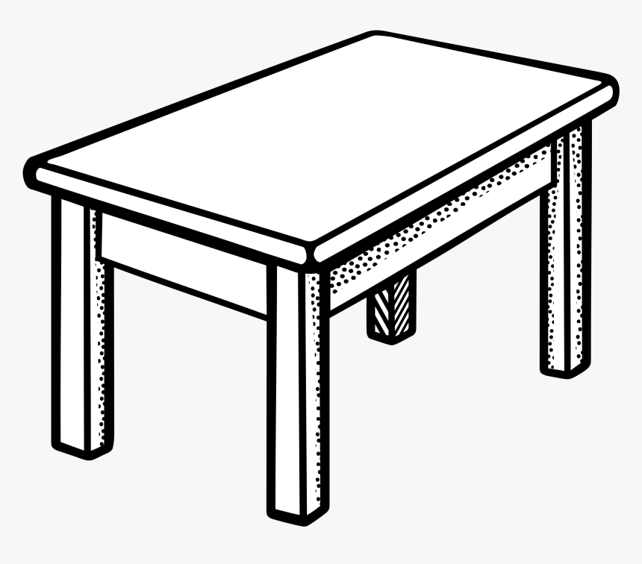 | 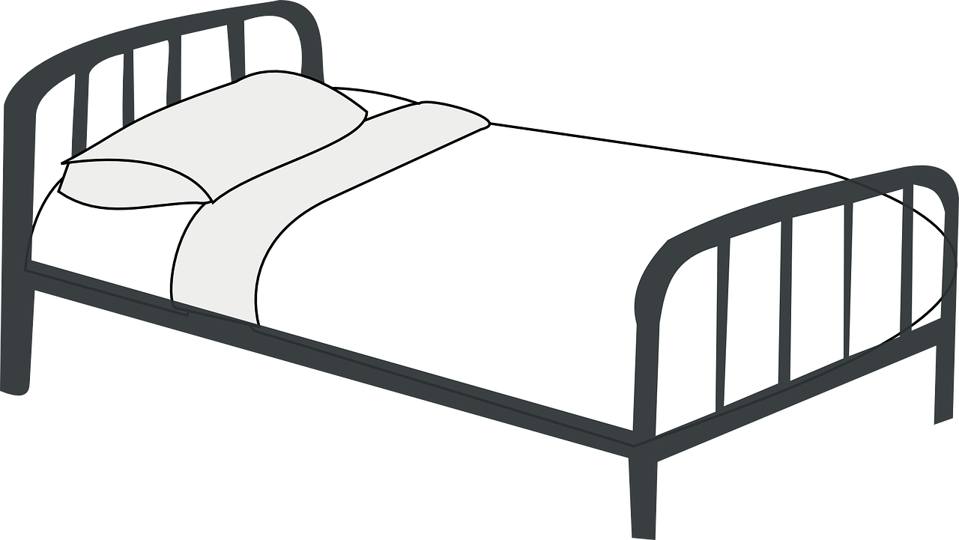 | 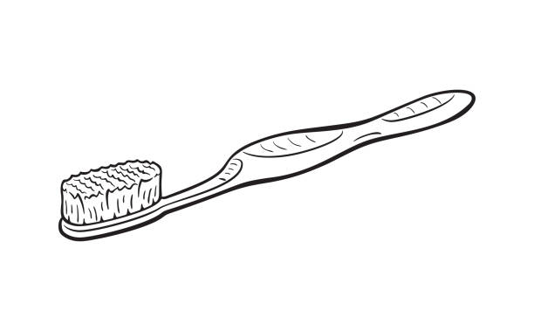 | 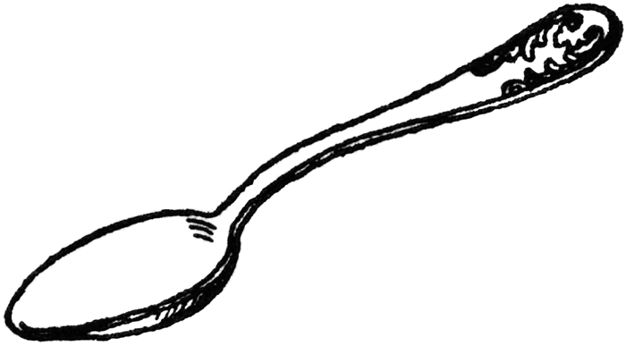
15. The living room is used for ____________________. ( sleeping, socializing, eating) (1 mark)
16. To clean utensils you need sponge, ____________________ and ________________. (1 mark)
17. Fill in the missing letters. ( 4 marks)
de _ ti _ _ or _ l s _ o _ n de _ ta _
18. Some people smoke tobacco and ______________________________ (1 mark)
19. A lemon tastes ______________________ (bitter, sour). (1 mark)
20. Smoke that someone breaths in form of other people is called _________________________________________. (1 mark)
21. Second hand smoke causes a disease called ______________________ (stomach cancer, lung cancer). (1 mark)
TOTAL SCORE

CHRISTIAN RELIGIOUS EDUCATION
1. God made us in his own ___________________________ and __________________. (2 marks)
2. Write down three ways of helping your parents at home. (3 marks)
_______________________________________________________________
_______________________________________________________________
_______________________________________________________________
3. Grandfather, aunt, uncle and cousins are our_________________________________. (1 mark)
4. Name two types of families that you know. (2 marks)
___________________________________________________________
___________________________________________________________
5. Draw and name two things that cannot be shared at home (2 marks)
6. God created on the fourth day, ________________________ (sky, sun). (1 mark)
7. The Holy Bible is divided into __________________ parts known as testaments. (66, 2) (1 mark)
8. According to Psalms 119:05, “Your _______________ is a lamp to guide me and a ________________________ for my path.” (1 mark)
9. Write down the first two books of the Bible (1 mark)
_________________________________________
_________________________________________
10. How many times did God call Samuel? ______________ times. (1 mark)
TOTAL SCORE

