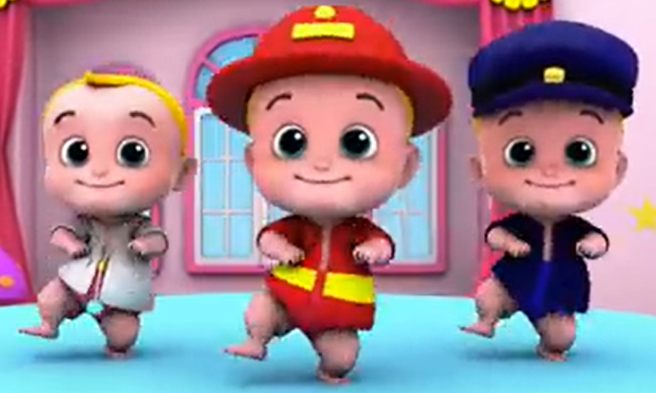
COMPETENCE BASED CURRICULUM
G2
GRADE 2
END TERM ASSESSMENT
TERM 1 2025
ENGLISH SECTION A
Name:_________________________________________________
School:________________________________________________
Grade:________________________________________________
Gender: Boy _______________ Girl ______________

For official use only
Refer to the teacher’s assessment rubric given in the teacher’s guideline.
TASK | Exceeding Expectation | Meeting Expectation | Approaching Expectation | Below Expectation
 | 22-25 | 21-18 | 17-15 | 15 and below
Comprehension
Language use

Task One: Comprehension
Read the stories below and answer the questions
1. A Day at the farm
Amos and Agnes are in the village. They have come to visit their grandparents. Today they are going to the farm. The farm is not very far from the house. They all walk together to the farm. Amos and Agnes are carrying the seeds. Amos will plant all the seeds. Hi sister Agnes will cover the seeds with soil.
a) _____________ and _______________ went to visit their grandparents.
b) Agnes will cover the seeds with the ________________________
c) Where did they walk to together?
________________________________________________________________________________________
2. Helping at home
Tito and Milka are at home. Tito is washing the dishes. Milka is drying them up. She is using a small towel to dry the plates. She wants to keep the plates in the cupboard. Milka and Tito like helping at home.
a) What is Tito doing? ___________________________________________________________________
b) What is Milka doing? ___________________________________________________________________
c) What do you do at home after school?
___________________________________________________________________
3. Myself
My name is Melissa Nyambura. I am eight years old. I live in Ruaka village. My parents are Mr. and Mrs. Kamau. I go to Kamuiru Primary School. I am in grade two.
a) How old is Melissa? ___________________________________________________________________
b) Where does she live? ___________________________________________________________________
c) Which school does she go to?
______________________________________________________________________________________________________________________________________
4. Crossing the road
Rama and his sister Njama were going to school in the morning. Njama warned Rama not to run when crossing the road. She also told him to look carefully before crossing. Rama didn’t listen. He crossed the road while running. He did not look left and right. A car was coming from the other side. Rama did not see the car. It hit him and he fell on the side of the road.
a) How did Rama cross the road? ______________________________________________________________________________________________________________________________________
b) Where were Rama and his sister going that morning?
______________________________________________________________________________________________________________________________________
c) Who did not listen to the instructions?
______________________________________________________________________________________________________________________________________

Task two: Language use
5. Write the correct word in the steps provided.
a) We must ____________________ our neighbours (Help/hate)
b) I but bread from the ________________ (shop/butchery)
c) The ____________ treats patients (pilot/doctor)

6. Use a or an.
a) John wanted to read __________ book.
b) The hen was chasing ________________ ant.
7. Write the words correctly.
a) aechert__________________
b) eldre _________________
c) yob ___________________

Task three: Dictation
1) _____________________________
2) _____________________________
3) _____________________________
4) _____________________________
5) _____________________________

