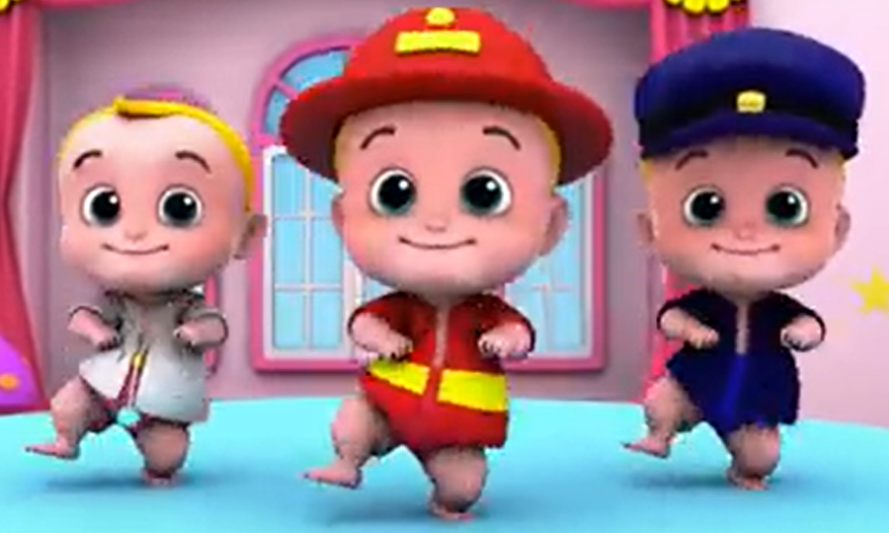
COMPETENCE BASED CURRICULUM
GRADE 2
END TERM ASSESSMENT
TERM 1 2025
G2
CREATIVE ACTIVITIES
Name:_________________________________________________
School:________________________________________________
Grade:________________________________________________
Gender: Boy _______________ Girl ______________

For official use only
Refer to the teacher’s assessment rubric given in the teacher’s guideline.
TASK | Exceeding Expectation | Meeting Expectation | Approaching Expectation | Below Expectation
 | 18-20(90%) | 17-15(85%) | 14-12(70%) | 11-0(55%)
1. State at least five types of songs (5 marks)
a) ________________________________________________________
b) ________________________________________________________
c) ________________________________________________________
d) ________________________________________________________
2. __________________________ is a prayer to our country. (2 marks)
3. ___________________________________ are songs that are sung by children. (2 marks)
4. Sacred songs are sung in the __________________________(2 marks)
5. ___________________ is the loudness or softness of a song. (2 marks)
6. Name the following musical instruments. (4 marks)
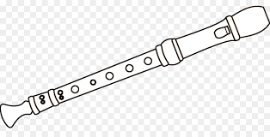 | 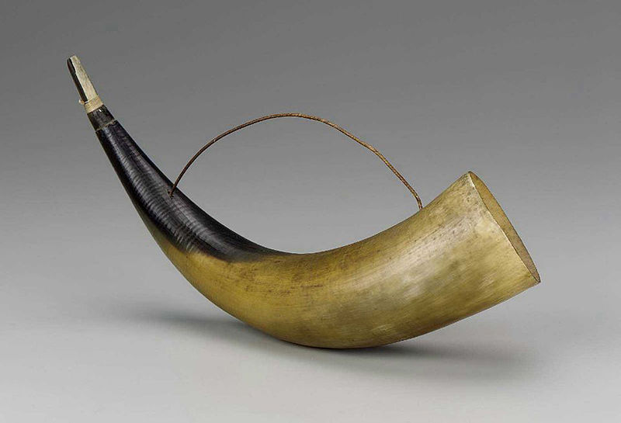

7. A guitar is played by________________________? (plucking, striking, heating) (3 marks)

8. Which parts of the body do we use when walking (3 marks)
____________________________
____________________________
____________________________
9. Name three parts of the body that we use when running. (3 marks)
____________________________
____________________________
____________________________
10. Which direction is easier for you to jump for height?
____________________________ (2 marks)
11. Name 3 parts of the body that we use while bending. (4 marks)
____________________________
____________________________
____________________________
12. Name 3 games which involve throwing. (3 marks)
____________________________
____________________________
____________________________
13. Name two methods of catching a ball (4 marks)
____________________________
____________________________

14. Name at least 5 geomatric shapes encountered in art. (5 marks)
____________________________
____________________________
____________________________
____________________________
____________________________
15. How do we create texture using rubbing techniques? (2 marks)
________________________________________________________
16. What material can be used to make chewed fibrous brushes? (2 marks)
________________________________________________________
17. Draw a chewed stick brush (3 marks)

18. Name three materials used in making rolled paper items. (3 marks)
________________________________________________________
________________________________________________________
________________________________________________________
19. Twisted papers are used in ________________ the house. (2 marks)
(decorating, vanishing)
20. Name 3 materials used in making twisted papers. (3 marks)
________________________________________________________
________________________________________________________
________________________________________________________

21. Name things that may float on water. (2 marks)
____________________________
____________________________

