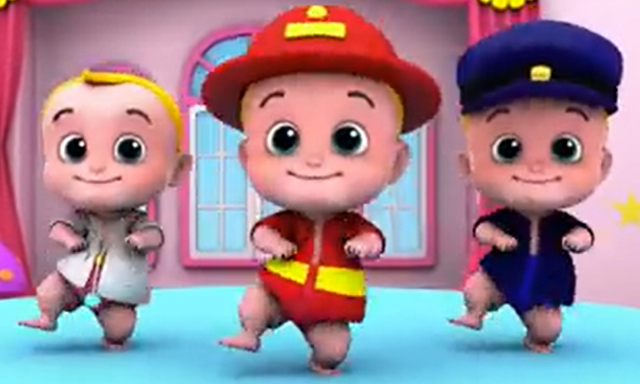
COMPETENCE BASED CURRICULUM
G1
GREDI YA 1
MTIHANI WA MWISHO WA
MUHULA WA KWANZA 2025
KISWAHILI SEHEMU YA B
- Kusikiliza na Kuzungumza
- Kusoma kwa sauti

Jina_________________________________________________
Shule________________________________________________
Gredi________________________________________________
Jinsia
Mvulana__________ Msichana_____________

KWA MATUMIZI YA MTAHINI
VIWANGO VYA KUTHAMINI
Kuzidisha Matarajio | Kufikia matarajio | Kukaribia matarajio | Mbali na matarajio
27-30 | 21-26 | 11-20 | 0-10

UFAHAMU WA KUSOMA, MATUMIZI YA LUGHA
Soma hadithi hizi ujibu maswali
- Mimi na wenzangu
Jina langu ni Bahati. Nina umri wa miaka sita. Niko gredi ya kwanza. Rafiki yangu anaitwa Rita. Sisi hucheza pamoja. Tuna penda mchezo wa kandanda.

- Bahati ya Rita hufanya nini pamoja?_________________________
- Wanapenda mchezo gani?____________________________________ (alama 2)

- Wanyama
Yohana ana wanyama watatu. Yeye ana paka wawili na mbwa mmoja. Paka wake wanaitwa Fifi na Fofoo. Mbwa wake anaitwa Rolo. Yeye huwapa wanyama wake chakula na maji safi.
- Yohana na wanyama wangapi?________________________________
- Je, mbawa hutusaidia vipi?____________________________________
- Yohana Huwatunza wanyama wake vipi?_______________________________________
- Mama
Nampenda mama sana. Yeye anaipenda pia. Mama hunitunza vizuri, Yeye hunisaidia na mambo mengi.

- Kwa nini unampenda mama?___________________________________
- Taja mambo ambayo mama hukusaidia. ________________________________________________________________ (alama 2)

- Baiskeli mpya
Gyan ana baiskeli mpya. Baiskeli yake ina rangi nyekundu, na bendera nyeupe. Gyan anajua kuendesha baiskeli yake. Yeye huiendesha baada ya shule.

- Taja rangi mbili zilizotajwa kwenya hadithi.________________________________
- Baiskeli ya Gyan ina nini? _______________________________
- Gyan huendesha baiskeli yake wakati gani?_______________________(alama 3)

- Familia yangu
Jina langu ni Daniella. Mimi ninaishi na baba na mama yangu. Nina kaka mmoja ambaye anaitwa Wambua. Nina dada wawili ambao ni Talia na Becky. Ninaipenda familia yangu sana.

- Daniella anaishi na ___________________________
- Baba na mama ni ________________________ (watoto, wazazi)
- Kaka ya Daniella anaitwa_________________________ (alama 3)

ZOEZI LA 2: MATUMIZI YA LUGHA
- Jaza nafasi kwa herufi inayofaa
- Ms_chana
- Pak_ (alama 2)
- Jibu maswali sahihi
- Mimi ni __________________ (mvulana, msichana)
- Ninasoma katika gredi ya __________________ (kwanza, moja)
- Kuna siku ___________________ kwa wiki. (sita, saba) (alama 3)

- Jibu maamkuzi haya
- Hujambo? _________________
- Shikamoo _________________ (alama 2)
- Andika vizuri
- zame _______________
- kusi ________________ (alama 2)

ZOEZI LA 3: KUANDIKA
Mwalimu atasoma sentensi. Andika. (alama 4)
- ______________________________________
- ______________________________________
- ______________________________________
- ______________________________________
Andika sentensi tano kuhusu shule yako.
- ______________________________________________________________________
- ______________________________________________________________________
- ______________________________________________________________________
- ______________________________________________________________________
- ______________________________________________________________________

