Fluid flow
1. Figure 5 below shows the cross-section of an aerofoil, with the aeroplane moving in the direction
shown by the arrow.

Sketch the streamlines to show how air flows past the wing as the aeroplane moves

2. State Bernoulli’s principle
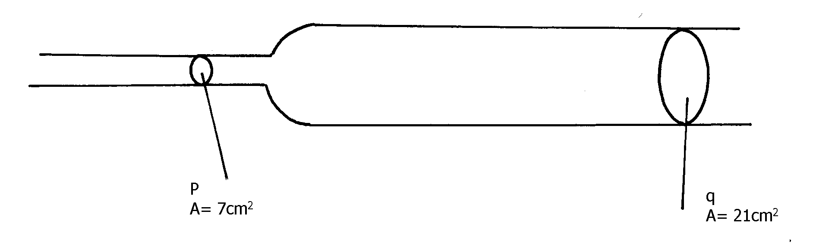
3. The diagram below shows a section of a pipe with different cross – sectional area.

Figure 4

Q

If water flows with a velocity of 5ms⁻¹ in section P, what would be the velocity of water in
section Q if the cross sectional areas are as shown?
4. In the diagram in figure 3, water flows through a section of a pipe whose diameter changes
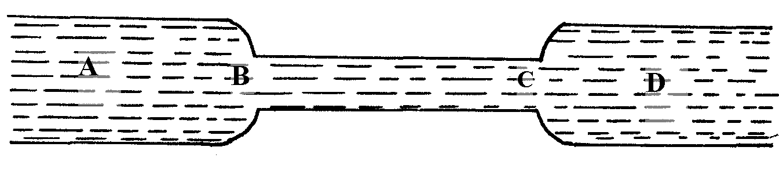
as shown

figure 3

Sketch a graph of the variation of pressure along the line ABCD
5 (i) State Bernoll’su principle
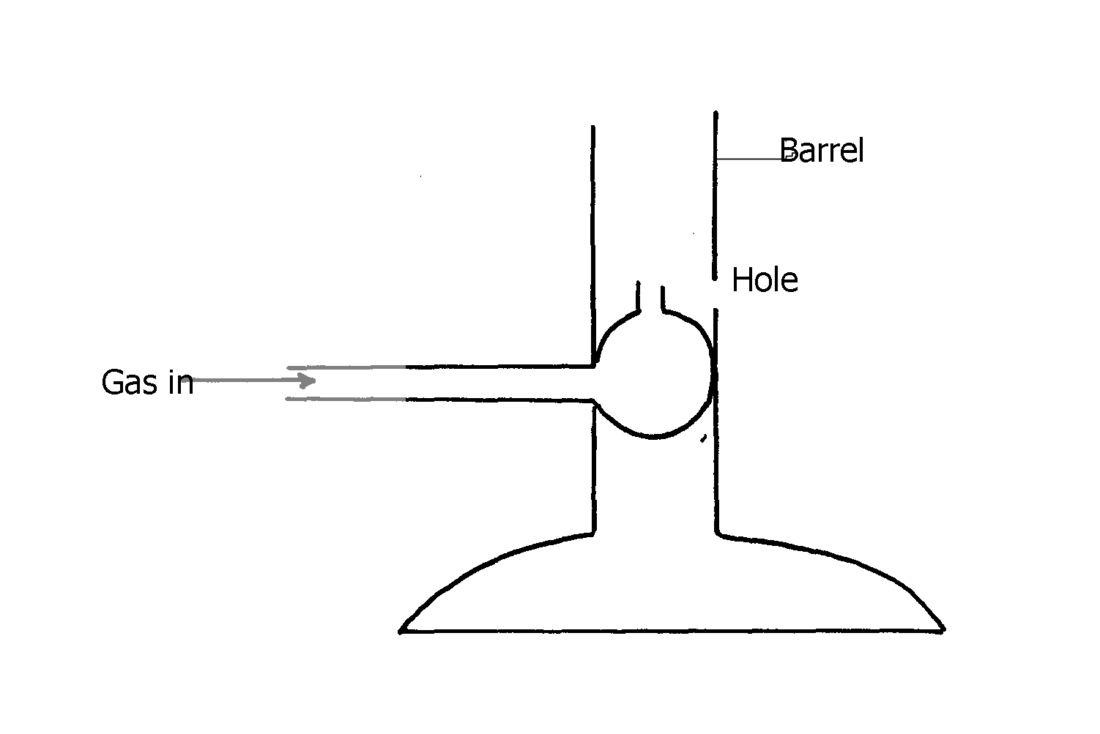

(ii)

Explain how air is drawn into the barrel
6. The diagram below (figure 6) shows a cross- section of an aeroplane wing. When the aeroplane
is moving at a constant height and constant speed, an upward force is exerted on its wing
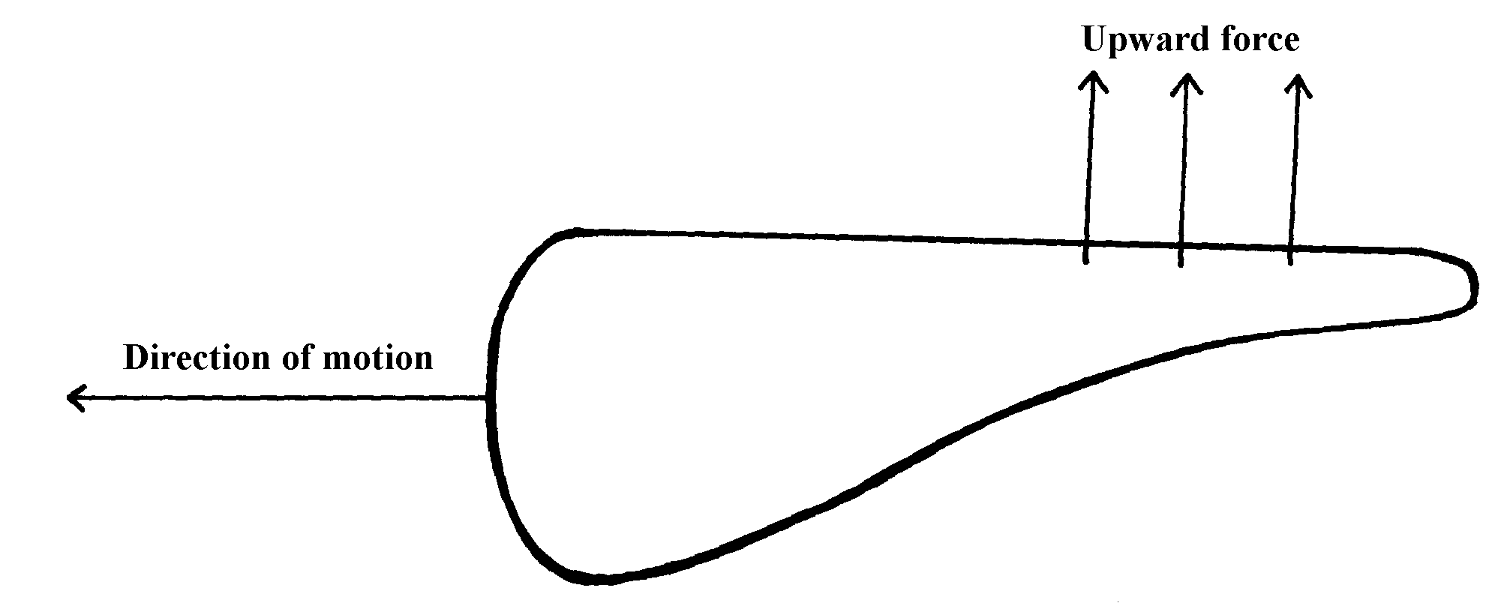

What is the cause of the upward force?
7. The figure below shows a light body floating in a container
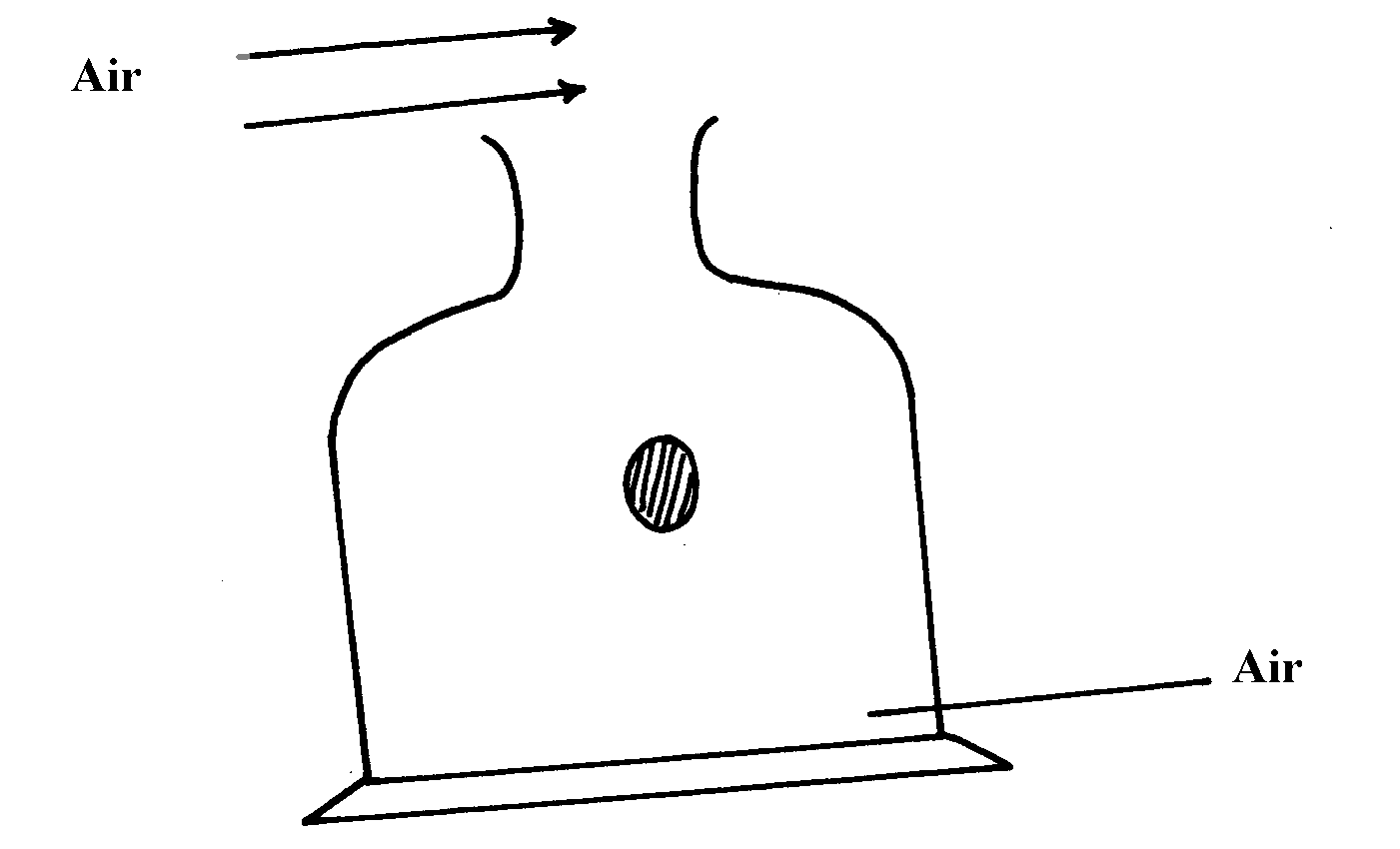

State and explain the observation when a stream of air is blown over the mouth of the container
as shown

8. Sea water of density 1.04g/cm³ is being pumped into a tank through a pipe of uniform
cross-sectional area of 3.142cm². If the speed of water in the pipe is 5m/s, determine the
volume flux in S.I units

9. The figure below shows a pith ball being lifted in to a funnel end of a blower.
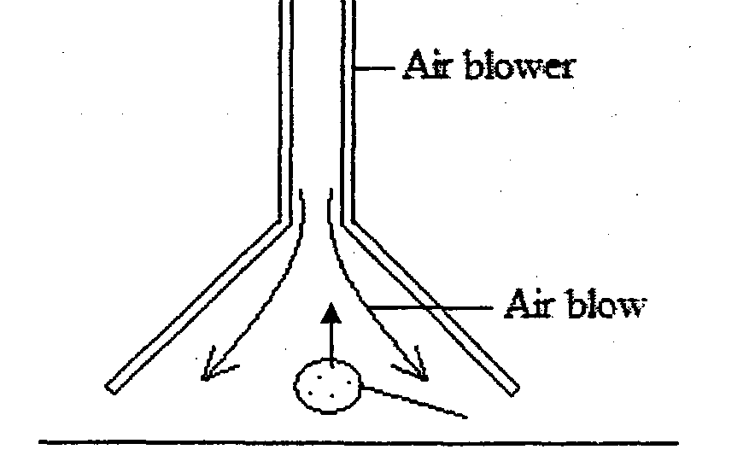

Explain this observation

10. (a) Define turbulent flow in fluids .
(b) The diagram below shows an obstacle placed in front of flowing water.
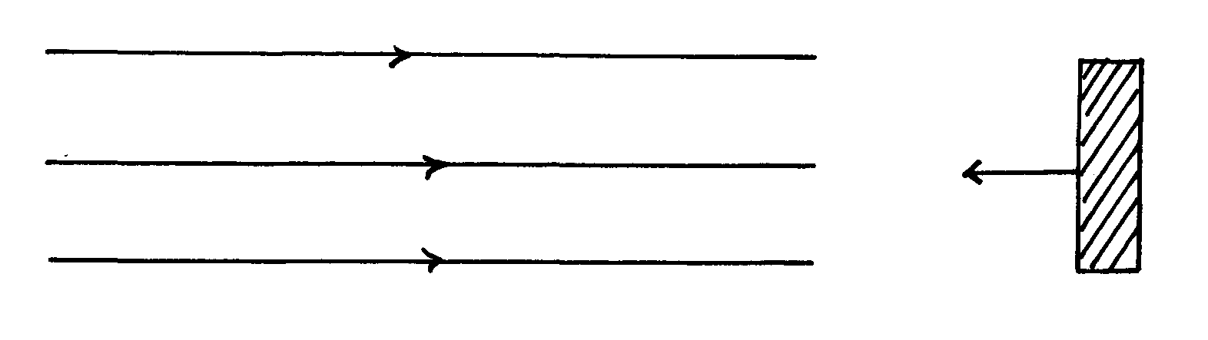
Water flow

Complete the diagram to show how the water flows around the obstacle.

11. Water flows in a horizontal pipe of varying cross –sectional area and diameter and shown
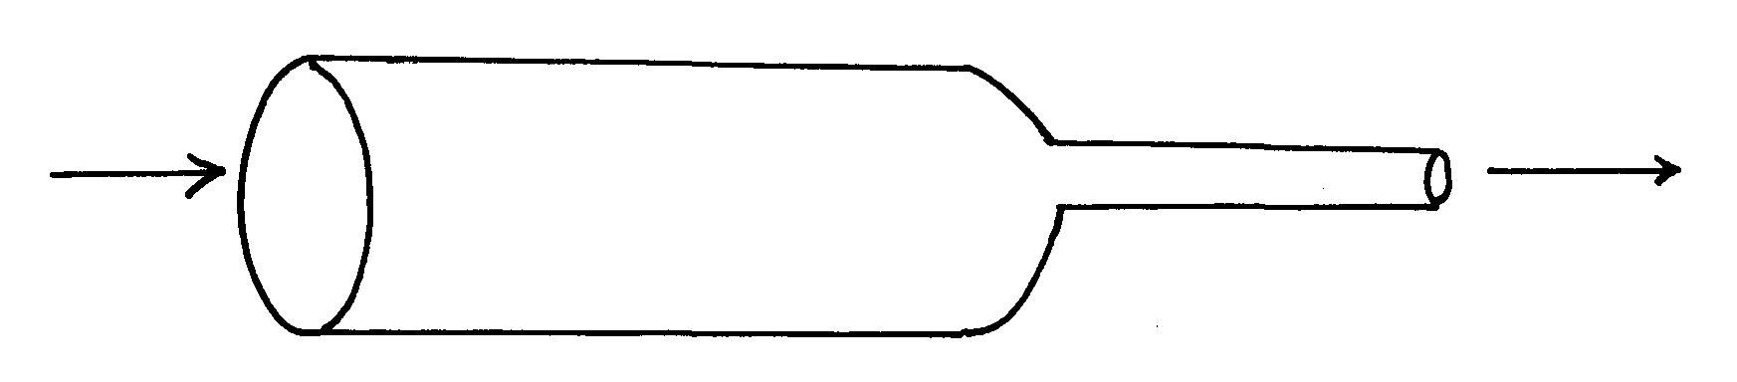
in the figure below.
A
B

If the cross-sectional area of A is 5cm² and that of B is 4,5cm² and also the rate at which the
water flows from A is 100m/s,. Calculate the speed water through B.
(d). Given the apparatus, density bottle, beam balance, granular solid, water and blotting paper,
describe the measurement on the experiment that can enable one to determine the relative
density of the granular solid.
(e).Draw a single pulley with a velocity ratio of 2.

Fluid flow

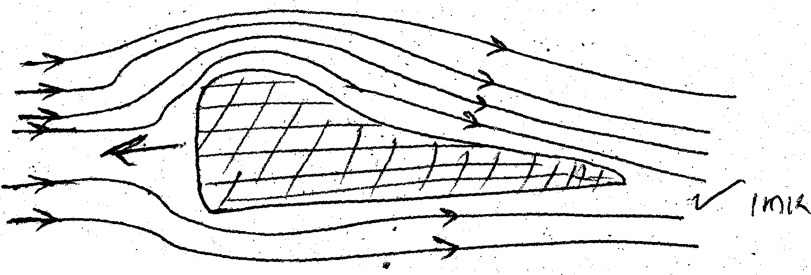
1.

2. The sum of potential energy, kinetic energy and pressure per unit volume of non-viscous
fluid flowing is constant

3. A₁V₁ = A₂V₂;
7 x 5 = 21 x V₂;
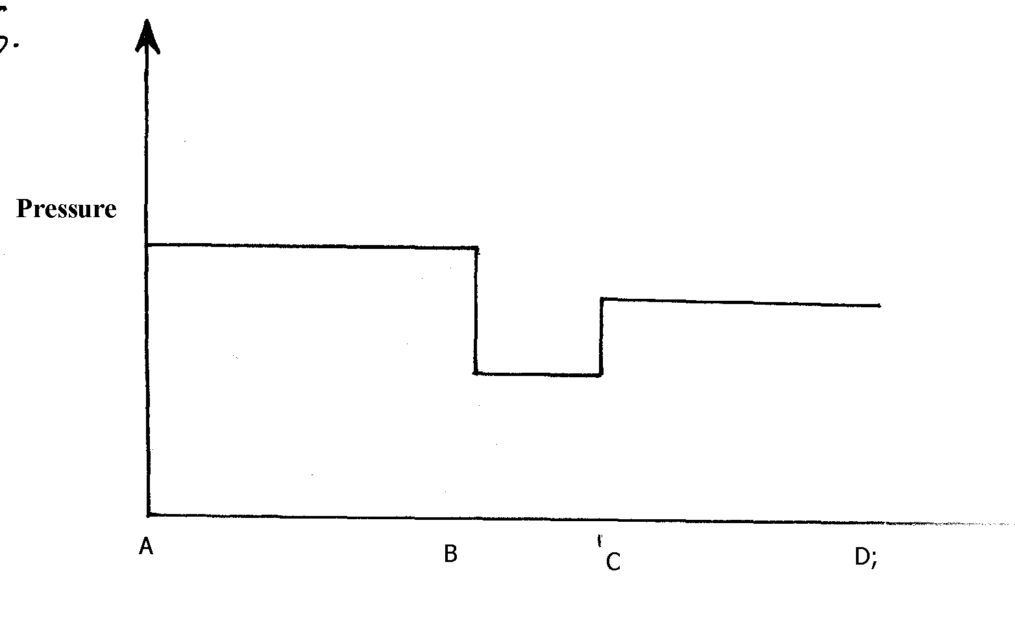
V₂ = 1.667m/s;

4.

5. (i) For a non-viscous, non compressible fluid, in continuous flow, the pressure at any part of it
is inversely proportional to the velocity of the fluid (1mk)
(ii) The gas jets in the barrel reduces pressure in the barrel hence the higher atmospheric pressure outside the barrel pushes air though the hole
1

6. Air flows over the top faster than air flow underneath; so air pressure on the top is less than air
pressure underneath √1
The difference in pressure causes the lift effect√1

7. High speed of air reduces pressure above the mouth of the container √1 higher pressure
below the body pushes it up

8. Volume flux = Velocity x cross-sectional area
= 5mls x 3.142 x 10⁻⁴m²
= 1.571 x 10⁻³m/s

