FARM TOOLS AND EQUIPMENT

There are five categories of farm tools and equipment namely:
- Garden tools and equipment e.g. pangas, jembe, pick axe, spade e.t.c.
- Workshop tools and equipment e.g. saws, hammers, planes, chisels e.t.c
- Livestock production tools and equipment e.g. milking stool, strip cup, milk churn etc.
- Masonry tools and equipment e.g. wood float, spirit level, plumb bob e.t.c
- Plumbing tools e.g. pipe wrench spanner, stock and die e.t.c

It is very important to identify the farm tools and equipment, give the correct users and maintenance practices.

The following relevant questions and their answers in this topic will greatly help and motivate the user to comprehend and understand the require concepts and practices:

1. List four maintenance practice carried out on a cross-cut saw
2. Identify the following tools and state their functions
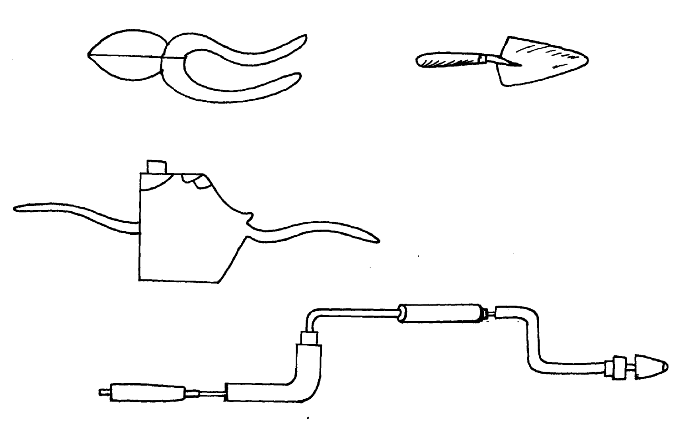

C
A

B

D

Identify A, B, C, D
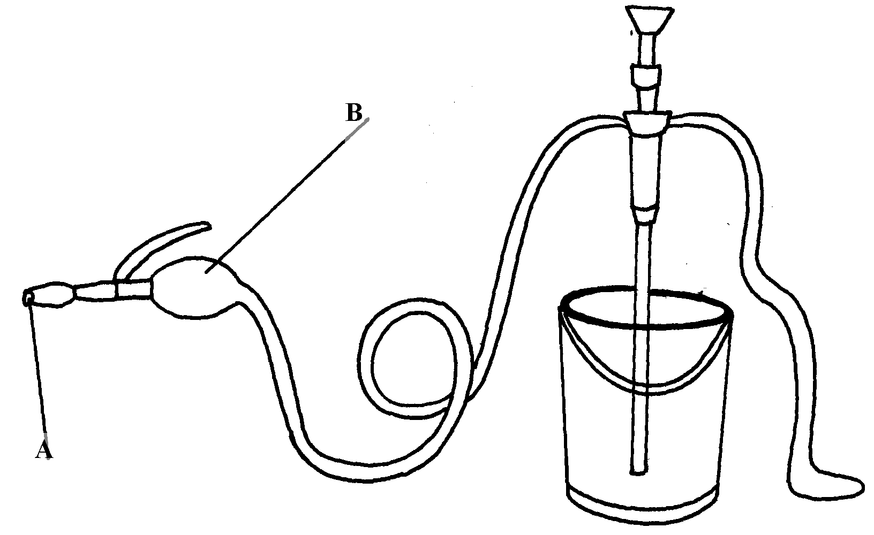
3. Study the illustration below and answer the questions that follow.

i) Identify the equipment represented by the illustration
ii) What is the use of the equipment?
iii) Name the parts labeled A and B
iv) What is the function of the part labeled A and B
4. What is the use of a garden fork?
5. Name the tool that a builder would use to check the vertical straightness of a wall during
construction
6. Name the farm tool that can be used when removing nails from timber
7. Give two examples of equipment that a livestock farmer can use in administering oral
anti helminthes
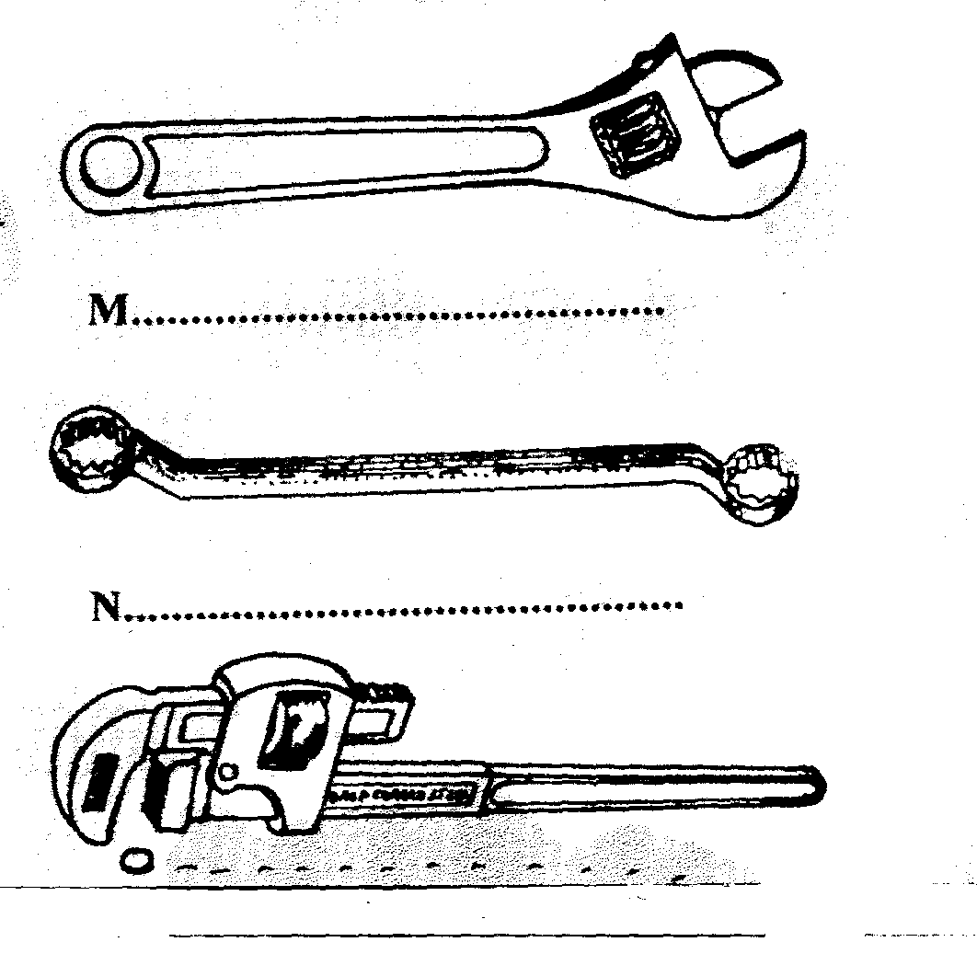
8. Below are farm tools, study them and answer the questions that follow:-
.....................................
O.............................................

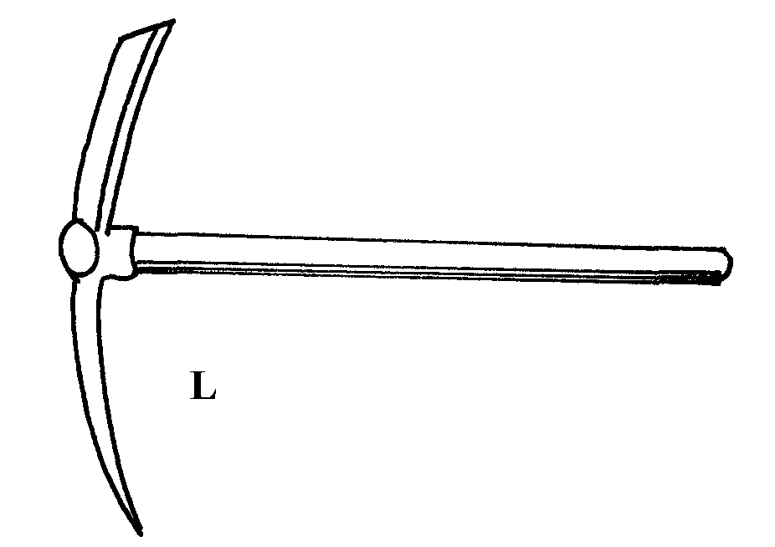

(a) Identify the tools L, M, N, O
(b) Give one functional advantage of tool M over tool N
9. Name a tool used to perform the following functions on the farm;
(i) Drilling of small holes on metal
(ii) Bore holes on wood
10. State the common faults in the operation of Knapsack spray
11. (a) Name the three tools in castration of livestock
12. Name the most appropriate set of animal handling tools that a farmer uses for the following operations:-
(i) Restraining a large bull when taking it around the show ring
(ii) Cutting tail in sheep
13. What is flushing in sheep production?
14. a)The illustration below shows a method of identifying pigs, study the diagram and answer the questions that follow:-
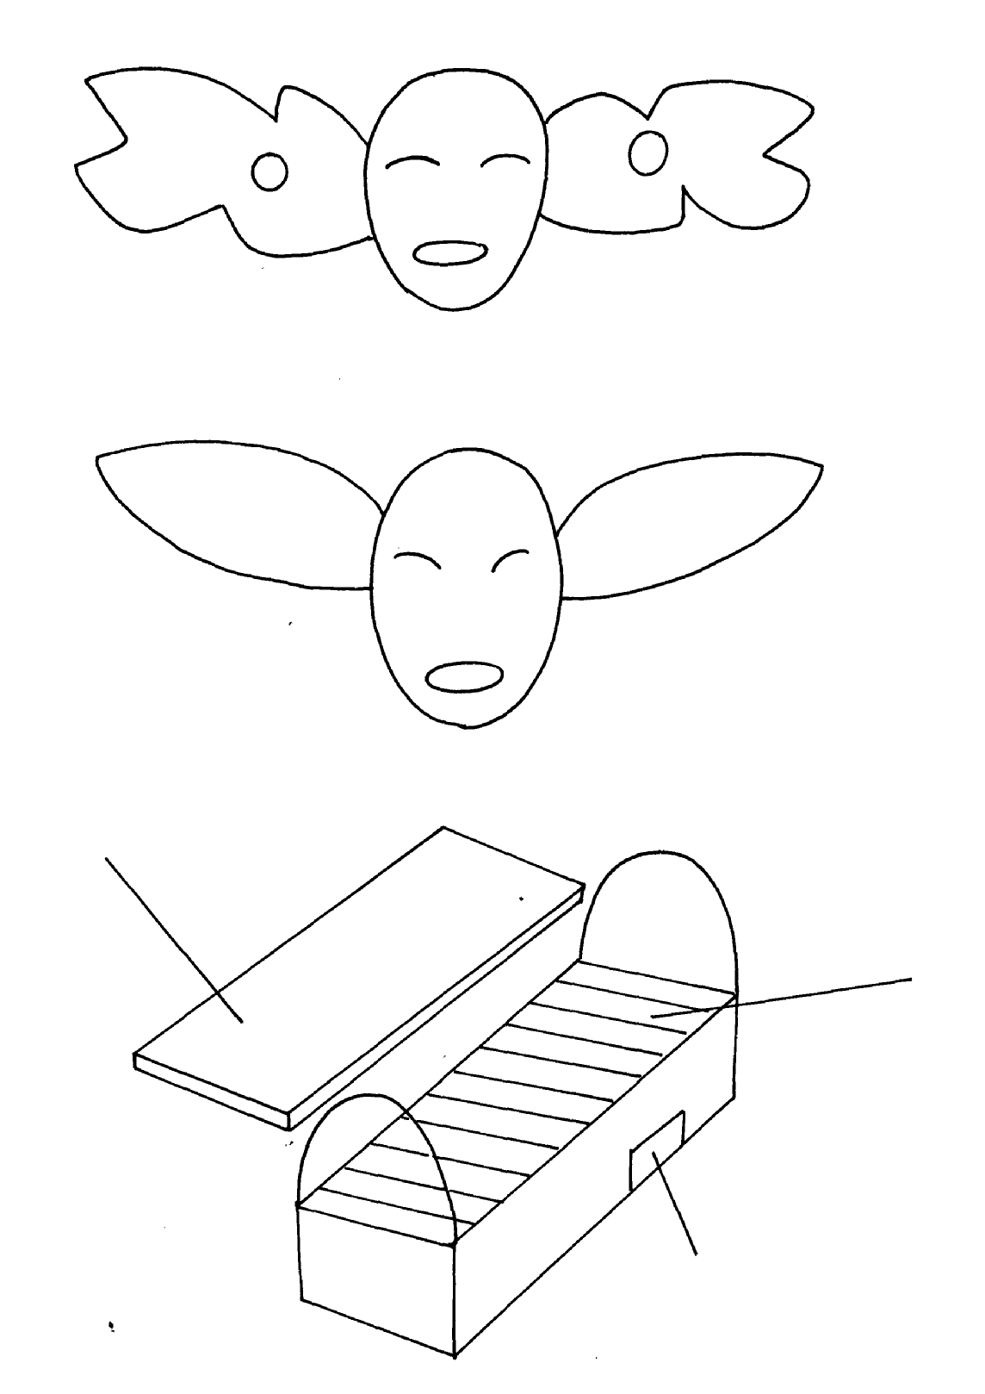
200
100
5
2
3
50
30
20

i) On the diagram A provided below, draw the mark to indicate a pig number 147,
using the procedure of ear-notching in diagram

A

ii) What is the recommended stage of growth in pigs at which the ear-notching should be
carried out?
iii) State any three reasons why weight is an important routine management practice in pig
production
b) Below are illustrations showing the various parts of the Kenya top bar hive. Use the illustration
to answer the question that follow
D

C

B
i) label the parts B ,C and D
ii) How can a farmer attract bees to colonize a new hive?
iii) Outline the procedure of opening the hive to harvest honey

15. a) Below are illustrations of farm tools
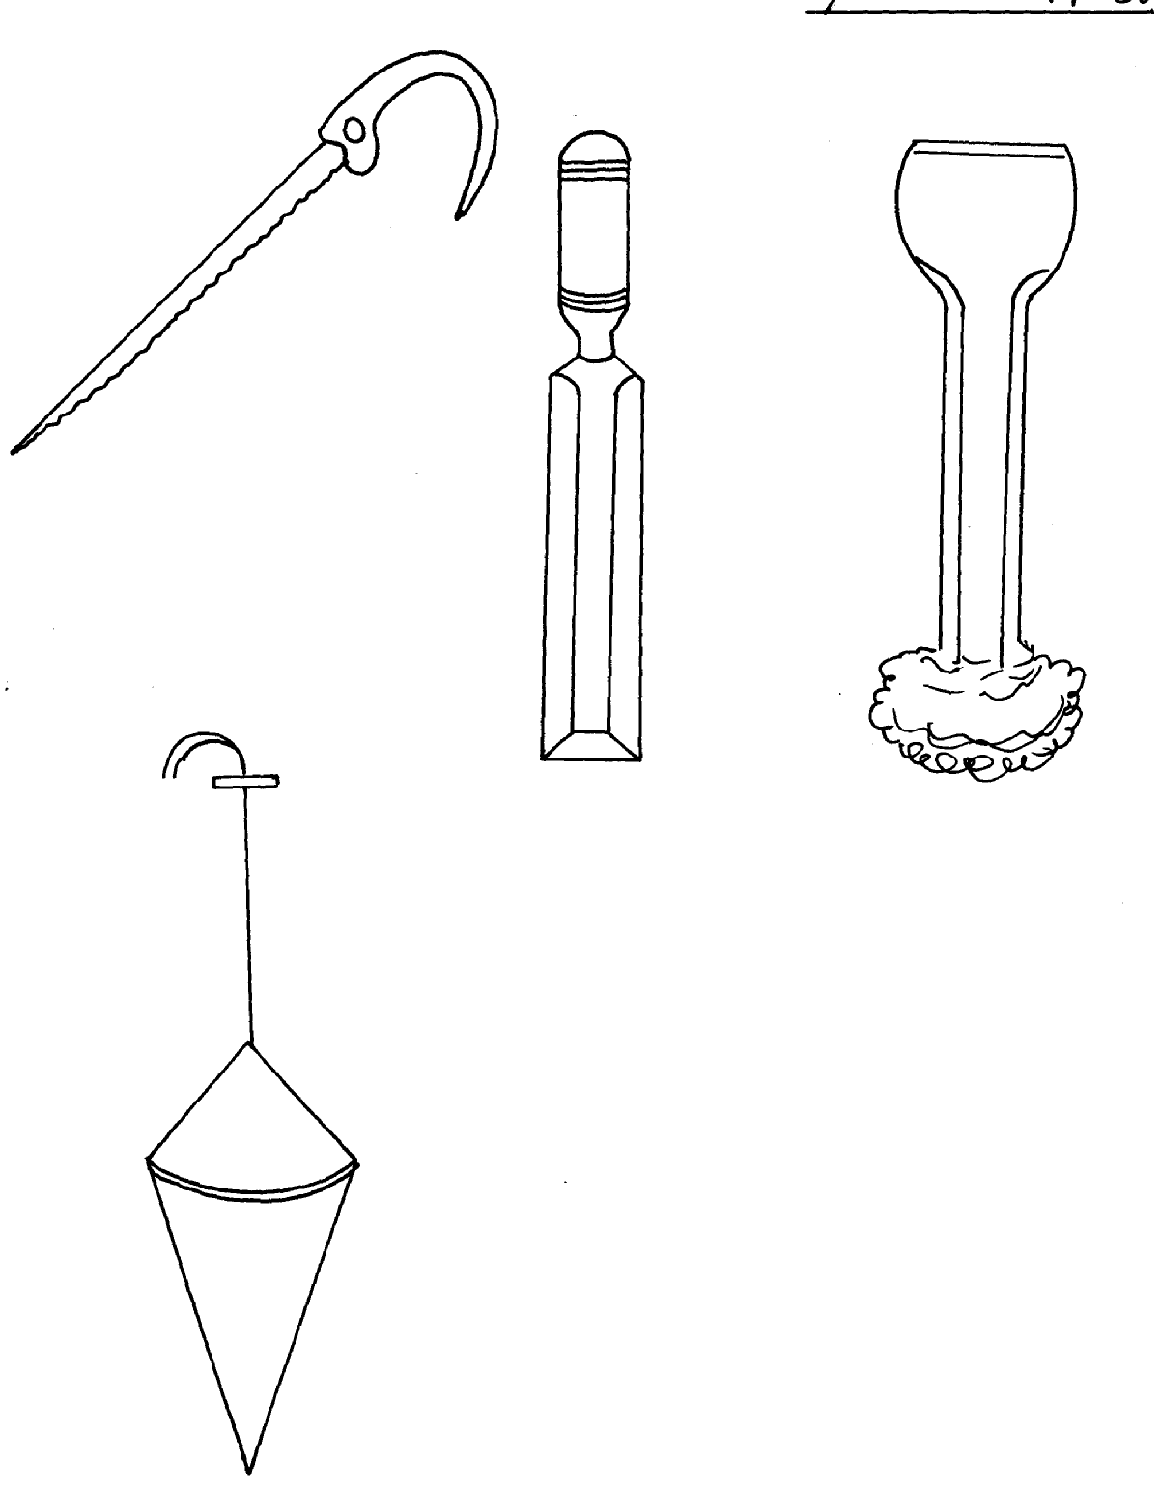
E
F
G
H

i) State the use of the tools
ii) Name the type of hammer that may be used for driving tool K during work

b) Given below is an illustration of one of the routine management practices in livestock
Production.
Study the diagram and answer the following questions

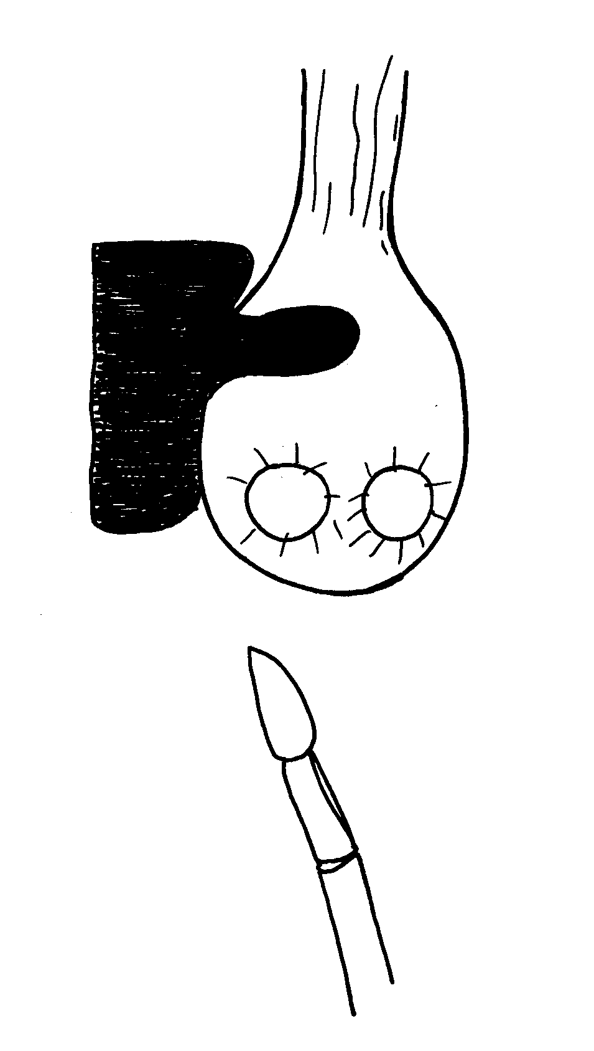

i) Name the practice indicated in the diagram above
ii) Describe the procedure you would follow when carrying out the practice named
in (i) above in piglets

16. Study the diagram below and answer the questions that follow;
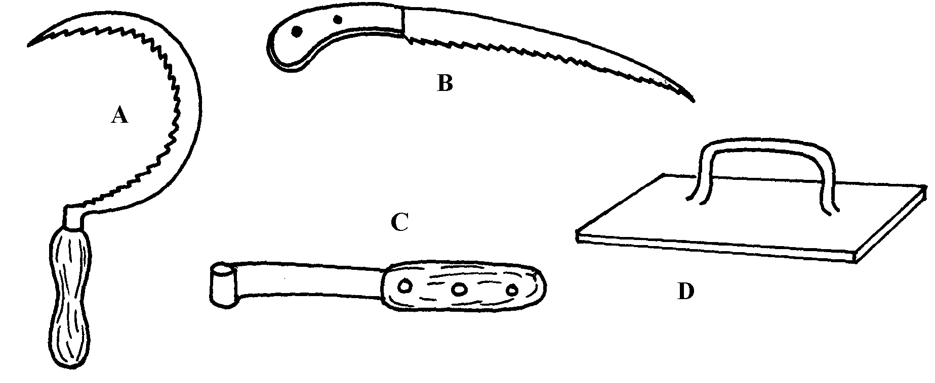

i) Identify the tools
ii) Give the use of each of the tools named above
iii) State two maintenance practices that should be carried out on tool D
17. List two equipments used in handling cattle during an Agricultural exhibition
18. Mention the use of the following tools.
i) Dibber
ii) Spokeshaves
iii) Tinsnips
iv) Burdizzo

19. List four precautions that should be taken when using workshop tools and equipment.

20. i) Below is an illustration of a farm equipment. Study it and answer questions that follow
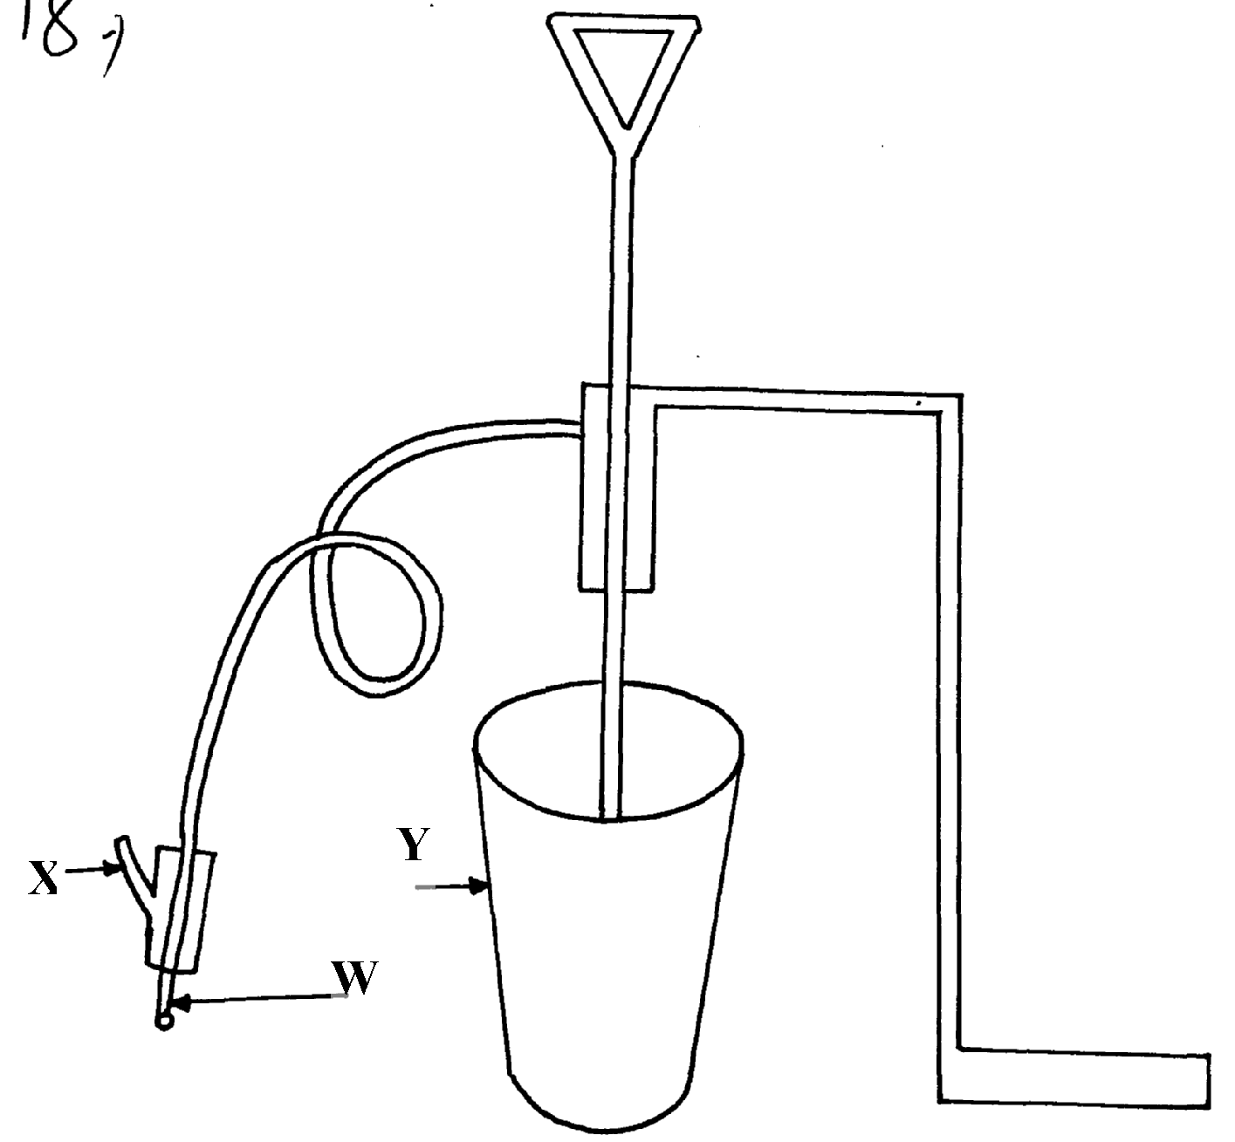

a) Identify the farm equipment illustrated above b) What is the use of the equipment c) Name the parts labelled W, X and
d) What is the functions of Y on the equipment
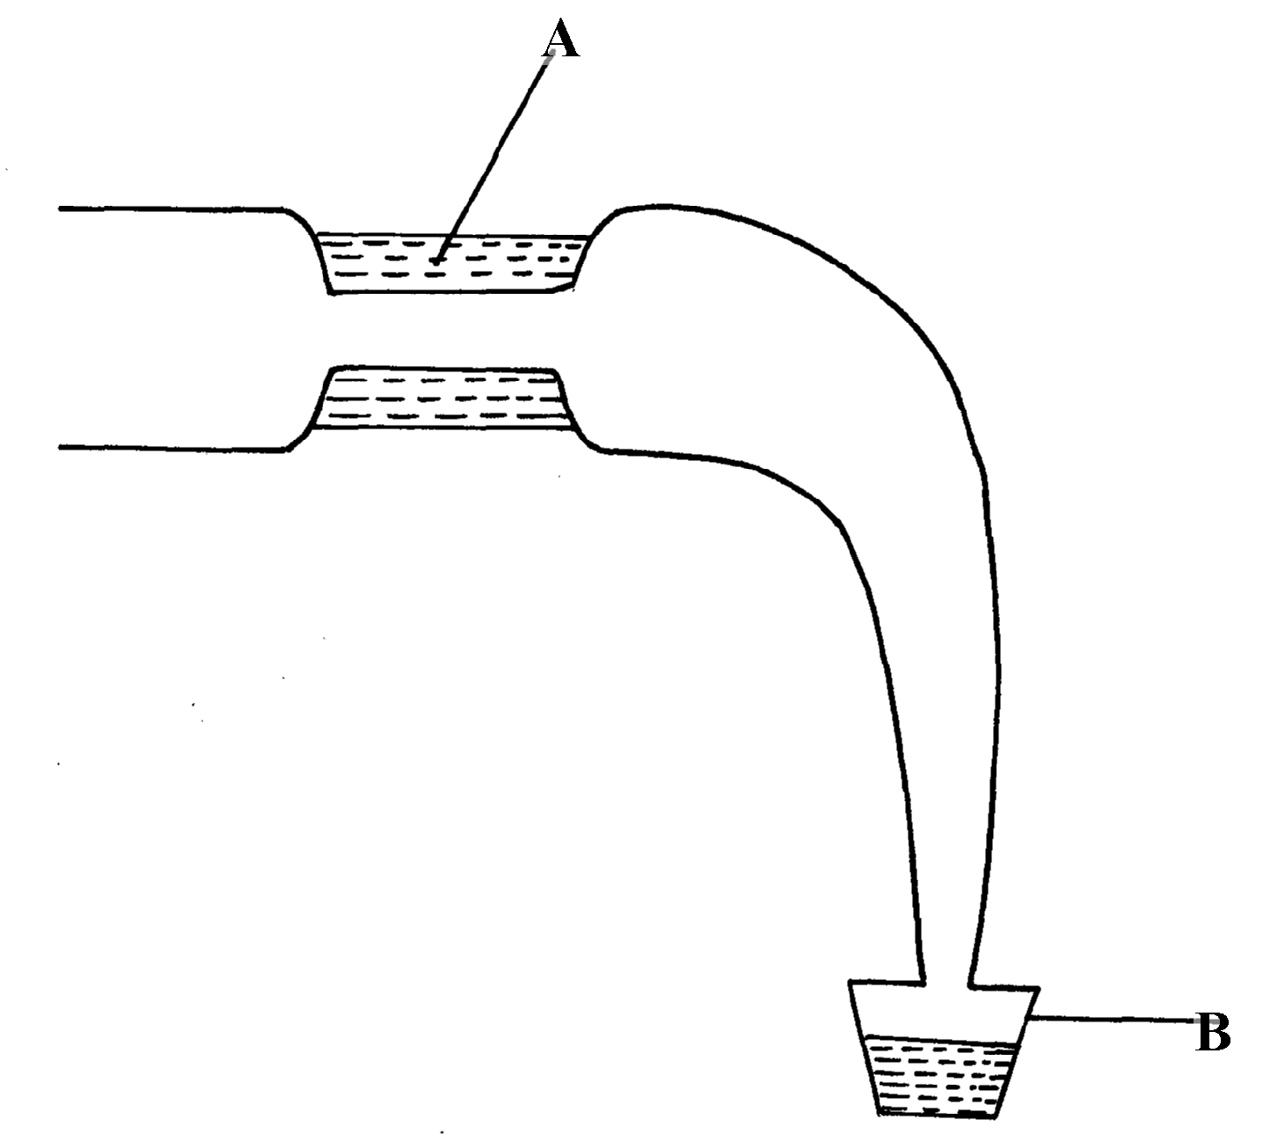
21. Use the diagram below to answer questions which follow

i) Identify the above diagram
ii) Name the parts labelled A and B

FARM TOOLS AND EQUIPMENT
1.
- Store the saw properly after use
- Oil the blade for long storage to avoid rust
- Sharpen the teeth properly
Tighten the handle screw if loose

2. A-Tin snip – cutting thin metal sheets
B-Spokes have – smoothing curved and circular surfaces
C- Ceardeners trowel – uprooting seedlings during transplanting
D-Brace drill – boring/ drilling holes in wood

3. i) Stir up pump/ bucket pump
ii) Spraying livestock with acaricide
iii) A – Nozzle B – lance handle
iv) A – Atomises the acaricide into spray B – Direct the nozzle to the parts to be sprayed

4. Garden fork is a tool used in weeding in the nursery beds/and in carrot fields

5. The tool for checking the vertical straightness of a wall is Plumb bob and plumbline

6. A tool for removing nails from timber is a claw harmer (1mk)

7. Two examples of equipment that a livestock farmer can use in administering oral
anti-helminthes (1mk)
- Narrow necked bottle
- Drenching gun
- Dosing gun

8. (a) L...- Pickaxe M- Adjustable spanner
O.............................................
N..- Ring spanner O..- Pipe wrench
(b) Give one functional advantage of tool M over tool N ( ½

9. Tools used to perform functions on the farm
- Hand drill
- Bit brace

10. - Blockage of nozzles and filters leading to uneven or no release of spray.
- Control pump may slacken or loosen, making it difficult to regulate the rate of spraying.
- Inadequate operating pressure due to leakages in the compressor pump, hoses or control valves.

11. (a) - Elastrator and rubber ring.
- The burdizzo.
- Sharp knife / scalpel.
(iii) Extracting blood samples for laboratory analysis

12. most appropriate set of animal hand tools that a farmer uses for the following operations:-
(i) Restraining large full when taking it around the show ring-bull ring and lead stick (1mk)
(ii) Cutting tail in sheep-rubber ring and elastrator (1mk)
(iii) Extracting blood samples for laboratory analysis-hypodermic needle and syringe

13. Provision of extra and quality feeds to sheep, two or three weeks before mating

14. ai) On the diagram a provided below, draw the mark to indicate a pig number 147,
using the procedure of ear-notching in diagram above
ii) the recommended stage of growth in pigs at which the ear-notching should be carried out?
- before wearing/3-7 weeks of age/21-56 days/1 month-22months)
iii) three reasons why weight is an important routine management practice in pig production
- to determine growth rate i.e. weight gain
- facilitate administration of drugs e.g. drenching
- for feeding i.e. to know the amount of feed to give
- to determine the service/breeding time (1x3=3mks)

b) i)B-entrance
C-top bar/bar
D-top cover/lid(1x3=3mks)

ii) by applying bees wax/honey/molasses on the sides or top of the hive/jaggery/sheep
sorrel/saliva /sugar syrup (Accept concentrated sugar solution-reject-sugar solution) (1x1=1mk)
iii) Outline the procedure of opening the hive to harvest honey
smoke the hive through the entrance using a smoker then light the hid to remove the top bar(the order must be considered) (1x2=2mks)

15. a) i) E-key hole saw/compass saw
F-wood chisel
G-cold/metal chisel
H-plumb bob (1/2x4=2mks)
ii) E-to cut or make key holes F-cutting timber
G-cutting metal H-checking whether a tall wall is vertical
iii) wooden hammer/mallet(1mk)

b)i) open castration/surgical castration (1mk)
ii) procedure you would follow when carrying out the practice named in( i) above in piglets
- restrain the piglets
- sterilize the blade
- disinfect the secretal sac
- slit the secretal sac to expose the testicle
- locate and hold the sperm duct
- cut the sperm dust by scrapping with the slide
- sew up the wound
- sterilize/disinfect the wound
- release the animal(piglet

16. i) A – Sickle
B- Pruning saw
C- Hoof cutter
D- Metal float
ii) A sickle is used in harvesting grass, rice, wheat by cutting
B Pruning saw is used for pruning tree crops, cutting hard stems in coffee
C Hoof cutter – Trimming hoofs in animals e.g. cattle, goats, sheep
D Float (wood or metal) smoothing concrete during plastering
iii) Maintenance on B
- Sharpen and reset the teeth
- Replace broken handle
- Oil the blade for long storage
17.
- Halter
- Rope
- Nose ring and leading stick

18. Mention the use of the following tools.
- Dibber.-making holes for transplanting
- Spoke shaves.-planning curved surface
- Tin snip.-cutting metal/iron sheets
- Burdizzo-castration (4x ½ =2mks)

19. four precautions that should be taken when using workshop tools and equipment.
- Use tools for correct purpose.
- Maintain them in good working conditions.
- Keep them safely after use.
- Handle tools correctly during use.
Use of safety devices / protective clothes

20. a) Bucket pump /stir - up pump (1x1 = 1mk)
b) Spraying acaricide on livestock (1x1 =1mk)
c) W - Nozzle
- X - Trigger
- Y - Pail /bucket
d)For holding acaricide solution during spraying. (1x1 = 1)

21. i) Identify the above diagram (1mk)
- Artificial vagina.
ii) Name the parts labelled A and B (2mks)
- A – warm water
- B – collecting cap

