FARM STRUCTURES

This topic entails the following:
- Description of parts of a building
- Identification of materials for construction
- Description of various farm structures and their uses
- Construction and maintenance of farm structures.

The following relevant questions and their answers in this topic will greatly motivate and help the user to comprehend and understand the required concepts and practices:

1. Mention four disadvantages of using steel materials for construction of farm structures
2. Give two reasons for placing a polythene sheet on a foundation of farm buildings
3. What is “calf crop” in beef production?
4. a) Outline the procedure in construction of a barbed wire fence
b) List any four wood preservatives
c) Give four factors that will determine the choice of farm building materials
5. i) Give four factors considered when citing a fish pond
ii) Give four features of a good laying nest
6 State two uses of a footbath in cattle dip
7 a) What is a green house
b) Name four materials used in green house construction
c) Give four maintenance practices carried out on a green house
d) Explain the importance of maintaining farm structures
8 Give two disadvantages of a barbed wire fence when used in paddocking
9 The diagram below illustrates a cross-section of a fish pond. Study it carefully and answer the
questions that follow:-

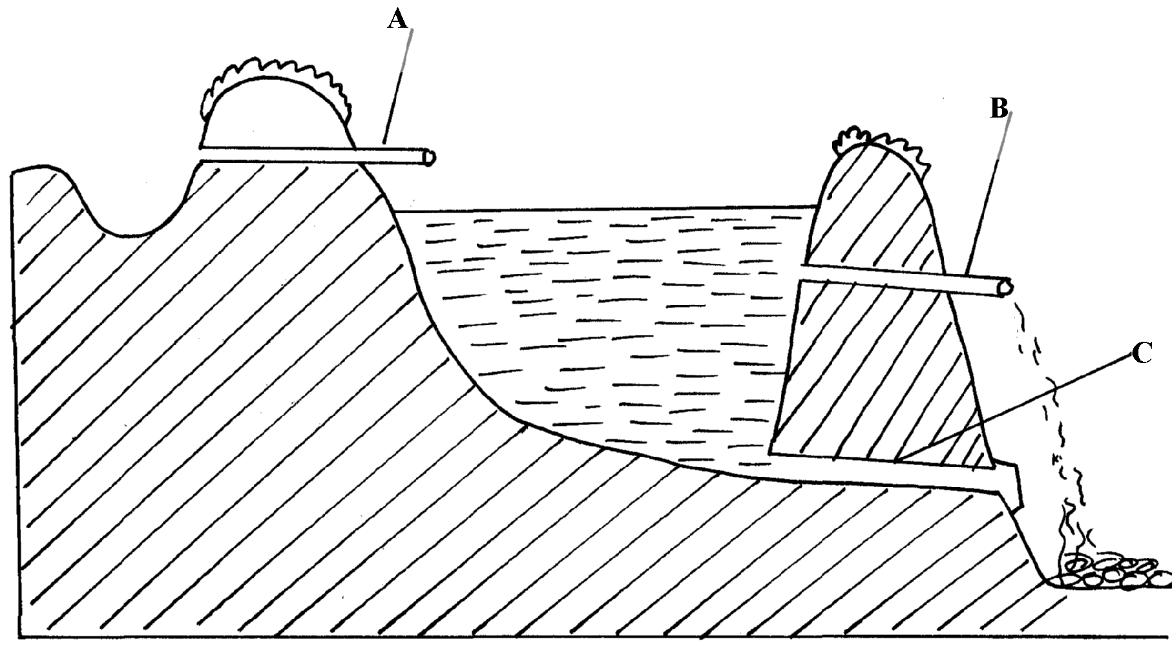
X
Y
Z

(a) Identify the parts marked A, B, C and C
(b) On the diagram the points marked X, Y and Z are possible sites where fish feeding
can be done. Which is the most appropriate point for feeding?
(c) Give two reasons why the floor of the pond should be covered with lime 14days before
filling it with water (d) Why should part marked B be screened?
(e) State three maintenance practices carried out on the structure

10. Study the farm structure below illustrating a pass:-
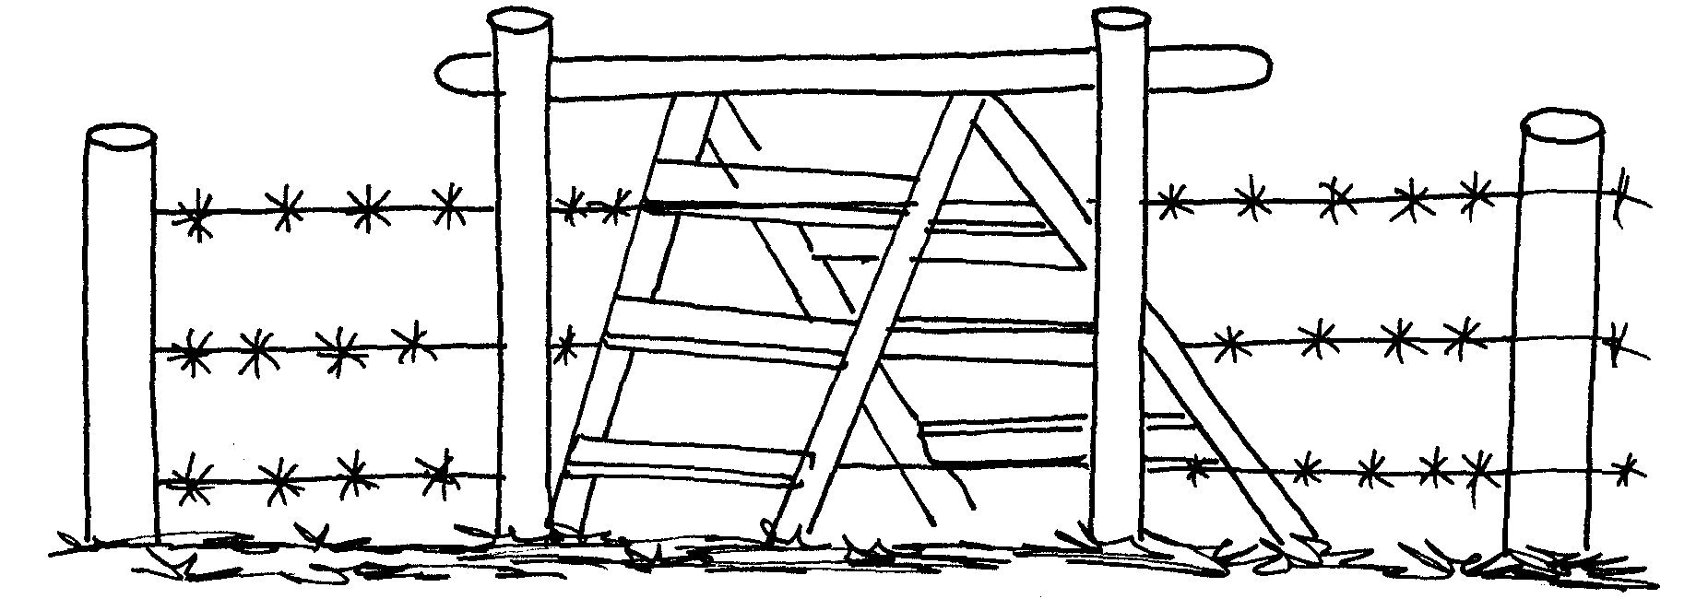

(a) Identify the type of pass illustrated above
(b) Distinguish between a pass and a gate
(c) Name one type of live fence
11 State four requirements of a good maize store
12 State three factors that determine the depth and size of foundation in a farm building
13 (a) Explain the uses of various hand tools in the construction of a poultry house
(b) Describe the procedure of erecting wooden rail fence
(c) Explain various factors considered when choosing the construction materials for farm building
14 State four features of a good calf pen
15 State four uses of a fence

16 Below is a diagram of a cross section of a farm structure. Study it carefully and answer the
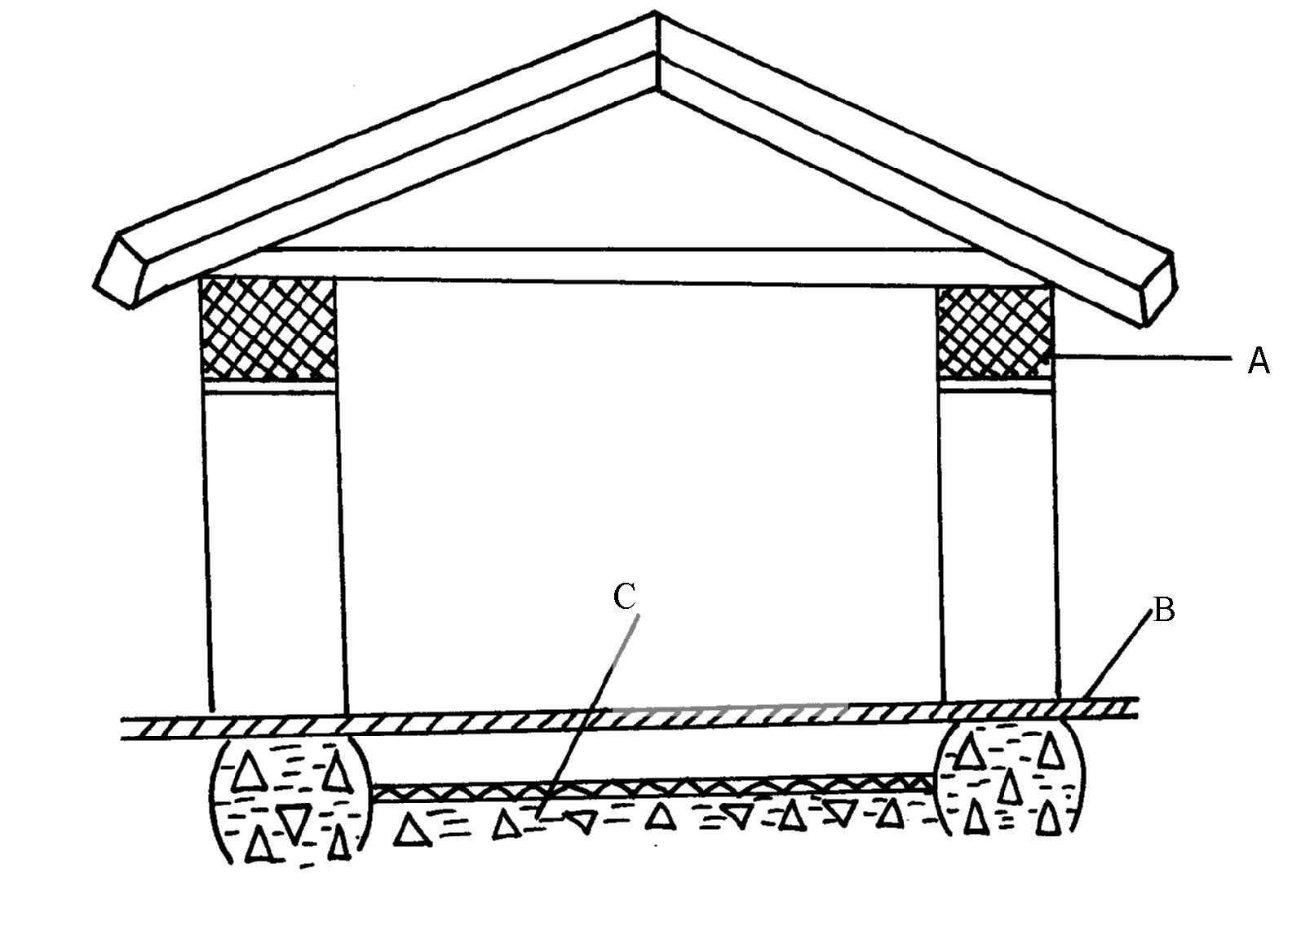
following questions.

(i) Identify the labeled parts A, B, and C
(ii) What is the importance of the part labeled B to the structure
(b) (i) When making concrete blocks the ratio 1:3:5 may be used. What do these figures
represent?
(ii) In a concrete mixture 1:3:5, twenty four cubic metres of sand were recommended to be
used in putting up of a foundation of a building. Find the volume of the other two
17 (a) Explain the maintenance practices of a fish pond
(b) Give four ways of controlling fish predators in a fish pond
18 Mention four reasons of treating timber before roofing farm buildings
19 List four uses of crushing in the farm
20 a) Define the term fence
b) List various types of fences
c) Describe advantages of fences
21 Study the illustration of a farm structure below and answer the questions that follow
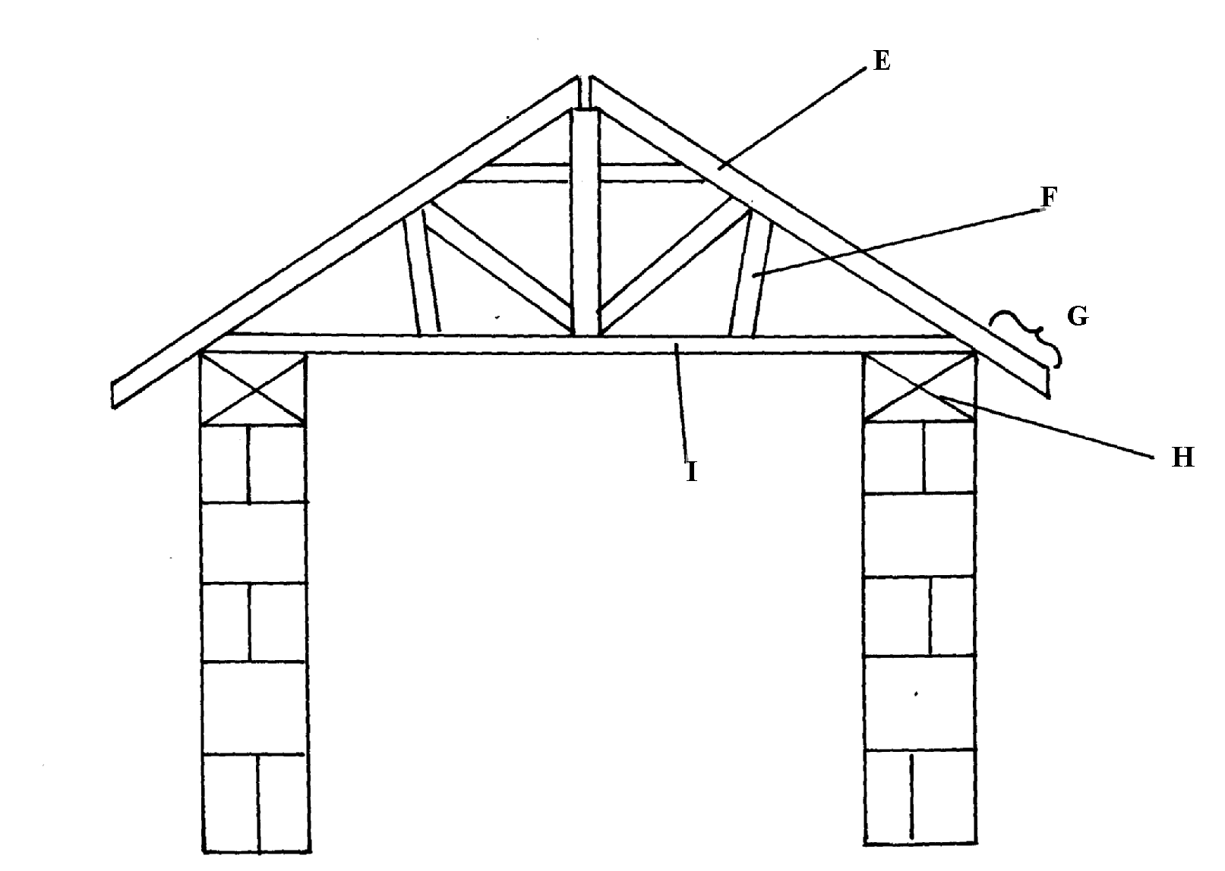

i) Name the parts labeled
ii) State the function of the parts labeled
iii) Name two chemicals preservatives used to treat the wooden parts of the structure against
insects and fungal damage

21. Below is a diagram of a fish pond, study it and answer the questions that follow
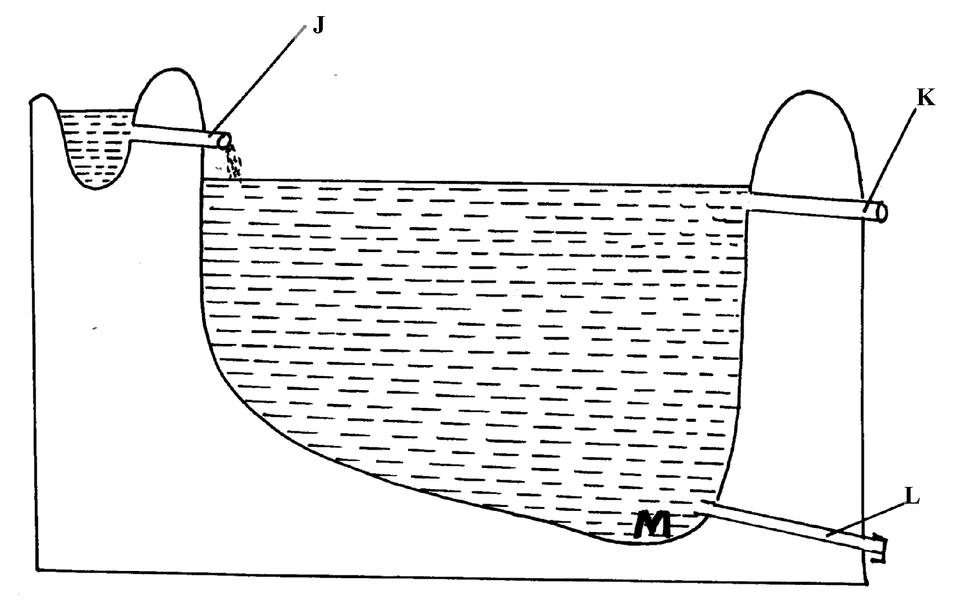

i) Label the parts marked K and L
ii) Give a reason why part M is usually deeper than the rest of the pond
iii) State three maintenance practices carried out in the pond
22. a) Explain five factors to consider when siting a fish pond
b) Explain the measures used to control livestock diseases
23. State four factors which influence the selection of materials for constructing a diary shed
24. a)The illustration below shows a method of identifying pigs, study the diagram and answer the questions that follow:-
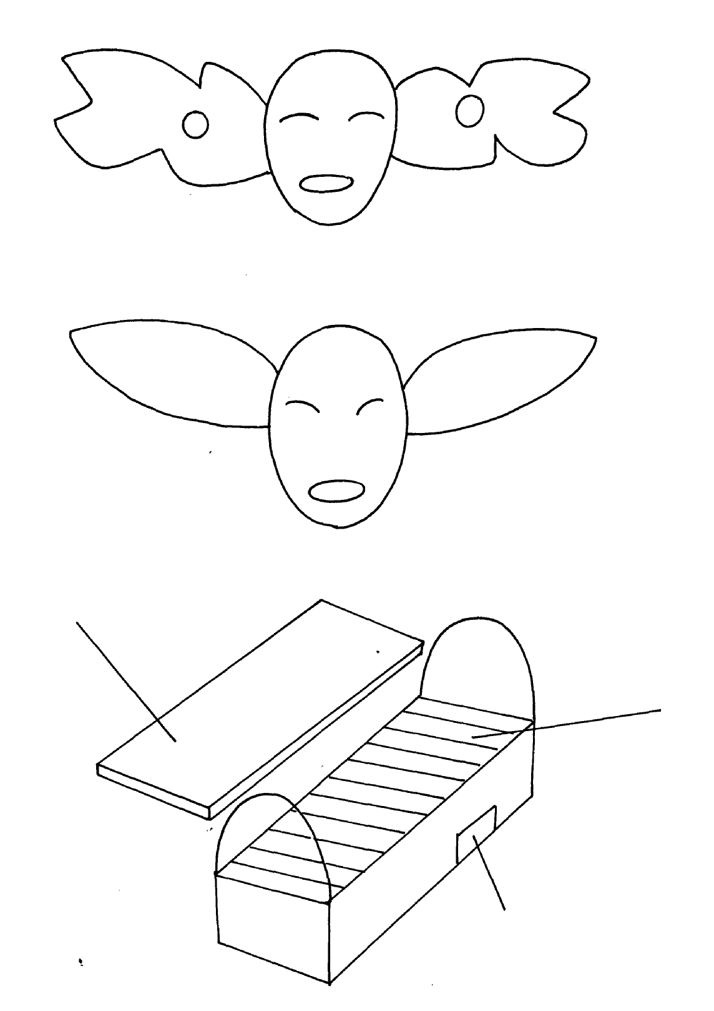
200
100
5
2
3
50
30
20

i) On the diagram A provided below, draw the mark to indicate a pig number 147,
using the procedure of ear-notching in diagram

A

ii) What is the recommended stage of growth in pigs at which the ear-notching should be
carried out?
iii) State any three reasons why weight is an important routine management practice in pig
production

b) Below are illustrations showing the various parts of the Kenya top bar hive. Use the illustration
to answer the question that follow
D

C

B

i) label the parts B ,C and D
ii) How can a farmer attract bees to colonize a new hive?
iii) Outline the procedure of opening the hive to harvest honey
25. a) State five maintenance practices of a mould board plough
b) Explain five structural and functional differences between the petrol and diesel engines c) List five uses of farm fences
26. State four uses of farm buildings
27. List four structural requirements for proper housing of farm animal to maintain good health
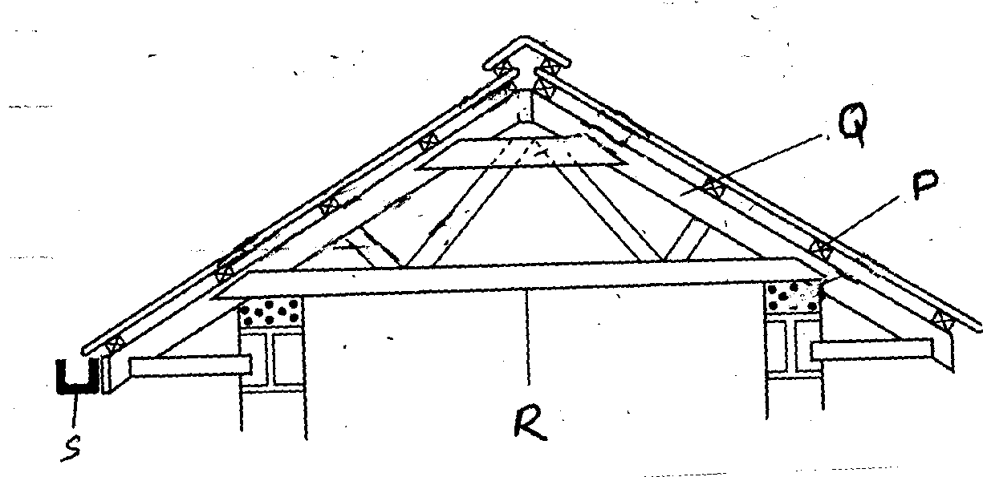
28. The diagram below is part of a farm structure. Study it and then answer the questions that follow:

(a) Name part of structure represented above
(b) Identify parts labelled P, Q, R, and S
(c) Give the functions of the part labeled P and S
29. The diagram below shows an activity of processing a farm product. Study it and answer the
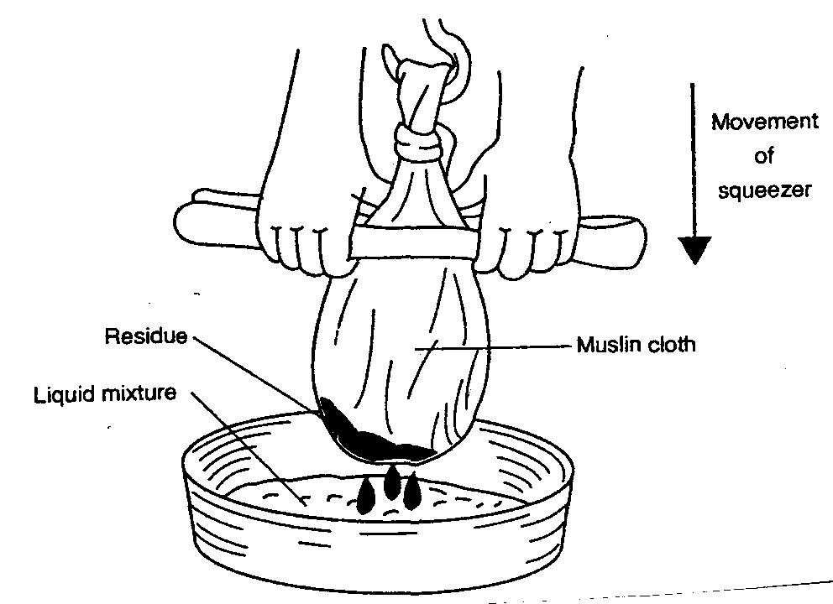
questions that follow:

(a) Name the product being processed
(b) Identify the method used in processing the product names in the diagram
(c) Outline the procedure used when harvesting the product named in the diagram
(d) List two factors that affect quality of the product processed in the diagram

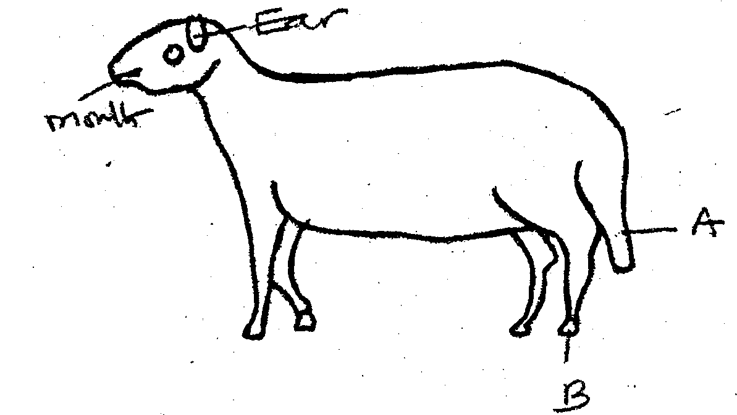
30. Study the diagram of a sheep shown below carefully and answer the questions that follow:
B
A
Mouth
Ear

(i) What operation is usually carried out on the part labelled A?
(ii) Give two reasons for carrying out the operation in (i) above
(iii) At what age should the above operation be carried out?
(v) Name routine management practice carried out on the part labelked B
31 (a) Describe five parts of a plunge dip
(b) Outline six uses of live fences on the farm
(c) Outline four factors that influence power output of drought animals
32. a) Explain the factors a farmer needs to consider before siting a farm structure on his farm
b) Outline the desirable features of a good grain store
c) Describe the uses of farm fences in promotion of agriculture
33. Name any two pests that attack timber used for construction in the farms
34. State three factors that may lead to dip wash being exhausted or weakened while in the
dip tank

FARM STRUCTURES
1.
- Steel is expensive
- Require high skilled labour
- Heavy and difficult to transport
- Rusts easily
Low workability
2.
- To prevent termites from rising up to the wall
- To reduce moisture rising up the wall
3. A group of calves kept according to age

4. a) Procedure in construction of a barbed wire fence
- Slash/ clear vegetation around fence line 2 m wide
- Measure and mark spots for holes using pegs
- Dig holes 60cm – 90cm deep depending areas where the poles are to be placed
- Assemble poles and other requirement materials
- Drop pole and struts at respective points
- Prepare concrete mixture
- Erect poles in pole holes
- Align the poles and put concrete using spade or soil
- Compact the concrete in holes
- Allow to settle for a few days while curing
- Put barbed wire around using appropriate tools
- Tighten the wire using wire strainer
- Mail barbed wire using fencing staple at required distance
- Put droppers along the fence as required 12x1=12 mks
b) Wood preservatives
- Creosote
- Old engine oil
- Paint/ far/ tanesc
- Copper sulphate
- Sodium dichromate
- Arsenic pentoxide
- Pentachloroplenol
- Triputyl tin oxide 4x1=4 mks
c) Choice of farm building materials
- Cost of materials
- Availability/ strength of the material
- Workability
Type of enterprise

5. (i) Factors considered when sitting a fish pond.
- Reliable source of water/ water source;
- Soil type / poorly drained clay soil the best;
- Topography / gently sloping;
- Security/ be secure from thieves / predators;
- Water quality / free of pollutants;
- Machine milking;
(ii) Features of a laying nest.
- Dimly lit; dark;
- Spacious / large enough to accommodate bird comfortably;
- Dry clean beddings;
- Have lockable doors;
- Kept in secluded parts of the house;
- Have slanting roofs to prevent birds from perching on;
5. Uses of footbath in cattle dip.
- To wash the foot off mud;
- Contains chemicals for controlling foot rot; CUSO₄ (blue vitriol/ formalin solution;)
6. (a) – A green house is a farm structure made up of glass or translucent material as wall and
roof to enhance and achieve optimum condition for valuable horticultural crop production.
(b) Material used in green house construction.
- Galvanizing iron.
- Aluminium or wooden frame.
- Glass or clear polythene sheet.
- Fibre glass or reinforced panels.
(c) Maintenance practices on green house.
- Dirty polythene sheet should be clear.
- Blocked systems should be repaired and cleared.
- Torn polythene material should be replaced.
- Should be fenced for security.
(d) Importance of maintaining farm structures.
- Last longer/ enhance durability.
- Reduce replacement cost.
- Protect livestock from predator.
- Prevent straying animals.
- To prevent diseases brought by cold winds.
- Make them effective in their use.

7. Disadvantages of barbed wire fence in paddocking:-
- Can remove wool from sheep
- Barbs can injure the animals
- Smaller animals can pass through if the wire strands are widely spread

8. (a) A .Inlet
B – Spillway/ overflow.
C - Drain pipe/outlet (1 ½ mk each = 1 ½ mks)
(b) The most appropriate part for feeding is part X (1mk)
(c) Two reasons why the floor of the pond should be covered with lime
- Facilitate the work of fertilizer in the pond
- Maintain PH of pond water ( ½ mk each 2pts = 1mk)
(d) Why should part marked B be screened?
- Prevent escape of fish
- Prevent entry f foreign /unwanted organisms ( ½ x 1pt = ½mk)
(e) three maintenance practices carried out on the structure
- Removing weeds
- Unblocking inlet and outlets
- Maintaining same water level
- repairing leakages on walls, floor e.t.c
- Draining of water during harvesting

9. (a)Stille ( ½ mk x 1pt = ½ mk)
(b) A pass allows only human passage while gate allows for both human and livestock in and
out of the farm ( ½mk mark as a whole)
(c) One type of live fence
- Electric
- Hedges

10. four requirements of a good maize store
- Leak proof
- Rat proof
- Properly ventilated
- Easy to clean
- Raised off the ground properly drained
- easy to load and unload/spacious (any 4x ½ =2mks)

11. three factors that determine the depth and size of foundation in a farm building
- Function of building
- Soil type
- Soil depth
- Drainage of area (any 3x ½ =1 ½ mks)

12. (a) the uses of various hand tools in the construction of a poultry house
- Jembe- levelling the ground
- Spade-scooping soil
- Tape-measuring distance
- Wheel barrow-carrying small load
- Spirit level-checking whether surface is vertical or horizontal
- Rip-saw/tenor saw-cutting timber
- Hand drill/bit brace-boring in wood
- Claw hammer-driving in/hitting and removing nails
- G-clamp-holding objects /wood when joining
- Tin-snip-cutting iron sheet
- Chisel
- Mallet (any 10x1=10mks)
(b) the procedure of erecting wooden rail fence(7mks)
- Locate the area to be fenced off
- Determine the amount of material needed
- Treat the post
- Clear the area
- Measure the distance 3-4m apart and place pegs
- Dig holes up to 60cm deep
- Put fencing post in hole and reinforce with concrete
- Place 3-4 horizontal rails
- Space at about 125mm,175mm, 225mm and 275mm from ground
- Fixed them onto post using nail (10x1pt=10mks)
(c) factors considered when choosing the construction materials for farm building
- Purpose of building determine strength and durability of material
- Availability of capital; depends on ability to purchase
- Aesthetic aspect:-determine by economic status of farmers
- Availability of material: easily obtained
- Durability: good quality .not be repaired often
- Resistant to extreme weather condition
- Safely of farm animals and farmer:- not have side effects/workability
- Suitability of the material.(any5pointsx2mks=10mks)

13. - Have adequate space
- single housing ( 1caf per pen)
- Properly lit
- Have proper drainage
-Well ventilated
- Drought free

14. - Demarcates boundaries of farms
- Prevents intruders, wild animals, thieves in the farms
- Facilitate mixed farming
- Enhance paddocking of farm for effective rotational grazing
- Control unnecessary movement in the farm
- Control inbreeding
- Isolate sick animal

15. (a) (i) A – Wall plate/team beam/lintel
B – Damp proof coarse
C- Hard core
(ii) - Prevents termite invasion
- Prevents water capillarity /dampness
(b) (i) 1 bag of cement
3 parts/wheel barrows of sand
5 parts /wheel barrows of ballasts or gravel
(ii) Sand
3 parts of sand = 24m³
1 bag = 1x24 = 8m³
3
ballast
parts = 24m³
5 parts = 5x24 = 40m³ (½mk)
3
16. (a) Maintenance of the fish pond
- Protection of the pond – regularly check pond walls, plant grass on the walls to help control soil erosion
- Pond bottom repair- check water seepage problems regularly, It can be done introducing an even layer of clay to seal off the bottom of pond properly
- Removal of weeds; -regularly remove all weeds that grow on the walls and around the ponds
- Maintenance of appropriate water level: Maintain the same level of water in the pond by use of inlet and outlets
- Inspection of pond: - Regularly check for cracks in the walls and seal immediately
- Cleaning the pond- once n a while to drain out the pond water, remove all stones, silt or roots that may have settled at the pond bottom, lime the water before refilling it with water
- removal of organic materials – any vegetative matter or food remains should be removed as soon as they are noticed to ensure they do not start decomposing
- Repair fence around the pond- In case of worn out posts, repair/replace immediately
(b) Ways of controlling of fish predators in a fish pond
- Put a strong wire fence around the pond
- Provide a wire screen above the pond to guard against prevatory birds
- A sire screen is put in the inlet, outlet and in the spillway
- Scare away in the binds as necessary
- occasionally drain the ponds to kill all unwanted predatora in the pond bottom

17. four reasons of treating timber before roofing farm buildings
- Prevent attack from insects
- Prevent attack from fungi (rotting)
- Resist weather condition:-extreme temperature
- Resist water penetration
- To harden woo-make it durable and more strong
- To avoid warping

18. four uses of crushing in the farm
- Spraying livestock against external parasites
- Identifying animals by use of such methods as branding ,ear-tagging and ear notching
- Vaccination
- Administering prophylactic drugs to the animals
- Treating sick animals
- Dehorning
- Pregnancy test
- Artificial insemination
- Taking body temperature
- Hoof trimming
- Milking

19. a) A fence is a structure that encloses a designated area and forms a physical barrier for
animals and human
b) List various types of fences
- live fence
- electric fence
- barbed wire fence
- chicken wire fence
- wooden fence
- pole and rail fence
- plain wire fence
- trench fence
- wall fence
c) Describe advantages of fences
- keep off intruders/thieves
- prevent damage of crops by animals
- control grazing in paddocks
- control breeding by separating male and female
- acts as wind break
- control pests and disease by controlling wild animals
- add aesthetic value
- provide livestock feed or human fruits or firewood
- add value to the farm
- provide security to the house stead and farm animas
- they form perimeter fence along the boundary to demarcate farm land from the neighbours
- used to isolate sick animals from the rest of the herd to prevent spread of diseases
- separate crop field from pasture facilitating mixed farming

20. i) E – rafter F- Struct
G- Eaves H- Wall plate
ii) E (Rafter) – To provide support for the roofing materials
F (Strut) – To support the rafter/ holding the weight of the roof
G (Eaves) – Prevent rain from falling on the wall
H- (wall plate)- To support the roof
iii) Chemicals for treating timber
- Tar
- Sodium dichromate
- Copper sulphate
- Arsenic pentoxide
- Old engine oil
- Pentachlorophenox
- Tributyl tin oxide
- Creosote
- Paint

21. i) K- Spill way (reject over flow pipe)
L- Drainage channel
ii) M is deeper to provide breeding place for the fish
iii) Maintenance of the pond
- Cleaning the pond by removing all foreign materials
- Repairing the dyke (bunds)
- Maintain good level of water
- Control predators
- Weed control around the pond
- Plant grass on dykes to prevent erosion
- Remove the silt if accumulated
- Regular pond fertilization
- Apply lime before refilling

22. a) Siting a fish pond
i) Soil type- clay soil is the best
ii) Topography – requires gentle slope not Lilly and flat
iii) Source of water – near reliable source
iv) Marketing centre should be close
v) Accessibility from the homestead
vi) Security – protected against predators
vii) far from natural source of fish
b)
- General farm hygiene, cleanliness of houses, equipment proper carcass disposal by burning/ burying/
- Disinfection to destroy pathogens e.g. Anthrax and calf diseases
- Isolation of sick animals – separated from healthy ones to avoid spread of diseases e.g. foot mouth
- Drenching/ deworming to control internal parasites e.g. tapeworms and roundworms
- Treatment of the sick animal – to prevent spread of diseases
- Vaccination to create resistance to diseases on regular basis e.g. foot and mouth, anthrax, new castle
- Control vectors – to avoid disease transmission e.g. ECF, nagana/ specific method
- Prophylactic approach/ use of drugs to avoid injection e.g dry cow therapy against mastitis
- Trypanocidal drugs to control trypanosomiasis
- Proper breeding to control breeding diseases e.g. brucellosis
- Proper feeding to prevent nutritional disorders e.g. milk fever, anaemia
- Slaughtering/ killing – to prevent spread of contagious diseases e.g. anthrax
- Quarantine – to avoid spread of diseases
- - prevent introduction of diseases
- Proper housing to avoid predisposing the animal to diseases e.g. ventilation, spacing
- Foot trimming to minimize occurrence foot rot

23. four factors which influence the selection of materials for constructing a diary shed
- Kind of dairy shed i.e. permanent or temporary
- Availability of materials
- Cost of materials
- Environment conditions of climate and soil type
- Durability of materials a
- Availability of killed labour for construction
- Capital available (1/2x4=2mks)

24. a)i) On the diagram a provided below, draw the mark to indicate a pig number 147,
2
using the procedure of ear-notching in diagram above
ii)the recommended stage of growth in pigs at which the ear-notching should be carried out?
- before wearing/3-7 weeks of age/21-56 days/1 month-22months)
iii) State any three reasons why weight is an important routine management practice in pig production
- to determine growth rate i.e. weight gain
- facilitate administration of drugs e.g. drenching
- for feeding i.e. to know the amount of feed to give
- to determine the service/breeding time (1x3=3mks)

b) i) B-entrance
C-top bar/bar
D-top cover/lid(1x3=3mks)

ii) by applying bees wax/honey/molasses on the sides or top of the hive/ jaggery/sheep
sorrel/salvial/sugar syrup
(Accept concentrated sugar solution-reject-sugar solution) (1x1=1mk)
iii) Outline the procedure of opening the hive to harvest honey
smoke the hive through the entrance using a smoker then light the hid to remove the top bar(the order must be considered) (1x2=2mks)

25. a) State five maintenance practice of a mould board plough
- Lubricate the moving pests
- Sharpen blunt share
- Tighten bolts and nuts
- Clean the plough after use
- Coat the unpainted parts with old engine oil before any storage
- Replace worn out parts (1x5=5mks)
b) Explain five structural and functional differences between the petrol and diesel engines
Petrol engine | Diesel engine
i)has a carburetor  ii)fuel and air mixed in the carburetor  iii)fuel ignited by an electric spark  iv)produces little smoke  v)is light in weight | i)Has an injector pump  ii)Fuel and air mixed within the cylinder  iii)fuel ignited by compression of air and fuel  mixture in the cylinder  iv)produces a lot of smoke  v)relatively heavy

c) List five uses of farm fences
- keep of wild life ,predation and intruders
- demarcates boundaries
- separate crop field from pasture land
- divide pasture land into paddock
- control movement of animals and people within the farm and prevent formation of unnecessary pests
- control disease and parasites helps in isolate sick animals
- helps in controlling breeding
- provide security
- act as wind break (1x5=5mks)

26. Uses of farm buildings
- Protect the farm animals from predators
- Provide shelter to the farmer and livestock
- Used to store farm produce and valuable inputs
- Controls livestock diseases and parasites
- Enhances efficiencies in farm planning, budgeting and production

27. Structural requirements for proper housing
- Well ventilation
- Free from cold/ draught
- Adequate space
- Proper drainage
- Leak proof roof
- Well lighting
- Easy to clean/ concrete floor

28. a) - roof
b) P- purklin Q- Rafter
R- Cross tie S- Gutter
c) P- Support roofing material/ iron sheet
Q – Collect water and safely directs it away from building

29. a) Honey
b) Crushing and straining
c) Procedure of harvesting the named product
- Wear protective clothes
- Approach hive quietly from behind
- Blow smoke around hive then through entrance
- Lower hive
- Remove lid/ cover
- Lift top bars and brush off with bees
- Cut honey combs with honey leaving 3cm of wax
- Put combs in container
- Place back bars
- Put lid
- Return hive in position
d) Factors that affect quality of product harvested
- Type of plant from which nectar is obtained
- Maturity stage
- Method of harvesting
- Method of processing
28. i)Docking
ii) Reasons for carrying out the operation
- Avoid incidences of blowfly
- Make mating easy
- Even distribution of fat in body
- Avoid dirtifying wool
iii) Age of operation
- within two weeks from lambing
iv) Methods used for operation
- use of rubber ring and elastrator
- cutting with sterilized docking knife
- use of burdizzo
- use of hot iron bar
v) Routine management practice carried out on part B
- hoof trimming

29. a) Five parts of plunge dip
  - Holding yard- Hold animal before dipping
  - Foot bath- Wash animal feet off dung, mud
-Prevent foot rot/ contain copper sulphur,
  - Jump- Narrow entrance allow single animal easily to jump in dip wash
  - Draining race- Animal held while dip wash drain back in dip tank
  - Drying yard- Animals need to dry before allowed to pasture, avoid contamination
  - Silt trap-raps mad, dung before dip wash flow back to dip tank, prevent siltation of dip tank
  - Shelter-Prevent evaporation
-Prevent dilution of dip wash with rains
b) Six uses of live fences
- Thorn species prevent wild animals and other invaders into the farm
- Tall varieties act as wind breakers
- Add aesthetic value to the homestead
- Roots holds soil firmly controlling soil erosion
- Species such as lantana canara can be used to feed livestock
- Provide shade to livestock and man
- Trimmed branches can be used as organic manure, wood fuel
- Some species have medicinal value 1x6=6 marks

c) Four factors that influence power output of drought animal
i) Training- Proper training of oxen will plough better and faster than untrained animal
ii) Feeding- Well fed animals work better than poorly fed animals
iii) Rest-Animals given enough rest work better than those that are not
iv) Honestly-Animals housed are protected from harsh condition e.g. cold thus work better
v) Disease control- Animals treated when sick, vaccinated, sprayed/ dipped against
external parasites/ dewormed against internal parasites are more efficient
vi) Age of animals- Young and very old animals give low output than averagely aged

