1. a) Geography is the study of the earth as a home of man

b) Vulcanicity is the process by which solid ,liquid or gaseous materials are forced out of the interior of the earth in to the earths crust or on to the earth surface

c) earth movements is the movement of the crustal rocks caused by forces originating and operating in the interior of the earth known us tectonic forces

1. Branches of geography
2. practical geography
3. physical geography
4. human and economic geography
5. Solar system consists of the sun, moon the eight known planets and heavenly bodies
6. i) Metamorphic rocks

ii) Igneous rocks

iii) Sedimentary rocks

5. Types of earth movements

i) Horizontal earth movement

ii) Vertical earth movement

1. weather is the daily atmospheric conditions of a place at a particular time

Climate is average weather condition s of a given place over a long period of time

7.(a)continental drift theory

It states that land was one land mass called pangea, surrounded by a huge ocean called Panthalasa due to different gravitational process, pangea broke into two parts, Gondwanaland to the south and Laurasia to the north, they were separated by a narrow ocean known Tethys. Gondwanaland and laurasia further raptured and drifted apart form the present six continents of the world.

b) – jigsaw fit of continental margins

- seaflow spreading

- climatology

-Geological structures

- Palaenthological evidences

- the mid- atlantic ridge

- paleomagnetic studies

- distribution of the ancient glacial deposits

8a) i. Volcano

ii. basic (basaltic) lava/shield dome

iii. acid lava cone

iv. complex cones (stratified and parasitic)

v. ash and cidar cones

vi. volcanic plug

vii. composite cone/ stratovolcanoes

viii volcanic depressions

ix. plug dome volcano / spine volcano/ plug volcano

b) – site for tourist attraction

- resulted in large central volcanoes (mountains)

- Formation of rich metallic minerals

Resulted into geothermal steam and power

Volcanic rocks are valuable as building materials

Volcanic mountains are water catchment areas

Some of volcanic rocks are used domestically as scrubbing e.g. pumice

9. a) shaking or trembling of the rocks on the surface of the earth caused by the shock waves that originates below the surface of the earth

b) mercalli scale

richter scale

10. seismic focus is the point where the seseimic waves originates while epicenter is the point directly above the seseimic focus

11. – it is experienced in the highland regions

- it fall in light showers over along period of time

It is formed over a relief features when moist air reaches the interior areas and forced to raise over mountains as it raises it expands, cools and on reaching condensation levels it condenses to form clouds which falls as rains. The rain is received on the windward side of the mountain.

The windward side receives a lot of rainfall while the leeward side experiences dry climate

clouds

rain little or no rain

windward side

mountain dry wind

moist winds

_ _ _ _ _ _ leeward side

sea_ _ _ _ _ _

12. direction is the distance from a particular known point on the map or on the surface of the earth while bearing is the direction measured as an angle and given in degrees (2mks)

13. the use of the compass

The use of bearing (2mks)

14. contours

Formlines

Hacheures

Spotheights

Trigonometrical station

Hill shading

Cliff and rock drawing

Layer tinting (2mks)

15. a photograph is an image of an object, person or scene in a form of prints or slides recorded by a camera on a film and later transferred onto a specially prepared paper ...... (2mks)

16. i) ground close up – the camera is focused on one major object

The object may block out the other things behind it

ii) Ground general view photographs – the camera is held horizontal to the ground facing area focused on

objects become progressively smaller as the distance from the camera increases

iii) ground oblique - it is taken when the photographer is standing on a higher ground than the object

the camera is tilted towards the object (6mks)

17. i) foreground

ii) middle ground

iii) background (3mks)

18

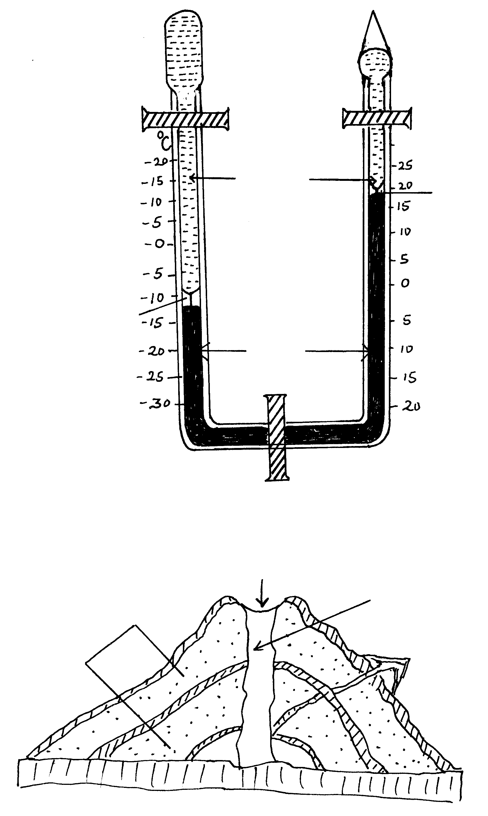

Layers of Ash

Crater

Pipe or vent

Layer of lava.

* + Crystal rocks are disturbed by earth movement leading to formation of a vent / pipe.
  + Initially crustal rocks experience violent explosion leading to shattering of rocks to form the first layer of Ash.
  + As the eruption proceeds, the violence ceases and lava pours out forming a layer on top of the Ash.
  + The process is repeated until a dome shaped feature with alternating layer of Ash and lava forms known as a composite volcano.

**Total marks (6mks)**