NAME...................................................................................ADM. NO....................................
CLASS…………………………………………………DATE.............................................
233/1
CHEMISTRY FORM 2
THEORY
2 HRS
INSTRUCTIONS TO CANDIDATES
(a) Write your name and Admission number in the spaces provided above.
(b) Sign and write the date of examination in the spaces provided above.
(c ) Answer ALL the questions in the spaces provided.
(d) Mathematical tables and silent calculators may be used.
(e) All working MUST be clearly shown where necessary
(f) Candidates should check the question paper to ascertain that all the pages are printed as indicated and that no questions are missing.
(h) This paper consists of 14 printed pages

This paper consists of 14 printed pages.. Candidates should check the question paper to ensure that all the Pages are printed as indicated and no questions are missing.
- Complete the table below for the characteristics of the sub atomic particles. ( 2marks)
sub atomic particle | Relative mass | Electrical charge
Proton | 1
Neutral | 1
- A sample of air contaminated with carbon monoxide and sulphur dioxide was passed through the apparatus shown in the diagram below.
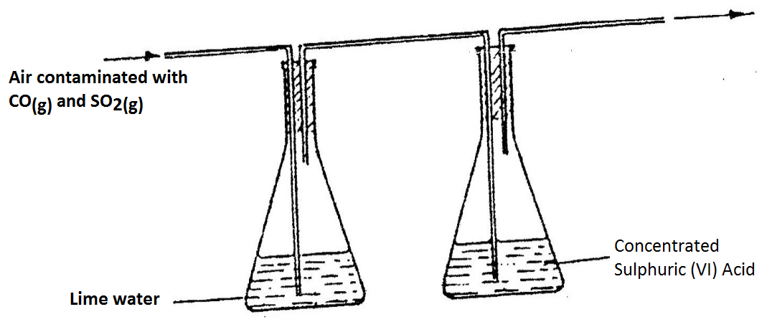
Which contaminant was removed by passing the contaminated air through the apparatus? Explain. (2mks) ………………………………………………………………………………………………………………………………………………………………………………………………………………………………………………………………………………………………………………………………………………
3. Explain how you would obtain solid lead carbonate from a mixture of lead carbonate and sodium carbonate powders. (3mks) ………………………………………………………………………………………………………………………………………………………………………………………………………………………………………………………………………………………………………………………………………………………………………………………………………………………………
4. Describe how the following reagents can be used to prepare copper (II) hydroxide, solid copper (II) sulphate, solid sodium hydroxide and distilled water. (3mks)
……………………………………………………………………………………………………………………………………………………………………………………………………………………………………………………………………………………………………………………………………………………………………………………………………………………………………………………………………………………………………………………………………………………………………………………………………………………
5. Aluminium metal is a good conductor and is used for overhead cables. State any other two properties that make aluminium suitable for this use. (2mks)
………………………………………………………………………………………………………………………………………………………………………………………………………………………………………………………………………………………………………………………………………………………………………………………………………………………………
6. State with reasons whether the changes below are physical or chemical. (3mks)
CHANGE | TYPE OF CHANGE | REASON
- Heating iodine crystals gently.

- Formation of brown coating on iron when exposed to moist air.

- Heating Zinc oxide

7. The table below shows the relative molecular masses and the boiling points of methane and water.
 | Relative molecular mass | Boiling point(ºC)
Methane | 16 | -161
Water | 18 | 100

Explain why the boiling point of water is higher than that of methane. (2mks)
………………………………………………………………………………………………………………………………………………………………………………………………………………………………………………………………………………………………………………………………………………………………………………………………………………………………………………………………………………………………………………………………………
8. (a. Two solutions J and K were tested with blue litmus papers and methyl orange indicator.
Blue litmus remained blue in both solutions. Methyl orange remained orange in K but turned yellow in J.
(a) What is the nature of substance J? Explain. (2 marks)
------------------------------------------------------------------------------------------------------------------------------------------------------------------------------------------------------------------------------------------
(b) Give an example of a substance that K is likely to be. (1mark)----------------------------------------------------------------------------------------------------------------------
9. Air was passed through several reagents as shown in the flow chart below.
Escaping gases
Concentrated KOH
solution

Excess heated
Copper turnings
Excess heated
Mg powder

AIR
  - Write an equation for the reaction which takes place in chamber with magnesium powder.(1mk)
………………………………………………………………………………………………………………………………………………………………………………………………………………………………………………………………………………………………………………………
  - Name one gas, which escapes from the chamber containing magnesium powder. Give a reason for your answer. (2mks)
………………………………………………………………………………………………………………………………………………………………………………………………………………………………………………………………………………………………………………………
10. A student set-up the apparatus below in order to determine the percentage by volume of oxygen in air.
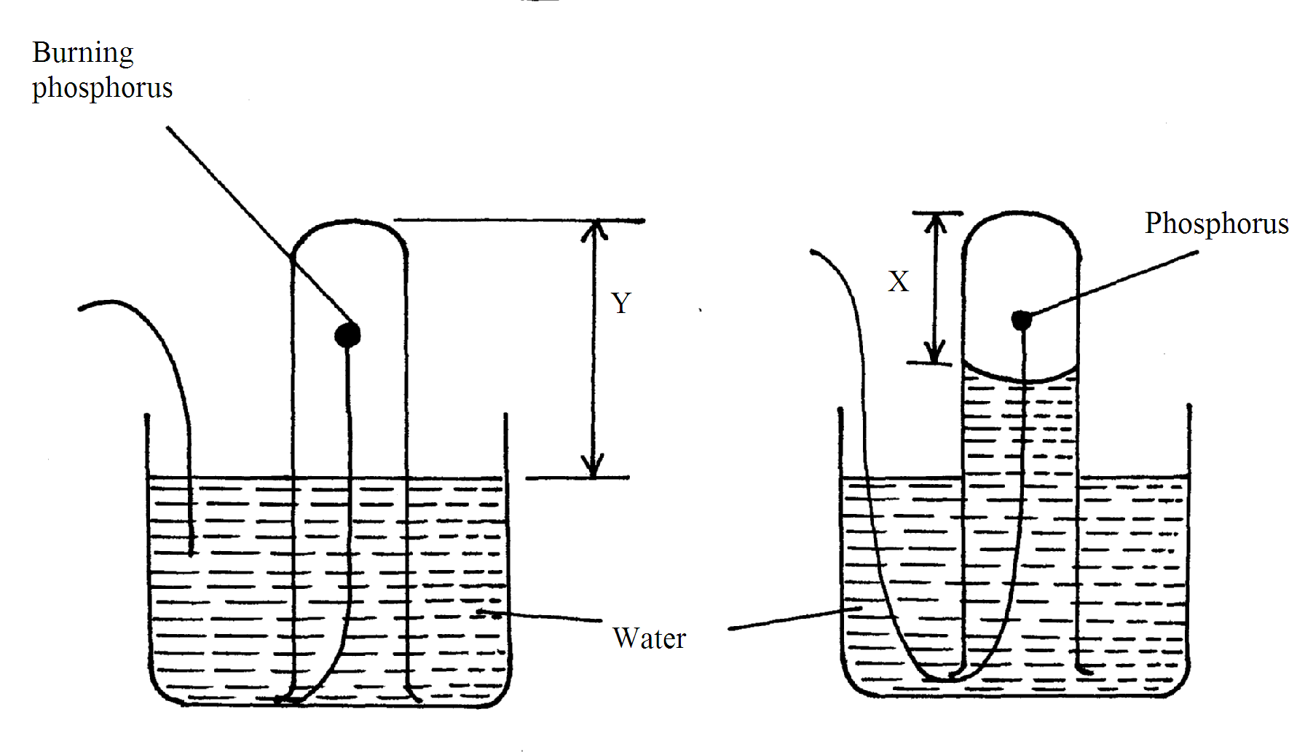
AT BEGINING
AT END

a) Why did water rise when the reaction had stopped? (1mk)
........................................................................................................................................................................................................................................................................
b) The student wrote the expression for the percentage by volume of oxygen in air as
$\frac{y−x}{y}x\text{100}\text{\%}$
Why was the volume of oxygen calculated using the above expression incorrect? (1mk)
..................................................................................................................................................................................................................................................................................................
c) What should have been done after the reaction had stopped in order to get a correct volume.
(1mk)
..................................................................................................................................................................................................................................................................................................

11. Study the table below.
Ion | Electronic configuration
L⁻ | 2,8,8
M²⁺ | 2,8
N³⁺ | 2,8,8
- Which elements belong to the same period of the periodic table? (1 mark)
--------------------------------------------------------------------------------------------------------------------
- What is the formula of the compound formed by L and N.? (1 mark)
---------------------------------------------------------------------------------------------------------------------
- Compare the atomic and ionic radii of element L. (1 mark)
--------------------------------------------------------------------------------------------------------------------
---------------------------------------------------------------------------------------------------------------------
- In temperate countries, salt is sprayed on roads to defrost and clear roads but the long term effect on this practice is costly to motorist.
- Explain the role of salt in defrosting the ice. (1mk)

- Explain why the long term effect is costing to motorist. (1mk)

- The grid below shows part of a periodic table. The letters do not represent the actual symbols of the elements
F
H
I
G

- Select the:
(i) Element which has the largest atomic radius. (1mk)
……………………………………………………………………………………………………
(ii) Most reactive non-metal. (1mk)
………………………………………………………………………………………………………
b) Show on the grid the position of the element J which forms J²⁻ ions with electronic configuration 2, 8, 8. (1mk)

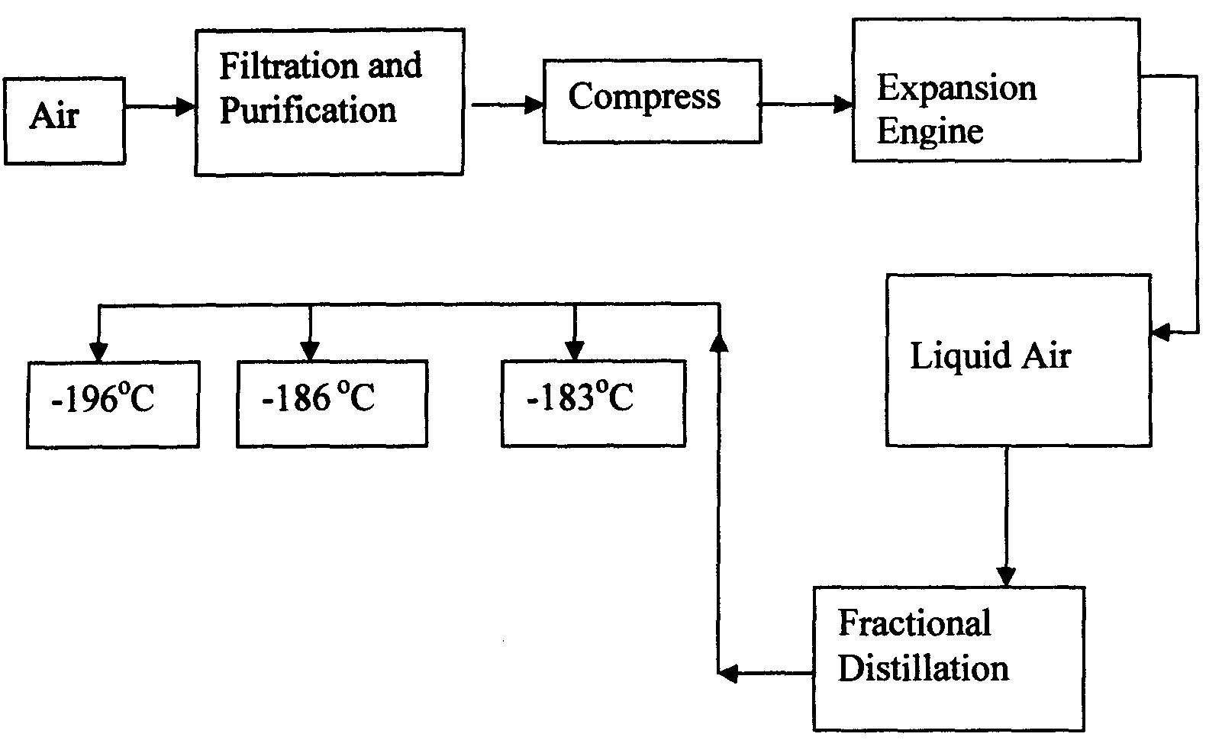
- Oxygen is obtained on large scale by the fractional distillation of air as shown on the flow chart below.

a) Explain why air is considered as a mixture (1mk)

b) Identify the substance that is removed at the filtration stage (1mk)

c) Explain why Carbon (IV) oxide and water are removed before liquefaction of air. (1mk)

d) Identify the component that is collected at -186°C (1mk)

- Study the table below and answer the questions that follow:-
Substance  Melting Point (ºC )  Boiling point (ºC) |  | A | B | C | D | E | F
 |  | 801 | 113 OR 119 | -39 | 5 | -101 | 1356
 |  | 1410 | 445 | 457 | 54 | -36 | 2860
Electrical  Conductivity | Solid | Poor | Poor | Good | Poor | Poor | Poor
Electrical  Conductivity | liquid | Good | Poor | Good | Poor | Poor | Poor

Identify with reasons the substances that:
(i) Have a metallic structure (2mks)

(ii) Have a molecular structure (2mks)

(iii) Substances A and C conduct electric current in the liquid state. State how the two
substances differ as conductors of electric current (2mks)

- Atoms of element X exists as 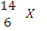and 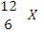
(a) What name is given to the two types of atoms. (1mk)
………………………………………………………………………………………………………
(b) Use dot (∙) and cross (x) diagrams to illustrate the atomic structure of 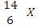 (2mks) ………………………………………………………………………………………………………………………………………………………………………………………………………………………………………………………………………………………………………………………………………………………………………………………………………………………………………………………………………………………………………………………………………
- Give 2 reasons why most laboratory apparatus are made of glass. (1mk)

(b) The diagrams below are some common laboratory apparatus. Name each apparatus and state its use. (2mks)
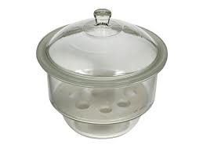
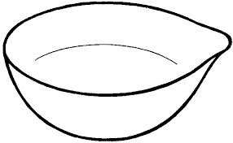
Name Name:

Use Use:

18. Soot is one of the environmental pollutants.
(i) Explain the term pollutant. (1mk)
………………………………………………………………………………………………………………………………………………………………………………………………………………………………
(ii) State how soot is formed from hydrocarbons. (1mk)
………………………………………………………………………………………………………………………………………………………………………………………………………………………………………………………………………………………………………………………
19. Phosphorus element smoulders in air to form two oxides
(a) Name the two oxides. (2 mks)
(i) ______________________________________________
(ii) ______________________________________________
(b) State the nature of the solution when the above mentioned oxides are dissolved in water. (1mk) ______________________________________________________________________________________________________________________________________________________________________________________________
20. (a) What is meant by the terms: ( 2 mark )
(i) Atom
_______________________________________________________________________________________________________________________________________________
(ii) Mass number
__________________________________________________________________________
__________________________________________________________________________
(b) The formula of element T is TCl₃. What is the formula of its sulphate? (1 mk) ____________________________________________________________
__________________________________________________________________________
21. Crystals of sodium carbonate decahydrate (Na ₂ CO ₃ . 10 H ₂ O ) were exposed to air for about four days.
(i) State what was observed. (1mk)
……………………………………………………………………………………………………… (ii) Name the process that took place. (1mk)
………………………………………………………………………………………………………
(ii) Write an equation for the reaction that occurred. (1mk)
………………………………………………………………………………………………………………………………………………………………………………………………………………
22. Explain why molten calcium chloride conducts electricity while silicon (IV) oxide does not. (2mks)
………………………………………………………………………………………………………………………………………………………………………………………………………………
23. The table below gives the first ionization energy of three elements
Element | A | B | C
1st ionization energy(kJ/mol) | 496 | 419 | 520
(i) Define the term first ionization energy. (1mk)
………………………………………………………………………………………………………………………………………………………………………………………………………………
(ii) Select the element that is the most reactive. Explain. (2mks)
………………………………………………………………………………………………………………………………………………………………………………………………………………………………………………………………………………………………………………………24. State the colour of the indicators in the solutions given in the table below: (3mks)
 | Colour in
Indicator | Acid | Base
Litmus | Red
Methyl orange |  | Yellow
Phenolphthalein | Colourless

