Electrostatics
1. (a) An earthed pointed conductor C is placed near an insulated conductor X charged positively
as shown below.
+ + + + + + +
C
X

State and explain what happens to charges on x finally.
(b) A spherical metal sphere is charged positively and brought to contact with the inside surface
of a hollow conductor it is then transferred to the cap of the telescope. State and explain
what is observed.
(c) On the axes below sketch a graph of charge against time for charging capacitor.

Charge
Q

Time (s)

(d) State two applications of capacitors.
2. The figure below shows an uncharged pith ball under the attraction of a charged ball.
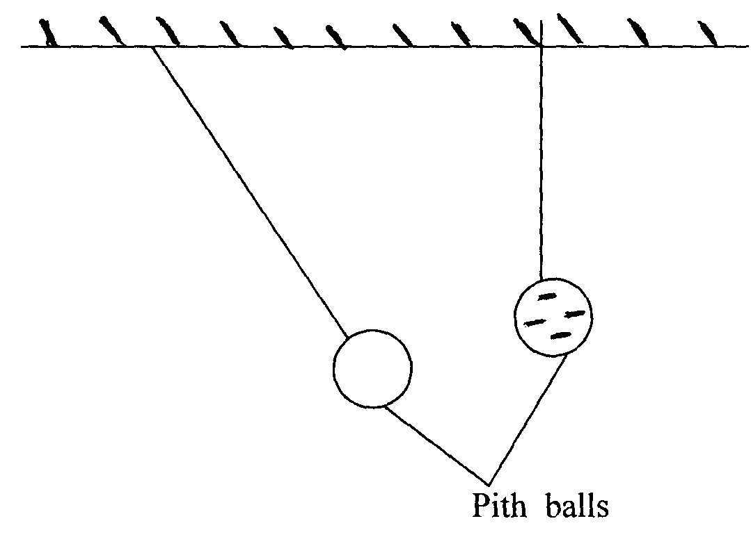

State and explain what would be observed after the two pith balls touch
3. a) Two metal cons A and B of different sizes rest on two identical gold leaf electroscope as shown.
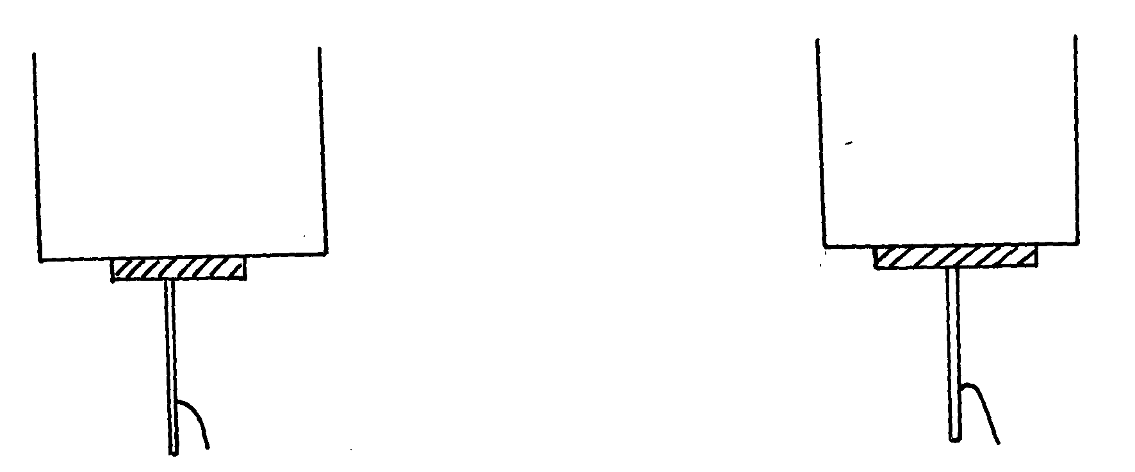

Compare the divergence of the gold leaves of the two electroscopes. Explain your answer
b) Two identical spheres A and B each standing on an insulated base are in contact. A
negatively charged rod is brought near sphere A as shown below
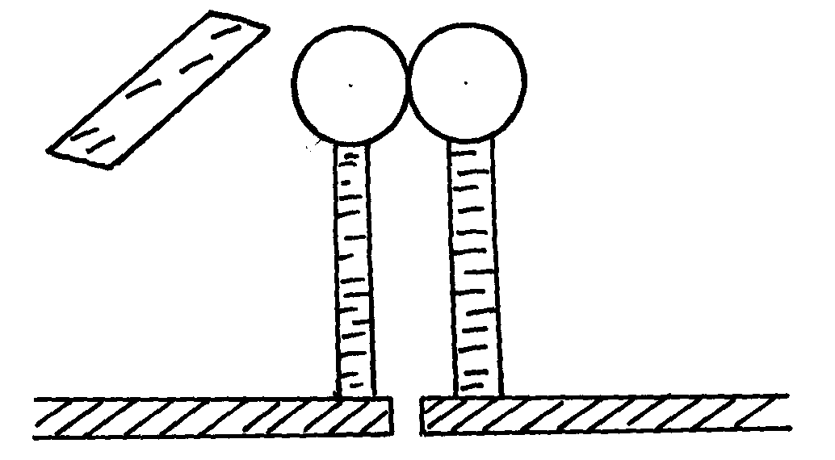
A
B

In what way will A differ from B if separated while the rod is near?

4. In the figure 1 below, explain what happens when one of the metal balls comes into contact with
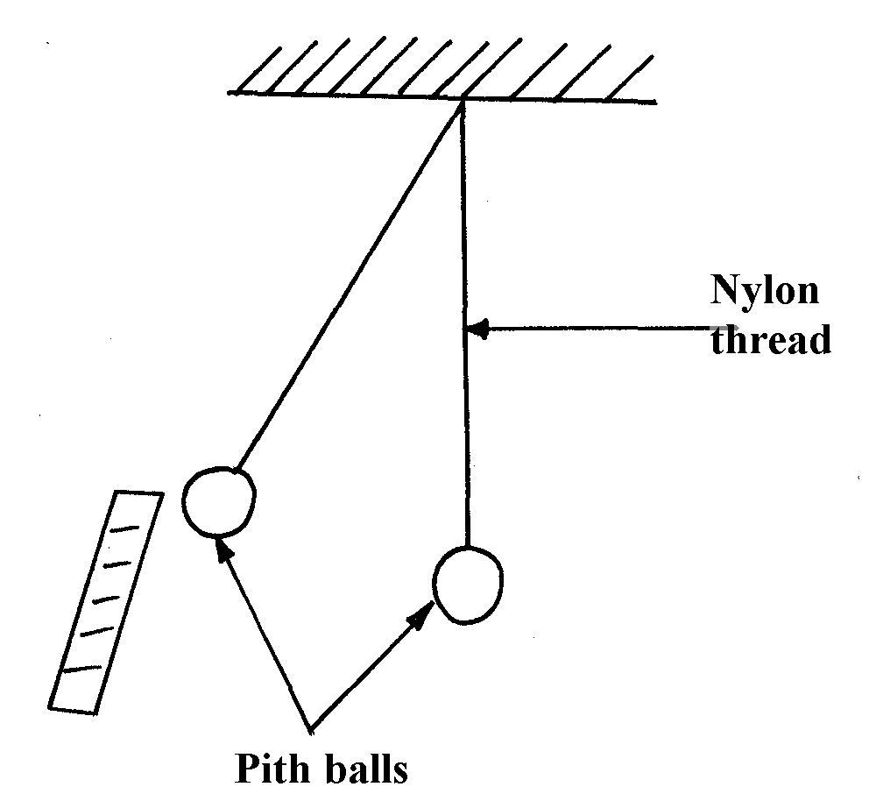
a negatively charged rod

figure 2

5. A gold leaf electroscope is positively charged as shown in the diagram in figure 1 where C is the
cap and L is the gold leaf. State and explain what happens to L when a positively charged rod is
brought near C without touching it.
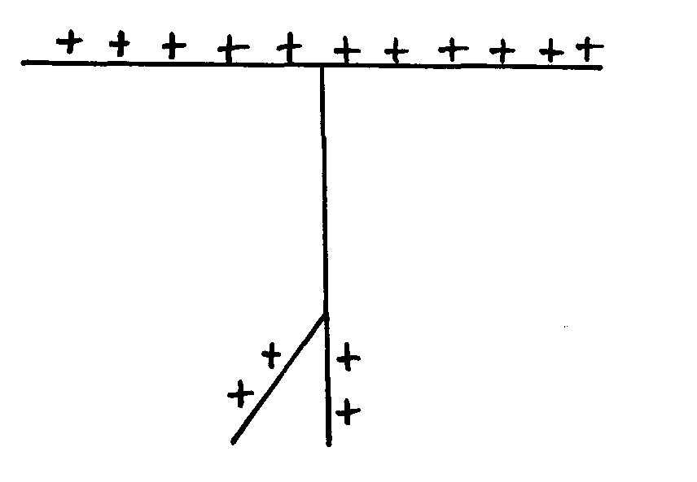
Figure 1

6. You are provided with a charged electroscope, an insulator and a conductor. Describe how
you would use these apparatus to distinguish in the insulator from the conductor

7. Two identical metal spheres A and B each standing on an insulating base are in contact.
A negatively charged rod is brought near sphere A as shown in the figure below.
A
B

In what way will sphere A differ from B if it is separated while the rod is near?

Electrostatics
1. a) Charges at x get neutralized. 1 mk
C is pointed and due to point action 1 mk charges leak off from C and are attracted
to x neutralizing it. 1 mk
b) Leaf rises. 1 mk
A position charge is induced on the surface of hollow conductor, these repels the charges
from the cap of the electroscope making the leaf to diverge with the charge. 1 mk
Charge
Time(s)
c)

1mk 

d) – Smoothening waves. 1 mk
- Reduction of sparks in induction coil 1 mk
- In camera flash. 1 mk
- delay circuits 1 mk (any two)
2. After touching, the pith balls share the charge and become negative hence they repel.
3. a) – The divergence of B is greater the divergence of A
- B has a smaller surface area than A, has low capacitance than A (Q= CV)
b) - A will have a net positive charge while B will have a net negative charge

4. The two balls will acquire negative charge and repel
5. The gold leaf will diverge further because more positive charges will be repelled from the cap
to the leaf by the positively charged rod
6. Each material is brought in turn to touch the cap. The conductor will discharge the
electroscope while the insulator will not (accept bring near conductor gauge)
7. A will have a positive charge when charged rod is brought near metal A. positive charges are
attracted towards it while the negative charges are repelled

