Electrochemistry
1. The setup below was used to carry out the electrolysis of Magnesium sulphate solution using
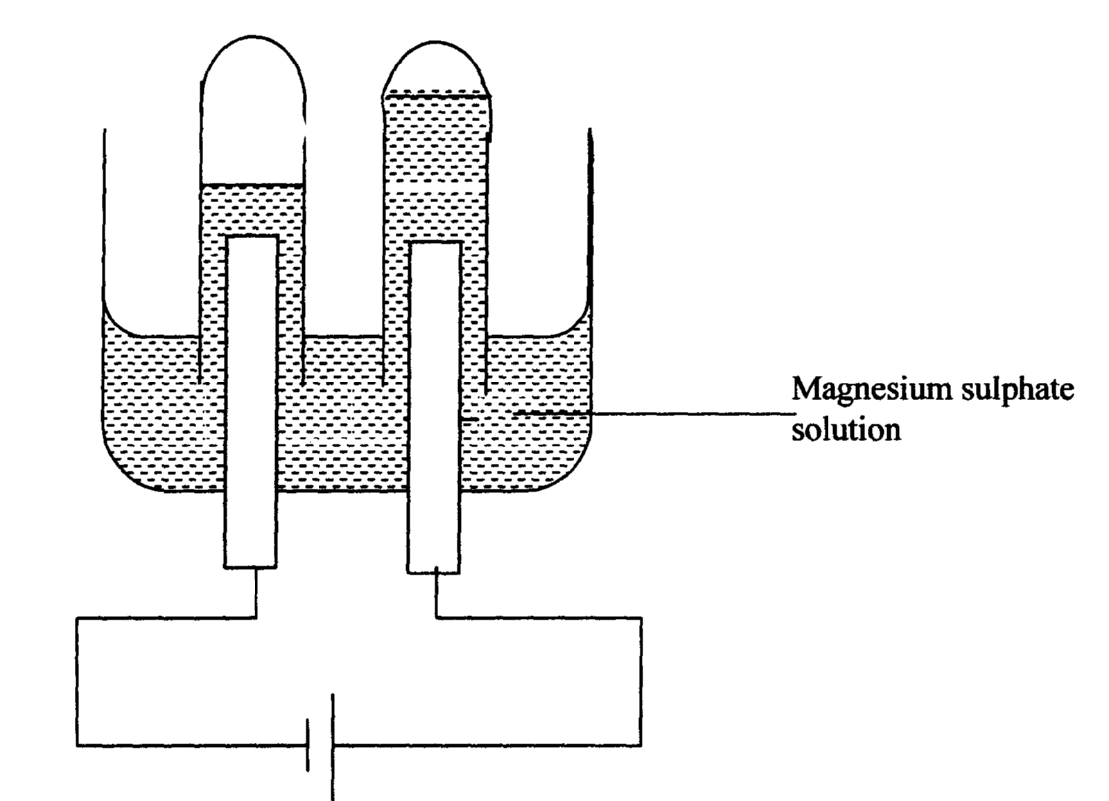
inert electrodes.

(i) Name a suitable pair of electrode that can be used in the above process.
(ii) State and explain the changes on the concentration of magnesium sulphate solution as
the process proceeds.
2. During purification of copper by electrolysis, 1.48g of copper were deposited when a
current was passed through aqueous copper (II) sulphate for 2 ½ hours. Calculate the
amount of current passed.
(Cu = 63.5 1Faraday = 96500C)
63
29
65
29
3 The diagram below represents a set-up that can be used for the electrolysis of dilute sulphuric acid
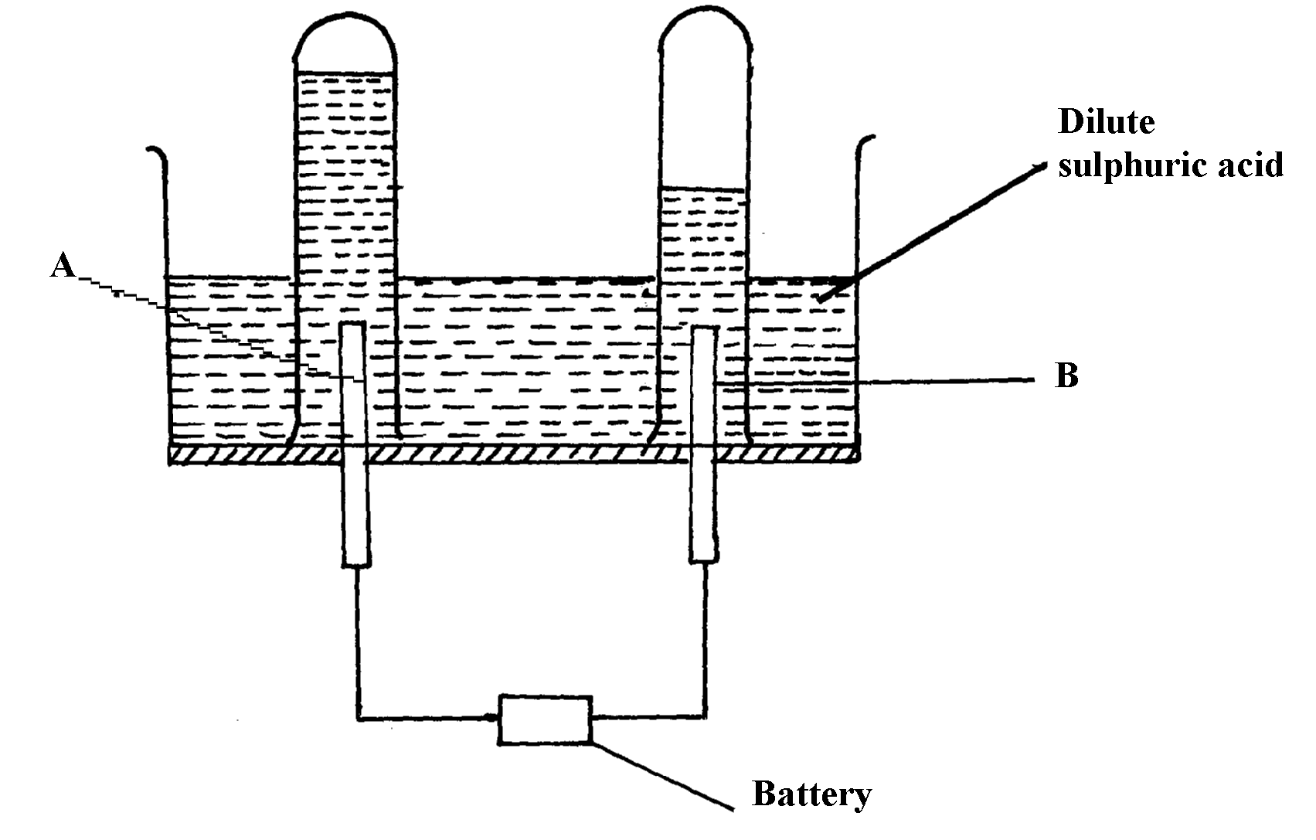

(a) Name the electrodes A and B
(b) Write an equation for the reaction taking place at electrode B
(c) What happens to the concentration dilute sulphuric acid as the reaction continues?

4. In an electrolysis, a current of 200A was passed through molten oxide of metal Q
for 58 minutes and 64.8g of the metal deposited. Determine;
i) Charge on metal Q
ii) The volume of oxygen gas produced at standard temperature and pressure
Q = 27 IF = 96500C, molar gas volume stp =22.4dm³
5. Consider the reduction potentials below.
Pb²⁺_{(aq)} + 2e Pb_{(s)} = -O.13V
Mg²⁺_{(aq)} + 2e Mg_{(s)} = -O.76V
a) Write the overall Redox reaction that takes place when the above half cells are connected.
b) Determine the E^{θ} value of the above cell.
(c) Calculate which group of the periodic table is element F?

6. An oxide of element F has the following formula:- F₂O₅
(a) Determine the oxidation state of F

Element | Sodium | Magnesium | Aluminium
Atomic number | 11 | 12 | 13

7. The table below gives elements and their atomic numbers. Answer the questions that follow:
Compare the electrical conductivity of sodium and aluminium. Explain
8. What mass of Zinc will be deposited from a solution of Zinc (II) Chloride when a current
of 3A is passed through the Zinc (II) Chloride solution during electrolysis for 50minutes?
(Zn= 65, 1 Faraday = 96500C)
9. Study the flow chart below and answer the questions that follow:
Copper Pyrites
CuFeS₂
Step (I)
Froth floatation,
Air
Gas Q
Gas Q
Step (II)
Cu₂S_{(s)}
Cu₂O
Cu_{(s)}
Pure Copper
Air
Step (III)
Cu₂S
Step (IV)
FeO
Step (V)

(a) Name gas Q …………………………………………………………… .
(b) With the help of diagram, describe how step (V) is carried out
10. Nitrogen and hydrogen react reversibly according to the equation:-
N_{2(g)} + 3H_{2(g)} 2NH_{3(g); Δ}H = -92kjmol⁻¹
The energy level diagram for the above reaction is shown below:-
N_{2(g)} + 3H_{2(g)}
2NH_{3(g)}
Reaction path
Energy
(KJ)

(a) How would the yield of ammonia be affected by:
(i) A decrease in temperature
(ii) An increase in pressure
(b) How does a catalyst affect reversible reaction already in equilibrium?
(c) On the above diagram, sketch the energy level diagram that would be obtained when
iron catalyst is added to the reaction

11. Study the electrode potentials in the table below and answer the question that follow:
(Letters are not the actual symbols of elements)
(E^{θ} /Volts)
H²⁺ _{(aq)} + 2 e⁻ H_{(s)} +0.34
Z²⁺ _{(aq)} + 2e⁻ Z_{(s)} -2.38
G⁺_{(aq)} + e⁻ G _{(s)} +0.80
T²⁺ + 2e⁻ T_{(s)} - 2.87
(a) Which one is the strongest reducing agent?
(b) Write the ionic equation for the reaction that takes place when Z is dipped in a solution
of G⁺ ions
(c) Calculate the E^{θ} cell value of the reaction in 22.(b) above
12. When a hydrocarbon was completely burnt in oxygen, 4.2g of Carbon (IV) oxide and 1.71g
of water were formed. Determine the empirical of the hydrocarbon. (H=10 C=12.0 O=16.0)
13. During electrolysis of aqueous copper (II) sulphate 144,750 coulombs of electricity were used.
Calculate the mass of copper metal that was obtained (Cu =64 1Faraday = 96,5000 coulombs)
14. Sodium metal reacts with oxygen according to the following equation:-
Heat
6Na_{(s)} + 2O_{2(g)} Na₂O_{2(s)} + 2Na₂O_{(s)}
State one physical and one chemical difference between Na₂O₂ and Na₂O
Physical difference ……………………………………………
Chemical difference……………………………………

15. The diagram below shows an electrochemical cell:
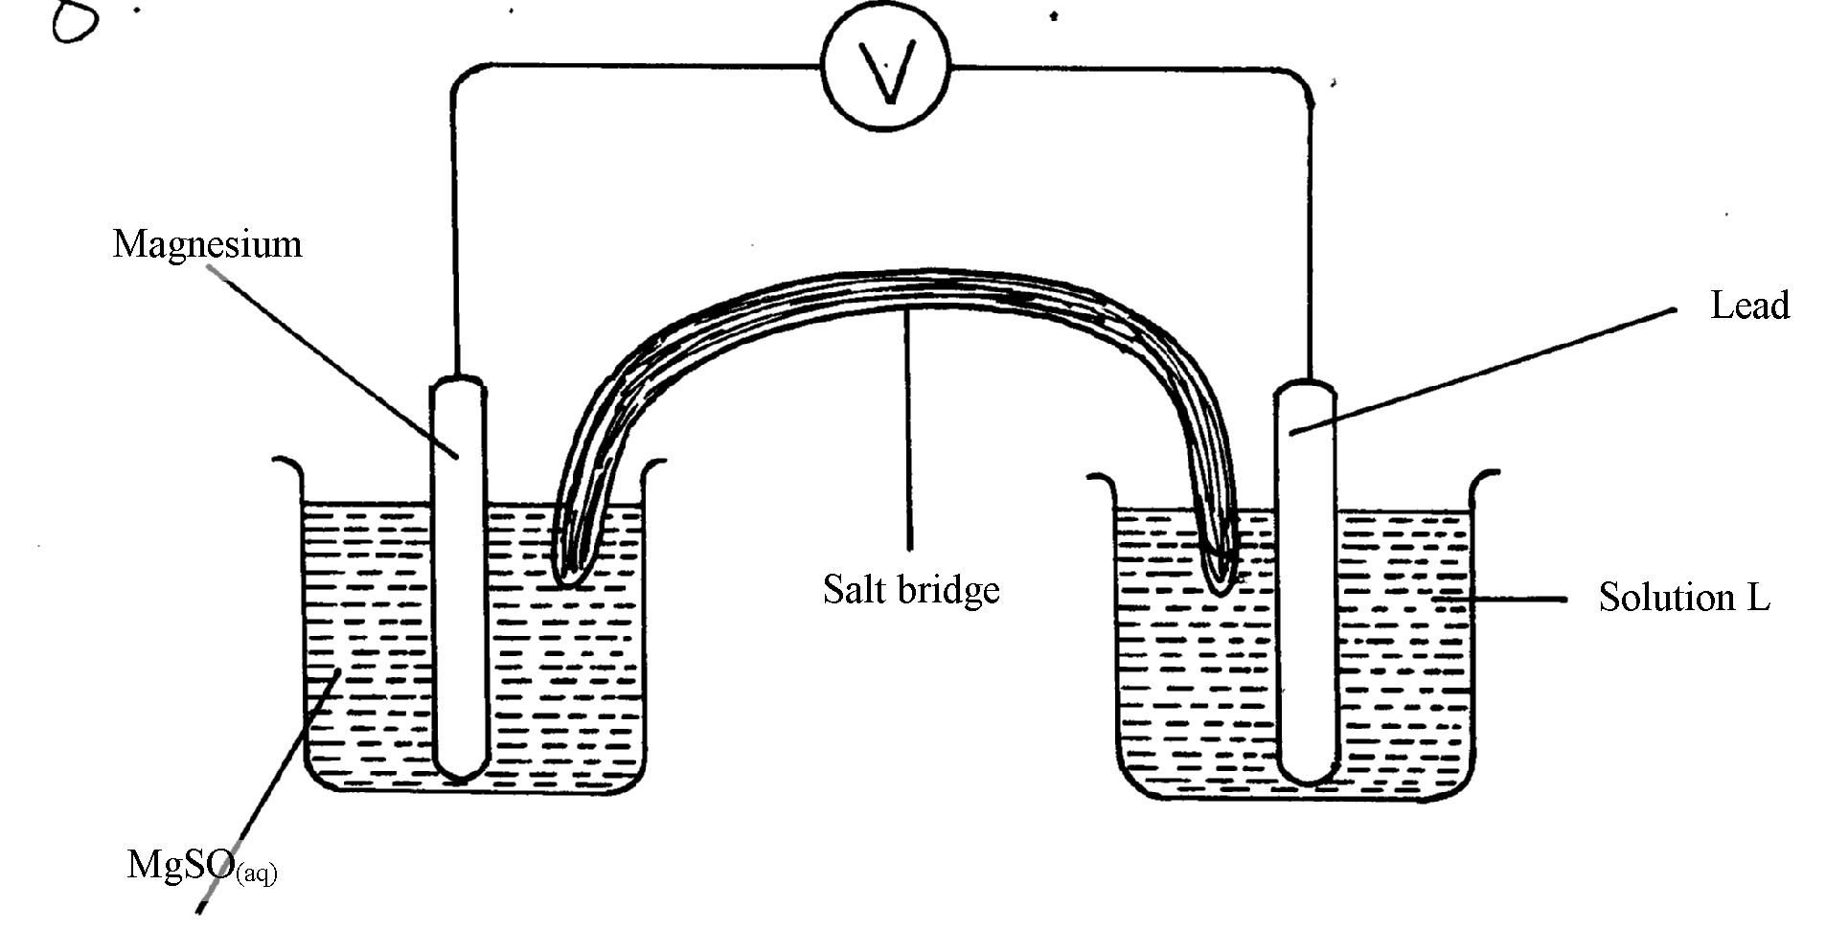
MgSO_{4(aq)}

- Give the formula of the possible salt L
(b) On the diagram show the direction of movement of electrons
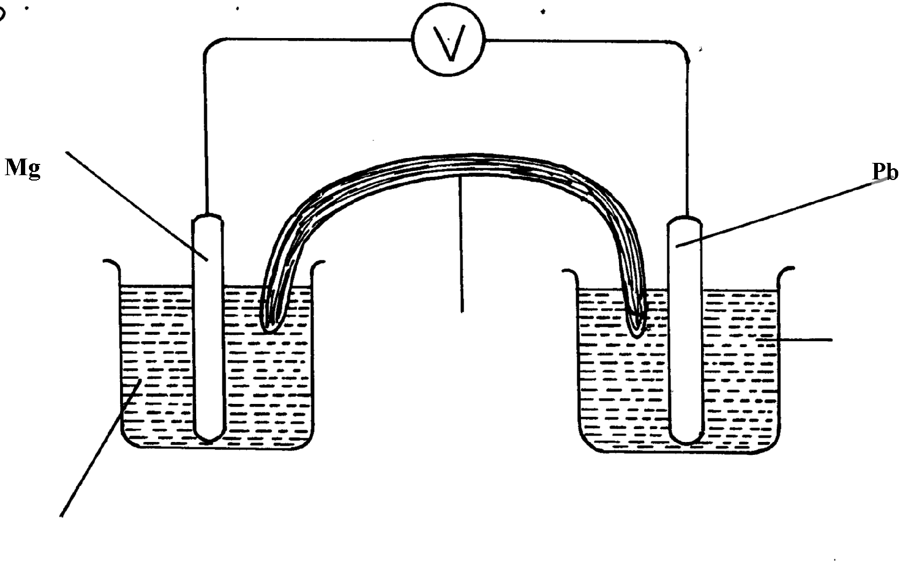
(c) Write the cell representation

6. The reaction blow is a redox reaction

MnO₄⁻_{(aq)} + 8H⁺_{(aq)} + 5Fe²⁺_{(aq)} ₎
(a) Identify the species reduced. Explain
(b) Write the equation for the oxidation reaction
17. Consider the cell diagram below
Cr_{(s)}/Cr³⁺_{(aq)} // Fe²⁺_{(aq)/}Fe_{(s)} E^{θ} = + 0.30V
i) Write the overall cell reaction for the above electrochemical cell
ii) Given that E^{θ} value for Fe²⁺_{(aq)} /Fe_{(s)} is -0.40V,calculate the E^{θ} value for Cr³⁺_{(aq)}/Cr_{(s)}
18. (a) Describe the process by which Trichloro fluoromethane Nitrogen is obtained from
air on a large scale

(b) Study the flow chart below and answer the questions that follow
Products
Ammonia
Gas J
Nitrogen (IV) Oxide
Copper (III) Oxide

Step VI Heat
Nitric (V) acid
Ammonia

Step IV
Ammonium nitrate
Step V
Nitrogen gas
Copper
Water
Water, air

Step III
Step I
Air
Platinum-Rhodium
High temperature
Step II Air

(i) Identify gas J
(ii) Using oxidation numbers, show that ammonia is the reducing agent in step VI
(iii) Write the equation that occurs in step V
(iv) Give one use of ammonium nitrate
(c) The table below shows the observations made when aqueous ammonia was added to
cations of elements E, F and G until in excess

Cation of | Addition of a few drops of aqueous ammonia | Addition of excess aqueous ammonia
E | White precipitate | Insoluble
F | No precipitate | No precipitate
G | White precipitate | Dissolves

(i) Select the cation that is likely to be Zn²⁺ ………………………………
(ii) Given that the formula of the cation of element E is E²⁺, write the ionic equation for the
reaction between E²⁺ and aqueous ammonia

19. a) Study the standard electrode potential for the half-cells given below and answer the questions that follow.(The letter do not represent the actual symbols of the elements)
E^{θ} Volts
N⁺_{(aq)} +e⁻ N(s) ; -2.92
J⁺_{(aq)} + e⁻ J_{(s)} ; +0.52
K⁺_{(aq)} + e⁻ ½ K_{2(g)} ; 0.00
½ G_{2(g)} + e⁻ G-_{(aq)} ; +1.36
M²⁺_{(aq)} + 2e⁻ M_{(s)} ; -0.44
i) Identify the strongest oxidizing agents. Give a reason for your answer
ii) Which two half-cells would produce the highest potential difference when combined?
iii) In the space below draw a complete electro chemical cell of the two-half cells mentioned
in (ii) above

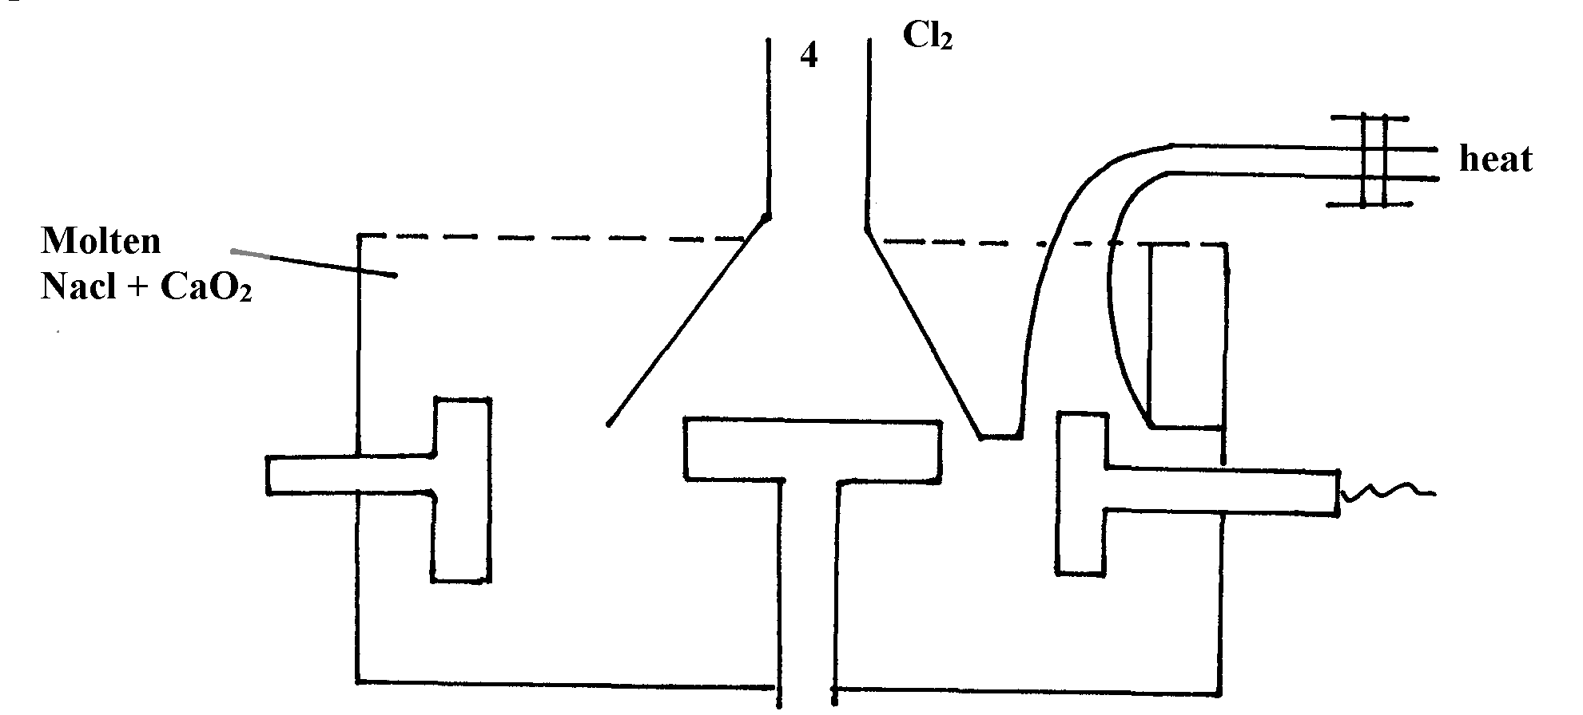
20. Below is a simplified diagram of the Down’s cell for the extraction of sodium. Study it
and answer the question that follow:-

Sodium

Molten
NaCl + CaCl₂

-

(i) From which substances are the electrodes made?
thode…………………………………………………………….
Anode……………………………………………………………………
(ii) State and explain why sodium chloride is mixed with calcium chloride
(iii) What is the role of the iron gauze
(iv) Write equations for the reaction at :-
cathode
anode
(v) Which property of sodium makes it possible to collect it as shown?

(b) When a current of 6.42 A was passed through an electrolyte Y²⁺ ions for 10minutes,
2.74 of Y were deposited
(i) Calculate the quantity of electricity passed in the experiment
(ii) Determine the relative atomic mass of Y (1Faraday = 96000 coulombs)

21. (a) The table gives the standard redox potentials for a number of half reactions. Use it to answer
the questions that follow:-
(E^{θ}/Volts)
Zn²⁺ _{(aq)} + 2e⁻ Zn_{(s)} -0.76
Fe²⁺ _{(aq)} + 2e⁻ Fe_{(s)} -0.44
I²⁺ _{(l)} + 2e⁻ 2I⁻ _{(aq)} +0.54
Fe³⁺ _{(aq)} + e⁻ Fe²⁺_{(aq)} +0.77
Ag⁺ + e⁻ Ag_{(s)} +0.88

(i) Relative to which half-cell reaction are the above electrode potentials expressed?
(ii) Calculate the e.m.f of the cell made up by combining the I_{2(l)} /2I⁻_{(aq)} electrode and
Zn²⁺_{(aq)}/Zn_{(s)} electrode
(ii) Which of the substances listed in the above table is :-
I. The strongest oxidising agent
II. The strongest reducing agent
(iv) Which substances could be used to convert iodide ions to iodine? Write balanced equations
for any possible conversions

22. a) The standard electrode potential for the elements chlorine and magnesium are:-
Cl_{2(g)} + 2e⁻ 2Cl⁻_{(aq)} E^{θ} + 1.36V
Mg²⁺_{(aq)} + 2e⁻ Mg_{(s)} E^{θ} - 2.36V
i) Which one of the two elements will act as an oxidizing agent? Explain.
ii) Calculate the electromotive force of a cell where the overall reaction is:-
Cl_{2(g)} + Mg_{(s)} MgCl_{2(s)}
b) The table below gives the reduction standard electrode potentials for divalent metals.
The letters are not their actual symbols. Use them to answer the questions that follow:-
Metal E^{θ} (volts)
P +1.50
Q - 0.44
R +0.34
S +0.76
i) Select two metals whose half cells can produce the highest voltage when connected.
ii) Draw a well labelled diagram of electrochemical cell formed by half-cells of metals P and Q
iii) Calculate the voltage produced by the cell in (ii) above
c) When nitrate solution of a certain metal X was electrolysed, 1.174g of metal X was
deposited by a current of 4 amperes flowing for 16minutes. Determine the formula of
the metal nitrate. (1F= 96,500, R.A.M of X= 59)
23. Study carefully the information given below and answer the questions that follow:-
Substance | Physical state at e.t.p | Solubility in water | Other information
A | Solid | - Soluble  - Blue solution | - solution conducts electricity forming two products B and C  - B is solid and C is a greenish –yellow gas
D | Gas | - Soluble  - Colourless solution | - Solution forms pale blue precipitate with A and then deep blue solution in excess
E | Solid | - Insoluble | - With a solution of A forms B and a colourless solution at E²⁺ions
(a) Identify the substances represented by the letters
- Give equations for the reactions in which:-
(i) Substance B is formed from the solution of A on electrolysis
(ii) Substance B is formed from solution A when reacted with E
(c) Give one use of gas C
(d) Name the ion responsible for the deep blue solution
24. (a) Study the standard electrode potentials for the elements given below and answer the questions
that follow. The letters do not represent the actual symbols of the elements
E^{θ}
Q + 2e⁻ 2Q- _{(aq)} +2.87
_{2(g)}
R_{2(g}) + 2e⁻ 2R-(aq) +1.36
S²⁺ _{(aq)} + 2e⁻ S (s) + 1.23
2T⁺_{(aq)} + 2e⁻ T₂(g) 0.00
U²⁺_{(aq)} + 2e⁻ U(s) -0.13
V²⁺_{(aq)} + 2e⁻ V(s) -0.76
(i) What is the E^{θ} value of the weakest reducing agent? *
(ii) Which element is likely to be hydrogen? Give a reason for your answer *
(iii) Draw a diagram for the cell that would be obtained when the half cell of elements
S and V are combined *
(iv) Calculate the e.m.f of the electrochemical cell in a (iii) above *
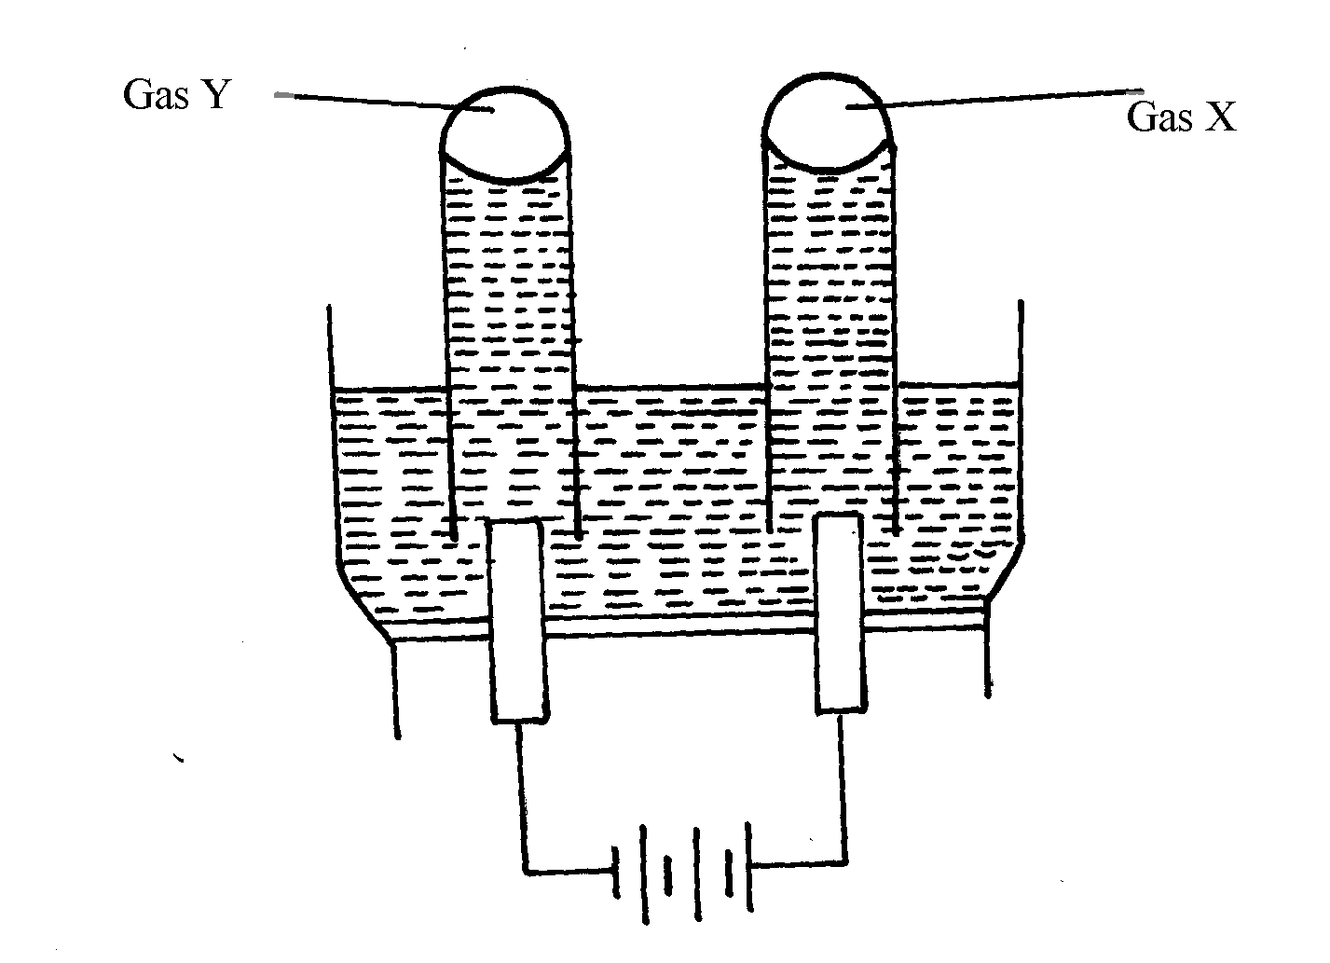
(b) The diagram below represents the electrolysis of dilute sulphuric (VI) acid

(i) Name the gases X and Y *
(ii) Write ionic equation for the formation of gas X *
(iii) At what electrode does reduction take place? Explain your answer *
(iv) Name the most suitable electrodes for this experiment. Explain your answer *

25. The flow chart below shows an analysis of mixture R that contains two salts. Study it
and answer the questions that follow:-

Mixture R
Residue V
Two metal oxides + CO₂ + NO₂ + O₂ +H₂O
Divide into two portions Step I
Filtrate W
Solution Z + CO₂
Step V
Add HNO₃
Filtrate X
Colourless solution
Colourless solution
Colourless solution
Step II
Add dil. H₂SO₄
White precipitate
Add excess NH₄OH to portion of Z
Add excess NaOH to portion of Z
Add excess
NH₄OH
Step III
Add excess
NaOH
Add water then filter
Step IV

Residue

(i) Write two ionic equations for the reactions between the cation in filtrate X and aqueous
ammonia (Ammonium hydroxide)until in excess
(ii) What conclusion can be drawn from Step IV only? Explain
(iii) What observation would indicate the presence of a NO₃⁻ ion in step I?
(iv) Write the formula of the anion in residue V. Explain
(v) Suggest the identity of the cation present in solution Z
(vi) Name the two salts present in mixture R

26. (a) The set-up below was used in the electrolysis of copper II nitrate solution:
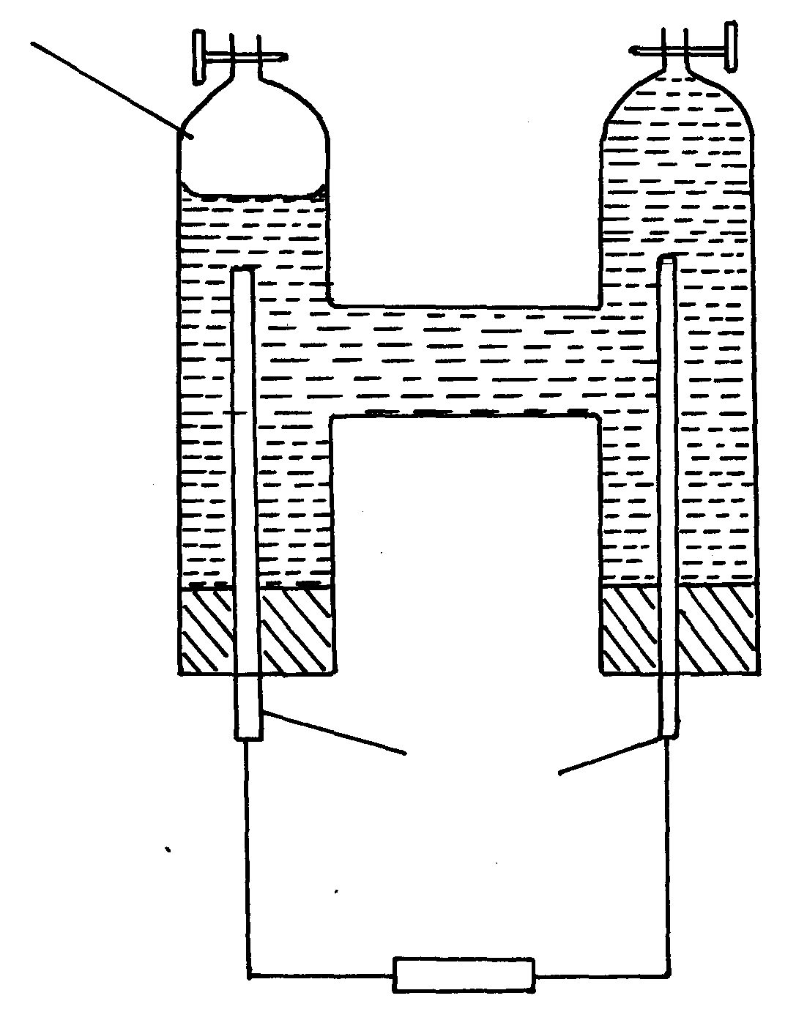
Gas P
Platinum rods

(i) What is electrolysis?
(ii) Show the anode and cathode on the diagram
(iii) Explain how you would confirm gas P
(iv) Write the equation for the reaction occurring at
(a) Anode
(b) Cathode
(v) State two changes that occur on the electrolyte after the experiment
(b) Below are the standard electrode potentials for electrodes B and D

B^{2t}_{(aq)} + 2e⁻ B_{(s)} – 2.92V
D^{2t}_{(aq)} + 2e⁻ D_{(s)} + 0.34V

(i) Identify the electrode which is ;
(a) The least reducing agent
(b) The strongest oxidizing agent
(ii) Calculate the e.m.f of the cell formed when the two electrodes are connected
(iii) Write a cell representative for the cell above
27. A typical electrolysis cell uses a current of 40,000 amperes. Calculate the mass (in Kg of aluminium produced in one hour). (Al = 27) (Faraday = 96500Coloumbs )

28. A strip of copper metal was immersed into a nitrate solution of metal Q overnight. Use the
information below to answer questions that follow
 | E^{θ} (Volts)
Q_{(aq)} + e⁻ Q_{(s)}  Cu²⁺ _{(aq)} + 2e⁻ Cu_{(s)} | +0.80  + 0.34

(a) State the observations made at the end of the experiment
(b) Give a reason for the observations made in (a) above
(c) Calculate the e.m.f of the cell above
29. (a) Excess marble chips (Calcium carbonate) was put in a beaker containing 150cm³
of dilute hydrochloric acid. The beaker was put on a weighing balance and the total
loss in mass recorded after every two minutes as shown in the table below:
Time (min) | 0 | 2 | 4 | 6 | 8 | 10
Total loss in mass (g) | 0 | 1.8 | 2.45 | 2.95 | 3.2 | 3.3

(i) Why was there a loss in mass?
(ii) The average rate of reaction was faster between 0 and 2 minutes than between
6 and 8 minutes. Explain why
(iii) State one way in which the rate of reaction can be increased
(iv) When aqueous sodium sulphate was added to contents of the beaker, a white precipitate
was formed;
(I) Identify the white precipitate ………………………………………………………
(II) Name one use of the substance named in (iv) (I) above
b) A student performed the following experiment with an intention to extract calcium metal
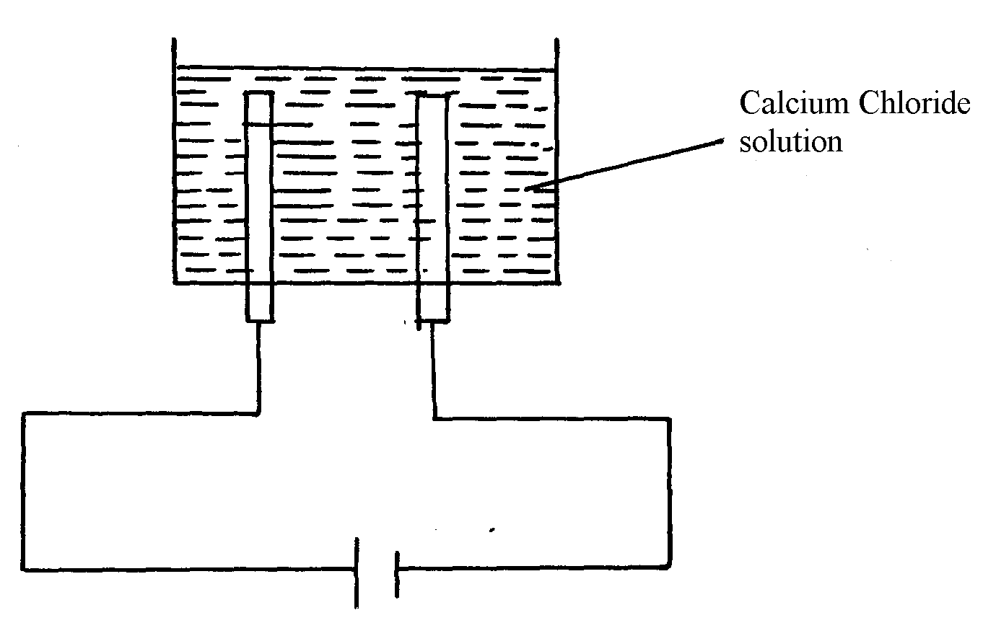

(i) The student was surprised that no calcium was produced in the experiment. Explain
why no calcium was produced
(ii) Write the equation for the reaction that occurred at the anode if the solution was concentrated
(iii) The electrolysis involved passing an electric current of 4A for one hour. Calculate the mass of
the product at the anode. (1Faraday = 96500C, Cl =35.5, H = 1.0, O =16, Ca = 40)

30. Cheptoo set-up some apparatus as shown in the diagram below:-
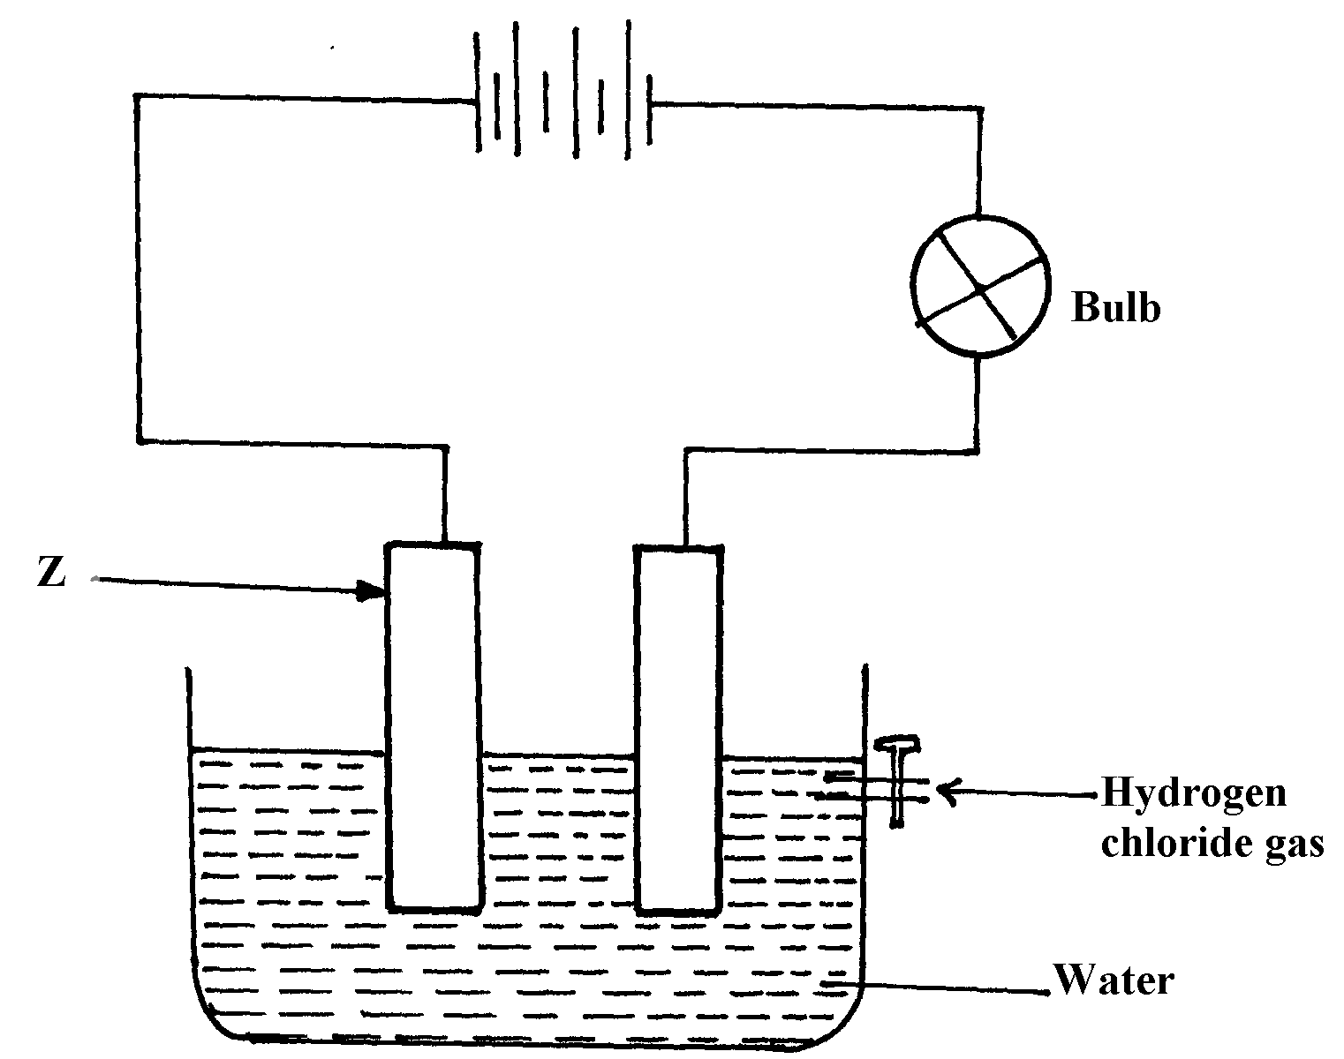

At the start of the experiment, the bulb did not light:-
(a) State and explain the observation made when the tap was opened to allow the hydrogen
chloride gas through the water for about 20 minutes
(b) Write the chemical equation for the reaction that took place at the cathode

31. Metals K and N were connected to form a cell as shown in the diagram below. Their reduction
potentials are as shown below:
K⁺_{(aq)} / K_{(s)} ≡ - 0.17V
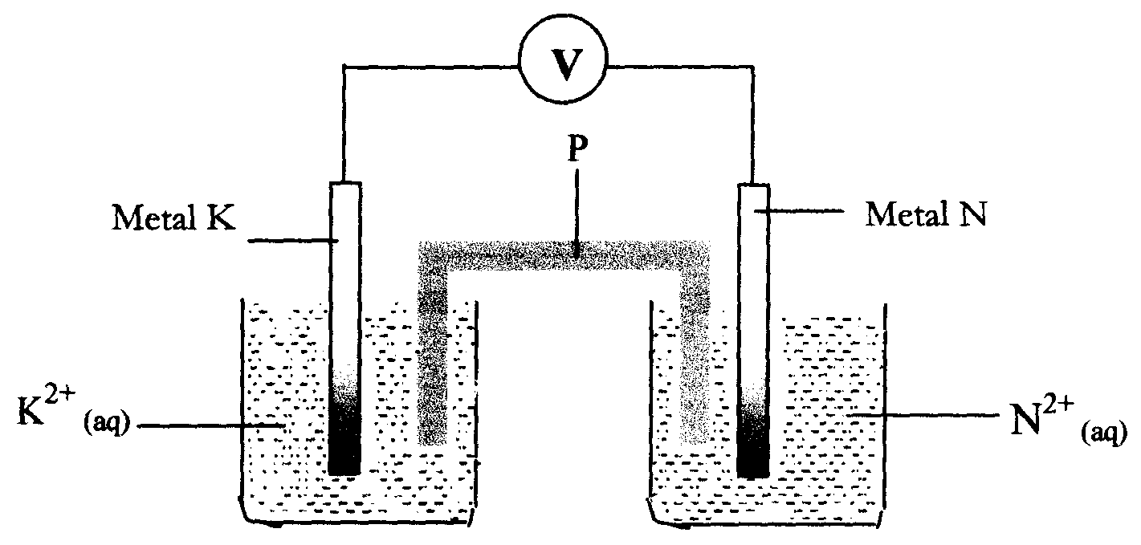
N⁺_{(aq)} / N_{(s)} = + 1.1 6V

I. Write the equation for the half-cell reaction that occurs at
Metal K electrode
Metal N electrode
II Identify P and state its role in the above setup
(i). Identity of P
(ii) . Role of P in the setup.
III. On the diagram, show the flow of
I. Electrons
II. Current.
IV Calculate cell potential (E) for the cell represented in the setup above
32. (a) The diagram below shows a Zinc –copper cell.
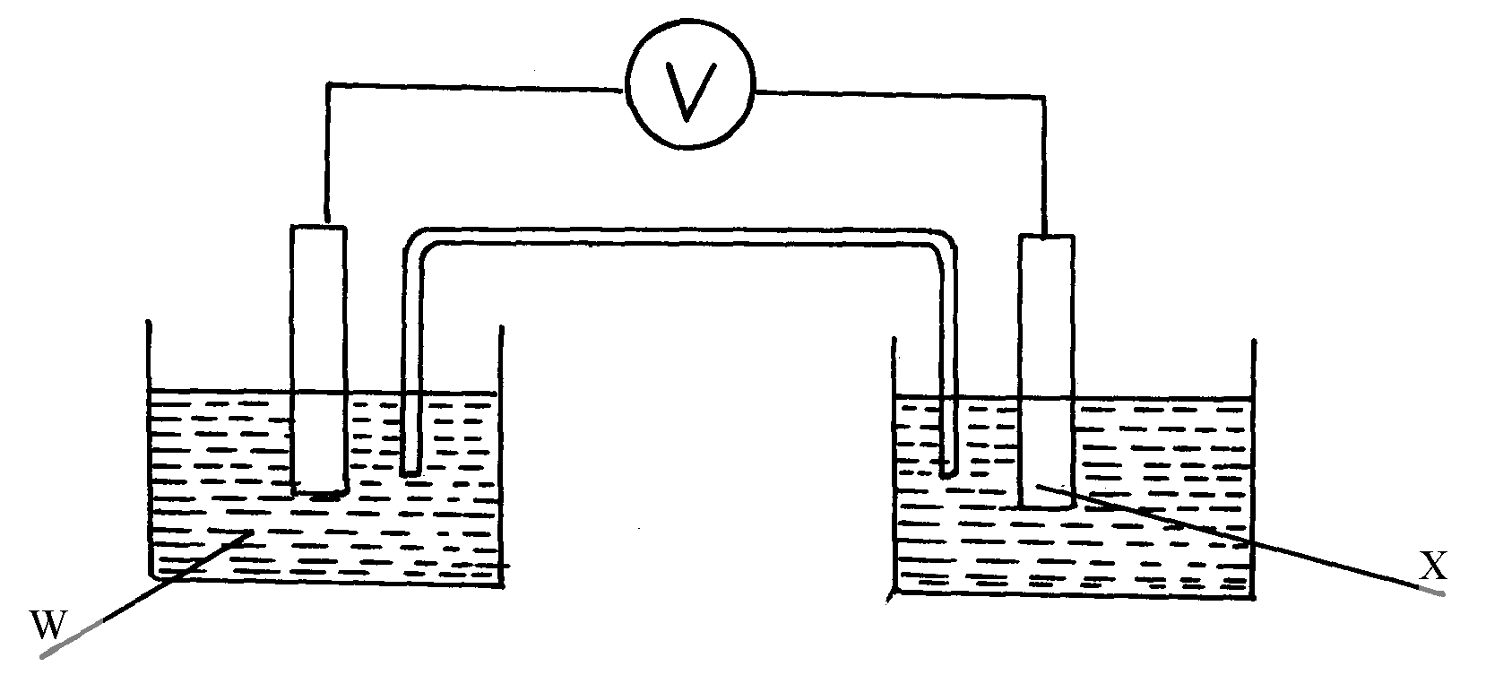

(i) Given the standard electrode potential of Zinc is -0.76V and that of copper is +0.34V, suggest;
(i)The identity of W …………………………………………………………………....
(ii) The identity of X …………………………………………………………………… .
(iii) The equation for the overall cell reaction
(iv) The reading on the voltmeter
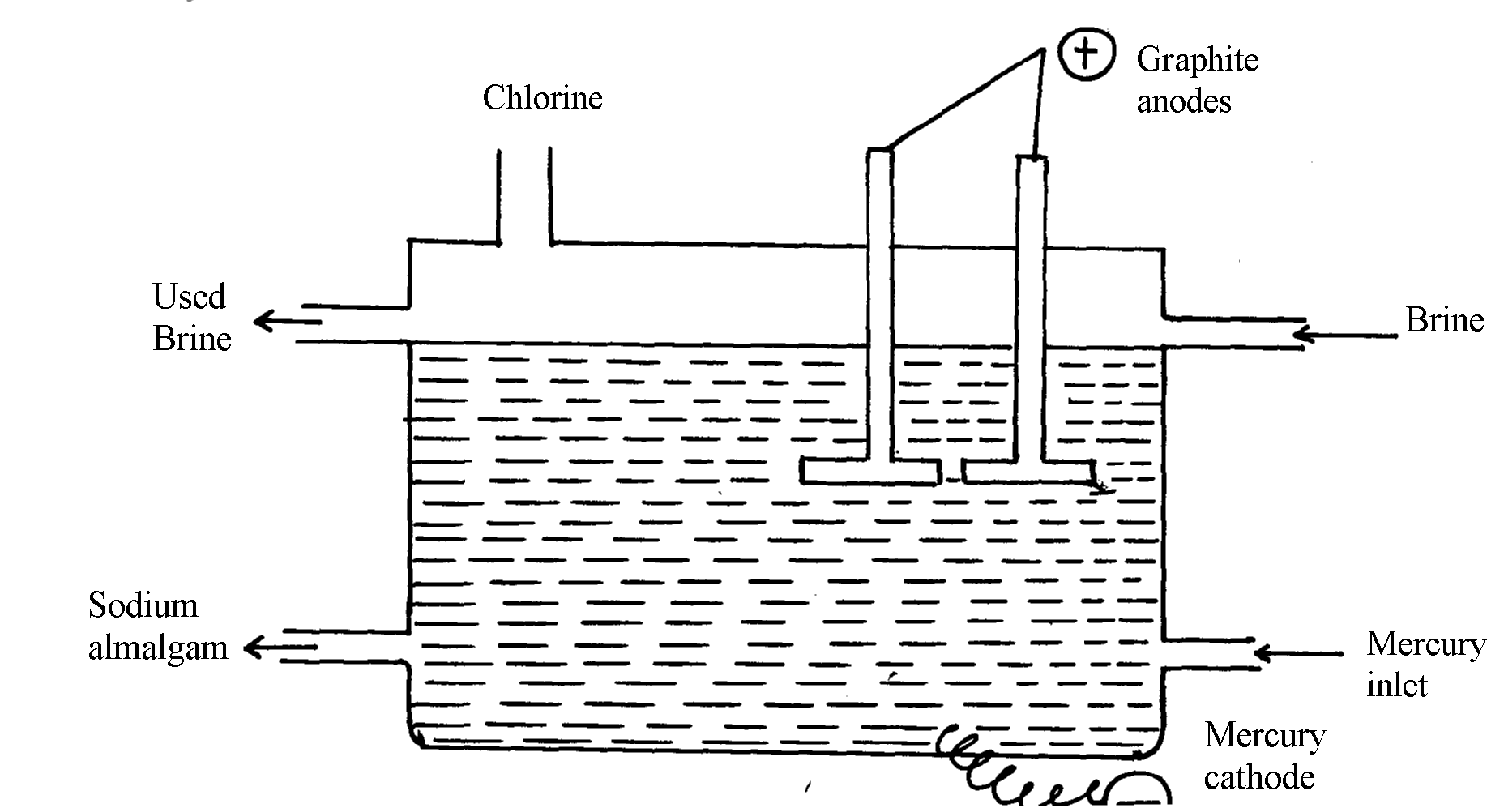
(b) Sodium hydroxide may be manufactured by the electrolysis of brine as in the diagram below:-

(i) State the chemical name of brine
(ii) Write the equations for the reactions are the electrodes
Anode
Cathode
(iii) Explain how sodium hydroxide is obtained from the product of this process

33. A typical electrolysis cell uses a current of 40,000 amperes. Calculate the mass (in kilograms)
of aluminium produced in one hour (Al=27, 1Faraday=96,500 coulombs)
34. The reaction between ammonia and oxygen to form Nitrogen (II) oxide is highly exothermic
4NH_{3(g)} + 5O_{2(g)} 4NO_{(g)} + 6H₂O_{(g)}
The reaction is carried out in presence of platinium-rhodium catalyst at 1173k and a pressure
of 911.952k pa.
i) Explain how each of the following would affect the yield of Nitrogen(II) oxide gas:
a) Reduction in pressure
b) Using a more efficient catalyst
35. The following table shows the standard reduction potentials of some half cells. Study the
table and refer to it to answer the questions that follow;
Half reaction E^{θ} volts
P⁴⁺_{(aq}) + e⁻ P³⁺_{(aq)} +0.61

Q³⁺_{(aq)} + e⁻ Q²⁺_{(aq)} +0.77

R_{2(g)} + 2e⁻ 2R⁻_{(aq)} +0.54

S²⁺_{(aq)} + 2e⁻ S_{(s)} -0.44

T²⁺_{(aq)} + 2e⁻ T_{(s)} -0.74

a) Identify the strongest oxidizing agent
b) Which substance would be used to oxidize R⁻ ion to the atom R
c) Study the cell represented below;
T_{(s)} / T²⁺_{(aq)}// S²⁺_{(aq)}/ S_{(s)}
i) Identify the electrodes
ii) Write equations for the reaction taking place in each half- cell
iii) Determine the cell equation and the electromotive force (e.m.f) of the cell represented in
(c) above
iv) In which direction does the electrons flow in the external circuit of the cell whose e.m.f
is determined in (iii) above
d) A steady current of 2.5A was passed for 15 minutes through a cell containing divalent ions
M²⁺. During this process 0.74g of metal M was deposited (IF = 96500C)
i) Calculate the quantity of electricity passed in this cell
ii) Determine the relative atomic mass of M
36. The following table shows the standard reduction potentials of some half cells.
Study the table and refer to it to answer the questions that follow;
Half reaction E^{θ} volts
P⁴⁺_{(aq}) + e⁻ P³⁺_{(aq)} +0.61

Q³⁺_{(aq)} + e⁻ Q²⁺_{(aq)} +0.77

R_{2(g)} + 2e⁻ 2R⁻_{(aq)} +0.54

S²⁺_{(aq)} + 2e⁻ S_{(s)} -0.44

T²⁺_{(aq)} + 2e⁻ T_{(s)} -0.74

a) Identify the strongest oxidizing agent
b) Which substance would be used to oxidize R⁻ ion to the atom R
c) Study the cell represented below;
T_{(s)} / T²⁺_{(aq)}// S²⁺_{(aq)}/ S_{(s)}
i) Identify the electrodes
ii) Write equations for the reaction taking place in each half- cell (2 mks
iii) Determine the cell equation and the electromotive force (e.m.f) of the cell represented
in (c) above
iv) In which direction does the electrons flow in the external circuit of the cell whose e.m.f
is determined in (iii) above
d) A steady current of 2.5A was passed for 15 minutes through a cell containing divalent ions
M²⁺. During this process 0.74g of metal M was deposited (IF = 96500C)
i) Calculate the quantity of electricity passed in this cell
ii) Determine the relative atomic mass of M
37. In the equation below identify the reagent that acts as an acid in the forward reaction.
Give a reason for your answer.
NH₄⁺_{(aq)} + H₂O_{(l)} NH_{3(aq)} + H₃O⁺_{(aq)}

38. A student set up the experiment shown below. Study it and answer the questions that follow.
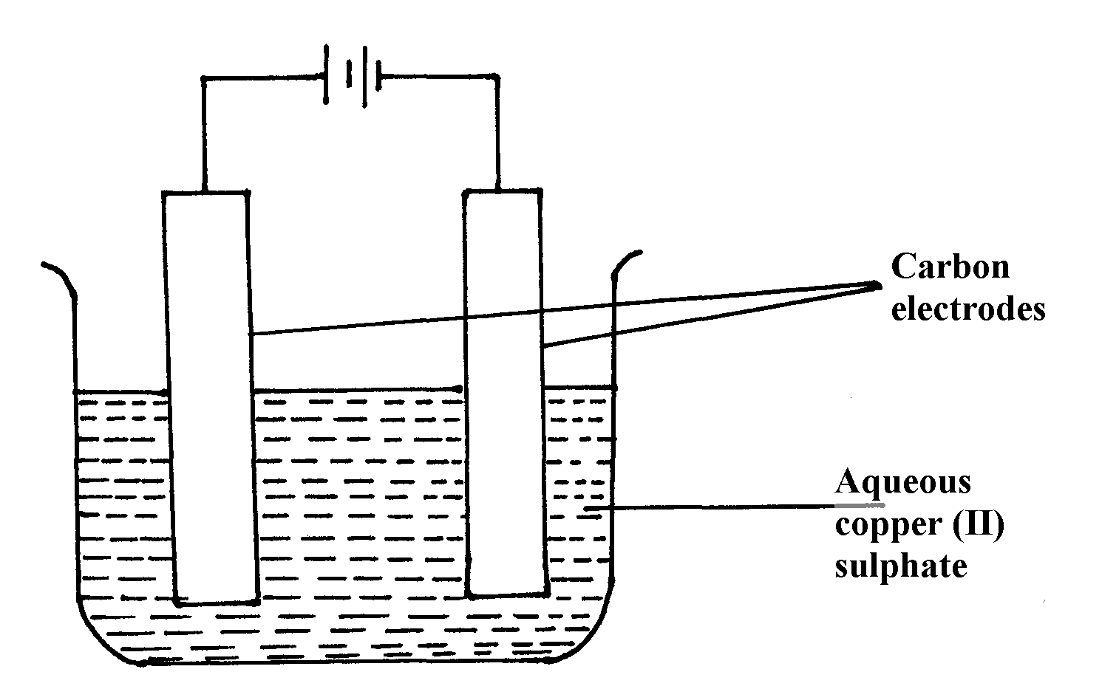

a) State any two observations the student made during the experiment
b) Explain what happens to the pH of the resultant solution at the end of the experiment
39. Copper (II) sulphate solution was electrolysed using copper electrode. A Current of 0.5A was
passed for 64.3 minutes and a mass of 0.64g of copper was deposited. (Cu = 63.5)
a) Which electrode decreased in mass during electrolysis? Explain
Substance | Water | Concentrated sulphuric(VI)acid | Concentrated sodium hydroxide
Ethene | Slightly soluble | Soluble | Insoluble
Ammonia | Very soluble | Very soluble | Very soluble
Hydrogen | Slightly soluble | Insoluble | Insoluble
b) Calculate the quantity of charge needed to deposits 1 mole of copper
40. State and explain what is observed when crystals of iodine are heated gently
41. (a) State Faradays First Law of Electrolysis
(b) Calculate the volume at s.t.p of hydrogen evolved when 2A of electricity are passed
through dilute sulphuric acid for 2hours.
(Molar gas volume at s.t.p = 22.4dm³, one Faraday= 96500coulombs)
42. The following is an equation for the reaction between ammonia and water
NH_{3(g)} + H₂O_{(l)} NH⁺_{4(aq)} + OH⁻(_{aq)}
(a) Name the base in the backward reaction
43. The common ores of Zinc are zinc blende and calamine:-
(i) Give the chemical formula of Zinc blende
(ii) Explain how the pollution caused by large scale extraction of Zinc can be reduced by
having a fertilizer plant close to it
44. The oxides of calcium and phosphorous react as shown below:-
6CaO_{(s)} + P₄O_{10(s)} 2Ca₃(PO₄)_{2(s)}
(i) Give a reason why these substances react and yet both are oxides
(ii) Work out the oxidation state of phosphorous in P₄O₁₀
(iii) State one use of Ca₃(PO₄)₂
45. The standard hydrogen electrode is used as the reference electrode. Some of the difficulties in
using hydrogen gas as an electrode are:
- Hydrogen is a gas at 25ºC
- Hydrogen does not conduct electricity
-The half-cell reaction, 2H⁺_{(aq)} + 2e⁻ H_{2(g)} is slow and takes long to reach equilibrium.
Explain how these difficulties are solved in the standard hydrogen electrode
46. The following are electrode potentials of the half cells
Half cell E^{θ} volts

²⁺
M_{(aq)} /M_{(s)} -0.76
C²⁺_{(aq)} / C_{(s)} – 0.34
(a) Calculate the potential difference of the following cell.
M_{(s)}/M^{2t}_{(aq)} // C^{2t}_{(aq)}/C_{(s)}
47. (a) Name two types of isotopes of phosphorous
(b) Explain why phosphorus is stored in water and not in oil like sodium
48. Use the cell representation below to answer the questions that follow:-
X_{(s)} /X³⁺_{(aq)} //W²⁺_{(aq)} /W_{(s)}
(a) Write the equation for the cell reaction above
(b) If the e.m.f of the cell is 0.30V and E^{θ} value for W²⁺/W is -0.44volts, calculate
the E^{θ} for X³⁺_{(aq)} /X_{(s)}

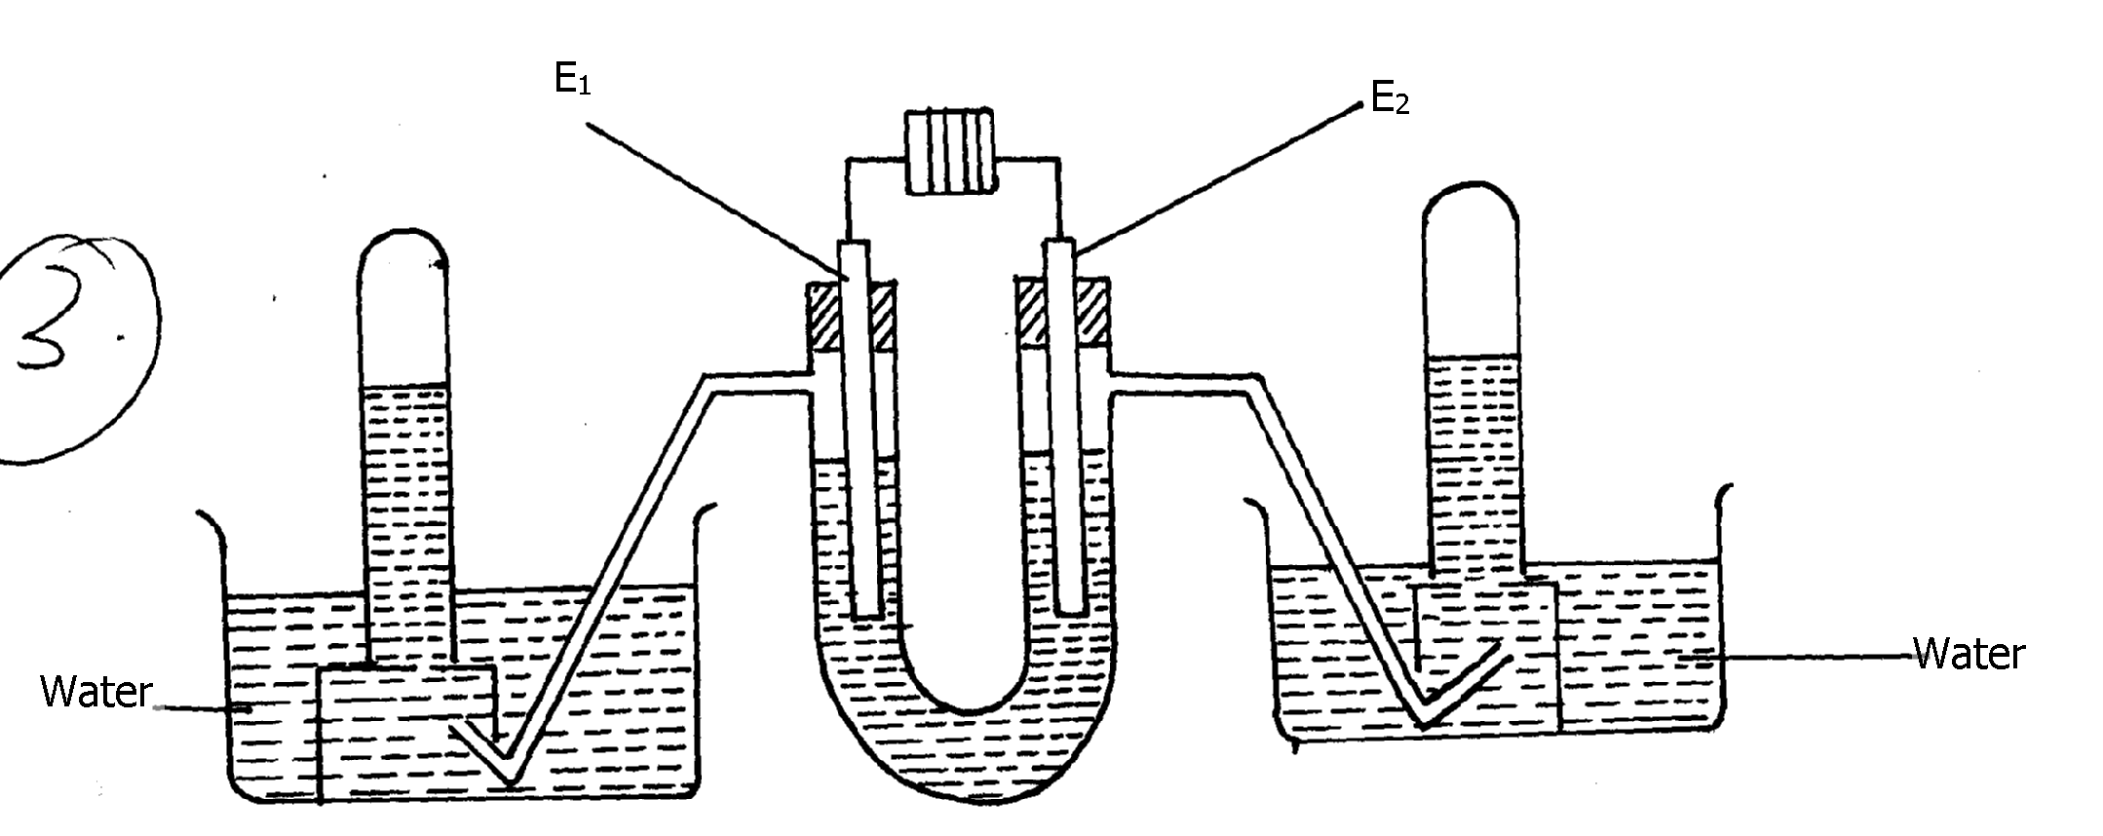
49. The following diagram represents the electrolysis of dilute sodium chloride solution using inert
electrodes

Dilute sodium chloride

Determine the electrode at which different electrolytic products would be produced if the
solution is electrolysed for several hours. Explain

50. Complete the following redox equations by adding the correct number of electrons on either
reactant or product side of the redox equations:-
(a) ClO⁻_{3(aq)} + 6H⁺(aq) Cl_{2(g)} + 3H_{2(l)}
(b) NO⁻_{2(aq)} + H₂O_{(l)} NO⁻_{3(aq)} + 2H⁺_{(aq)}

51. The following are standard reduction potentials;
Half-cell | E^{θ}/Volts | Using iron
Al_{(s)} / Al³⁺_{(aq)} | -1.66
Zn_{(s)} / Zn²⁺_{aq)} | -0.76
Fe_{(s)} / Fe²⁺_{(aq)} | 0.44
Ni_{(s)} / Ni²⁺_{(aq)} | 0.25

Rewrite the E^{θ} values of the above half-cells using iron as a reference electrode

52. Calculate the mass of metal J that would be dissolved at the anode when a solution of J (III)
nitrite is electrolysed using a current of 1.5amperes for 15minutes (1 Faraday = 96,500C; J = 52)

53. Consider the following standard electrode potentials:
Sn²⁺_{(aq)} + 2e- Sn_{(s)} +0.144v
Fe²⁺_{(aq)} + 2e- Fe_{(s)} - 0.44v
Zn²⁺_{(aq)} + 2e- Zn_{(s)} - 0.76v

Some modern cars are made from steel coated with other metals. Using this data above state
and explain the best suited metal for coating steel

