Electrochemistry
1. i) Carbon – carbon/ platinum – carbon
ii) - The concentration of magnesium sulphate increase
- Hydrogen and oxygen given off at the electrodes reduce the water content
2. Cu²⁺ + 2c- __________ Cu_{(s)}
Mass =
1.48 = 63.5 x I x 2.5 x 60
2 x 96500

I = 1.48 x 2 x 96500
63.5 x 2.5 x60
= 29.988 A
3. a) Anode is electrode A (1 mk)
B is cathode
b) 2H⁺ _{(aq)} + 2e- _________ H_{2 (g)}

c) The acid becomes more
4. i) 200 X 58 X 60 C _______________ 64.8g √ ½
9500C ____________________ 27g√ ½

27 X 200 X 58 X 60 √ ½ = +3 √ ½
64.8 X 96500

ii) 40H-_{(g)} __________________2H₂O_{(L)} + O²_{(g)} +4e⁻ √ ½

4 X 96500 ________________ 22.4dm³ √ ½

200 X58 X 60 X 22.4
4 X 96500 C
= 40.39dm³ √ ½
5. a) Mg_{(s)} + Pb²⁺_{(aq)} ________ Mg²⁺ _{(aq)} + Pb_{(s)}

b) 0.13 – (-0.76)
= +0.53V
6. (a) 2F = 10 ⇒ 2F – 10 = 0; 2F = 10 ∴F = +5
1
F = +5 (penalize -5)
1
(b) Group V

7. Aluminium has a higher electrical conductivity than sodium. ^{√1} Aluminium has three
delocalized ^{√½} electrons in its metallic structure while sodium has only one delocalized
electron in its structure. ^{√½}

8. Q = It ^{√½}
= 3 x 50 x 60 ^{√½}
= 9000 C ^{√½}
1 mole of Zn is liberated by a charge of 2 f.
i.e 96500 x 2 x 65g of Zn
9000C ?
= 65 x 9000 ^{√1} = 12.124g Zn ^{√½}
96500 x 2

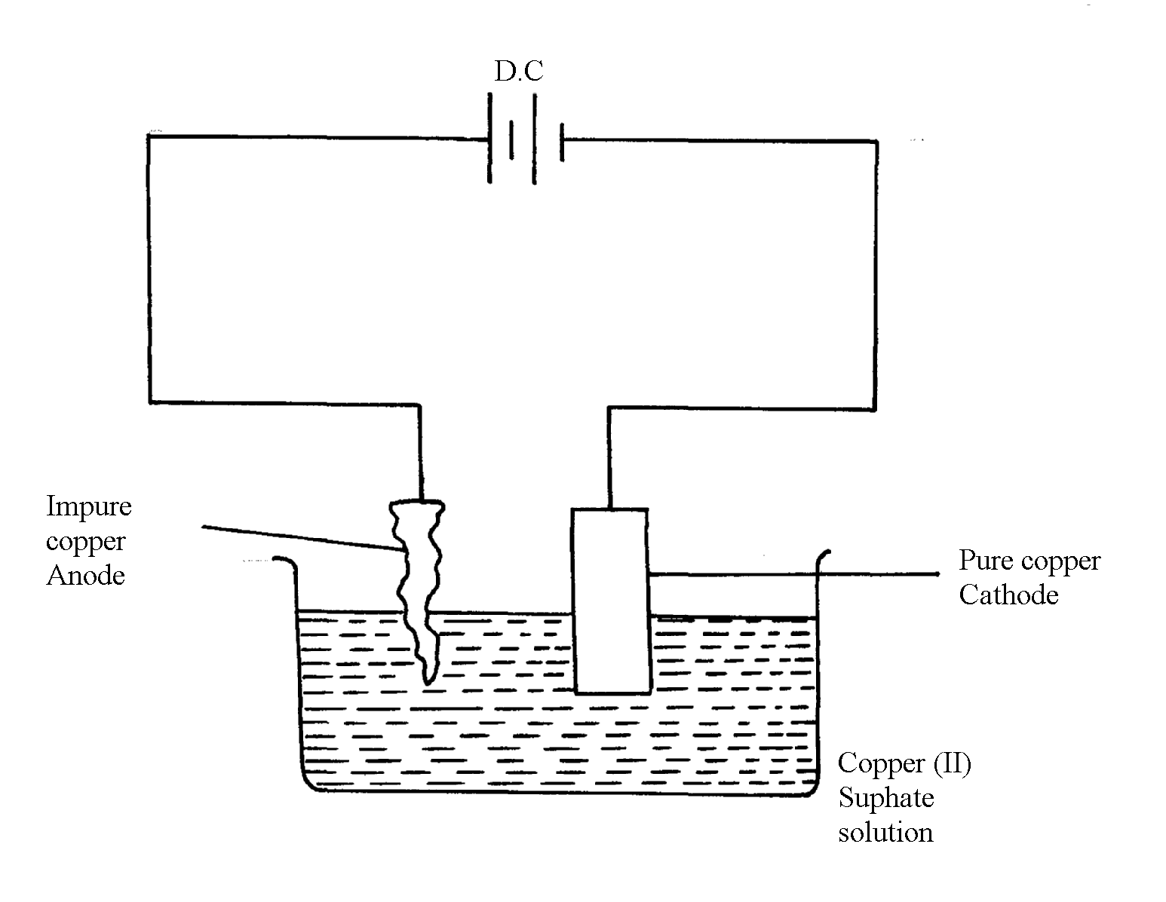
9. a) Q is sulphur (IV) oxide SO₂(g). ^{√1}

b)

- Impure copper is the while pure copper is cathode. During electrolysis impure copper is
purified and pure copper deposited on the cathode as shown in the half electrode reaction below;
CATHODE EQUATION:
Cu²⁺ + 2e Cu(s) ^{√½}
- The cathode is therefore removed and replaced after an interval.

10. a) i) the yield of NH₃ would be lowered √ ½ any supply of heat makes NH₃ to decompose
to N₂ and H₂
ii)the yield of NH₃ would be increased
b)a catalyst accelerate the rates of both forward and reverse reactions equally√ ½ . Equilibrium position is not affected by a catalyst√ ½
c)
N_{2(g)} + 3H_{2(g)}
2NH_{3(g)}
Reaction path
Energy
(KJ)
Catalysed reaction

11. a)T√
b)Z_{S} + 2G⁺ 2G_{(S)} + Z_{(aq)} ²⁺√1
c)E^{θ} cell = E - E
= 0.08 – (-2.38)√1
= + 3.18

12. Mass of due to C = 12 x 4.2 = 1.145√ ½
44
Mass of due to H = 2 X 1.71 = 1.889√ ½
18

Moles of C = 1.145 = 0.095√ ½
12
Moles of H = 0.1889 =0.1889√ ½
1
Moles ratio c: r
0.095: 0.1889√ ½
1: 2
E.F = CH₂√ ½ (accept alternative method)

13. 96,500 coulombs 1 faraday
144,750 ,, ?

144,750 faraday√ ½
96,000
= 1.5 faradays√ ½

Copper (II) ions = 2 faradays (penalize ½ mk for missing/wrong units)
2 faradays yield = 64g of copper
1.5 faradays yield = ?
= 1.5 x 64g√ ½
2
=48g of copper was obtained√ ½

14. Physical difference:-
Na₂O₂ – yellow while Na₂O is white
Chemical difference:-
 1
N₂O₂ reacts with water to form NaOH and O₂ while
 1
Na₂O reacts with water to form NaOH only

15. (a) Pb(NO₃)₂
(b)

(c) Mg_{(s)} / Mg²⁺ _{(aq)} // Pb²⁺ _{(aq)} / Pb_{(s)}

16. (a) MnO₄ is reduced;
Oxidation number of Mn is reduced from +7 to +2
(b)5Fe²⁺_{(g)} 5Fe³⁺_{(aq)} + 5e₋;

17. i) 2 Cr_{(S)} ____________ 2Cr³⁺_{(aq)} +6e

3Fe²⁺ _{(aq)} + 6e ____________ 3Fe_{(g)}

2Cr_{(g)} + 3Fe²⁺_{(aq)} _________ 2 Cr³⁺_{(aq)} +3 Fe _{(g)} √

ii) 0.30 = - 0.44 - E^{ǿ}_{R}
E^{ǿ}_{R} = - 0.44 – 0.30
= - 0.74V √

18. (a) – Filtration of air/electrostatic precipitation/purification
 ½
- Passing through sodium hydroxide/potassium hydroxide to absorb Carbon (IV) oxide gas
- Cool to remove water vapour as ice
 ½
-Cool remaining air to liquid by repeated compression and expansion of liquid air
 1
 1
- Fractional distillation of liquid air- Nitrogen collected at -196ºC
(b) (i) Nitrogen (II) Oxide
-3
+2
0
0
Reduction
Oxidation
(ii)
NH_{3(g)} + CuO_{(s)} N_{2(g)} + H₂O_{(l)} + Cu_{(s)}

OR - Oxidation number of N₂ in NH₃ increases from -3 to 0. Oxidation number of reducing
agent increases or oxidation number of Cu in CuO decreases from +2 to 0 hence is a reducing agent

(iii) NH₄NO₃ N₂O + 2H₂O
(iv) Fertilizer/expose
(c) (i) G or G
(ii) E²⁺_{(aq)} + 2OH⁻_{(aq)} E(OH)_{2(s)}

19. a) i) G// G_{2(g)} Not G⁻
It has the highest potential OR highest reduction potential √ 1 mark
ii) G and N or G_{2(g)} // N_{(g)} √ 1 mark
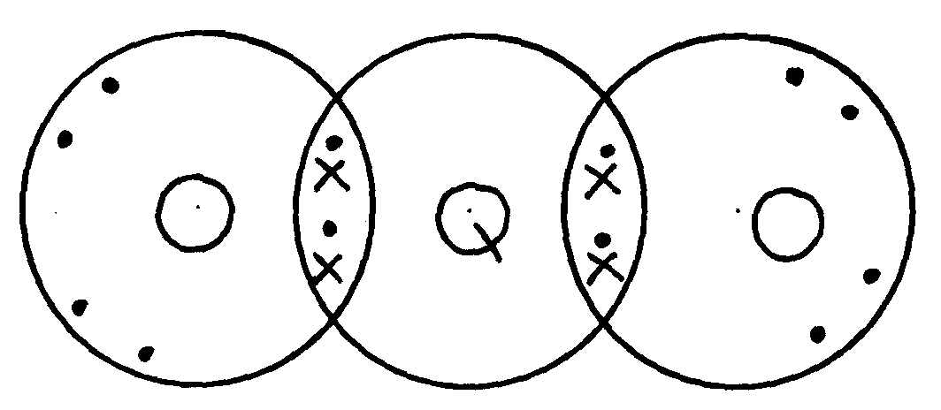
iii)

20. a) (i) Cathode – steel
Anode – Carbon / graphite
(ii) To lower the melting P⁺ hence reducing cost of heating the salt.
(iii) To prevent the two products from recombining.
(iv) Cathode
Na⁺_{(l)} + e⁻ Na_{(l)}
Anode
2 Cl⁻_{(l)} Cl 2_{(g)} + 2 e-
(v) less dense than electrolyte/ has low density
b) (i) quantity = 6.42 X 10 60 = 3852
(ii) 3852c province 2.74
2X 96000 “ (2 X 96000) X 2.74
3852
= 136.58

21. .a) i) H⁺_{(aq)} + e⁻ ½ H₂

ii) E cell = 0.76 + 0.54 = +1.3 volts

iii) I. Fe³⁺
II. Zn
IV. Fe³⁺ ion
2 Fe³⁺ + 2 e⁻ 2 Fe²⁺ E⁰ = + 0.77
2 I I_{2g} + 2e E⁰ = - 0.54
_{(aq)}
_{(aq)}
_{(aq)}
2 Fe³⁺ + 2I⁻ 2Fe²⁺ + I ₂ E⁰ = + 0.23

22. a) i) Chlorine Has a higher reduction potential
ii) +1.36 2.36 = +3.72

b) i) P and S
ii)
iii) +1.50 – 0.44 + + 1.94

c) Q = 4 X a6 X 60 = 3840C
1.17g ________ 3840
59 g _________ 59 X 3840 = 192981.261 C
1.174
If 96,500c ___________ IF
192891.261 _____ 192981.261 X 1
96500
Charge of X = +2
Formula X(NO₃)₂

23. (a) B – Copper metal
C – Chlorine gas
D – Ammmonia gas
E – Zinc
(b) (i) Cu²⁺_{(aq)} + 2e⁻ Cu_{(s)}
(ii) CuSO₄ + Zn_{(s)} ZNSO₄ + Cu_{(s)}
Cu²⁺ + Zn_{(s)} Cu_{(s)} + Zn²⁺_{(aq)}

(c) – Water treatment
-Manufacture of hydrochloric acid
(d) Tetra mine copper (II) ions

24. (a) (i) E^{θ} = 1.13V

(ii) T₂ because it’s standard electrode potential is zero. i.e. point of reference.
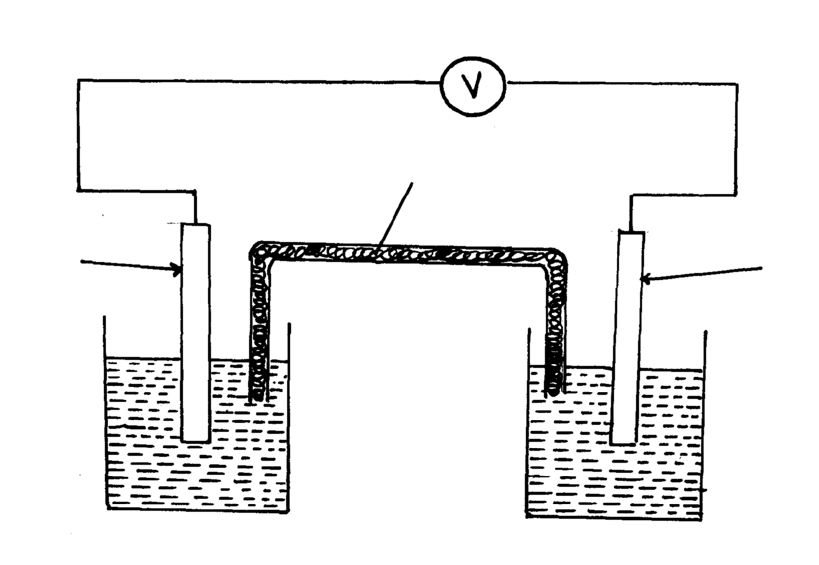

(iv) E.m.f = + 1.23 - - 0.76 = 1.99 V

(b) (i) x - Oxygen
y – Hydrogen

(ii) 4OH⁻_{(aq)} 2H₂O + O₂ + 4e

(iii) Reduction takes place at electrode Y. H⁺ ions gain electrons to form hydrogen gas.

(iv) Platinium / graphite/ Nickel because it is inert.

25. (i) Zn²⁺_{(aq)} + 2OH⁻_{(aq)} Zn(OH)_{2(s)}
Zn(OH)_{2(s)} + 4NH_{3(aq)} Zn(NH₃)4 ²⁺_{(aq)} + 2OH⁻_{(aq)}
(ii) The mixture consists of a soluble compound and an insoluble compound.
(iii) Evolution brown fumes of NO₂ gas
(iv) CO₃²⁻ - Because its reaction with HNO₃ produces CO₂ gas or 2H⁺_{(aq)} + CO₃2-_{(aq)} H₂O_{(l)} +CO_{2(g)}
(v) Pb²⁺ ion
(vi) Lead (ii) Carbonate
Zinc (II) Nitrate
26 A (i) Process by which an electrolyte is decomposed by passing an electric current through it.
(ii) Anode – left pt rod
Cathode – right pt rod
(iii) – Blue /pale green colour fades
- P solution becomes acidic

B (i) a. – D²⁺
b. – D²⁺
(ii) C
E _{cell} = E_{ordn} – E_{ordn}
= +0.34 –(-2.92) = +3.26V
(iii) B_{(s)} / B²⁺_{(aq)} // D²⁺_{(aq)} / D(_{s)}; E = + 3.26V

27 Q = 40000 x 60 x 60 = 144000000c
 1
Mass of Al = 144000000 x 27
3 x 96500
= 13.43kg
 1
28. a) Strip of copper metal dissolved forming blue solution. ^{√½}
b) Copper displaces ions ^{√½} of Q from solution since copper is more electropositive ^{√½} than Q.
c) E.m.f of cell = (0.80 - 0.34)V ^{√½}
= 0.46V ^{√½}

29 (a) (i) Carbon (IV) Oxide gas evolved was lost to the atmosphere
(ii) Concentration of reactants higher between O and R
Reaction rate faster
(iii) Grinding the marble chips
(iv) Calcium sulphate
(v) Plaster of Paris

(b) (i) Hydrogen ions discharged;
It takes less energy than calcium ions
(ii) 2Cl⁻_{(aq)} Cl₂ _{(g)} + 2e
(iii) Q = 1t = 4 x 1 60 x 60 ( ½ mk)
= 14400C
2 x 96500C = 2 x 35.5 (½mk)
14400C = 14400 x 2 x 35.5
2 x 95600
= 5.297g (½mk)

30. a) the bulb light√ ½
Hydrogen chloride gas ionized in water to give H⁺ and cl⁻(aq) that are responsible for
conduction of electric current√1
b)2H⁺(aq) +ze⁻ H₂(g)√1

31. Q = it IF = 69500C 2F ______ 206g of Pb
= 40x(5x60) = 1200x1 F = 0.01243 x 206
= 1200 C 96500 2F
= 0.01245 F = 1.280g
b) I K_{(s)} ________ K²⁺ _{(aq)} + 2e⁻

Na+ 2e ________ N_{(g)}

II 1. Salt bridge

2. Complete the circuit
Balance the ions in each half cell
III
IV E cell = E Red – E oxd
= +1.16 – (-0.17) = +1.33V
32. (a) (i) Zinc sulphate / Zinc chloride / Zinc nitrate solution
(ii) Copper
(iii) Zn_{(s)} + Cu²⁺_{(aq)} Zn²⁺_{(aq)} + Cu_{(s)}
(iv) E = 0.34 + 0.76
= 1.0V

. (b) (i)Concentrated sodium chloride solution
(ii) 2 Cl⁻(aq) Cl_{2(g)} + 2e
Na⁺(aq) + e N_{(l)}
(iii) Sodium amalgam is flown into water. It reacts forming sodium hydroxide solution

33. Quantity of electricity = (40,000 X 60 X 60) Coulumbus √ ½ mark
3 x 96,500 Coulumbus produce 27g of Al

჻ 40,000 X 60 X 60 X 27 Kg √ ½ mark
3 X 96,500 X 1000 √ ½ mark
= 13.43Kg √ ½ mark
Subtract ½ mark if units missing or wrong
[Total 12 marks]
34. i) Increased yield of NO/ √ 1 mark Equilibrium shifts to the right // favours the
forward reaction// reduced pressure favours forward reaction// increased volume
number of molecules
ii) It will not affect the yield // remains the same
Catalyst do not affect position of Equilibrium
35. a) R
b) T
c) i) T_{(g)} and S_{(g)}

ii) Half cell one Half cell two
T(s) – 2e-____ T2+ S2+(aq) + 2e _____ S(s)
OR: T(s) ____ T2+_{(aq)} + 2e-

iii) T_{(s)} _______ T²⁺ _{(aq)} + 2e, E = +0.74V

iv) From T(s)/ T2+ half cell to S2+/ S(s) half cell through conducting wires

d) i) Q = It
= 2.5 x (15x60)
= 2250C

ii) RAM = mass x valency x 96500
Q
= 0.74 x 2 x 96500
2250
= ¹⁴²⁸²⁰/₂₂₅₀
₌ 63.476
36. a) R
b) T
c) i) T_{(g)} and S_{(g)}

ii) Half cell one Half cell two
T(s) – 2e-____ T2+ S2+(aq) + 2e _____ S(s)
OR: T(s) ____ T2+(aq) + 2e-

iii) T_{(s)} _______ T²⁺ (aq) + 2e, E = +0.74V

iv) From T(s)/ T2+ half cell to S2+/ S(s) half cell through conducting wires

d) i) Q = It
= 2.5 x (15x60)
= 2250C

ii) RAM = mass x valency x 96500
Q
= 0.74 x 2 x 96500
220
= ¹⁴²⁸²⁰/₂₂₅₀
₌ 63.476
37. NH⁺₄√ 1, proton donor√
38. a) - Bubbles of colourless gas at the anode√ ½
- Brown deposits at the cathode √ ½
- Blue color of the solution fades Any 2 ½ mark each

b) The Ph decreases
Removal of OH⁻ ions leaves an excess of H⁺ hence the solution becomes more acidic√
39. a) Anode. Copper anode dissolves
b) Q = 0.5 X 60 X64.3 = 1929C
0.64g of Cu _______ 1929 C
჻ 63.5 of Cu
63.5 X 1929√ ½
0.64
= 191393 C √ ½

40. The grey-black solid changes to purple gas iodine sublimes at low temperature due to
weak Van der walls forces

41. (a) The mass of substance liberated during electrolysis is directly proportional to the quantity
of electricity passed
(b) Quantity of electricity = 2 x 2 x 36000 = 14400c (½mk)
Volume of gas evolved = 14400 x 22.4 = 1.671dm³
2 x 96500 (1 ½ mk)
42. (a) OH⁻ √1 (1 mk)

43. (i) ZnS- No mark if the letters are joined
(ii) SO₂ produced as a by-product is used in contact process to obtain H₂SO₄. This acid is used in making fertilizers e.g. ammonium sulphate
1

44. (i) CaO is basic and P₄O₁₀ is acidic
(ii) Let the ON of P be x
4x + (-2 x10) = 0
4x = +20
4 4
 ½
x = +5
1
(iii) Used as a fertilizer
1

45. Platinum electrode is used, H₂ is bubbled over the pt electrode immersed in 1M H+ i.e 1M HCl.
 1
The electrode is coated with finely –divided platinum catalyst

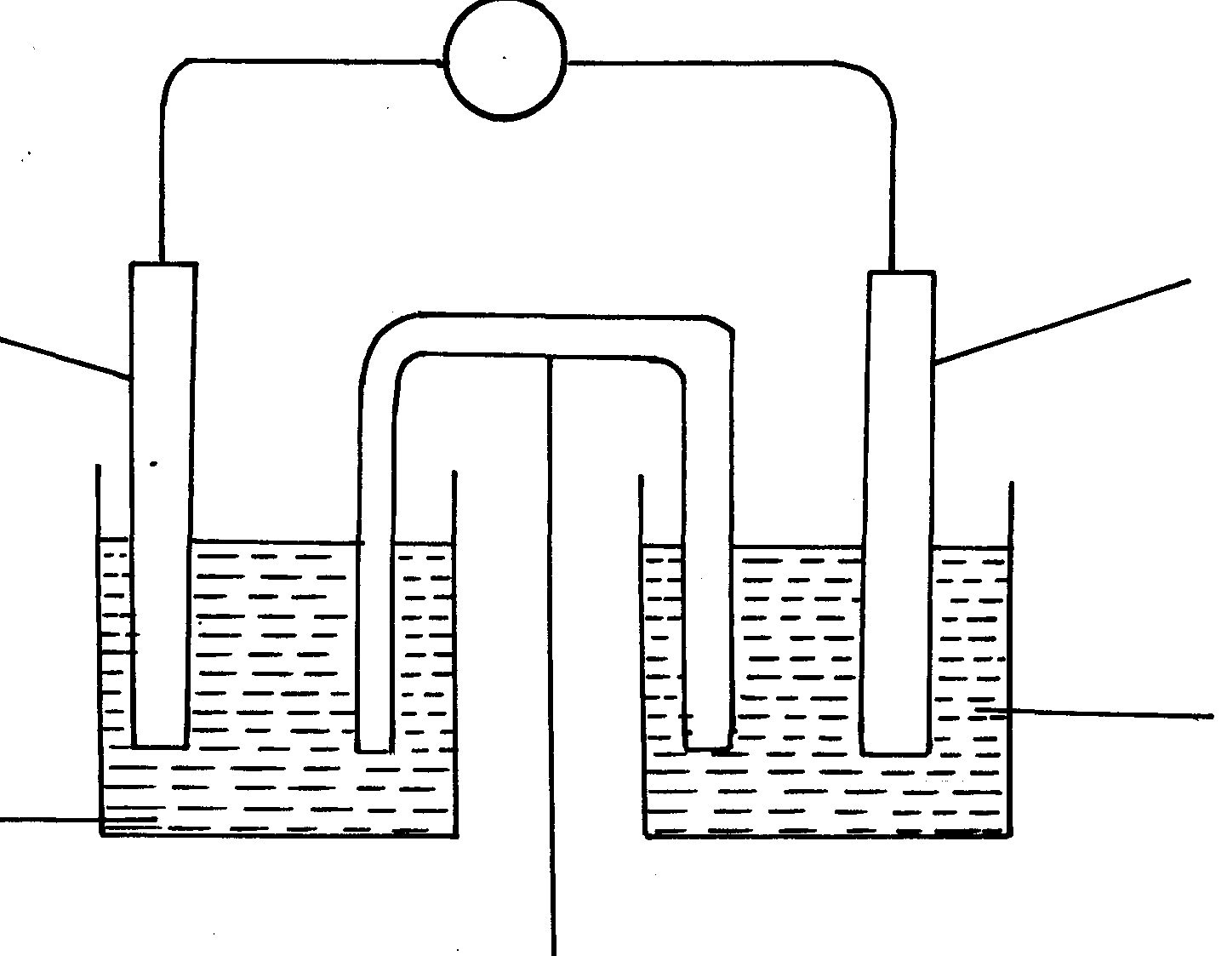
(b)electrochemical cell
V
(½mk)
C_{(s)}
M_{(s)}
(½mk)

C² _{(aq)}
(½mk)
M²⁺_{(aq)}
(½mk)
46. + 0.76 + 0.34 = 1.0Volts
47. (a) - Red- Phosphorous
- White – Phosphorous
(b) Phosphorous is insoluble in water because its non-polar while water is polar.
It cannot be stored in oil because oil is non-polar it will dissolve the phosphorous.

48. (a) 2X_{(s)} + 3W(aq) 2X³⁺_{(aq)} + 3W_{(s)}

(b) E^{θ}(X/X³⁺_{(aq)} + - 0.44 = 0.3V

E^{θ}(X_{(s)} /X³⁺_{(aq)} = +0.74V
H H H H H H H H

H – C – C – C – C – C – C – C – C - H

H H H H H H H H
E^{θ}(X³⁺_{(aq})/X_{(s)} = -0.74V

 ½
 ½

Salt bridge

49. Electrode - E₁ is the anode
Dilute electrolyte – OH⁻ ions are discharged.
4 OH⁻_{(aq)} 2H₂ O_{(e)} + O_{2(g)} + 4e⁻
Oxygen gas is produced.
Discharge of hydroxyl ion increases the concentration of sodium chloride.
Chloride, Cl⁻ are then discharged.
Chloride, Cl-, are then discharged
Chloride gas is produce
2Cl⁻_{(aq)} Cl_{2(g)} + 2e⁻

50. a) C10₃⁻ (=) Cl + 3(-2) = -1(=)Cl -6 =-1,Cl= + 5

⁺⁵
⁰
C10₃⁻ _{(aq)} 6H⁺_{(aq)}+5e⁻ Cl_{2(g)}+ 3H₂O_{(l)}

b) NO⁻₂ (=) N+2 (-2) = -1(=) N-4 = -1 (=) = N+ 3
⁺³
⁺⁵

NO⁻₂ +H₂O_{(l)} NO⁻_{3(aq)}+2H⁺_{(aq)} + 2e⁻

51.
Half Cell E^{θ}/_{V} | E^{θ}/_{V} using iron ref - electrode
Al_{(s)} /Al³⁺_{(aq)} - 1.66 | - 1.22
Zw_{(s)} / Zn²⁺_{(aq)} - 0.76 | +0.32
Fe _{(s)}/Fe ²⁺_{(aq)} - 0.44 | 0.00
Ni_{(s)} /Ni ²⁺_{(aq}) - 0.25 | + 0.19

52. θ = 1.5 X 60 X 15 = 1350
J³⁺_{(aq)} + 3e⁻ J_{(s)}
3F = 3 X 96500 = 289 500C
289500C deposit = 52g of J_{(s)}
= 1350 C deposit = 1350 X 52
289500 = 0.2 2425g

53. Tin (Sn) its oxidation potential is +0.144V. It is the least likely to combine/ react with elements
of weather

