Effect of an electric current on substances
1. The set-up was used to electrolyse Lead (II) bromide. Study it and answer the questions
that follow;

Cathode
Anode
Molten Lead (II) briomide
Bulb
Carbon electrode

(a) Write an ionic equation for the reaction that occurred at the cathode
(b) State and explain what happened at the anode
2. When an electric current was passed through two molten substances E and F in separate
voltammeters. The observations recorded below were made:-
Substance | Observation | Type of structure
E | Conducts electric current and a gas is formed at one of the electrodes
F | Conducts an electric current and is not decomposed
Complete the table above
3. (a) Differentiate the following terms :-
Electrolyte and non-electrolyte
(b) The diagram below is a set-up used to investigate the conductivity of electric current
by some aqueous solution. Study it and answer the questions that follow;
Bulb
Graphite rods
Substance to be tested
Beaker

(i) State the observation made on the bulb when each of the following solution were put
onto the beaker
(a) Sugar solution
(b) (i) Salt solution
(ii) Classify the substance in (i) above as either electrolyte or non-electrolyte
(b) If in the above set-up of apparatus, the substance to be tested is Lead II Bromide,
what modification should be included in the set-up?
(c) Write an Ionic equation at the electrodes and state the observation:-
Anode

4. (a) The diagram below shows the set up used to investigate the effect of an electric current
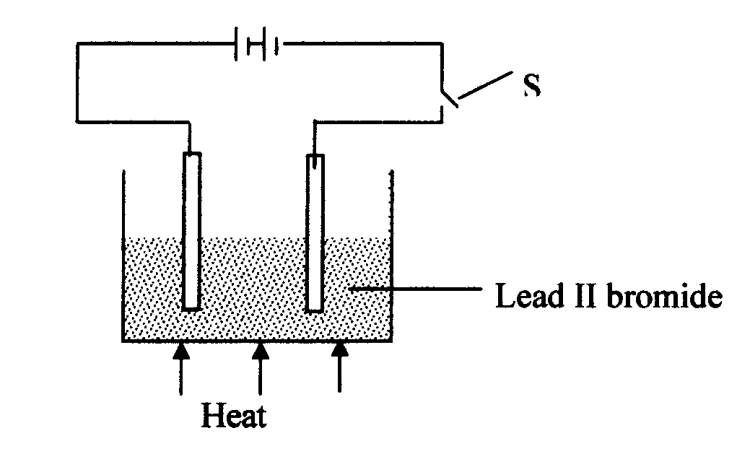
on molten lead (II) bromide

i. Explain what happens to the lead II bromide during electrolysis
ii. Why is it important to carry out the experiment in a fume chamber?
5. (I) Define the following terms:
(a) Crystallization
(b) (i) Salting out as used in soap making
(ii) Starting with barium carbonate solid, dilute sulphuric acid and dilute nitric acid,
describe how you would prepare dry barium sulphate solid

(iii) Study the scheme below and answer the questions which follow:
Colourless gas which relights glowing splint
Heat
T
Solid S
Water
Burn on nichrome wire
Lilac flame
Colourless solution

(a) Identify ;
(i) The cation present in solid S
(ii) The anion in solid S
(b) Write an equation to show how solid S is heated in process T
(iv) Copper II chloride solution dissolves in excess ammonia solution to form a deep blue
solution. Give the ion responsible for the deep blue solution
(v) A solution of hydrogen chloride is an electrolyte but a solution of hydrogen chloride in
methylbenzene in a non-electrolyte. Explain
6. (i) State Faraday’s first law of electrolysis
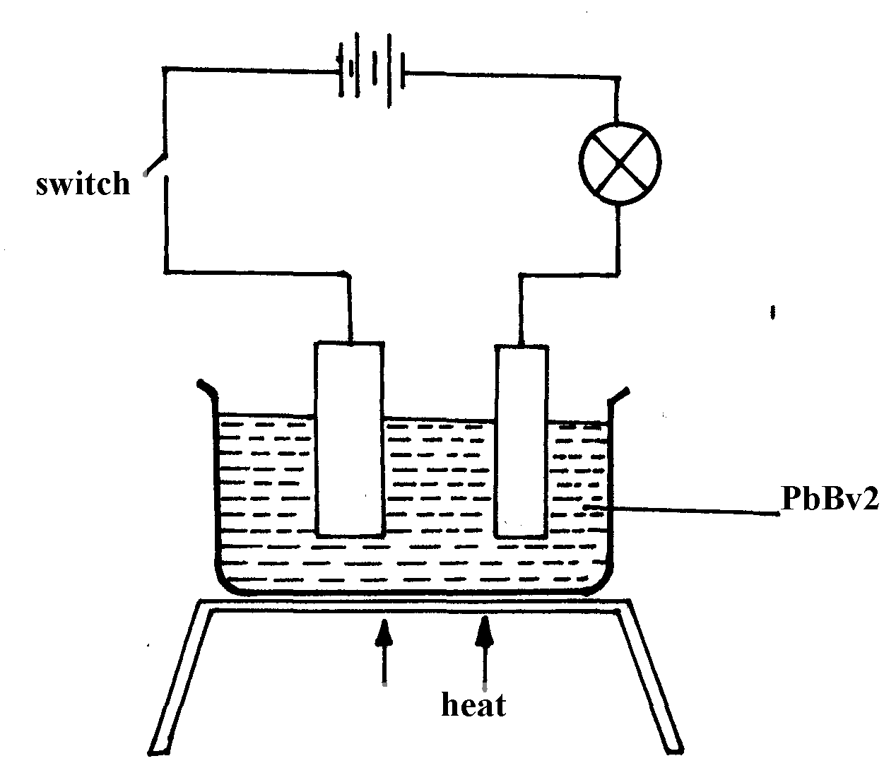
(ii) The diagram below shows a set-up used for the electrolysis of molten Lead bromide:-
Switch

PbBV₂

Heat

State the observations that would be made at the anode and cathode as the electrolysis progressed
7. (a) (i) Describe how you would prepare pure crystals of lead II nitrate in the laboratory from
lead II oxide
(ii) Write an equation for the reaction that takes place in (a)(i) above
(b) (i) State what happens when lead II nitrate is strongly heated
(ii) Write an equation for the reaction in b(i) above
(c) (i) State what is observed when ammonia solution is gradually added to a solution of
lead II nitrate until the alkali is in excess
(ii) Write an ionic equation for the reaction that takes place in (i) above
8. The diagram show an experiment for investigating electrical conduction in lead (II) fluoride. Study it and answer the questions that follow:
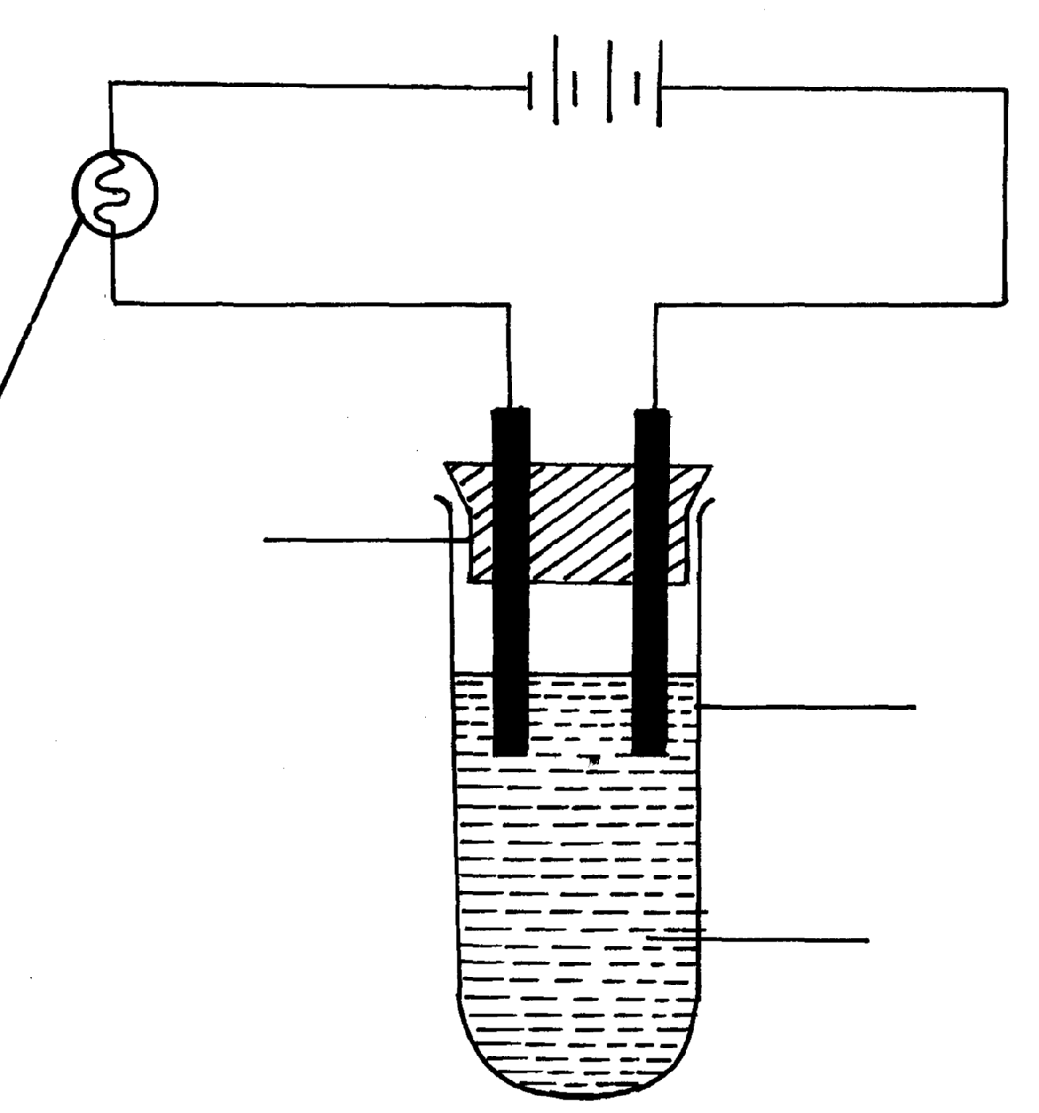
Bulb
Boiling tube
Gas
Flow of electrons

Lead (II) fluoride
(a) On the diagram
(i) Label the anode and the cathode
(ii) Show the direction of movement of electrons
(iii) Complete the diagram by indicating the condition that is missing but must be present for
electrical conduction to take place.
(b) Why is it necessary to leave a gap between the cork and the boiling tube?
(c) State the observations that are expected at the electrodes during electrical conduction and
at the experiment
(d) Write equations for the reactions that take place at the electrodes
(e) Why should this experiment be carried out in a fume chamber?
II. The table below shows the electrical conductivity of substance A, B and C
Substance | Solid state | Molten state | Aqueous solution
A | Conducts | Conducts | Not soluble
B | Doesn’t conduct | Conducts | Conducts
C | Doesn’t conduct | Doesn’t conduct | Not soluble

(a) Which one of the substance is likely to be plastic?
(b) Explain why the substance you have given in (a) above behaves in the way it does
(c) Which of the substances is likely to be sodium chloride? Explain
(d) Give the type of structure and bonding that is present in substance A

9. Study the diagram below and use it to answer the questions that follow:-
Lead (II) bromide
A
B
Heat

(a) Identify electrodes A and B
(b) Name the product formed at the anode
(c) Write the electrode half equation of reaction at electrode A
10. Explain the differences in electrical conductivity between melted sodium chloride and
liquid mercury

11. Below is part of a flow diagram for the contact process:
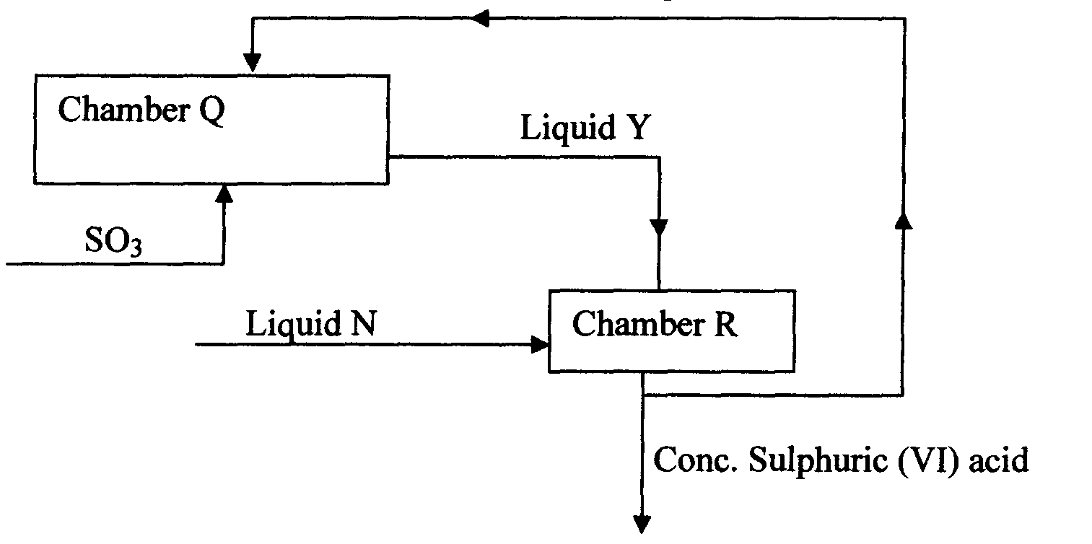

(a) Name :
I. Liquid Y ……………………………………………………….
II. Liquid N………………………………………………………….
(b) Write the equation for the reaction taking place in;
I. Chamber Q
II. Chamber R

12. In an experiment to investigate the conductivity of substances, a student used the set-up shown
below.
The student noted that the bulb did not light.
a) What had been omitted in the set up.
b) Explain why the bulb lights when the omission is corrected.

