Term 2 - 2022
DRAWING AND DESIGN (449/1)
FORM FOUR (4)
Time: 2½ Hours
Marking Scheme
Section A (50 marks)
Answer all questions in this section

1. (a) (3 marks)
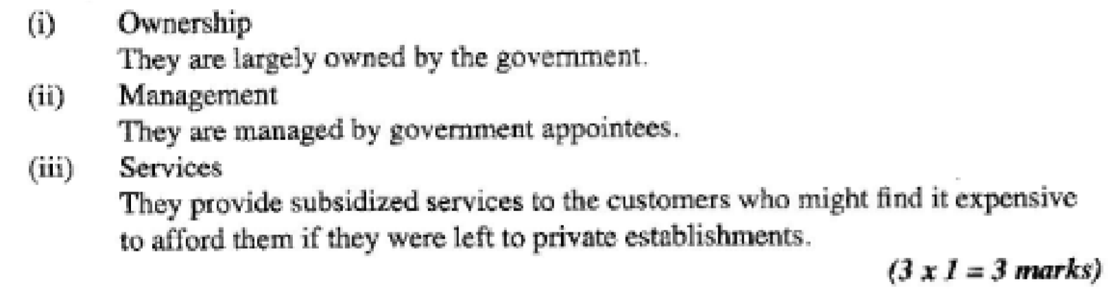

2. ( a )

(b)

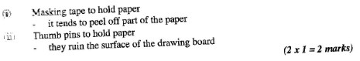
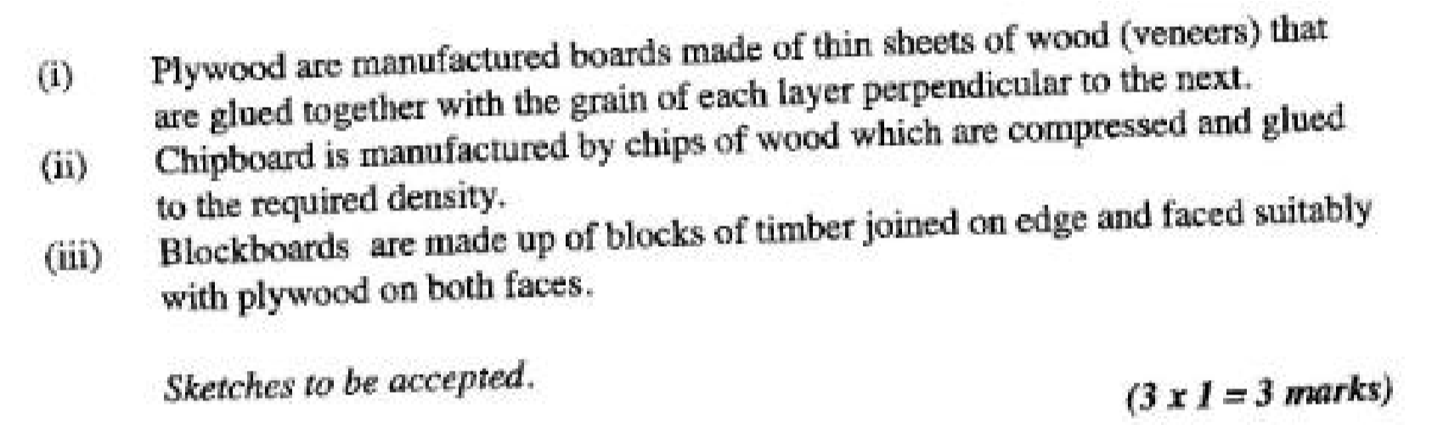
3. (a). (3 marks)
- Use of the item to be fabricated or manufactured
- Availability of the material
- Durability of the material
- Cost of the material
- Weather conditions like internal or external
- Ease in the use of materials or workability
(b). Explain the meaning of the term “alloy” as applied in materials and give two examples ( 2marks)
Alloy is a metal made from two or more metals example bronze, brass, and aluminum

4. State the importance of following steps in the design process. (3 marks)
- Evaluation: Testing to see if it has satisfied the need and if not to find out where or why it has failed
- Final drawing: used to manufacture the real object by the craftsman.
- Mock-up: use to test or find out whether or not the design is satisfactory. Imperfections not seen when drawing may show up in mock-up.

5. Construct an ellipse using the rectangle method whose sides are 80mm
by 45 mm. (5 marks)
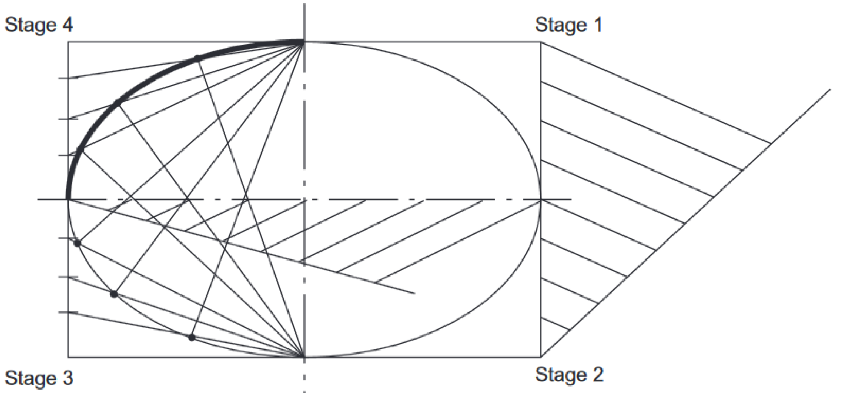

6. Construct a regular octagon inside a square whose sides are 80mm. ( 5 marks)
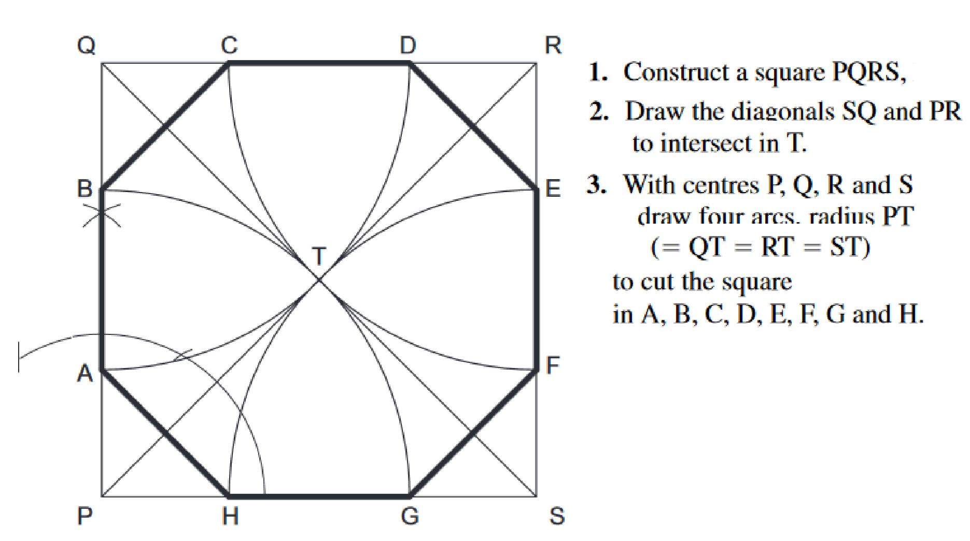

7. Two views of a machine component are shown below in Figure 1. Sketch the block in oblique taking X-X as the lowest point (6 Marks)
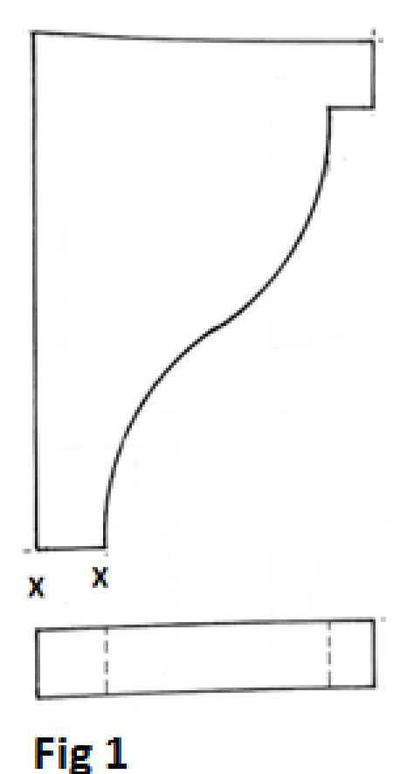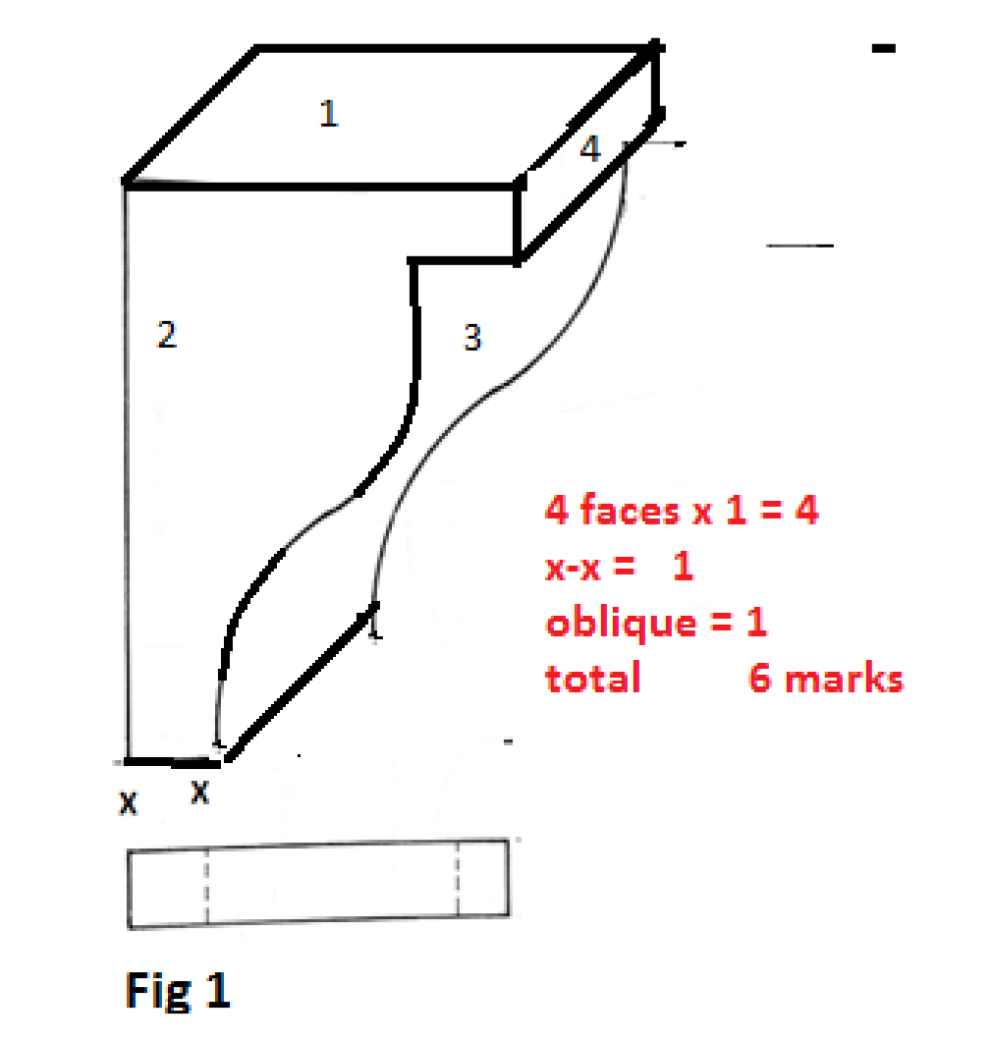
8. Draw an isometric circle whose diameter is 60mm using ordinate method. (4 marks)
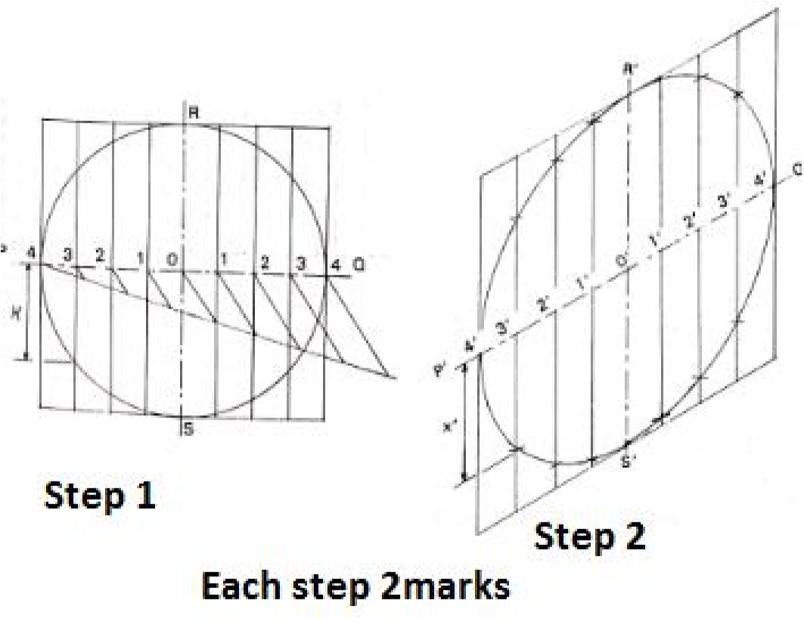

9. Front elevation of a pentagonal pyramid truncated by the cutting plane X_X is given in figure 2.
Sketch the auxiliary view and a plan. (7 marks )
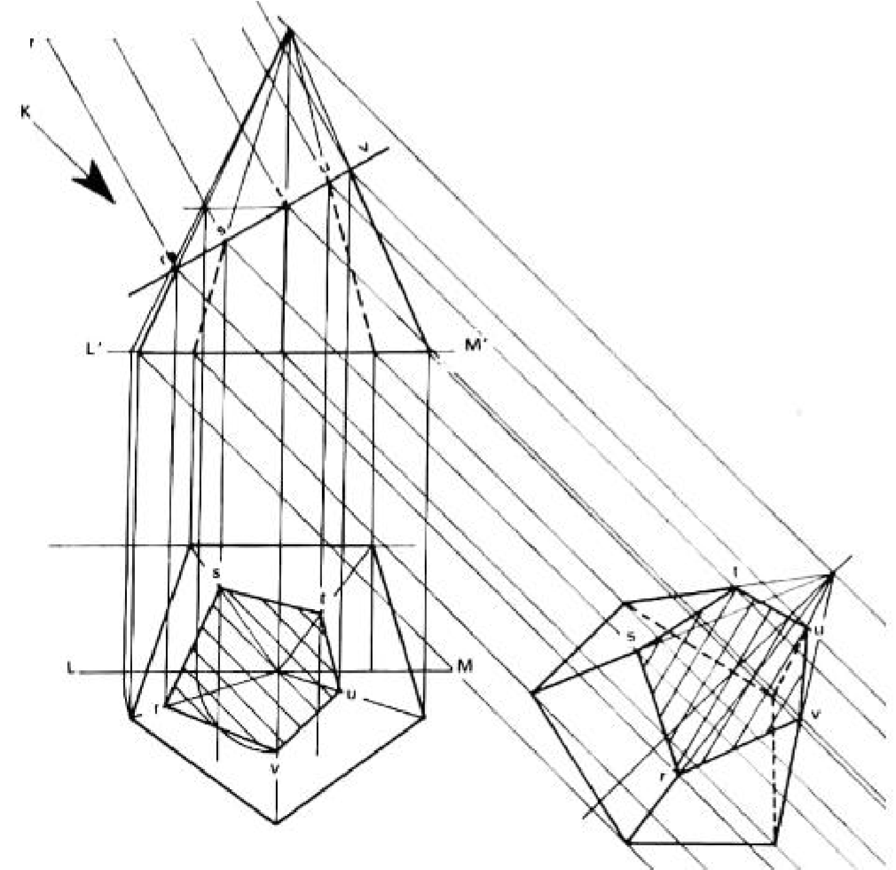

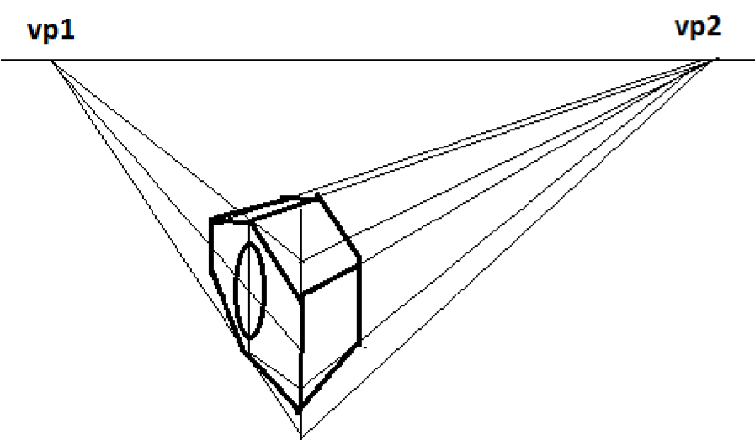
10. Two views of a machine part are shown in figure 3. Sketch a two point perspective of the block. (7 marks ) Section B (20 Marks)
This is a compulsory question.
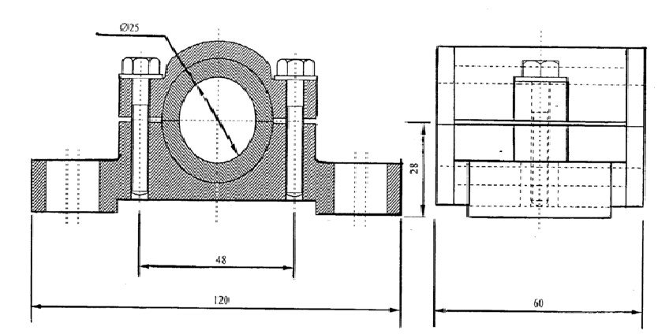
Students are advised not to spend more than 1 hour answering this question 11.
Section C (30 Marks)
Answer any two questions from this section 12.
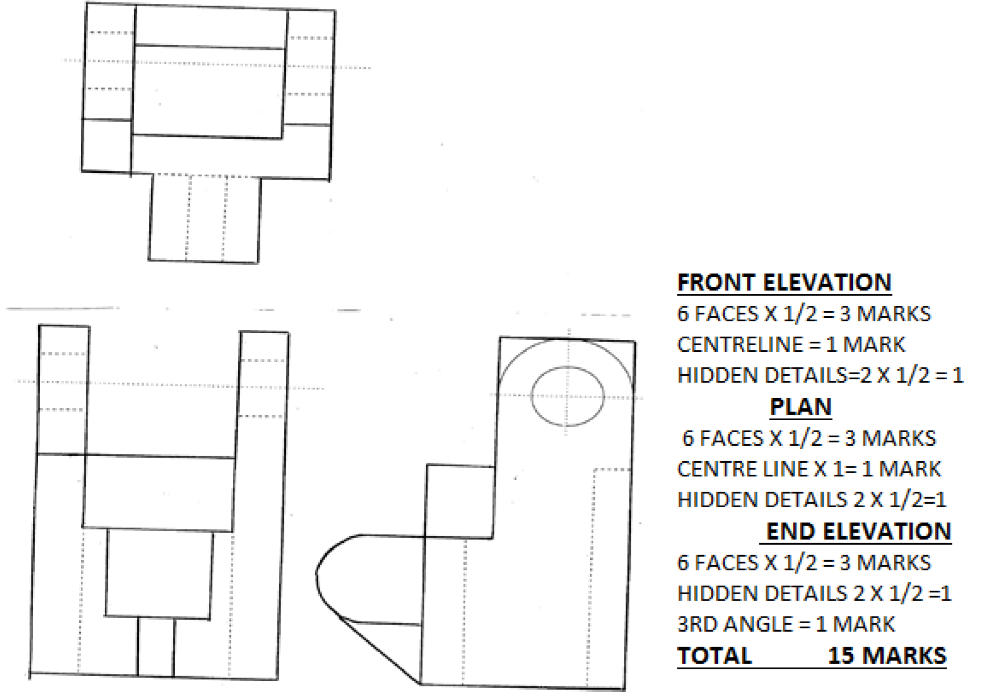
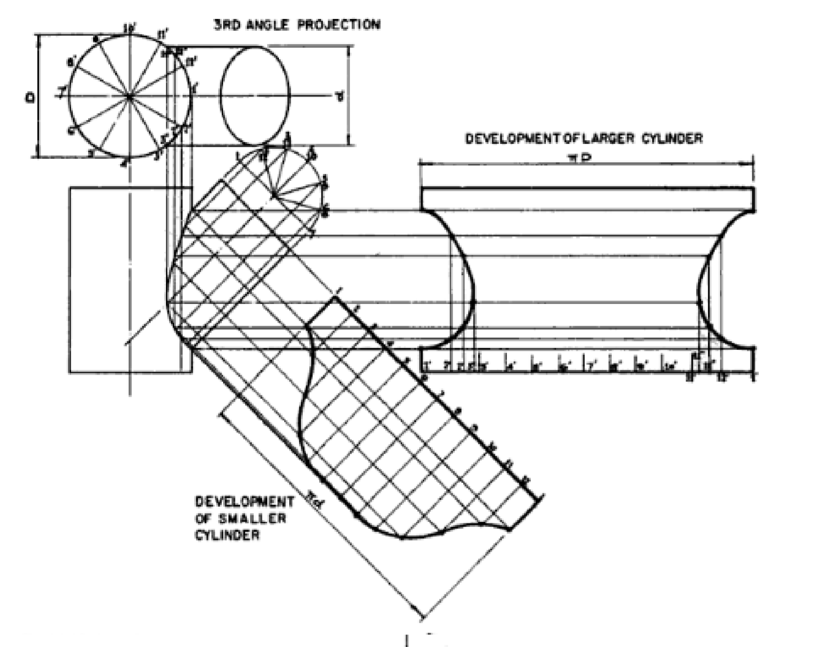
13.
14. (a) Define the term involute. ( 2 marks)
- Draw an involute to a circle of with a diameter of 30mm. (8 marks)
- Draw a tangent to any point T on the involute. (5 marks)
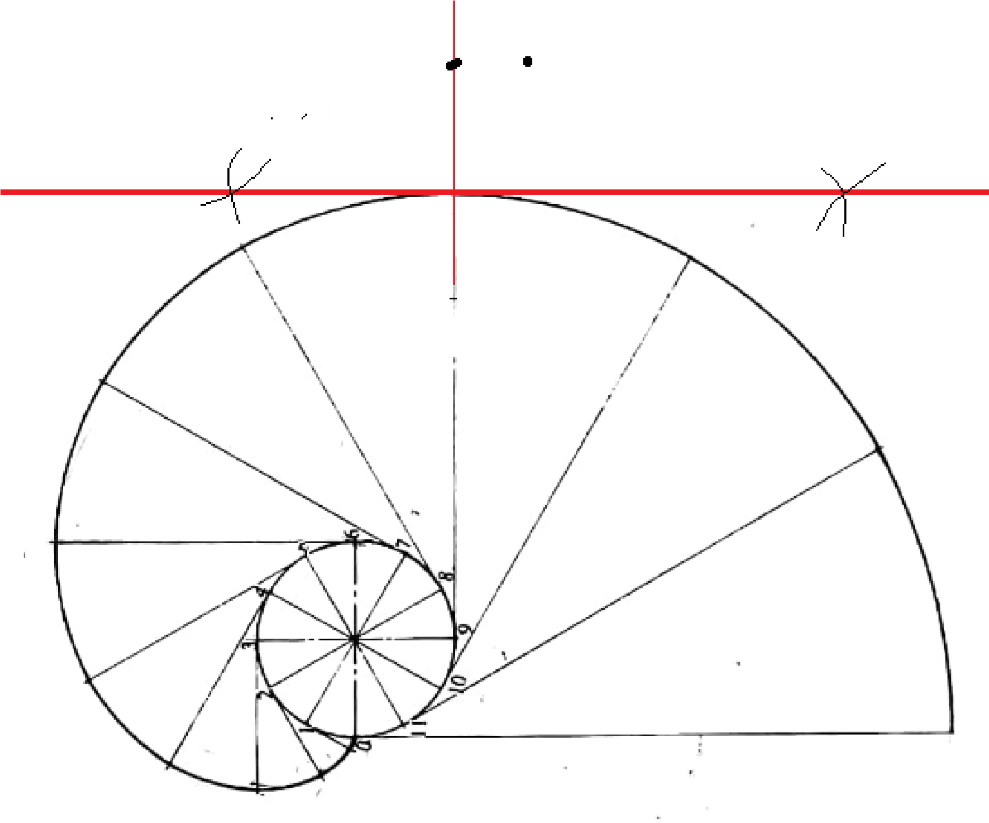
Involute: Is a curve that is obtained by attaching a string which is imaginary and then winding and unwinding it tautly on the curve given

