- Commercial arithmetic
1 | - 48, 000 – 20, 000  = 28, 000  = Ksh. 350, 000  Sales 350, 000 + 100, 000 = 450, 000  - (i) Sales in February  (ii)  Commission |  |  |  |  | M₁  M₁  M₁  A₁  M₁  M₁  A₁  M₁  M₁  A₁ |  | ✓exp
2 | Total expense  (a)  In Ksh.  (b)  = 37.81%  (c)  (d) |  |  |  |  | M1  M1  A1  M1  A1  M1  A1  M1  M1  A1 |  | ✓exp  ✓attempt to simplify
3 | A = 3P  3 = (1.2)n |  |  |  |  | M1  M1  A1
 |  |  |  |  |  | 3
4. | 100 Yens = 63.16 (Bank sold Yen)  36632.8 Yen =  = 23137.27648  = ksh 23137. |  |  |  |  | M1  A1
 |  |  |  |  |  | 02
5. | No of good eggs = 24 x 30 – 54  = 666  Total cost = 24 x 225  = shs 5400  Cost with profit of 22% expected =  = 6588  New price per egg =  = 9.892  = sh 10.00 |  |  |  |  | M1  M1  M1  A1
 |  |  |  |  |  | 04
6. |  |  |  |  |  | M1  A1  M1  A1
 |  |  |  |  |  | 04
7 | ½ of 2400E = 1200E  In ksh. = 1200E x 95.65  = Ksh.114,780  Number of dollar = Kshs.114,780  76.50  = sh1500.39 |  |  |  |  | M1  M1  A1
 |  |  |  |  |  | 3
8 |  | SECTION B (50 MARKS)  Selling price = 88/100 of marked price  (a)  - 4800 = 88/100 of m.p  4800/88 x 100 = m.p  = sh.5454.54  - 145/100 of buying price = 4800  buying price = 48000 x 100  145  = 3310.34  (b) 5454.54 – 3310.34 x 100  3310.34  = 0.6477 x 100  = 64.77%  - 87.5 of 3310.34  100  = 2,896.55
10 |  |  | 5% | M₁  M₁  A₁  3
11 |  |  | 200s + 600t = 22 000  250s + 510t = 22 700  1000s + 3000t = 110 000  1000s + 2040t = 90800  960t = 19 200  t = 20  s = 40  (0.5 × 200 × 20) + (0.3 × 510 × 40)  2500 + 6120 = 8620  +  20007200  %  19% | B1  M1  A1  B1  M1  M1  A1  M1  M1  M1 |  |  | For both  Elim  For shorts  For trousers
12. |  |  | (a) Cost of tonne of rice is US $ 500  Shipping cost of rice = 20/100 x US$ 500 = US$ 100  Transport to Nairobi = 5/100 x US$ 500 = US$ 25  Custom duty = 10/100 x US$500 = US$ 500 = US$ 50  Total cost in dollars = 500 + 100 + 50 + 25 = US$ 675  Converting this to ksh = 76.60 x 675 = ksh 51705  (b) To make profit of 20% he must sell rice at 120% of the cost price per tonne  Selling price of a tonne of rice = 120/100 x sh 51705  = ksh 62046  1 tonne has 1000kg, selling price of 1kg of rice = 62.046  = sh 62.00  (c) Total collection = sh 62046 in US dollars this becomes  = = US$ 793.4271  Actual profit = US$ 793.4271 – 675 = 118.4271  Actual percentage = 118.4271/625 x 100  = 17.545% | B1  B1  B1  A1  B1  B1  B1  B1  B1  A1
 |  |  |  | 10
15. Total exp = 600000 + 100000 M1
= Sh. 700000
Profit = 108000 – 700000
% profit = 380000 x 100
60000
63¹/₃ % A1

3

16. (a) Swiss Franc = ⁵²/_{1.28} M1
= 40.625 A1

(b) Kenya shillings = 40.625 x 45.21
= 1837 B1

3
17. | Let the rates be x% and y% respectively  x x 50000 = 2250  100  y x 45000 = 2250  100  ∴x = 4.5%  y = 5% | M1  M1  A1
 |  | 03
18. | Sitienei – x  Lagat – 1.1x  Rotich – 1.155x  Diff = 1.155x – 1.1x = 0.55x = 110,000  X = 2,000,000  Rotic paid 1.155 x 200,000 = 231000 | M1  M1  A1
 |  | 03
19. | 5000 x 84.15  = sh. 420750  420750 – 289850  = sh. 130900  Amount = 130900 x 100  65.45  = 200,000 Japanese Yen | M1  M1  A1
 |  | 03
B(0,2)
2 units
C
O
A(-3,0)
? 3 units
20  a.)  b.) | A = 1200000 (1 – ⁸/₁₀₀)²  1200000 (0.92)²  = 1,051,680  1015680 (1-¹²/₁₀₀)⁴  1015680 (0.88)⁴  = 609098.58  ¹²⁵/₁₀₀ x 609098.58  = 761373.23  761373.23 = 1200000(1- r/₁₀₀)⁷²  (1/ ^{r}/₁₀₀)⁷² = 0.6344776  ⁷²/₇₂ log (1- r/₁₀₀) = ^{-0.1975836}/₇₂  Log(1- ^{r}/₁₀₀) = ⁻ 0.0027442173  1-^{r}/₁₀₀ = 0.9937011  ^{r}/₁₀₀ = 0.0062988  r = 0.62988 % p.m. | M1  M1  M1  A1  M1  A1  M1  M1  M1  A1  10 | Follow thro’ if A1 is missing  A1 if A above is lost.

21. | 50x + 25y = 200  2x + y = 8…….(i) | M1  M1  M1  A1 | ✓eqn (i)  ✓ eqn (ii)  ✓ solving  ✓ both
 |  | 04
22. | Yen = 1000 x 105 x 105 + 1260  100 = 111510 Yen  Ksh = 111510 x 63  105 = Ksh. 66906 | M1  A1  B1
 |  | 03
23 | R.P 240.50 – 22.90  = Sh 217.60  % profit = | M1  M1  A1
 |  | 3
24 | When x = 5 and y = 8 | B1  B1  B1
 |  | 3
25 |  | M1  M1  A1
 |  | 3

26. 2x - 3y + 6 =0
-3y = -2x – 6
y = 2x + 2
3
When y = 0 x = -3
x = 0 y = 2
∴ Co-ordinate of y – intercept is (0,2)
” ” x – intercept is (-3,0)
∴ ∠ CAO = tan⁻¹ 2
3
= 33.69º
∴∠θ = 180 – 33.69º
= 146.31º

27. Point y (4 + -2, 7 + -1) = (1, 3)
2 2
grad AB = 7 + 1 = 8
4 + 2 6
grad xy = - ¾
grad xy = - ¾
y – 3 = - ¾
x – 2
y = - ¾ x + ¹⁵/₄

28. Y = 3x – 1
M =3
M₁m₂ = -1
M₂ = -¹/₃
y – 3 = -¹/₃
x -2
3y – 9 =-x +2
3y = -x + 11
3 3 3
Y = ^{x}/₃ + ¹¹/₃

29. Pt T is 1 + 5, 4 + 10 = (-2, 7)
2 2
grad. of grid xy = 10- 4 = 14 = -7
-5 -1 -6 3
∴grad of L₂ = 3
7
Take a general pt P(x,y) on L₂
⇒ y - 7 = 3
x - 2 7
⇒ 7y – 49 = 3x + 6
7y = 3x + 55
Equation of L₂
Or y = 3x + 55

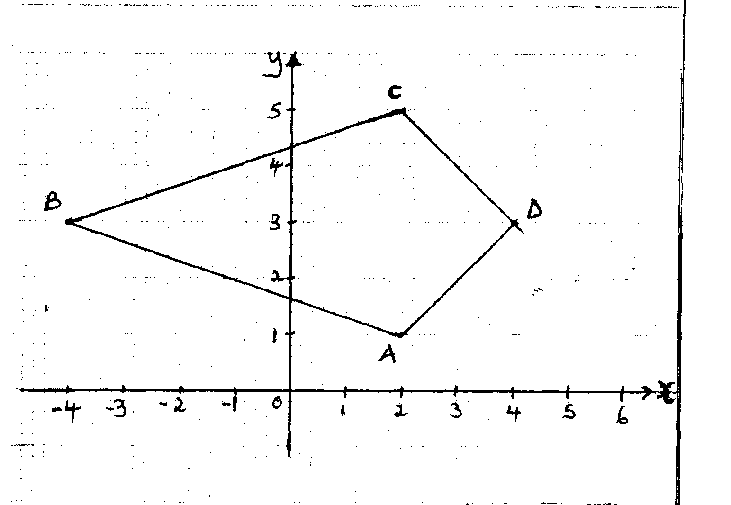
30. a, b

(c) Name : a kite

31. (a) Grad of line QP = 4-2 = 2 = -1
1-3 -2
Grad of line QR = 1
Take a pt Q(1,4) and T(x,y) on line QR
y- 4 = 1
x – 1
y – 4 = x -1
y = x + 3 .....equ. of QR

(b) y= x+3 …(i) Equ of QR
y = 3x -7 ...(ii) Equ. of Pr
Solving simultaneously ;:
x +3 = 3x -7
2x = 10
x = 5
Substituting ; y = 8
∴R is the pt (5,8)
~
~
5
8
1
4
4
4
3
2
4
4
7
6
(c) PS = QR = - =

OS = + =
~

S is the point (7,6)

32. a) Gradient OA = Gradient of CB
-1 – 0 = - ½
2 – 0
Gradient of CB
y – 3 = - ½
0 – 4
2y – 6 = 4
2y = 10
y = 5

b) i) AN = ON – OA = ½ OM – OA
OM = OA + ½ AB = (2) + ½ (2)
= 3
AN = ½ 3 - 2 = ½ - ¹/₃
= ½ 1 -1

ii) NC = OC – ON
= 0 - ³/₂ = -³/₂
5 ½ ½

iii) AC = OC – OA = 0 - 2 = 2 -1
5 -1 3

c) AN = ½ - 1
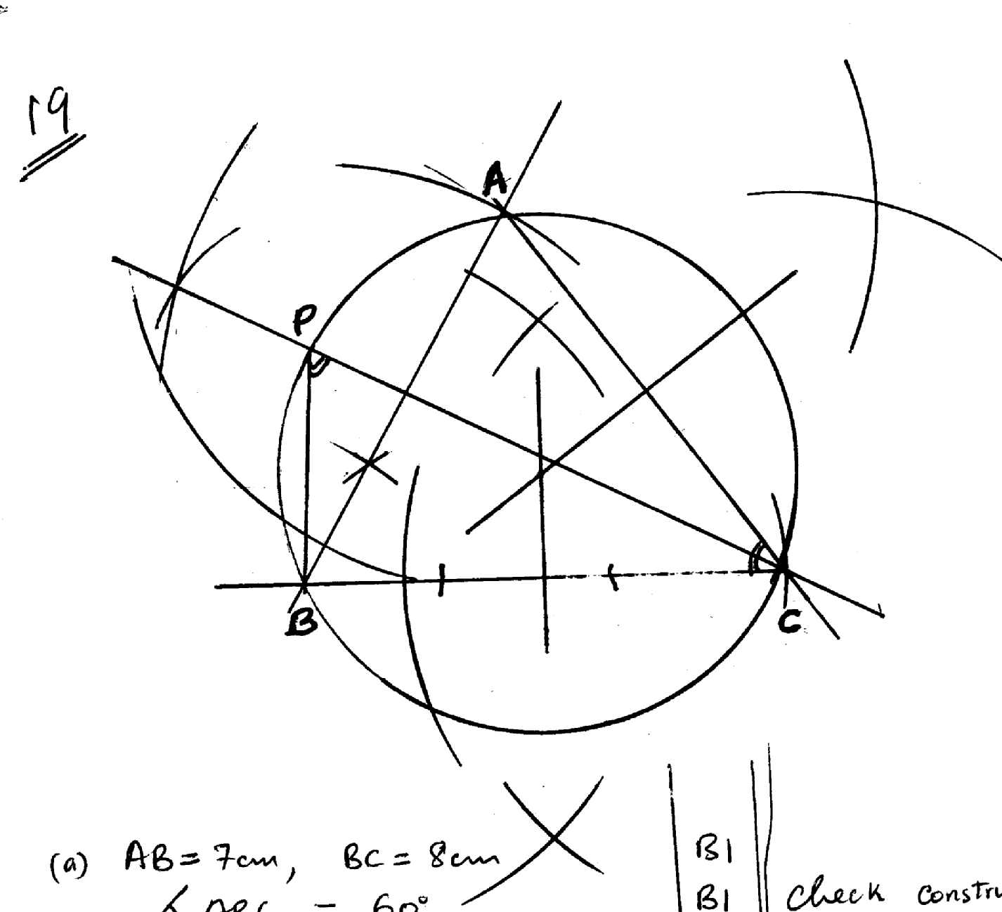
3

NC = ³/₂ -¹/₃

4AN = AC And A is a common point hence A, N, C lie on a straight line.

33. a) ∆ ABC line AB = 7 cm and BC = 8 cm.
Construction of ∡60º

(b) AC = 7.6 + 0.1 and
∡ ACB = 53 + 1º

(c) 2 sides bisector 1
Circle drawn radius 4.4. ± 0.1

(d) Bisect ∡ ACB
Bisection line to cut the circle to identify P
∡ PBC measure ≡

(a) AB = 7 cm, BC = 8 cm
∡ ABC = 60º
-
(b) AC = 7.6 + 0.1 cm
∡ ABC = 53º±0.1

(c) Perpendicular bisectors of any two sides.
Circle drawn
Radius = 4.4.±0.1. cm

(d) ∡ ACB bisected
Bisection line drawn to cut circle at P
∡BPC = ∡BAC = 67º
∡ PBC = 88 ± 0.1º

34.
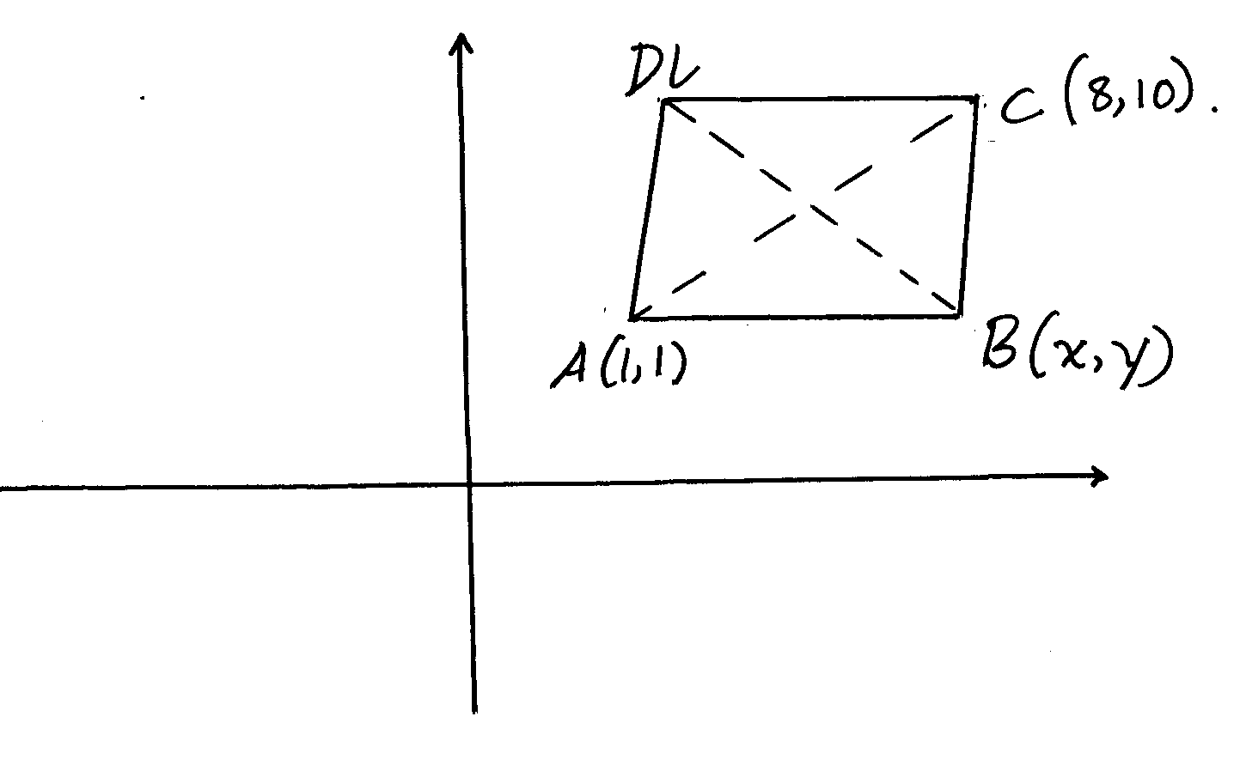
M (1+8, 1+10) = M (4.5, 5.5)
2 2

b) AB: 4x – 5y = -1 x 2
BC: 5x – 2y = 20 x 5
8x – 10y = -2
25x – 10y = 100
-17x = -102
x= ¹⁰²/₁₇ = 6.0
24 – 5y = -1
5y = -25
Y = 5
∴ B(6,5)

x+ 6.0 = 4.5 x = 3
2
y + 5 = 5.5 y = 6
2
∴ D (3,6)

c) AB = √ (16 – 1)² + (5-1)²
√25 + 16
√41 = 6.40 (units)
35. Mid ordinate
Area = 1.2 (6.2 + 4.3 + 2.6)
= 15.72

