FORM 4 END TERM 2 2024 EXAMINATION

CHEMISTRY PAPER TWO MARKING SCHEME

1. Environmental effect

Amount of heat produced

Cost

Availability

Ease of storage

Any two (2mks)

1. (i) 3mks

H=MCT 450cm3 x 4.2jg-1 K-1 x(46.50C-250C)

40635 = 40.635kJ

1000

(ii) 2mks

Molar mass CH3CH 2OH = 46g√½

Mass of ethanol =125.5g-124.0g =1.5g

Moles of CH3 CH2 OH = 1.5g √½ =0.0326moles

46

40.635√ 1 = -12446.4724kJmole-1 1mk (-ve sign)

0.0326

1. 1mk

CH3 CH2 OH(l) + 3 Oa (g) 2CO2(g) + 3H 2O(I) H =-1246.4724kJmol-  1 mk

1. 2 m

Heat loss to the surrounding by radiation, conduction, convection.

Heat absorbed by reaction vessels.

Experimental errors when reading thermometer

Any two (2mks)

1. 1mk

The heat change that occurs when one mole of a substance is completely burnt in oxygen 1mk

**2.** a) Noble gases - **reject rare/inert gases 1 mk**

b) K and W accept Lithium and Potassium 2mks

c) Q√1, has the least number of protons hence experiences weakest nuclear force of attraction.√1mk

d) L3M2√1mk

e) i) Making electric cables: √ 1/2mk it is a good conductor of electricity,/it is ductile/forms unreactive oxide. 1/2 mk

ii) Making cooking pans/sufurias√1/2mk : It is malleable √1mk: good conductor of heat. 1/2 mk

f) R2O3

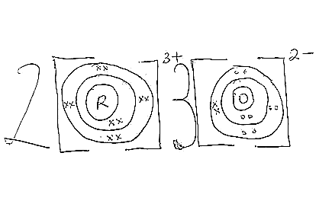(2mks)

g) Oxide of L has a giant ionic structure with strong ionic bonds√½ while the oxide of N has a simple molecular structure with weak van der Waals forces.√½

h) 2W (s) + 2H2O (l) 2WOH (aq) + H2 (l) √ ½

Moles of W =1.95/39

= 0.05 moles√ ½

Moles of H2= 0.05/2

= 0.025 moles√ ½

Volume of H2= 0.025x 24000

= 600cm3√ ½

3a) (i) Strong reducing agent →E √1mk

(ii) Ecell = 0.44- 0.34 = + 0.10V √ 1mk

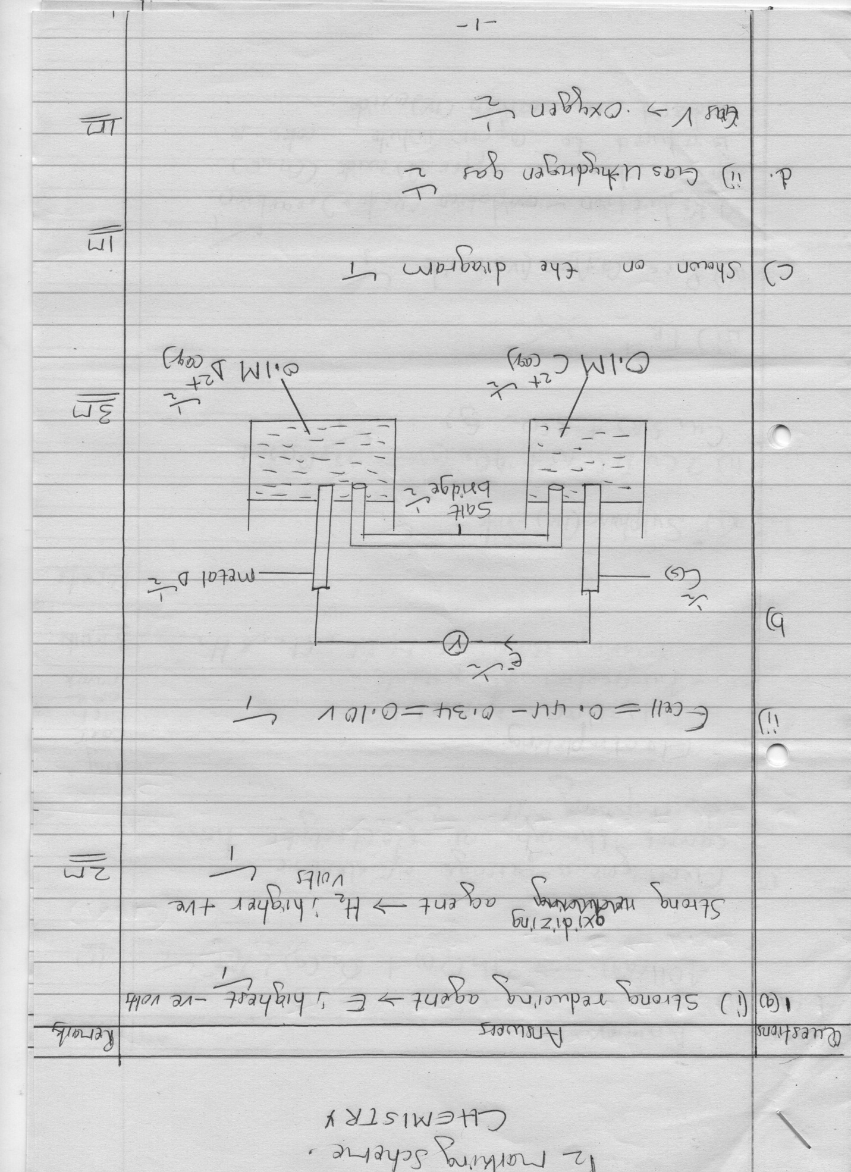

1. i) Shown on the diagram 1

(ii) Gas U → hydrogen gas √1 mk

Gas V → oxygen gas √1 mk

(iii) 4OH-(aq) → 2H2O (l) + O2 (g) + 4e- √1 mk

1. Electrolysis is passage of electric current through an electrolyte hence decomposing it √1 mk 1

* Electroplating
* Extraction of reactive metals
* Purification of metals
* Manufacture of NaOH, Cl2, and H2

Any two (2mks)

4. (a) (i) Ore P-Copper pyrites

Gas L – Sulphur (IV) oxide

Slag M- Iron (II) silicate

(3 mks)

(b) (i) Through froth floatation, it is mixed with water, oil and air and then stirred.√1mk

(ii) To increase surface area. .√1mk

(c ) To facilitate removal of iron (II) oxide impurity. .√1mk

FeO (s) + Si O2 (s)  FeSiO3 (s)

(d) Anode – Impure copper √½

Cathode – Strips of pure copper √½

(e) Sulphur (IV) oxide produced cause acid rain/is poisonous

Dust produced pollutes the air

Smoke from the machines pollute the air

Noise from machine cause air pollution

Open holes left cause gulley erosion/cause land degradation

One correct for √ 1mk

(f) Making electrical wires.

Making soldering instruments.

Making alloys e.g brass (Cu, Zn) bronze (Cu + Tin)

Making coins

Any two (2 mks)

(g) Q = 1t

= 100 x 20 x 24 x 60 x 60

= 172, 800, 000C √ ½

2 x 96500C deposit = 64g of Cu

172,800,000C ?

172,800,000 x 64 √ ½ = 57301.5544g √ ½

193,000

Mass in kg = 57301.5544 = 57.3kg of copper √ ½

1,000

5. a)

Plotting-- 10 correctly plotted points 1 mk

9 correct points √½

Scale-- occupies more than half on both axis(√½ on each axis)

Curve—must be smooth (penalize fully if a straight line joined using a ruler)

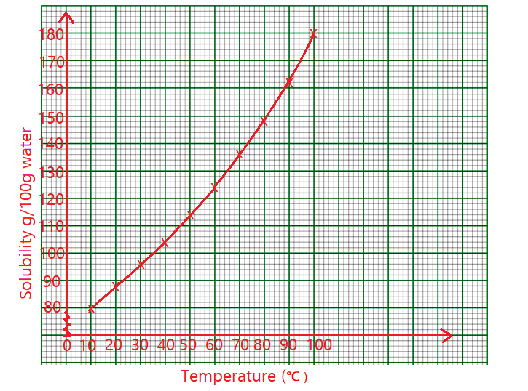

b)

i) 130g/100g of water √1mk (1mk)

ii)Mass dissolved in 100g of water at 82oC is 149g. Mass dissolved in 50g of water will be

50x149/100= 74.5g √1mk

c)At 370C , 102 g√½ of KNO3 are dissolved in 100cm3 of water. Mass dissolved in 1000cm3 is

102x1000/100= 1020g√½. Moles /liter = 1020/101√1mk = 10.099M√1mk or the student can get the moles of salt in 100cm3 102/101=1.0099M then calculate the moles in 1000cm3 =1.0099x1000/100= 10.099M

d) i) 650C √1mk

ii) 130-85= 45g √1mk

**5. i) To dry hydrogen gas** √1mk

**ii) Anhydrous calcium chloride/silica jel** √1mk

**iii)To suck/remove/pump the vapour formed when hydrogen burns.** √1mk

**iv)Water** √1mk

**vi)“dry” is a substance that is free from water/moisture**√1mk  **while “anhydrous” is a substance that does not contain water of crystallization.** √1mk

6.(a) (i) Butanol √1mk

(ii)propanoic acid √1mk

iii)Ethylbutanoate √1mk

b(i) hydrogen gas √1mk

F-1,2 dibromo propane. √1mk

1. C-propanoic acid√1mk
2. Nickel catalyst ½ mk

150-250ᴼC ½ MK

1. Oxidation √1mk
2. C3H8(g)→ CH4(g)+ C2H4(g) √1mk
3. Conc H2SO4 √1mk

vii H H

H

C C √1mk

H

Br

Br