**NAME: ……………………………………..……………….CLASS: …………ADM: ……..…………**

**SIGNATURE: ………………………INDEX NO: ……………………. DATE: …………………….**

**233/2**

**CHEMISTRY**

**Time: 2 Hours**

**MOKASA II EXAMINATIONS JULY 2024**

**CHEMISTRY PAPER TWO**

**Instructions to students:**

* *Write your* ***name, admission number*** *and* ***class*** *in the spaces provided.*
* *Answer* ***all*** *questions in the spaces provided*
* *This paper consists of* ***11 printed*** *pages containing 7 questions.*
* *Candidates should check the question paper to ascertain that all the pages are printed as indicated and that no questions are missing.*
* *Candidates must answer all questions in* ***English***

|  |  |  |
| --- | --- | --- |
| **Question** | **Maximum**  **Score** | **Student’s**  **Score** |
| **1** | **11** |  |
| **2** | **11** |  |
| **3** | **14** |  |
| **4** | **11** |  |
| **5** | **13** |  |
| **6** | **11** |  |
| **7** | **9** |  |
| **TOTALS** | **80** |  |

1. The grid below represents part of the periodic table. The letters do not represent actual symbols of the elements. Study it and answer the questions that follow:-

**H**

**A**

**P**

**B**

**S**

**E**

**T**

**G**

**Y**

**Q**

**Z**

**V**

**J**

**K**

**W**

1. Select an element with the highest ionization energy. Explain (1mark)

…………………………………………………………………………………………………………………………………………………………………………………………………………

1. Compare the ionic radius of G and Y. Explain (2marks)

………………………………………………………………………………………………………………………………………………………………………………………………………………………………………………………………………………………………………………..

1. In terms of structure and bonding compare the melting point of the oxides of E and T (3marks)

……………………………………………………………………………………………………………………………………………………………………………………………………………………………………………………………………………………………………………………………………………………………………………………………………………………

1. On the space provided below draw a labeled diagram showing how the chloride of element P can be prepared (2marks)
2. State one use of element J (1mark)

……………………………………………………………………………………………………

1. From the grid above select the most electropositive element ($\frac{1}{2}$ mark)

……………………………………………………………………………………………………

1. Sketch a graph to show the trend on atomic radius across the period to which element H and P belong. (2marks)
2. a) A piece of unpolished aluminium foil is not attacked by water or steam. Explain why this is so.(1mark)

………………………………………………………………………………………………………………………………………………………………………………………………………………

b) Zubeida a form four student at Joburg high school collected a piece of rock in the school compound .The rock was suspected to contain aluminium. Explain how Zubeida can confirm the presence of aluminium in the ore. (3marks)

……………………………………………………………………………………………………………………………………………………………………………………………………………………………………………………………………………………………………………………………………………………………………………………………………………………………………………………………………………………………………………………………………………………………………………………………………………………………………………………………………………………………..

c) The diagram below illustrates the hall’s cell for extraction of aluminium .Study it and answer the questions that follow.

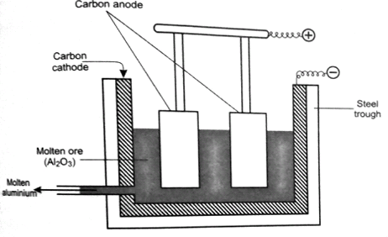

S

Y

1. Name the ore from which aluminium is extracted ($\frac{1}{2}$ mark)

…………………………………………………………………………………………………..

1. Name substances S and Y (1mark)

S……………………………………………..

Y…………………………………………….

1. The melting point of alumina is 2015oc yet the electrolysis process is carried out at 800oc. Explain how this is achieved. (1mark)

……………………………………………………………………………………………………………………………………………………………………………………………………

1. Write the overall equation that takes place in the hall’s cell during electrolysis. (1mark)

…………………………………………………………………………………………………..

1. Duralumin is an alloy of aluminium and magnesium. State two reasons why it is mostly preferred in construction of aeroplane body parts. (2marks)

…………………………………………………………………………………………………………………………………………………………………………………………………….

1. State two uses of aluminium. (1mark)

…………………………………………………………………………………………………………………………………………………………………………………………………..

1. a) Draw a well labelled diagram to show how zinc metal is extracted by electrolysis. (2marks)

|  |  |
| --- | --- |
| Reaction | Eo(V) |
| MnO-4 (aq) + 8H+ (aq) + 5e- Mn2+ (aq) + 4H2O(l) | +1.44 |
| M3+(aq)+ e- M2+(aq) | +077 |
| A2+(aq)+ 2e- A(s) | +0.34 |
| P2+(aq)+ 2e- P(s) | -0.23 |
| T2(g)+ 2e- 2T-(aq) | +2.86 |

b) Use the standard electrode potentials given below to answer the questions that follows

1. State whether acidified MnO-4 (aq) can oxidise M2+.Give a reason for your answer. (2marks)

……………………………………………………………………………………………………………………………………………………………………………………………………………………

1. Write the e.m.f of the half-cell of A if P was used as a reference electrode. Show working. (1mark)

…………………………………………………………………………………………………………

1. Select two half cells which would produce the highest e.m.f when combined (1mark)

…………………………………………………………………………………………………………

1. Draw a well labelled diagram of the electrochemical cell formed when the half cells named above are combined. (3mark)
2. Calculate the e.m.f of the electrochemical cell above. (2marks)
3. An alloy containing iron was dissolved in an acid and the total volume made up to 250cm3.25cm3 of tis solution required 18.0cm3 of 0.15M acidified potassium dichromate VI to react with completely as shown **Cr2O2-7 (aq) + 14H+ (aq) + 6Fe2+ 2Cr3+ (aq) +6Fe3+ 7H2O(l)**

Calculate the mass of iron in the alloy. (Fe=56) (3marks)

1. a). When a mixture of concentrated sulphuric (VI) acid and copper turnings is strongly heated, a colourless gas and a solid mixture of white and black solids are formed. When the solid mixture is treated with distilled water and filtered a blue filtrate and a black residue are obtained. Explain the observation on the solid mixture formed in the above experiment. (3marks)

………………………………………………………………………………………………………………………………………………………………………………………………………………………………………………………………………………………………………………………………………………………………………………………………………………………………………………………………………………………………………………………………………………………………………………………………………………………………………………………………

…………………………………………………………………………………………………………………………………………………………………………………………………………………………………………………………………………………………………………………………………………………………………………………………………………………………………………

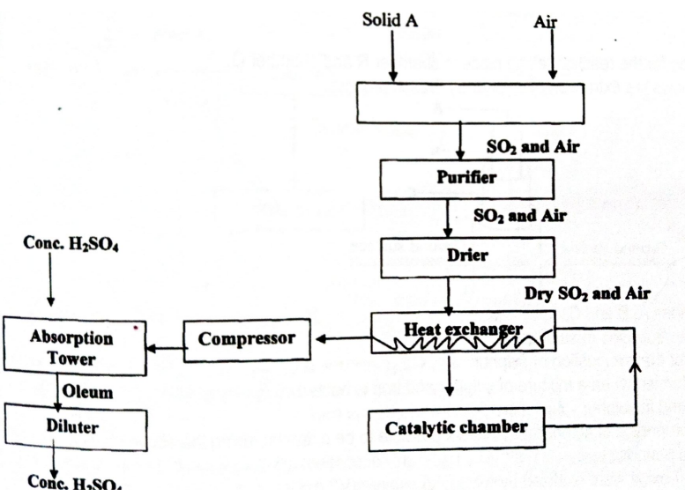b). Study the flow chart below and answer the questions that follows.

1. Besides sulphur name two possible identities of solid A (1mark)

………………………………………………………………………………………………………………………………………………………………………………………………………………

1. Explain why it is important to remove the impurities in the above process (1mark)

……………………………………………………………………………………………………….

1. Explain why in the above process sulphur (VI) oxide gas is not directly dissolved in water to form sulphuric (VI) acid but instead dissolved in concentrated sulphuric (VI) acid (2marks)

………………………………………………………………………………………………………………………………………………………………………………………………………………………………………………………………………………………………………………………………………………

1. Write the chemical equation that takes place in the catalytic chamber. (1mark)

………………………………………………………………………………………………………...............

1. State two conditions for the reaction in iv above to take place (2marks)

………………………………………………………………………………………………………..

1. Give a reason why the above process is called the contact process (1mark)

………………………………………………………………………………………………………..

1. 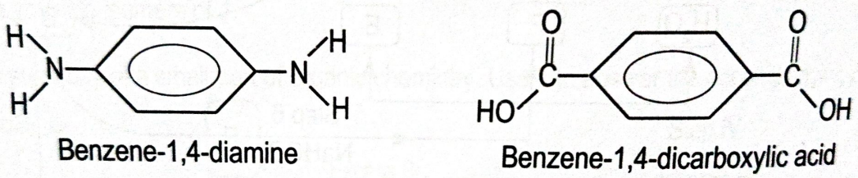Kevlar is a polyamide which is made from two different monomers whose structures are shown below
2. Draw the structure of Kevlar. (1mark)
3. State one disadvantages of continued use of Kevlar (1mark)

……………………………………………………………………………………………………………

1. Kevlar is used to make body suits for superbike riders due to being tough and friction less. Name one other application it is popular for. (1mark)

…………………………………………………………………………………………………………….

1. 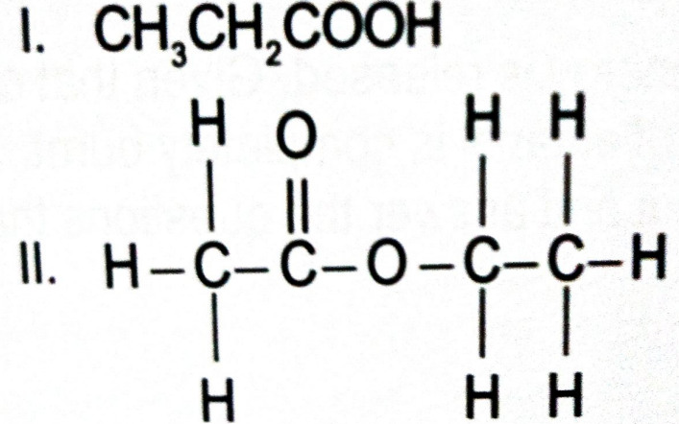Give the names of the molecules shown below (2marks)

I……………………………………………………………………………….

II………………………………………………………………………………

1. Study the reaction scheme below and answer the questions that follows.

HOBr

Ethan-1, 2-diol

K

Terylene

Step IV

Step VI

Step VIII

Ethene

Y

Ethane

Step V

Step VII

Cl2

Ethanol

Step I

CH3CH2COOC2H5

Q and X

Step II

Step III

Water

1. Name substances K and Y (2marks)

K……………………………………………………………………………………………Y……………………………………………………………………………………………

1. Write the chemical equation for the reaction in step VI (1mark)

…………………………………………………………………………………………………….

1. Name the reagent and two conditions for step VII (3marks)

Reagent……………………………………………………………………………………………….Conditions…………………………………………………………………………………………………………………………………………………………………………………………………….

1. Name the process that takes place in: (2marks)
2. Step III…………………………………………………………………………………..
3. Step VIII………………………………………………………………………………..

1. a. After 112 days 1/16 of the mass of R remained, Determine the half-life of R (3marks)

b. (i) State **two** ways in which nuclear reactions differ from ordinary chemical reactions (2marks)

……………………………………………………………………………………………………………………………………………………………………………………………………………………

(ii) The following is a part of Uranium decay series

238

**U**

92

234

**Th**

90

234

**Pa**

91

Z

**X**

A

Step I

Step II

Step III

(iii) Which particles are emitted in **step I** and **II** (1mark)

……………………………………………………………………………………………………

(iv) If a beta particle is emitted in **step III,** find the values of **Z a**nd **A** (2marks)

(v) State two factors that determine the stability of an isotope (1mark) ………………………………………………………………………………………………………………………………………………………………………………………………………………………………………………………………………………………………………………………………

(vi) State one application of radioactivity in each following fields: (2marks)

1. Tracers ……………………………………………………………………………………………...
2. Paper industries……………………………………………………………………………………..
3. A) Chemical reaction occur as a result of collision of particles. Give a reason why not all collisions are effective (1mark)

……………………………………………………………………………………………………………………………………………………………………………………………………………………

B) State and explain how the following factors affect the rate of a chemical reaction (4marks)

Pressure…………………………………………………………………………………………………………………………………………………………………………………………………………….

Temperature………………………………………………………………………………………………………………………………………………………………………………………………………

C) Bismuth chloride reacts with water according to the equation below.

BiCl3 (aq) + H2O (l) BiOCl (s) + 2HCl (aq)

(Colourless)

(White)

1. State and explain the observation made when a few drops potassium hydroxide are added to the system at equilibrium. (2marks)

……………………………………………………………………………………………………………………………………………………………………………………………………

D) Define the Lechatelier’s principle (1mark)

………………………………………………………………………………………………………………………………………………………………………………………………………………………………………………………………………………………………………………………

E) State one industrial application of dynamic equilibrium (1mark)

………………………………………………………………………………………………………………………………………………………………………………………………………………