Carbon and its compounds
1. a) – making of pencil
- As a lubricant
b) Graphite has delocalized in its structure hence it conducts electricity. Carbon uses all
the four valency electrons to form covalent bonds hence do not have delocalized elect
conduct electricity

2. a) Carbon (IV) oxide (CO₂) 1
b) 2NaHCO₃(s) Na₂CO₃(s) + H₂O(l) + CO₂(g) 1
c) – Paper manufacture 1
- Manufacture of glass.
- Softening of hard water.

3. Magnesium has a higher affinity for combined oxygen that carbon./Mg is more reactive
than carbon thus displaces it from its oxide.

4 a) Carbon (iv) Oxide
b) Blue flame. Carbon (iv) oxide burns in air with a blue flame 1

5. a) A brown solid is formed

b) CuO_{(g)} + C_{(g)} ___________ Cu_{(g)} + CO_{(g)}

c) As a fuel in water gas
6. (a) Covalent bond is bond between non-metal atoms where shared electrons are donated equally
by all the atoms involved.
Dative bond is a bond in which shared electrons are donated by one atom.
 ½
(b) The presence of triple bond in nitrogen requires very high temperatures to break

7. (a) Reduction by using carbon
b) J, carbon and H
decreasing order of reactivity 7. Study the structures A and B:
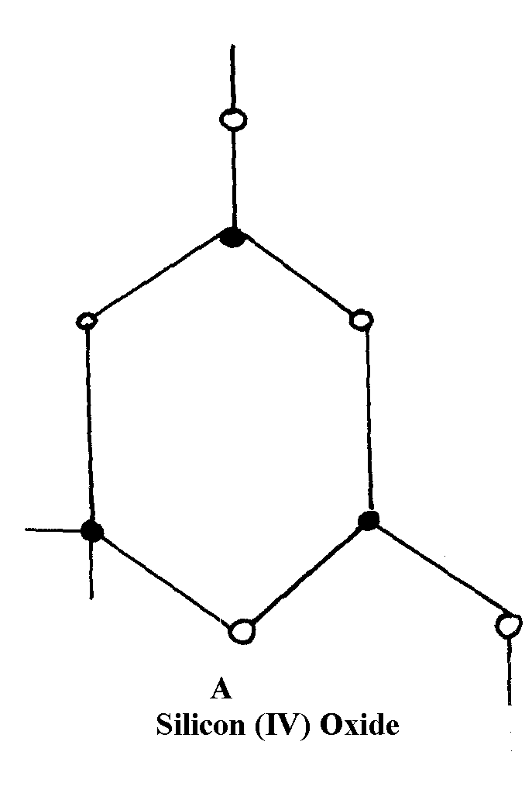
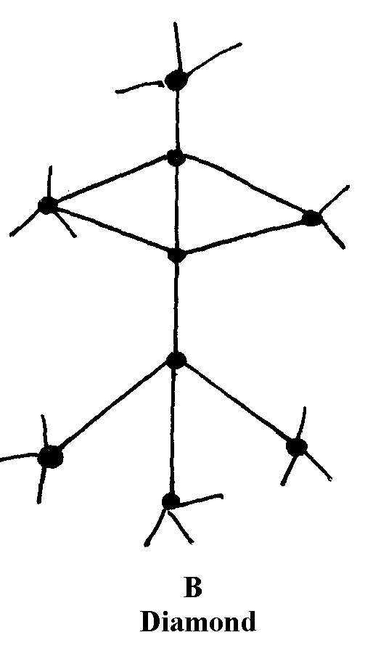

8. (i) Have giant atomic structure
1
(ii) To make drill bits or used in jewellery (any one)
1

9. (a) Allotropy is the existence of an element √1 in more than one form without change of state.
(b) Graphite contains delocalized √1 electrons between the layers while diamond has no
3 free √1 electrons. Its atoms are strongly bonded.

10. (a) C_{(s)} + CO_{2(g)} 2CO_{(g)} √1 (1 mk)
(b) Burn charcoal in sufficient √1 oxygen Carbon (II) oxide 3
(being a reducing agent) is easily oxidized to carbon (IV) oxide.√1 (1 mk)

11. (a) Black^{√ ½} solid changes to reddish brown^{√ ½}
(b) CuO_{(s)} + CO_{(g)} Cu_{(s)} + CO_{2(g)} √ (1 mk) 2

12. (a) Difference forms of a substance at the same physical state;
(b) In graphite each carbon is bonded to 3 others and there are Vander waals forces between
hexogous;
- In diamond each carbon atom is covalently bonded to four others making a rigid mass;

13. a) - Copper (ii) oxide changes √ ½ from black to brown/ reddish brown/ red brown√ ½
- A white ppt forms in the boiling tube √ ½
b) CO_{2(g)} + Ca(OH)_{2(aq)} _______ CaCO_{3(g)} + H₂O_{(l)} √ 1
c) Unreacted carbon (ii) Oxide is poisonous/ toxic/ pollutant it is converted to the less harmful
gas CO₂

14. a) A the substance is a gaining kinetic energy making it to vibrate vigorous up B,
at point B to C the kinetic energy a gained is used to beak down the particle in solid state at
this point the substance start melting and the temperature is constant.
d) It is not water because the melting of water is 100⁰c not 115⁰c.
e) The melting point will be lower because of the impurity Nacl.
f) The temperature is constant.
15. (a) (i) Carbon (II) Oxide or CO – (reject Carbon monoxide)
(ii) Combines with haemoglobin to form caborhaemoglobin which prevents carrying of
oxygen
(b) (i) CO(_{g)} + C_{(s)} 2CO_{(g)}
(ii) ZnO_{(s)} + CO_{(g)} Zn_{(s)} + CO_{2(g)}
(c) Orange/yellow Lead (II) Oxides turns grey
(d) CaCO_{3(s)} + 2HCl_{(aq)} CaCl_{2(aq)} + CO_{2(g)} + H₂O_{(l)}
(e) Methanoic acid and concentrated sulphuric acid
(f)
Gas X
Water

16. (a) (i) - Ammonia gas 1
- Calcium carbonate. 1
- Brine 1 or Concentrated sodium chloride.
- Coke (Any three materials)

(ii) - Carbon (IV) oxide. 1
- Ammonia gas. 1
- Water (Any two)

(iii) Chamber 3 1
Chamber 2 1

(iv) U – Ammonia chloride 1
V – Sodium hydrogen carbonate. 1

(b) (i) HN₃(g) + H₂O(l) + CO₂(g) + NaCl(aq) NH₄Cl(aq) + NaHCO₃(s)
OR
NH₃(g) + H₂O(l) + CO₂(g) NH₄HCO₃(aq)
NH₄HCO₃(aq) + NaCl(aq) NH₄Cl(aq) + NaHCO₃(s)

(ii) NaHCO₃ Na₂CO₃(s) + CO₂(g) + H₂O_{(l)}

(iii) Ca(OH)₂(s) + 2NH₄Cl(aq) CaCl₂ + 2NH₃(g) + 2H₂O(l)

c) - Manufacture of glass.
- Softening of hard water.
- Manufacture of papers.
- Manufacture of soap.
- Refining of metals.

17. (a) (i) – The gas is collected over water
- The gas is not passed through a drying agent
(ii) PbCl₂ is formed which is insoluble hence prevents contact between the carbonate and the acid
Heat
(iii) CO_{2(g)} + C(s) 2CO(g)
CO_{2(g)} + 2NaOH_{(aq)} Na₂CO_{3(aq)} + H₂O_{(l)}

(iv) – Solid CO₂ used as a refrigerant
    - Used in making aerated drinks
    - Solid CO₂ is used in cloud-seeding
    - CO₂ used as an ingredient/air material in solvary process
(v) – Denser than air
- Does not support combustion (burning)
(b) Reducing Property
Heat
(c)- Al₂(CO₃)₃ hydrolyses in water/moisture forming H⁺ ions which reacts with the carbonate
and dissolves
Heat
(d) (NH₄)₂ CO_{3(s)} NH_{3(g)} + CO_{2(g)} + H₂O_{(g)}

18. Brown fumes of a gas are produced as the charcoal dissolves in the acid. The charcoal
reduces nitric (V) acid to nitrogen (IV) oxide gas that is brown while the charcoal is oxidized
to carbon (IV) oxide.

19. (a) Due to formation of calcium hydrogen carbonate which is a soluble salt

(b) 2CaCO_{3(s)} + 2CO_{2(g)} + 2H₂O 23Ca(HCO₃)_{2(aq)}
(- Award 1mk if equation is correctly balanced
- Penalize ½ mk if equation if not balanced)
20. a) A – Concentrated sulphuric acid (vi) acid √1
b)
c) HCOONa_{(s)} + H₂SO₄ HCOOH _{(L)} + NaHSO_{4(S)}

Hence; HCOOH_{(l)} CO_{(g)} + H₂O_{(L)}
Accept conc H₂SO₄ (reject where concentrated is not mentioned)
Workability √1
Correct method of collection√1
Of the gas √1
The two equations should be mentioned 2 mks

