CROP PESTS AND DISEASES
This topic entails the following:
- Definition of a pest and a disease
- Main cause of crop diseases
- Description of harmful effects of crop pests and diseases
- Identification of crop pests and diseases
- Control measures of crops pests and diseases

The following relevant questions and their answers in this topic will greatly motivate and help the user to comprehend and understand the required concepts and practices:

1. State two possible causes of swelling on the roots of legume crops
2. Discuss the various cultural methods of controlling pests in crops
3. What does the term ‘close season’ mean in crop production?
4. Explain five cultural methods of pest control in stored grains
5. Name four symptoms of viral infections in plants
6. Study the illustrations given below and then answer the questions that follow:-
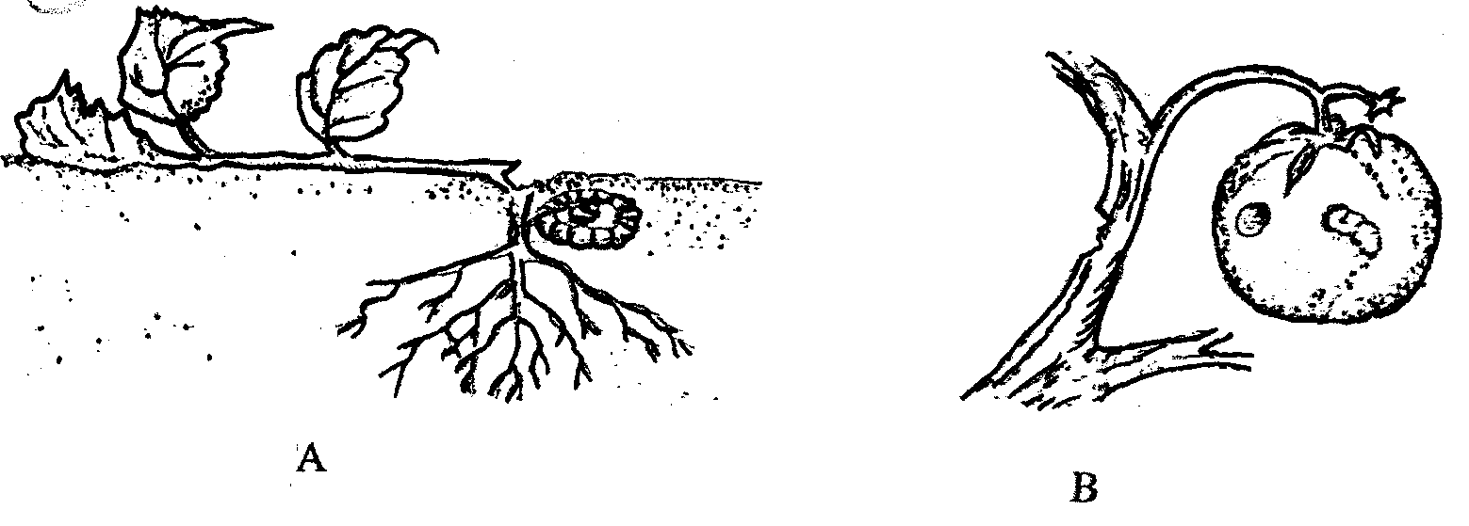
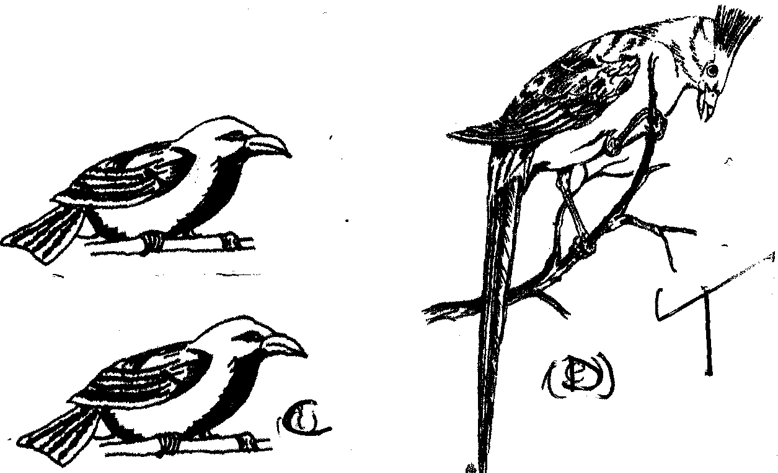

D
C

(a) Identify the pests shown by the illustrations B, C and D
(b) State one effective method of controlling the pest labelled
(c) Name the type of crop commonly attacked by the pest labelled ‘C’
7. State the various practices carried out in the field to help control crop diseases
8. State two ways in which pesticides kill crop pests

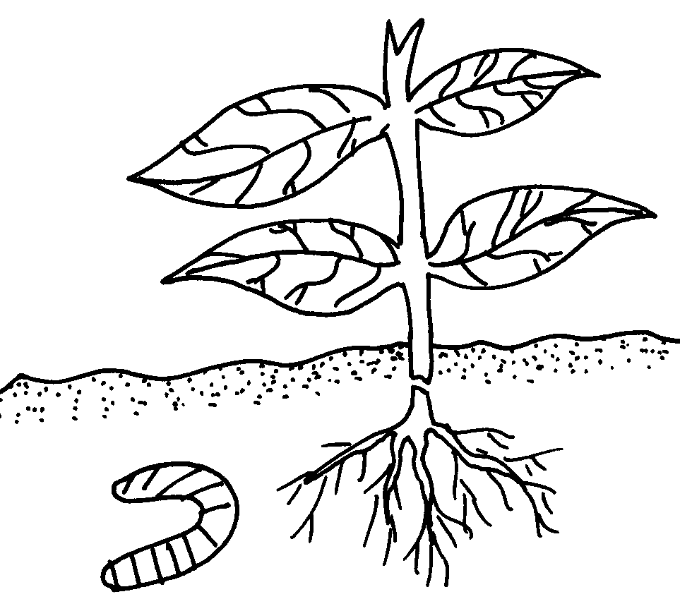
9. The diagram below shows kale seedling attacked by a pest
Z

(a) Identify the pest
(b) What damage does the pest cause to the crop
(c) State two methods of controlling the pest
11. Define the term ‘economic injury level of a pest and integrated pest control management
12. List four harmful effects of crop pests
13. The diagram below shows a fungal disease in a section of potato crop leaf
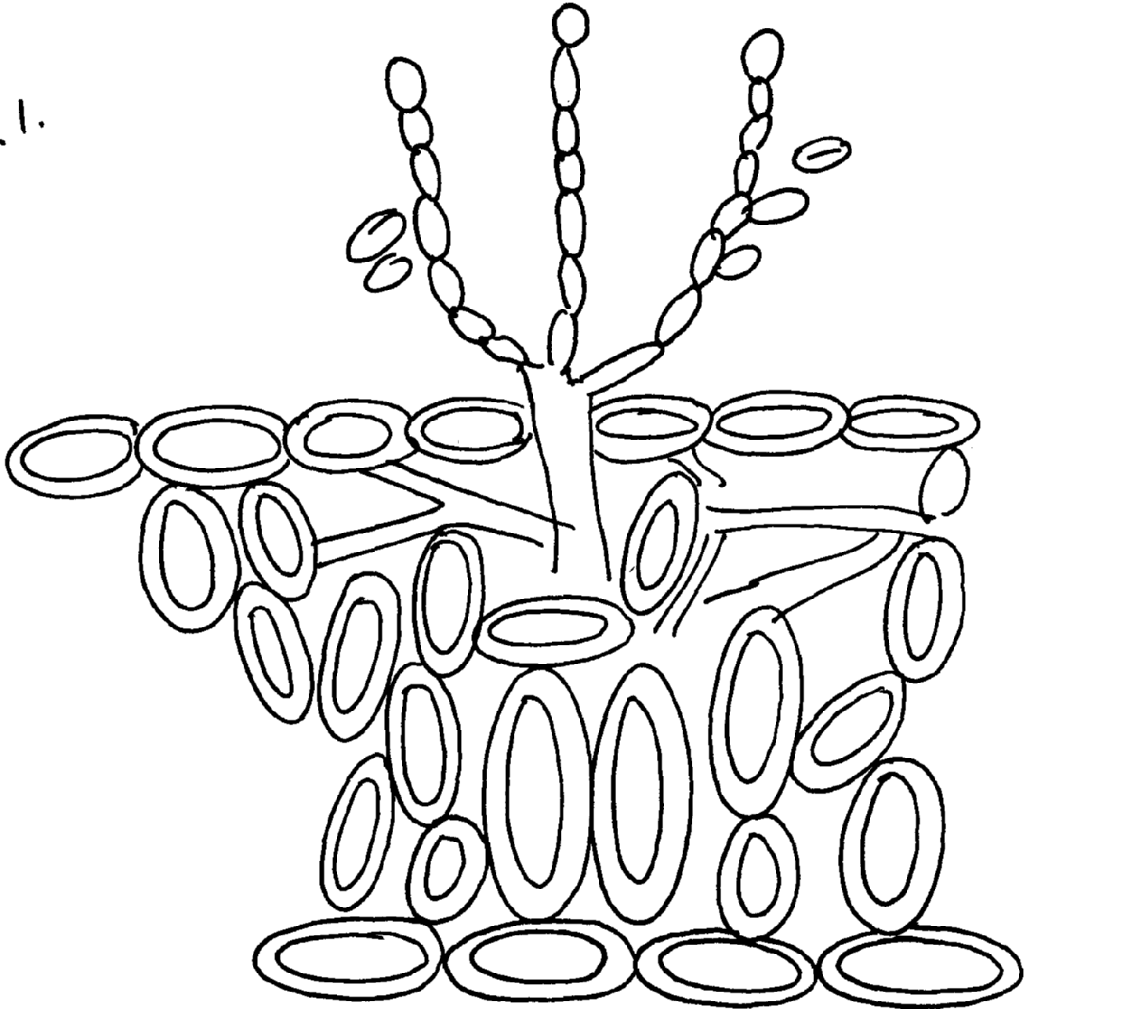

a) Identify the fungal disease
b) (i) State the causal organism of the disease identified above
ii) Give two symptoms of the above disease
c) Give two control measures of the disease
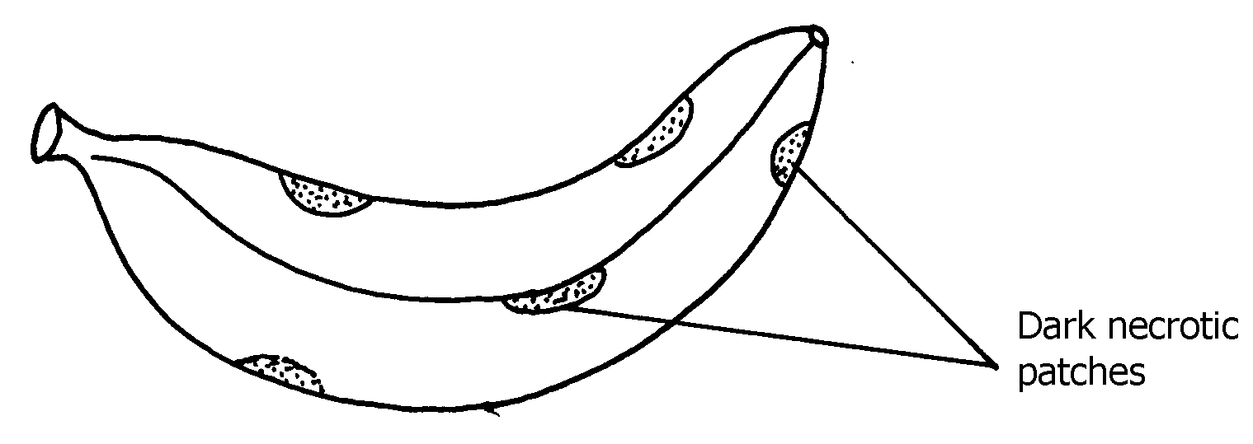
14. The diagram below shows a banana fruit infected by a certain disease.

- Identify the disease
- Suggest any one control measure for the disease you have named in (a)
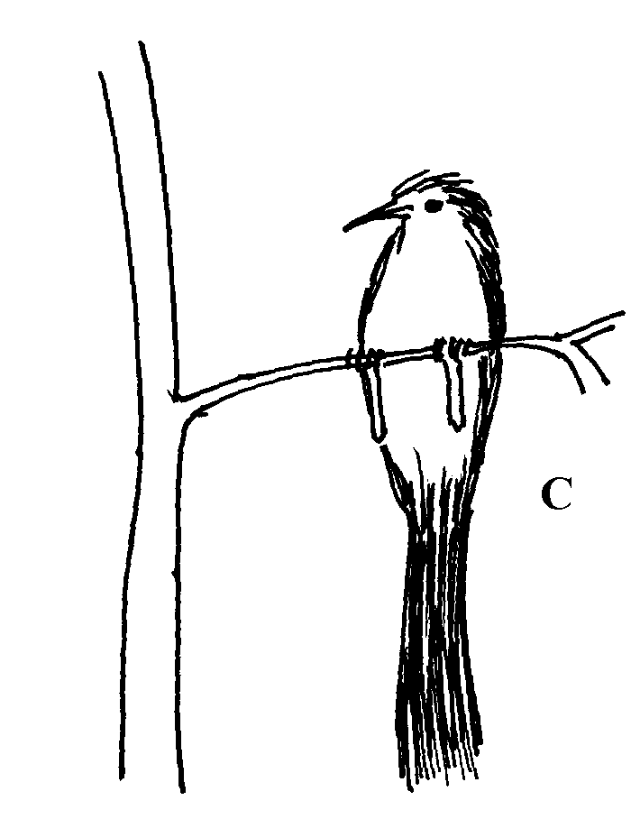
15. The diagram below shows a crop pest;

(a) Identify the crop pest
(b) State two damages the pest would cause to crops

16. Give two symptoms of nematode attack on bananas.
17. Give four cultural practices used in controlling crop pests
18. State three symptoms of coffee berry disease.

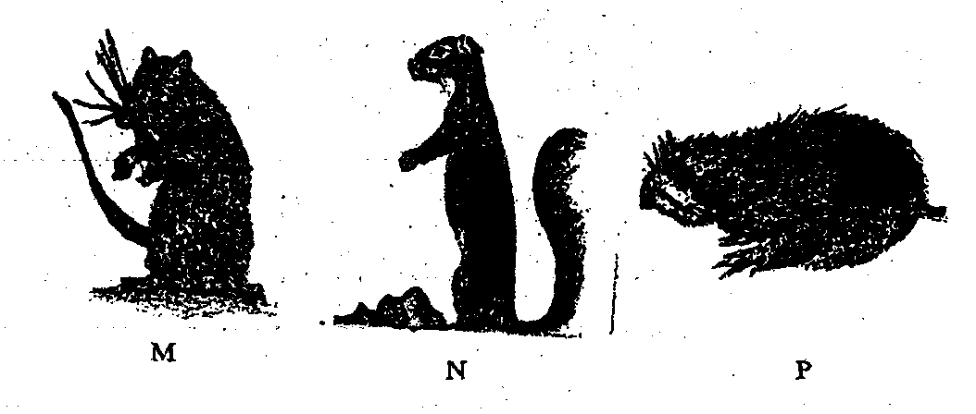
19 (i) Use the diagrams below to answer the question that follow.

(a) Identify the crop pests labeled M, N and P
(b) State one control measures of crop pests labeled M
(c) State the damage caused to crops by crop pest labeled N
20. State and explain the cultural methods of pest control

CROP PESTS AND DISEASES

1. two possible causes of swelling on the roots of legume crops
- Infection by nematodes
Nodulation/ nitrogen fixing bacteria
2. the various cultural methods of controlling pests in crops
- Timely planting-done early e.g. maize escape stalk borer
- proper tillage-to expose soil boring pest i.e. white grubs
- Timely harvesting-enables crops i.e. maize to escape weevil attacks
- close season-avoids growing susceptible crops for some period to control pink worms in cotton
- trap cropping-plant crops together with main crop to trap/attract pests before they attack e.g. sorghum round the maize plantation
- trap rotation-rotate crops preferred by certain pests with those which are not e.g. groundnuts and potatoes rotated with maize and beans to starve pests
- establishing resistance crop varieties-this enables crops to resist pest using natural mechanism e.g. goose neck sorghum against birds ,tiltering sorghum against shoot fly
- field/farm hygiene-keep the field free from any plant material harboring pests by rouging ,removal of crop residues
- Alteration of environmental conditions by creating microclimates that are not conducive to some pests e.g. open pruning, mulching for traps
- Destruction of alternative host especially weeds that host pests e.g. Removal of mallow weeds help control cotton strainers. Use of clean planting material e.g. seeds, suckers, crown bananas weevils are controlled
- Proper spacing-makes it difficult for pests to move from one plant to another through close spacing in ground nuts controls aphids
- Using organic manure which discourages eelworms
- Irrigation-overhead irrigation in cabbages controls aphids(any 10x2 must be discussed)
3. What does the term close season mean in crop production?
- A period during when a particular crop is not supposed to grown in a given areas so as to
control diseases and pests built up.
4. - Use of clean planting materials.
- Timely planting.
- Proper seed bed preparation.
- Use of resistant crop varieties.
- Proper weed control/ destruction of alternate host.
- Observing field hygiene.
- Mulching.
- Use of close season.
- Use of trap crops.
- Proper spacing.
- Timely harvesting.
- Use of crop rotation.
6. Four symptoms of viral infections in plants
- Leaf curling
- Mosaics
- Malformation/distortions
- resetting (short internodes)
- Leaf chlorosis
7. (a) B - American bollworm ½mk

C - Weaver bird ½mk
D – Mongoose bird ½mk
(b)- Flooding with water
- - Fumigation of the soil with furadan
- - Physical killing ( ½ x1 = ½mk)
(c) Fruits ( ½ x 1 = ½mk)
8. (b) The various practices carried out in the field to help control crop diseases
- Crop rotation
- Rugueing/destroy infected plants
- Plant disease-free plant/use certified seeds
- Closed season
- Early planting /timely planting
- Proper spacing
- Timely weed control
- Use of resistant varieties
- Application of appropriate chemicals
- Use of clean equipment
- Quarantine
- Heat treatment to kill pathogens
- Pruning to create unfavorable micro-climate for diseases
- Proper nutrition to prevent deficiency

9. - Some pesticides cause suffocation of pests by blocking respiratory surfaces
- Some pesticides are stomach poisons that kill pests by damaging the cells/ tissues
- Some pesticides damage the pests nervous system
- Some pesticides kill pests by destroying digestive system
10. a) Cutworm
b) - Cuts the stem causing lodging
- Reduce plant population
c) - Use of appropriate insecticides
Removing and killing it
11. i) This is a situation in which pest population caused damage beyond tolerance
ii) This is the use of combination of both chemical and cultural pest control methods
12. four harmful effects of crop pests
- Some e.g. nematodes damage crop roots causing wilting and death of the plant
- Some like squeals unearth planted seeds leading to low plant population some destroy crop leaves lowering photosynthetic area-result to reduced yield
- Sucking pest deprive plants of food by sucking plants sap
- Some pests attack fruits berries and flowers lowering their quality and quantity
- Some pests destroy embryo seeds lowering their germination potential
- Some transmit crop diseases
- Some e.g. stalk borer eat the growing points causing retarded growth
- They lower mansetabills of crops produce by lowing quality
- Where the leaf is the major product pest damage lower the quality and quantity through defoliation
13. a)Potato blight
b) (i) Pythophthora infestants
ii) dry patches i.e. necrotic lessiory on leaves and fruits
- affected fruits appear rotten and fall off prematurely
c) spraying with copper fungicides
- rogueing the affected crop
14. (a) – Anthracnose of Bananas / Banane anthrancnose;(1x1=1mk)
(b) – Spray with (appropriate) fungicide
- Plant resistant varieties
15. a)- Mouse bird
b) - Destroys grains in records
- Destroys fruits e.g. tomatoes
16.
- Cause swellings called galls on the roots.
- Leads to blockage of the vascular vessels which transport materials within plants leading to wilting and stunting growth of the crops.
17. four cultural practices used in controlling crop pests
- Timely planting
- Proper tillage
- Close season
- Trap cropping
- Timely harvesting
- Crop rotation
- Planting resistant varieties
Field hygiene
18. three symptoms of coffee berry disease.
- Fungal disease
- Favoured by high rainfall
- Flowers have dark brown blotch /stred on brown petals
- Green servier have small dark sunken parches/lessions
- Barry (dip in the ground/dry up on the in the black mummified condition and when squeezed they are empty
19. (a) M – hedgehog N- Squirrel P – Rat
(b) M – Use dogs
N- eat germinating maize/bean seedling
21. - timely planting
- Early planting
- Timely harvesting
- Early harvesting
- Proper tillage
- Close season- period when that crop is not grown anywhere trap cropping
- Crop rotation
- Planting resistant carieties
- Field hygiene
- Alteration of environmental
- Crop nutrition
- Destroying alternative host
- Use of clean planting material
- Proper spacing
- Lose of organic manure

- Irrigation.

