MARKING SCHEME CHEM PP 1 FORM 3

1. The table below shows information about elements K, L, M, P,R and V
Element | Group | Electron configuration of ion
K | VI | 2,8,8
L | VI | 2,8
M | II | 2,8
P | III | 2,8
R | I | 2,8
V | VII | 2,8
a)Write down electron configuration of elements K and M. (1MK)

K: 2, 8, 6
M: 2, 8, 2
b)Write the formula of
i) Ion of L
L²⁻ (1mk)
ii) Compound formed between K and P. (1mk)
P₂K₃
2. The PH values of solutions A,B,C,D are given in the table below
Solution PH
A 9.8
B 2.0
C 5.2
D 12.0
Which solution is identified as.
i) Strong acid. B (1mk)

ii) Weak base A (1mk)

iii) Lemon juice. C (1mk)

3. In an experiment two similar boiling tubes were filled with carbon (IV) oxide. One of the boiling tubes was inverted over a trough of water and the other over a trough containing sodium Hydroxide solution. Draw two diagrams to show the result obtained after 10 minutes. (2mks)

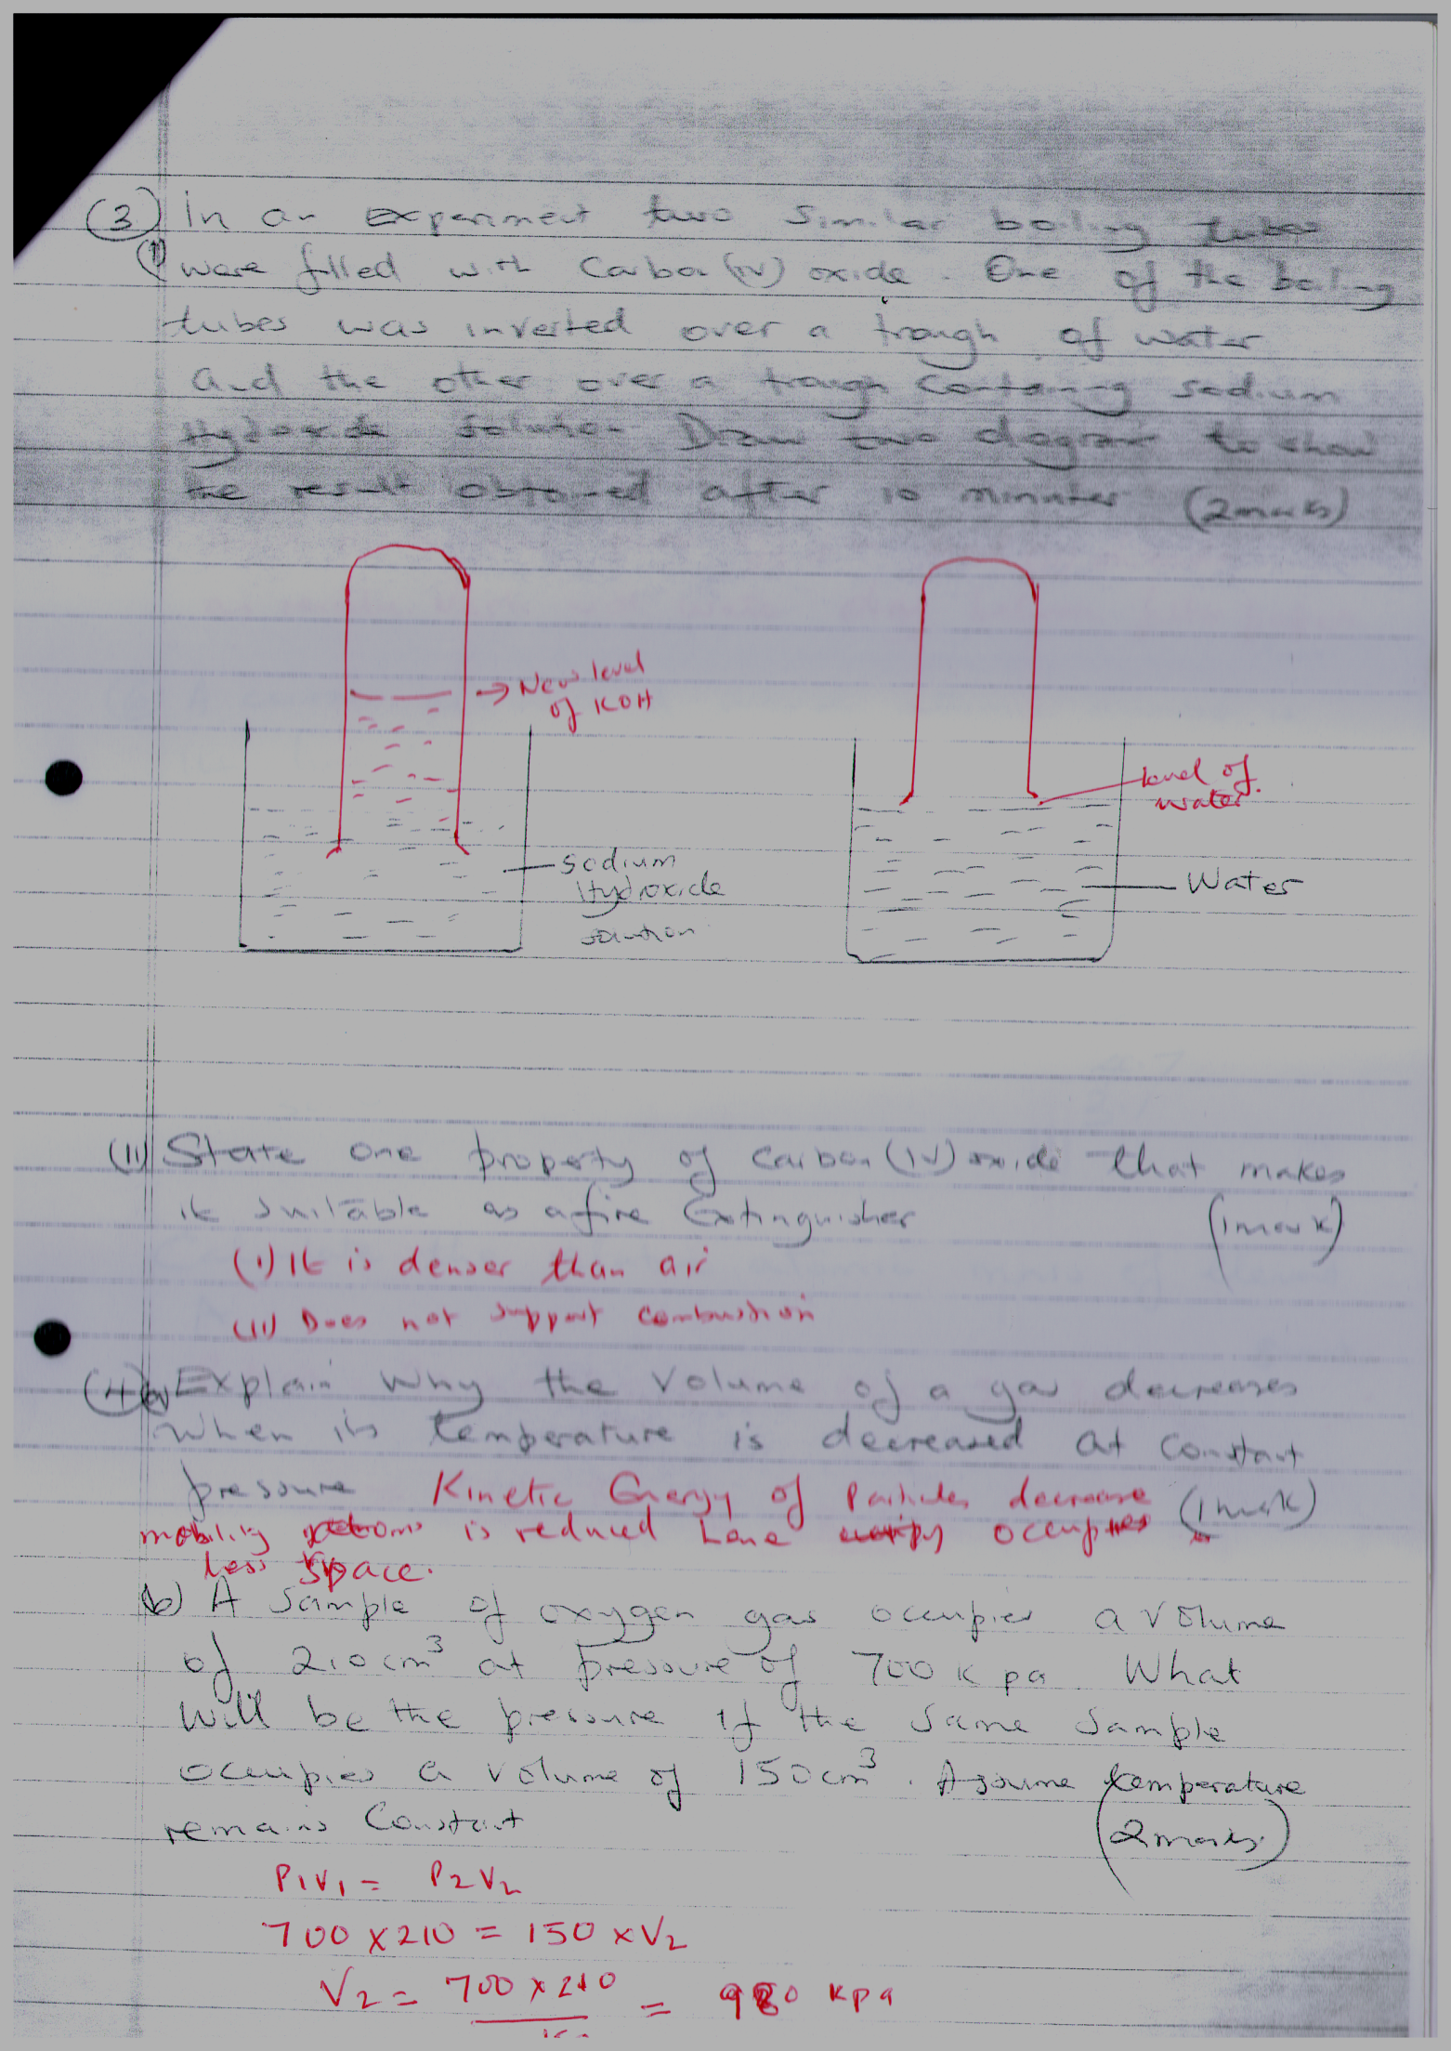

ii) State one property of carbon (IV) oxide that makes it suitable as a fire extinguisher. (1mk)

(i)it is denser than air
(ii)does not support combustion

4a) Explain why the volume of a gas decreases when its temperature is decreased at constant pressure. (1mk)
Kinetic energy decreases hence decreases mobility.

b) A sample of oxygen gas occupies a volume of 2.0cm³ at pressure of 700K pa. What will be the pressure if the same sample occupies a volume of 150cm³. Assume temperature remains constant. (2mks)
p₁v₁₌p₂v₂
700x210=150xv₂ (1 mk)
V₂=700x210 =980kpa
150 kpa (1 mk)
5. Describe how a solid dample of lead (II) chloride can be prepared using the following reagents. Dilute nitric acid, dilute Hydrocloric acid and lead (II) carbonate. (3mks)
Add excess lead(ii)carbonate (1 mk) to dilute nitric (v) acid. Filter (1/2 mk) to obtain Lead(ii)nitrate solution as filtrate. Add dilute (1/2 mk) Hcl. Filter (1/2 mk) off lead (ii)chloride as residue .wash with water (1/2 mk) dry between filter papers. (1/2 penalty for omitting excess acid)

6. A certain element A whose atomic number is 14 has three isotopes. The table below shows the mass number and relative abundance of each isotopes.
Isotopic mass % abundance
28.0 92.2
29.0 4.7
30.0 3.1
Calculate the relative atomic mass of element A. (3mks)
RAM=92.2x28.0+4.7x29.0+3.1x30.0 (1 mk)
100
=2810.8 (1 mk)
100
=28.108 (1 mk)
7. Some potassium chloride was found to be contaminated with copper (II) oxide. Describe how a sample of potassium chloride can be obtained from the mixture. (3mks)
Add water (1 mk) to the mixture, potassium chloride dissolves ((1/2 mk), filter (1/2 mk) off copper(ii)oxide and evaporate (1 mk) filtrate to crystallize crystal potassium chloride.

8. The following diagram shows the effect of electric current on lead (II) Chloride.
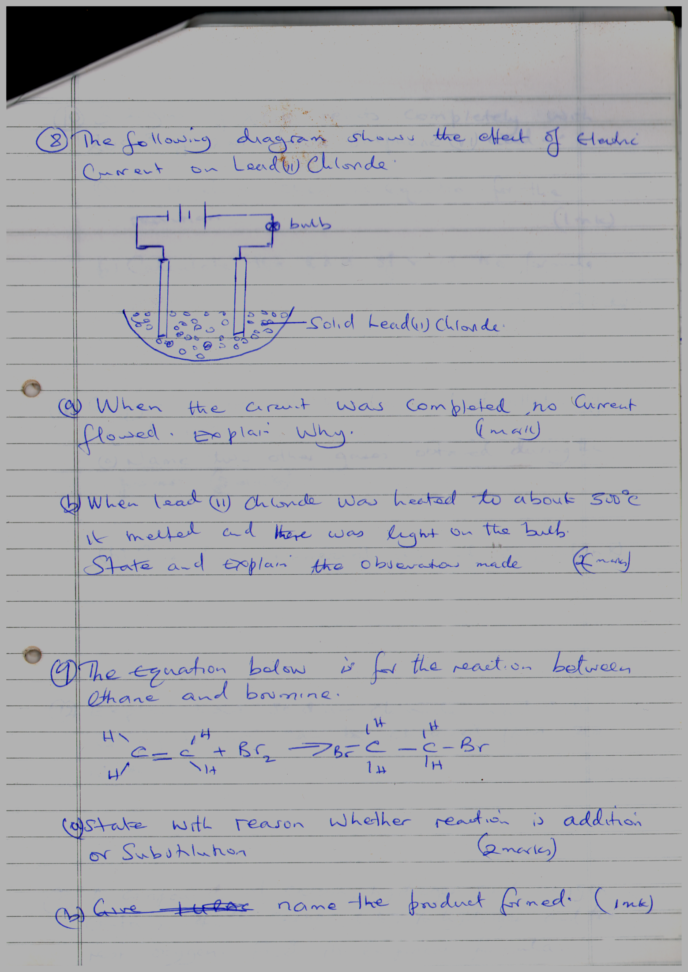
a) When the circuit was completed no current flowed. Explain why. (1mk)
Solid lead(ii)chloride does not conduct electricity for there are no mobile ions
b) When lead (II) Chloride was heated to about 300⁰C it melted and there was light on the bulb. State and explain the observation made. (2mks)
Bubbles (1 mk) of yellow green –chloride ions (1 mk) migrate to the anode and are discharged to form chlorine gas

9. The equation below is for the reaction between ethane and bromine.
H H H H

C= C + Br2 Br C C Br

H H H H
a) State with reason whether reaction is addition or substation. (2mks)
- A double C = C bond is opened.
- An addition reaction/compound is unsaturated only one product is formed. (1 mk)

b) Name the product formed. (1mk)
1, 2 – dibromoethane (1 mk)

10. 3.2 gms of XOH reacts completely with 20cm³ of 2m dilute sulphuric (vi) acid.
a) Write down chemical equation for the reaction. (1mk)
2XOH_{(aq)}+H2SO_{4(aq)}→X2SO_{4(aq)}+H₂O_{(l)}
b) Calculate the RAM of X in the formula XOH. (2mks)
1000cm3→2 Moles
20cm3→ 2 x20=0.04 Moles (1 mk)
1000

Moles of XOH→0.04x2 (1/2 mk)
=0.08 Moles
3.2 =0.08
17+x
X=23 (1/2 mk)

11. Oxygen is obtained by fractional distillation of liquid air
a) Name two other gases obtained during the process. (2mks)
Nitrogen and Argon

b) Give two commercial use of oxygen . (1mk)
(a) Oxyacelyne flame
(b)Extraction of steel
(c) Burning fuels in space rockets
(d) Used by mountain climbers, deep sea divers and hospitals to aid breathing
(1/2 mk each for any two)

12. Explain how sodium chloride used in the solvary process can be obtained from sea water. (3mks)
Pass the sea water through shallow (1 mk) ponds evaporation (1 mk) takes place and salt crystallizes (1 mk) in the final pond where it is collected washed.

13. A compound of carbon, hydrogen and oxygen contains 40% carbon, 6.67% hydrogen and the rest oxgen. Find its empirical formula. If its relative molecular mass is 180. Find its molecular formula. (4mks)
C H O
40 6.67 53.3 (¹/₂ mk) 3.333 6.67 3.331 (1/2 mk)
Moles 40 6.67 53.3 3.331 3.331 3.331
12 1 16 (1/2 mk)

EMF=30 E.F = CH₂O (1/2 mk)
N =180
30
=6 (1/2 mk)
MF:C₆H₁₂O₆ (1/2 mk)

14. Explain why there is a general increases in the first ionization energies of the element in period 3 of periodic table from left to right. (2mks)
No of protons (1 mk) increase across period hence nucleus (1 mk) attraction on valence electron increase

15a) What is a dative covalent bond. (1mk)
Is a covalent bond where the shared electrons are from one species.

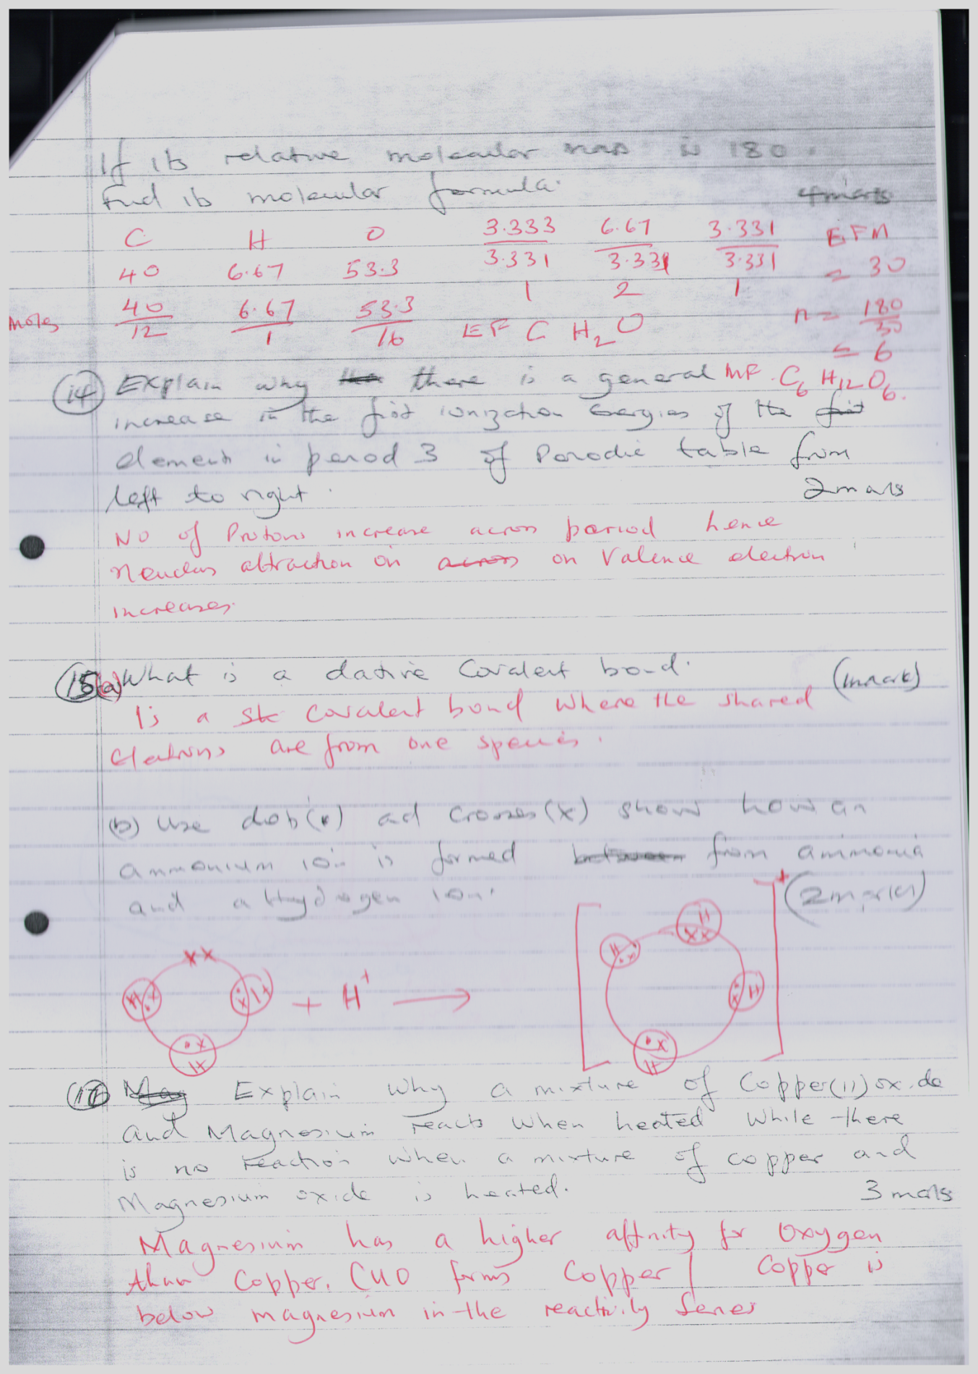
b) Use dots ( ) and crosses (X) show how an ammonium ion is formed. From ammonia acid a Hydrogen ion. (2mks)
+ (1 mk)

N

(Penalise ½ mk if atoms not labeled)

16. Explain why a mixture of copper (II) oxide and magnesium reacts when heated while there is no reaction when a mixture of copper and Magnesium oxide is heated. (3mks)
Magnesium has a higher affinity (1 mk) for oxygen than copper, hence Mg will displace (1 mk) Oxygen from Copper(ii)oxide.
17a) What is the chemical name to rust. (1mk)
Hydrated iron(iii)oxide.

b) How does paint stop rusting. (1mk)
Prevents metal to come into contact with oxygen and water.

c) The cars in Mombasa rusts faster than those in Nairobi. Explain. (1mk)
Salty water accerates rusting .

18. The set up below is used to prepare and collect dry carbon ( Iv) oxide gas. Complete the diagram. (3mks)
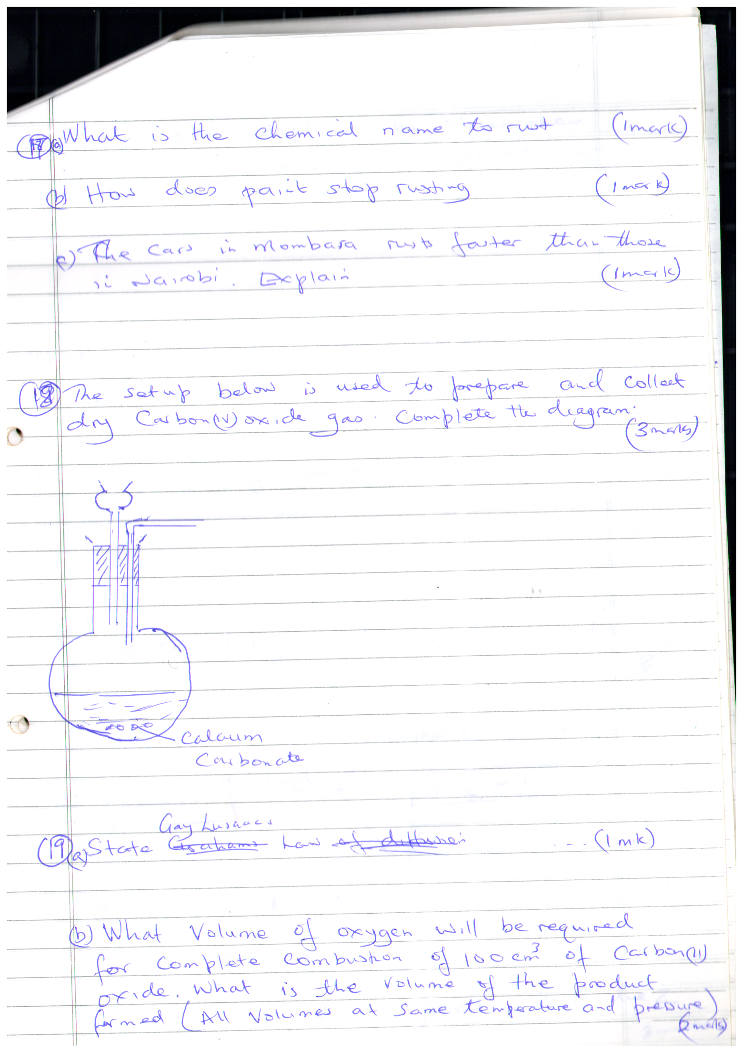
Drying agent – 1mk
Method – 1 mk
Workability – 1 mk

19. State Gay lusaacs law. (1mk)
When gases combine they do so in volumes that bears simple ratio to one another and to the product if it is gaseous.

b) What volume of oxygen will be required for complete combustion of 100cm³ of carbon (II) oxide. What is the volume of the product formed ( All volumes at same temperature and pressure) (2mks)
2CO_{(g)}+0_{2(g)}→(1 mk) 2CO_{2(g)} 100 50 100 volume of product = 100 cm³ (1 mk)

20. State and explain the observation made when Hydrogen gas is passed over heated copper (II) oxide. (3mks)
Black copper(ii) oxide (1 mk) turns brown –CUO is reduced by hydrogen (1 mk) to CU_{(S)}
Droplets of clear liquid (1 mk) observed –hydrogen is oxidized to water (1/2 mk).

21. Molecular chlorides undergo hydrolysis.
a) What is meant by hydrolysis. (1mk)
(a) Hydrolysis is the breaking down of a substance by water

b) Write down a chemical equation for the hydrolysis of silicon /9iv) Chloride. (1mk)
SiCl_{4(l)}+2H₂O_{(l)}→SiO_{2(s)}+4HCl_{(aq)}
22. Describe a simple experiment that can be used to distinguish between C₃H₆ and C₃H₈ (3MKS)
Potassium Manganate (vii) decolourises (1 mk) acidified C3H6 (1 mk) while C3H8 does not. (1 mk)

Red brown gas Y
heat
Solid X
Yellow residue. Z
23.
Colourless gas W

a) Name
i) solid X .Zn(NO₃)_{2(s)}
ii) The red brown gas.NO_{2(g)}
iii) Name ions present in the residue Z. Zn²⁺,O²⁻ (3mks) (1/2 mk each)
24. A few drops of silver nitrate were added to sodium chloride solution is a test tube
a) What observation was made. (1mk)
White ppt is formed
b) Write a balanced chemical equation for the reaction. (1mk)
AgNO_{3(aq)}+Nacl_{(aq)}→Agcl_{(s)}+NaNO_{3(aq)}
c) Write an ionic equation for the reaction. (1mk)
Ag⁺_{(aq)}+Cl⁻_{(aq)}→AgCl_{(s)}
25. Magnesium carbonate decomposes when reacted according to the equation.
MgCO_{3(s)} MgO_{(s)} + CO _{2(g)}
Calculate the volume of carbon (iv) oxide which is produced when 8.4g of the carbonate is decomposed (Mg= 24.0 C= 12.0 o = 16.0) Molar gm at stp = 22.4dm³) (3mks)
84gms produces 22.4dm³of Co₂ (1 mk)
8.4gms →22.4 x8.4 (1 mk)
84
=2.24dm³ (1 mk)
26. The products formed by the action of heat on nitrates P, Q, and R are as shown in the table below
Nitrate of metal | Products formed
P | Metal oxide, Nitrogen (IV) oxide and oxygen gas
Q | Metal , nitrogen (iv) oxide and oxygen
r | Metal nitrate and oxygen gas
a) Arrange the metals in order of decreasing reactivity. (1mk)
R,P,Q
b) Name a metal that could possibly be R. (1mk)
Na or K
C) Select a metal that would not displace hydrogen from dilute hydrochloric acid. (1mk)
Q
27. Ethanol CH3CH2OH and dimethylether CH₃ OCH₃ are two compounds with same molecular mass. Explain why. (3mks)
Ethanol has hydrogen bond (1 mk) which are stronger (1 mk) than vaanderwalls forces (1 mk) hence higher boiling point
28. The electron arrangement of element X is 2;8:8:2.
i) In which group and period of periodic table is element X. (1mk)
Group 2 Period 4
ii) State what would be observed if element X was placed in warm water. (1mk)
Bubbles are seen /effevercence
iii) If methyl orange was added to the resulting solution what would be observed Explain. (1mk)
Methly orange turns yellow

