Term 2 - 2022
FORM 4
CHEMISTRY PAPER 2 (233/2)
Time: 2 Hours

Name …………………………………………….……… ………………………….Index Number……………............
Admission Number………………….…...………............................................Class…………………………

Instruction to the candidates
- Write your Name and Index number, Admission Number and Class in the spaces provided at the top of this page.
- Answer all the questions in the spaces in the spaces provided in this paper using English.
- KNEC Mathematical tables and silent electronic calculators may be used.
- All working MUST be clearly shown where necessary
For Examiner’s use only
Questions | Maximum score | Candidate’s Score
1 | 10
2 | 14
3 | 14
4 | 10
5 | 11
6 | 11
7 | 10
 | 80

This paper consists of 12 printed Pages
Candidates should check the question paper to ensure that all the pages are printed as indicated and no questions are missing.
- (a) Define nuclear fission. (1 mark)
………………………………………………………………………………………………………………………………………………
…………………………
  - State two similarities between nuclear fission and nuclear fusion? (2 marks)
……………………………………………………………………………………
……………………………………………………………………………………
……………………………………………………………………………………
……………………………………………………………………………………
  - The following table shows the activity of a sample of protactinium (²³⁴₉₁Pa), a radioactive element, measured at regular intervals.
Time (sec) | 10 | 30 | 50 | 70 | 90 | 110 | 130 | 150 | 170 | 190
Activity(c/s) | 33 | 29 | 23 | 17 | 14 | 12 | 10 | 9 | 8 | 6
  - Plot a graph of activity against time. (3 marks)

  - From the graph:
    - The initial activity of the element. (1 mark)
……………………………………………………………………………………
    - Determine the half-life of the nuclide. (1 mark)
……………………………………………………………………………………
  - State two dangers associated with radioactivity. (2 marks)
………………………………………………………………………………………………………………………………………………
…………………………
- (a)Acrylan and orlon are names of fibers which are made of the polymer.
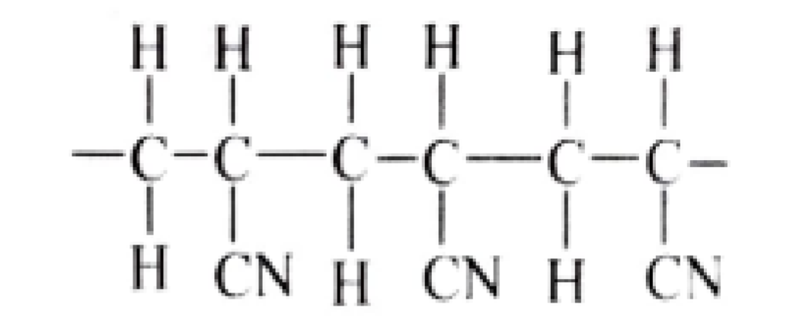
  - How many repeat units are shown in this structure? (1 mark)
……………………………………………………………………………………
  - Draw a structural formula of the monomer unit from which the polymer is made. (1 mark)
……………………………………………………………………………………………………………………………………………… ………………………………………………………………………………………………………………
  - State two disadvantages of using the above synthetic fiber. (2 marks)
………………………………………………………………………………………………………………………………………………
…………………………
  - Detergents contain additives that enhance their cleaning performance. Name two such additives. (2 marks)
………………………………………………………………………………………………………………………………………………
…………………………
  - Calculate the mass of ethanol that can be made from 56g of ethene. (2 marks)
………………………………………………………………………………………………………………………………………………
………………………………………………………………………………………………………………
  - An organic compound P is found on analysis to have the empirical formula C₆H₁₄O. Compound P is slightly soluble in water. On oxidation compound P is converted into a compound Q of empirical formula C₃H₆O and relative molecular mass 116. Both compound P and Q react with sodium metal liberating hydrogen gas.
  - To what class of compounds does compound P belong? (1 mark)
……………………………………………………………………………………
  - Draw the displayed structural formula of P. (1 mark)
……………………………………………………………………………………………………………………………………………… ………………………………………………………………………………………………………………
  - Deduce the molecular formula of Q and draw its displayed structural formula. (2 marks)
……………………………………………………………………………………………………………………………………………… ………………………………………………………………………………………………………………………………………………
…………………………………………………………………………………………………………………………………………
  - What other test would you carry out on Q to confirm the presence of the functional group you have indicated? (2 marks)
……………………………………………………………………………………………………………………………………………… …………………………
- ( a) During the electrolysis magnesium sulphate a current of 2 amperes was passed through the solution for 4 hours. Calculate the volume of the gas produced at the anode. (1 faraday 96,500 coulombs and volume of a gas at room temperature is
24,000cm³). (2 marks)
……………………………………………………………………………………………………………………………………………… ………………………………………………………………………………………………………………………………………………
……………………………………………………
  - Table gives standard reduction potentials for some half cells.
Half-cell | Half-cell equation | E^{θ} /V
I | Cr³⁺ (aq) + e⁻ → Cr²⁺ (aq) | -0.41
II | Cd²⁺ (aq) + 2e⁻ → Cd (s) | -0.40
III | Na⁺ (aq) + e⁻→ Na (s) | -2.71
IV | Cu²⁺ (aq) + 2e⁻ → Cu (s) | +0.34
V | Pb²⁺ (aq) + 2e⁻ → Pb (s) | -0.13
VI | Br₂ (aq) + 2e⁻ → 2Br⁻ (aq) | +1.07
VII | 2H⁺(aq) + 2e⁻ → H₂(g) | 0.00
VIII | Fe²⁺(aq) + 2e⁻ → Fe(s) | -0.44V
IX | O₂(g) + 2H₂O (l) + 4e⁻ → 4OH⁻(aq) | +0.40V
X | H₂O₂(aq) + 2H⁺(aq) + 2e⁻ → 2H₂O(l) | +1.23V
- Identify: (1 mark)
  - The strongest oxidizing agent.
……………………………………………………………………………………
  - The strongest reducing agent.
……………………………………………………………………………………
- Construct an electrochemical cell from half-cells V and VI. (3 marks)
- Write the equation and calculate the electrode potential for the electrochemical cell constructed from half-cells V and VI. (2 marks)
……………………………………………………………………………………………………………………………………………… ………………………………………………………………………………………………………………………………………………
……………………………………………………
- Explain why it is not advisable to use aqueous sodium sulphate as the salt bridge in the electrochemical cell formed between half-cells V and VI. (1 mark)
………………………………………………………………………………………………………………………………………………
…………………………
- Write the cell diagram for an electrochemical cell made using half-cells V and VI. (1 mark)
……………………………………………………………………………………
- Write an equation to show how rusting occurs.(2 marks)
………………………………………………………………………………………………………………………………………………
………………………………………………………………………………………………………………
- Give two reasons why electroplating is necessary. (2 marks)
………………………………………………………………………………………………………………………………………………
…………………………
4. Below is a periodic table grid study it and answer the questions. (The letters does not represent the actual symbols of the elements)
 |  |  |  |  |  |  |  | B
C | D |  | E |  |  |  | F
 | G |  |  |  |  |  | H
I
- Which element will require the least amount of energy to remove one of the outermost electrons. (1 mark)
……………………………………………………………………………………
- Select the most reactive metal. (1 mark)
……………………………………………………………………………………
- What name is given to the family of elements to which elements D and G belong? (1 mark)
……………………………………………………………………………………
- An element A has atomic number 9. Indicate the position of A on the grid.
(1 mark)
- Explain why the atomic radius of D is smaller than that of C. (1 mark)
………………………………………………………………………………………………………………………………………………
………………………………………………………………………………………………………………
- Explain why the atomic radius of A is smaller than its ionic radius. (2 marks)
………………………………………………………………………………………………………………………………………………
………………………………………………………………………………………………………………
- Element C combines with oxygen to from an oxide. Using dots (•) and crosses(x) to represent the outermost electrons, show how the two elements combine. (1 mark)
………………………………………………………………………………………………………………………………………………
………………………………………………………………………………………………………………………………………………
…………………………………………………………………………………………………………………………………………
- Explain why chloride of E has higher melting point than chloride of D. (2 marks)
……………………………………………………………………………………………………………………………………………… ………………………………………………………………………………………………………………………………………………
……………………………………………………
5. ( a) Describe how you can determine change in mass when magnesium is heated. (3 marks)
……………………………………………………………………………………………………………………………………………… ……………………………………………………………………………………………………………………………………………… ………………………………………………………………………………………………………………………………………………
………………………………………………………………………………
(b) The table below shows the tests that were carried out on five portions of a compound and the results obtained. Study it and answer the questions that follow.
 | Test | Observation
1 | Addition of few drops of sodium hydroxide to the first portion until in excess. | White precipitate soluble in excess.
2 | Addition of few drops of aqueous potassium iodide to the second portion | No yellow precipitate is formed.
3 | Addition of few drops of acidified barium nitrate to the third portion. | White precipitate formed.
4 | Addition of few drops of Lead (II) nitrate to the fourth portion. | White precipitate formed.
5 | Addition of few drops of dilute nitric (V) acid to the fifth portion. | Effervescence of a colorless gas.
- Identify the ions likely present in; (2 marks) I. Step 2
……………………………………………………………………………………
II. Step 5
……………………………………………………………………………………
- Write an ionic equation for the reaction in the fifth portion. (1 mark)
……………………………………………………………………………………
- Dilute nitric (V) acid was added to a solid which is an alloy of copper. The resultant mixture was then filtered. To the filtrate, few drops of sodium hydroxide solution was added till in excess.
  - Sate any two observations made when dilute nitric (V) acid is added to the alloy. (2 marks)
………………………………………………………………………………………………………………………………………………
………………………………………………………………………………………………………………
  - Name the other metal present in the alloy. (1 mark)
……………………………………………………………………………………
  - Write an ion equation for the reaction that took place when few and excess sodium hydroxide solution is added. (2 marks)
………………………………………………………………………………………………………………………………………………
…………………………
- ( a) Study the flow chart below and answer the questions that follow.
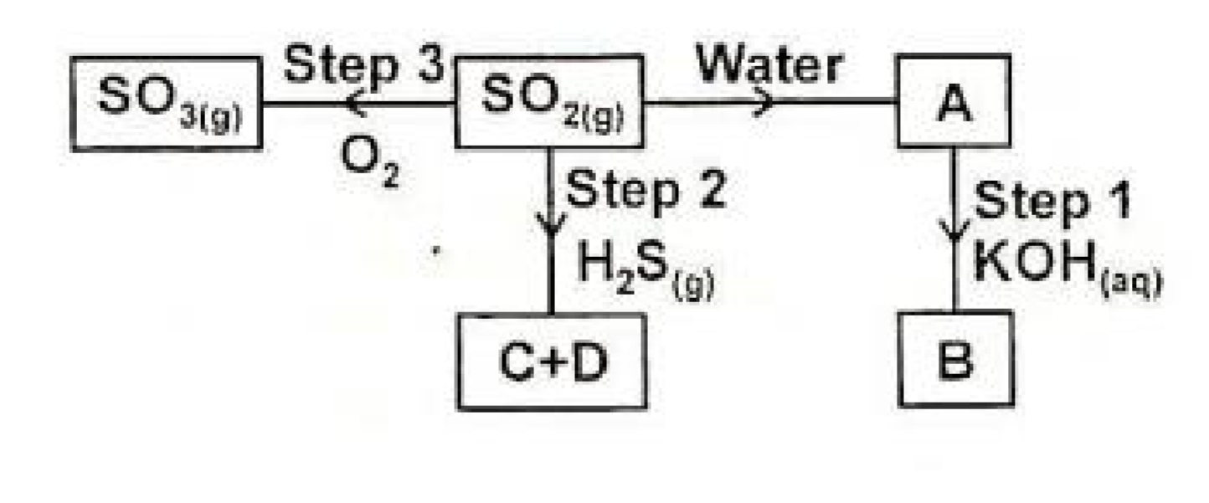
  - Name a suitable method of gas collection that can used to collect Sulphur (VI)
oxide gas in the laboratory. (1mark)
……………………………………………………………………………………
  - Name substances A, B, C and D. (2 marks)
……………………………………………………………………………………………………………………………………………… ……………………………………………………………………………………………………………………………………………… ……………………………………………………
  - State the property of Sulphur (IV) oxide exhibited in step 2. (1mark)
……………………………………………………………………………………
(b) (i) Explain the observations made when burning magnesium is lowered into a gas jar containing carbon (IV) oxide. (3 marks)
……………………………………………………………………………………………………………………………………………… ……………………………………………………………………………………………………………………………………………… ……………………………………………………
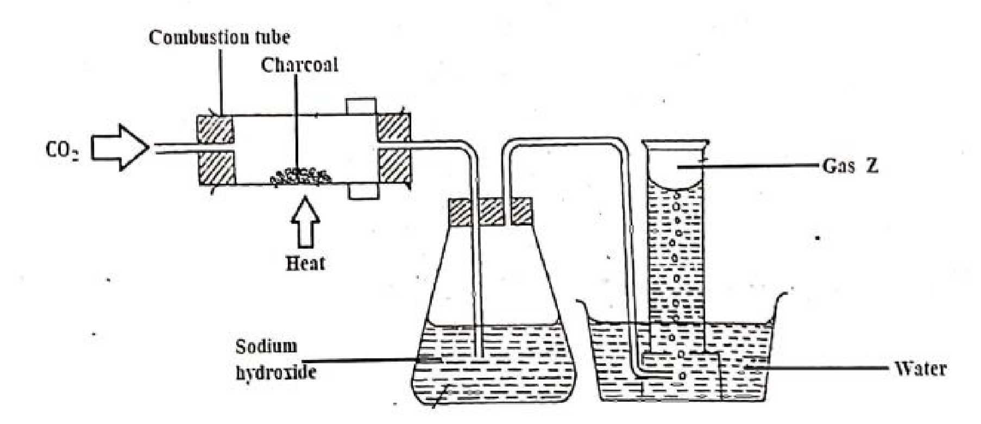

(
ii) Study the diagram below and answer the questions that follows.

Gas Z

CO

CuO

    - Name gas Z. (1 mark)
……………………………………………………………………………………
    - Write an equation for the reaction taking place in the combustion
tube. (1mark)
……………………………………………………………………………………
    - State and explain the observations made in the combustion tube. (1 mark)
………………………………………………………………………………………………………………………………………………
………………………………………………………………………………………………………………
- The flow chart in the figure below represents some stages in the extraction of lead metal. Study it and answer the questions that follow.
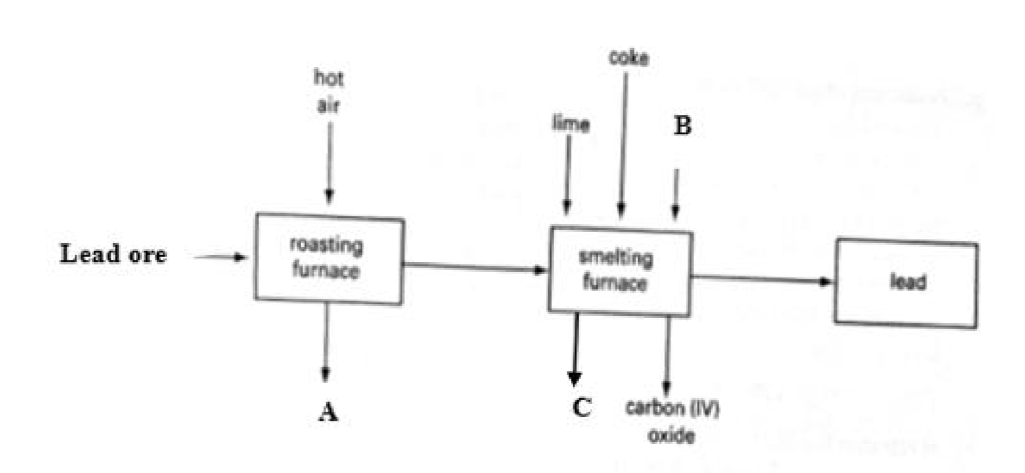
- Identify:
(i)The lead ore. (1 mark)
……………………………………………………………………………………
(ii)Substance A, B and C. (3 marks)
……………………………………………………………………………………
……………………………………………………………………………………
……………………………………………………………………………………
- Write an equation for the reaction that forms substance C. (1 mark)
……………………………………………………………………………………
- Name an impurity resent in the ore. (1 mark)
……………………………………………………………………………………
- State the process by which the ore is concentrated. (1 mark)
……………………………………………………………………………………
- Write an equation for the reaction which occurs in the roasting chamber.(1 mark)
……………………………………………………………………………………
- State any one use of lead.(1 mark)
……………………………………………………………………………………
- Give one reason why the extraction of lead causes pollution to the environment.(1 mark)
……………………………………………………………………………………
LAST PRINTED PAGE

