NAME: …………………………………………. INDEX NO: ……………………………….

SCHOOL: ……………..……………………… DATE : …………………………………..

CANDIDATE’S SIGNATURE:………………….



MANGU HIGH SCHOOL TRIAL 2 MOCK 2021

Kenya Certificate of Secondary Education (K.C.S.E.)
CHEMISTRY
PAPER 2
TIME: 2 HOURS
OCT/NOVEMBER 2021

INSTRUCTIONS TO CANDIDATES
- Write your Name, Index Number and School in the spaces provided above.
- Sign and write the Date of Examination in the spaces above.
- Answer all the questions in the spaces provided in the question paper.
- Mathematical tables and non-programmable electronic calculators may be used.
- ALL working must be clearly shown where necessary.

FOR EXAMINER’S USE ONLY
QUESTIONS | MAX SCORE | CANDIDATE’S SCORE
1  2  3  4  5  6  7 | 13  11  12  12  10  15  08
TOTAL | 80

- Study the information in the table below and answer the questions that follow.
The letters do not represent the actual symbols of the elements.
Elements | Electronic configuration | Ionization energy kJmol⁻¹
P | 2:1 | 519
C | 2:8:1 | 494
R | 2:8:8:1 | 418

- What is the general name given to the group which elements P, C and R belong? (1mk)

- What is meant by ionization energy? (2mks)

- Explain why element P has the highest ionization energy. (2mks)

- (a) When a piece of element “C” is placed on water, it melts and hissing sound is produced as it moves on the surface of the water. Explain these observations. (2mks)

(b) Distinguish between a strong and a weak base. Give an example of each. (2mks)

- Neutralization is one of the methods of preparing salts.
  - What is meant by neutralization? (1mk)

  - Describe how you would prepare crystals of sodium nitrate starting with 200cm³ of 2M sodium hydroxide. (3mks)

  - Write an equation for the reaction that takes place when a solid sample of sodium nitrate is heated. (1mk)

- The diagram below represents a set-up that was used to obtain dry nitrogen from air. Study it and answer the questions that follow.

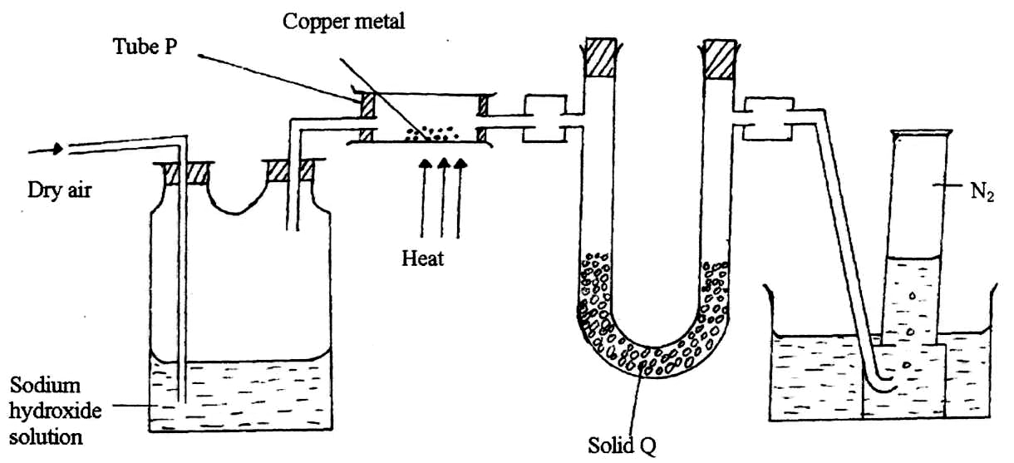

- Name solid Q. (1mk)

- What is the purpose of NaOH_{(aq)}? (1mk)

- Write an equation for the reaction which took place in tube P. (1mk)

- Give the name of one impurity in the nitrogen gas obtained. (1mk)

- Why is liquid nitrogen used for storage of semen for artificial insemination? (1mk)

(b) The set-up below was used to prepare nitric acid.

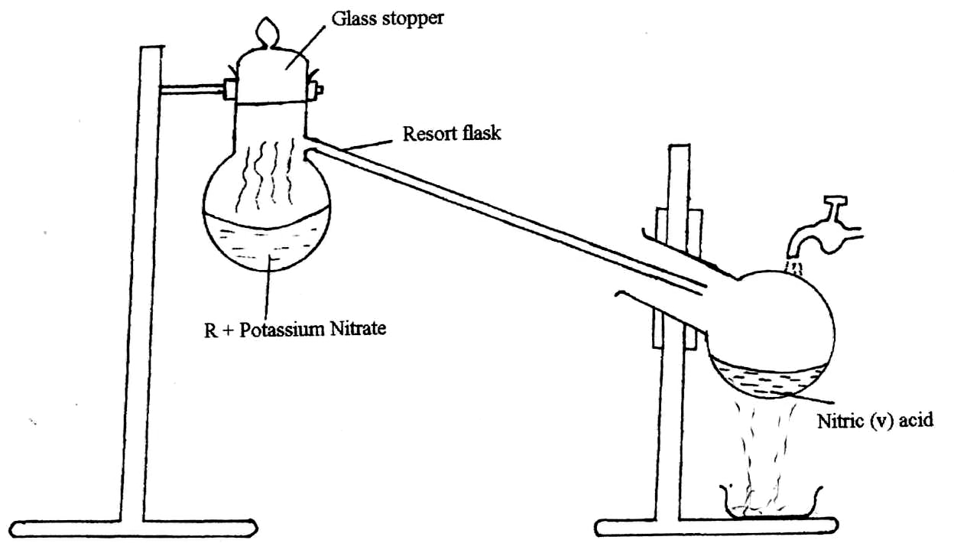

  - Give the name of liquid R. (1mk)

  - Write an equation for the reaction which took place in the retort flask. (1mk)

  - Explain the following:-
  - Nitric acid is not stored in clear / transparent glass. (2mks)

  - The reaction between copper metal with 50% nitric acid (one volume of acid added to an equal volume of water) in an open test tube produces brown fumes. (2mks)

- Chlorine is a member of group VII.
    - What is the family name of group VII elements? (1mk)

    - Explain why the reactivity of Iodine is lower than that of Bromine. (2mks)

    - Chlorine gas used for industrial purposes is obtained by electrolysis of brine.
- Name two other products of this electrolysis. (2mks)

- Write the equation for the reaction at the anode. (1mk)

    - Sodium chlorate (NaClO₃) is used as a herbicide. It is formed according to the following equation:
6NaOH_{(aq)} + 3Cl_{2(g)} NaClO_{3(aq)} + 5NaCl_{(g)} + 3H2O_{(l)}
Sodium chloride is less soluble than sodium chlorate and crystallizes out first. Sodium chlorate is obtained from the remaining solution by crystallization of saturated solution.
- State one condition necessary for this reaction. (1mk)

- Calculate the maximum mass of sodium chlorate in kilograms that can be formed from 206m³ of chlorine gas. (1 mole of gas = 24dm³, Na = 23.0, Cl = 16.0).
(3mks)

    - Name two other uses of chlorine. (2mks)

- (a) The table below contains information from the measurements made of the radioactivity in counts per minutes from a radioisotope iodine – 128.
Counts per min | 240 | 204 | 180 | 156 | 138 | 122 | 108
Time (min) | 0 | 5 | 10 | 15 | 20 | 25 | 30

- Plot a graph of counts per minute against time. (3mks)

- Use the graph to determine the half-life of iodine – 128. (1mk)

- What is the counts rate after 22 minutes? (1mk)

- After how many minutes were the counts rate 160 counts per minute? (1mk)

(b) If isotope 232 decays to 216 as a result of X alpha-particles and Y-beta particles
emission 90 83
- Find the numerical value of X and Y. (2mks)

- Write the nuclear equation. (1mk)

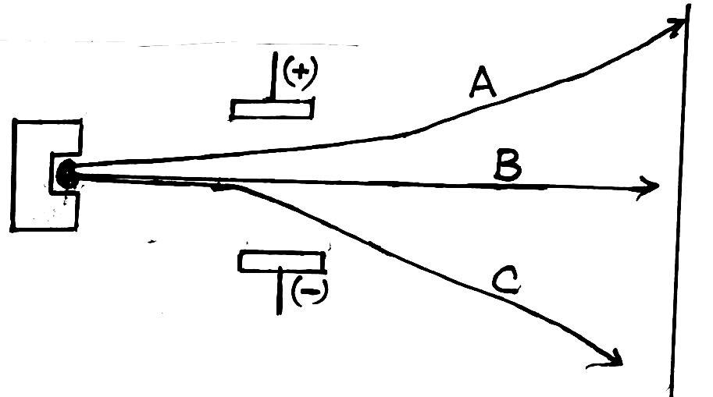
(c) A radioactive material emitted radiations as shown below.

- Identify: A (1½mks)

B

C
- Which radiation: (1½mks)
  - Has no mass?

  - Has the lowest ionizing power?

  - Contains Helium particles?

- The raw material for extraction of aluminum is bauxite.
    - Name the method that is used to extract aluminium from bauxite. (1mk)

    - Write the chemical formula for the major components of bauxite. (1mk)

    - (i) Name the major impurities in bauxite. (2mks)

(ii) Explain how the impurities in bauxite are removed. (1mk)

    - Crayolite is used in the extraction of aluminium from bauxite. State its function. (1mk)

    - Describe how carbon (IV) oxide is formed during the extraction of aluminium. (2mks)

    - Aluminum is a reactive metal yet utensils made from aluminium do not corrode easily. Explain this observation. (2mks)

- Standard electrode potentials for half cell reactions are shown below.
A²⁺_{(aq)} + 2e A_{(s)} - 0.76V
B²⁺_{(aq)} + 2e B_{(s)} - 0.13V
C⁺_{(aq)} + e C_{(s)} +0.80V
D²⁺_{(aq)} + 2e D_{(s)} +0.34V
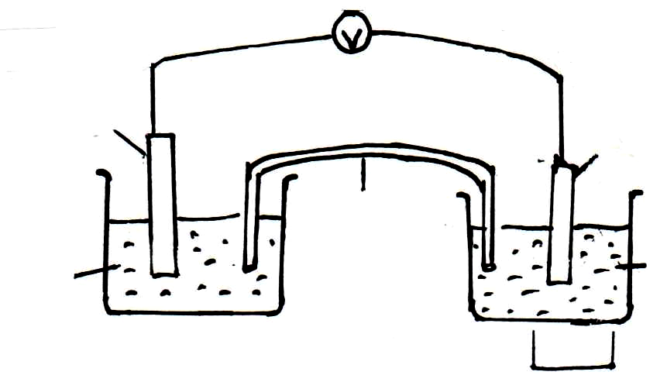
The cell below was set-up using A and B electrodes.

B
A

Salt bridge
B(NO₃)_{2(aq)} A(NO₃)_{2(aq)}

    - (i) Give the half-cell equations for each half cell. (1mk)

(ii) Write the overall cell equation. (1mk)

(iii) Calculate the e.m.f. of the cell above. (1mk)

(iv) Describe how the salt bridge helps in maintaining the change balance in each half cell when the cell is in operation. (2mks)

(v) It is not advisable to use potassium chloride salt bridge when Lead (II) nitrate solution is used as an electrolyte in the above set-up. Explain. (2mks)

    - Sodium hydroxide is a chemical that can be prepared industrially in a mercury cell.
- Give the name of the main raw material used. (½mk)

- In the cell, graphite is used as anode electrode. Name another substance that can be used in place of graphite (carbon). (½mk)

- Give two uses of sodium hydroxide. (2mks)

- Give two reasons why mercury is recycled. (2mks)

- Write the equation in which sodium hydroxide is produced. (1mk)

- If the volume of hydrogen produced in the mercury cell is 100 litres. Calculate the mass of sodium hydroxide formed at room temperature.
(H = 1.0, Na = 23.0, O = 16.0 MGV = 24 litres) (2mks)

- (a) Name two advantages of synthetic fibre over natural fibre. (2mks)

- The scheme below shows reactions starting with ethanol. Study it and answer the questions that follow.
R

Excess Cl_{2(g)} in the
Presence of light

S
CH₃ CH₃

Soda lime + Step II
Heat
CH₃ COONa
J
CH₂ = CH₃
Polymer Q
HCl Step III

NaOH

Step IV Na_{(s)}
CH₃ COOH
CH₃CH₂OH
Gas G and compound H

Step V CH₃CH₂OH +
Conc. H₂SO₄
Compound T

- Name gas G. (1mk)

- Write the structural formulae and names of:
    - T (1mk)

    - S (1mk)

- Name the homologous series to which T belongs. (1mk)

- Write down the structural formula of compound R. (1mk)

- Name the compound R. (1mk)

