

1. Explain why very little Carbon (IV) oxide gas is evolved when dilute sulphuric (VI)

acid is added to lead (II) carbonate. (2 marks)

***Insoluble Lead (II) sulphate is formed preventing any further reaction.1***

1. Air was passed through several reagents as shown below:

Concentrated sodium hydroxide solution

Air

Excess copper turnings hydroxide solution

Escaping

gases

Excess heated magnesium powder

(a) Write an equation for the reaction which takes place in the chamber containing magnesium

powder. (1 mark)

***3Mg (s) + N2 (g) → Mg3 N2( s) 1***

(b) Name **one** gas which escapes from the chamber containing magnesium powder. Give a

reason for your answer. (2 marks)

***Argon1***

***- It is inert1***

1. (a) Hydrogen can reduce copper (II) Oxide but not aluminium oxide. Explain. (1 mark)

***Hydrogen is above Cu √½ and below Al in the reactivity series√½ of elements.***

(b) When water reacts with potassium metal, the hydrogen produced ignites explosively on the

surface of water.

(i) What causes this ignition? (1 mark)

***The reaction is too exothermic that a lot of heat is produced causing ignition of***

***hydrogen in presence of oxygen.***

(ii) Write an equation to show how this ignition occurs. (1 mark)

***H2 (g) + O2 (g) → H2O (g)***

1. In an experiment an unknown mass of anhydrous sodium carbonate was dissolved in water

and the solution made up to 250 cm3. 25cm3 of this solution neutralized 20 cm3 of 0.25 M

nitric acid. Calculate the mass of unknown sodium carbonate used. (3 marks)

(Na = 23.0, C = 12.0, O = 16.0)

***Na2CO3 (aq) + 2HNO3 (aq) → 2NaNO3 (aq) + CO2 (g) + H2O (l)***

***Mole ratio Na2CO3:HNO3 = 1:2√½***

***Moles of HNO3 in 20 cm3 = 20/1000 × 0.25 = 0.005 moles√½***

***Moles of Na2CO3 in 25 cm3 = ½ of 0.005 = 0.0025 moles√½***

***If 25cm3 = 0.0025 moles***

***in 250cm3 = ?***

***250 x 0.0025 = 0.025 moles√½***

***25***

***RFM of Na2CO3 = 106√½***

***I mole of Na2CO3 = 106 g***

***0.025 moles =?***

***0.025 x 106 = 2.65g of Na2CO3√½***

***1***

1. Carbon and silicon belong to the same group of the periodic table, yet Carbon (IV) oxide

is a gas while silicon (IV) oxide is a solid with a high melting point. Explain this difference

(2 marks)

***Silicon (IV) Oxide has giant atomic structure√½with strong covalent bond√½holding the***

***atom together. These require a lot of energy to break, hence it has high melting point.***

***Carbon (IV) Oxide has simple molecular structure√½with weak Van Der Waals forces√½***

***holding the molecules together which require little energy to break, hence is a gas at room***

***temperature and pressure.***

1. An ion of oxygen is larger than oxygen atom. Explain. (2marks)

***The oxide ions has 2 extra electrons √½ that causes greater electron repulsion than in***

***oxygen atom√½***

1. (a) What is meant by the term solubility of salts? (1 mark)

***This is the maximum mass of a salt that will dissolve in 100 g of water at a given***

***temperature√1***

(b) Calculate the solubility of a salt given that 15 g of the salt can saturate 25 cm3 of water.

(1 mark)

***15 g dissolve in 25 cm³ water***

***x g dissolve in (15x100) √½ = 60g/100g water√½***

***25***

1. (a) State the Graham’s law. (1 mark)

***Grahams law states;***

***Under the same conditions of pressure and temperature, the rate of diffusion of a***

***gas is inversely proportional to the square root of its density. √***

(b) A 100 cm3 of Carbon (IV) oxide gas diffused through a porous partition in 30seconds.

How long would it take 150 cm3 of Nitrogen (IV) oxide to diffuse through the same

partition under the same conditions?) (C = 12.0, N = 14.0, O = 16.0) (2 marks)

***Time CO2 = √ MCO2***

***Time NO2 √ MNO2***

***Where 100cm3 of CO2 takes 30 seconds***

***∴ 150cm3 of CO2 takes 30/100 x 150 = 45 seconds √½***

***45 = √44***

***TNO2 √ 46***

***45 = 0.975***

***TNO2***

***TNO2 = 45 √½ = 46 sec √½***

***0.97***

***OR***

***RCO2 = √MNO2***

***RNO2 √ MCO2***

***But RCO2 = 100cm3 = 3.33 cm3 per sec√½***

***30 s***

***3.33 = √46 √½ = 1.0225***

***RNO2 √ 4***

***RNO2 = 3.33√½***

***1.0225***

***= 3.26 cm 3 per second***

***Time for No = 150 cm3***

***3.26cm sec -1 = 46 sec√½***

1. Given this reaction; RNH2 + H2O RNH3+ + OH-

Identify the acid in the forward reaction. Explain. (2 marks)

***The acid is water H2O: Reason H2O has donated a proton (H+) to*** ***RNH2***

1. The table below shows three isotopes of element neon. Study it and answer the questions that follow;

|  |  |
| --- | --- |
| Mass number of Isotope | Percentage abundance (%) |
| 20 | 90.9 |
| 21 | 0.3 |
| 22 | 8.8 |

a) What are isotopes (1mk)

***Atoms of the same element with different mass numbers.***

b) Calculate the relative atomic mass of an atom of neon. (2mks)



***= 18.18 + 0.063 + 1.93***

***= 20.173***

1. A gas occupies 0.4dm3 at 200c and 1.0 x 103Pascals what will be the temperature of the gas when the volume and pressure of the gas when the volume and pressure of the gas is

0.1dm3 and 1.0 x 103Pascals respectively. (3mks)





***T2 = 1.0 x 103 x 0.1 x 293***

***1.0 x 103 x 0.4***

***= 73.25k***

1. (i) On complete combustion of a hydrocarbon 0.88g of carbon (iv) oxide and 0.36g

of water were formed (i) calculate the molecular formula of the hydrocarbon

given that relative molecular mass of the hydrocarbon is 70. (c = 12, H = 1, O = 16) (2mks)

***CO2 H2O***

***0.88 0.36***

***44 18***

***0.02 0.02***

***~~0.02~~ ~~0.02~~***

***~~0.02~~ ~~0.02~~***

***1 1***

***Mole ratio CO2 : H2O = 1:1***

***E.F = CH2***

***(CH2)n = 70***

***14n = 70***

***N = 70 = 5***

***14***

***M.F = (CH2)5 = C5H10.***

ii) Draw the structural formular of the hydrocarbon in (i) above (1mk)

***H H H H H H***

***│ │ │  │ │***

***H C C C C = C or H C C = C ─ C H***

***H H H H H H H H H***

***Or***

***H H H***

***H C C C=C***

***H H H***

***H C H***

***H***

1. 0.28g of aluminium reacted completely with oxygen gas. Calculate the volume of oxygen used. (molar gas volume is 24000cm3 Al = 2.7) (3mks) ***4Al(s) + 3O2(g) →2Al2O3(s)***

***Mole ratio 4:3***

***No. of moles of Al = 0.28***

***27***

***= 0.01 moles***

***No. of moles ofAl = 0.28***

***27***

***=0.01moles***

***No. of oxygen = 0.01 x 3***

***4***

***= 0.0075moles***

***Volume of oxygen gas = 0.0075 x 24000***

***= 180cm3***

1. A solution of bromine in water is a chemical reaction in equilibrium. The reaction

involved is represented by the equation below;

Br2(aq) + H2O(l) 2H+(aq) + Br-(aq) + OBr-(aq)

Yellow Colourless

State and explain the observation made when concentrated sulphuric (IV) acid is added to the mixture at equilibrium. (2mks)

***Yellow colour intensifies***

***Conc. H2SO4 is a dehydrating agent hence removes water from the sytem making the equilibrium to shift to the left.***

1. Study the table below and answer the question that follow. The letters do not represent

the actual symbols of the element.

Formula of ion Electron configuration

W2+ 2

V2- 2.8

X3+ 2.8

U2+ 2.8

Y- 2.8.8

a) Select elements found in;

i) the same group (1mk)

***W and U***

ii) period three (1mk)

***Y X and U***

b) What is the family name given the group members to which element Y belongs

(1mk)

***Halogens***

1. Study the diagram below and answer questions that follow

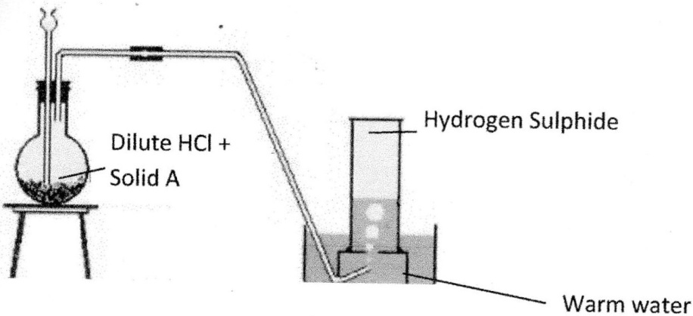

1. Identify solid A (1mk)

***iron (ii)sulphide***

1. Give a reason why warm water is used (1mk)

***Hydrogen sulphide is less soluble in warm water***

1. What observation would be made if hydrogen sulphide gas was bubbled into a solution of lead (II) nitrate. (1mk)

***Black precipitate is formed***

1. Study the table below and answer the questions that follow

|  |  |  |  |  |  |  |
| --- | --- | --- | --- | --- | --- | --- |
| Substance | A | B | C | D | E | F |
| Melting Point (°C) | 801 | 113or 119 | -39 | 5 | -101 | 1356 |
| Boiling Point (°C) | 1410 | 445 | 457 | 54 | -36 | 2860 |
| Electrical solid | Poor | Poor | Good | Poor | Poor | Poor |
| Conducting Liquid | Good | Poor | Good | Poor | Poor | Poor |

Identify with reasons the substances that

1. Have a metallic structure (1mk)

***C Good conductor of electricity in both solid and liquid state due to delocalized electrons***

1. Have a molecular structure (1mk)

***D or E***

* ***Poor conductors of electricity in both solid /Liquid state***
* ***Have relatively low M.P and B.P due to molecular structure***

1. Suggest a reason why substance B has two melting points (1mk)

***Exits as allotropes***

1. Sodium Hydrogen carbonate was heated strongly in the laboratory by a student
2. Write a balanced chemical equation for the above equation (1mk)

***2NaHCO3(s) Na2CO3(s) + H2O(l) + CO2***

1. Using an equation show how sodium carbonate is used to soften hard water (1mk)

***Na2CO3(s) + MgSO4(aq) Na2SO4(aq) + MgCO3(s)***

1. Draw the structural formula and name the possible isomers of organic compounds with the following molecular formula C3H7Br. (2mks)

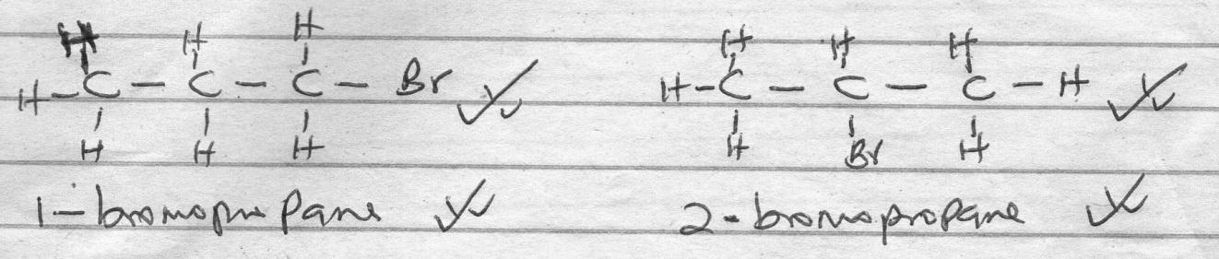

1. Study the chart below and answer the following questions

Green Solid W

Black Powder K

Blue Solution

Heat

Dilute H2SO4

+ Gas X that forms white

PPT with Ca(OH)2(aq)

1. Name
2. Green solid W (1mk)

***solid W-Copper (ii) Carbonate***

1. Black powder K (½ mk)

***Powder K-Copper (ii) Oxide***

1. Gas X (½ mk)

***Gas X–Carbonate (iv) Oxide***

1. Write the equation for the complete decomposition of the green solid W identified above (1mk)

***CuCO3(s) heat CuO(s0 + CO2(g)***

***(if heat is missing penalize fully)***

1. The PH values of solutions K, L, M, N and P are as shown below.

|  |  |  |  |  |  |
| --- | --- | --- | --- | --- | --- |
| Solution | K | L | M | N | P |
| PH Value | 5 | 2 | 10 | 7 | 14 |

1. Which solution reacts with zinc carbonate most vigorously to liberate carbon (IV) oxide. (1mk)

***L***

1. Given 2M hydrochloric acid and 2M ethanoic acid, which one is a stronger acid? Explain.

(1mk)

***2M hydrochloride acid because it ionizes completely***

1. What is the purpose of the weak base in the toothpaste? (1mk)

***To neutralize the acidic substance left by the bacteria after consuming the food remains in the Mouth and on the teeth***

1. Study the diagram shown below to answer the questions that follow. The curve shows the

heating curve of water in the laboratory.

A

B

C

D

E

1080C

1000C

Temp 0C

Time (Min)

(i) At what temperature does the water boil? (1 Mark)

***Between (100 and 108)0C. ✓1***

(ii) Is the curve for a pure water or impure water? Give a reason for your answer (1 Mark)

***Impure water ✓ (½ Mark)***

***It boils over a temperature range √ (½ Mark)***

(iii) Give the effect of impurities on the boiling point of water (1 Mark)

***It raises the boiling point of the water. ✓1***

1. A student lowered burning magnesium in a gas jar of carbon (IV) oxide as shown in the

diagram.

Magnessium

ribbon

Gas jar

CO2

(a) State and explain the observation made in the gas jar (2 Marks)

***The magnesium continue to burn ✓ (1 mark) in the gas jar producing a white solid i.e.***

***magnesium oxide and black specs i.e. carbon. This is because the heat produced***

***decomposes ✓ (1 mark) CO2 (g) to carbon and oxygen which supports the burning of***

***magnesium.***

(b) Write the equation of the reaction that takes place in the gas jar (1 Mark)

***2Mg(s) + CO2(g) 2MgO(s) + C(s) ✓ (1 mark)***

1. (a) Using a dot (•) and cross (x) to represent the outer most electrons, draw diagrams to

show the bonding in magnesium sulphide. (1½ Marks)

**✓ ( ½ Mark) ✓ ( ½ Mark)**

Mg2+

S2-

2+

2-

•

•

•

•

•

•

•

•

•

•

x

x

x

x

x

x

**✓ ½ mark – *charges shown on both ions***

(b) State the structure of the above compound. ( ½ Mark)

***Giant ionic structure ✓ ½ mark***

(c) Give two properties of substances with the above structure (1 Mark)

***- Have high melting and boiling points ✓ ½ marks***

***- Conducts electricity in molten or aqueous state ✓ ½ mark***

***- Soluble in polar solvents like water ✓ ½ mark Any 2 for ½ m = 1m***

1. Given sodium carbonate solid, lead (II) nitrate solid and water, explain how you can obtain

a solid sample of Lead (II) carbonate. (3 Marks)

***Put the sodium carbonate salt into water in a test tube and stir to form a solution of the***

***salt✓ ½. Put the Lead (II) nitrate in water in a test-tube too and stir to make a solution***

***of the salt ✓ ½ . React equal portions ½ of the two solutions in a boiling tube where***

***Lead (II)carbonate ½ is precipitated out at the bottom. Filter the mixture ✓ ½ to obtain***

***Lead (II)carbonate precipitate as residue. Wash it with distilled water and dry it between***

***two blotting✓ ½ papers to obtain dry crystals of the salt.***

1. The diagram below shows part of Solvay process.

K

J

L

Brine

with ammonia

Carbon (IV) Oxide

NH4Cl(aq)

NaHCO3 (s)

Solid x

Solid Y

1. Name solid X (1 Mark)

***Calcium oxide// Quick line ✓ 1 mark***

1. State the process taking place in chamber L (1 Mark)

***Filtration// Fractional crystallization/ crystallisation of NaHCO3. ✓ 1***

1. State two uses of sodium carbonate (1 Mark)

***- Manufacture of glass***

***- Water softening***

***- Manufacture of NaOH***

***- Manufacture of laundry detergents***

***- Paper making process***

***- In textile***

1. The scheme below shows some reactions starting with ethyne. Study it and answer the questions that

follow.

CHBrCHBr

HC≡CH

CH2CH2

Substance N

Conc.

H2SO4

Substance X

1 mole

HBr (g)

Reagent M

Pt (s)

+

Reagent Y (1 Mole)

(a) name substance (i) ***X Bromo ethene ✓ ½ mark*** ( ½ Mark)

(ii) ***N Ethyl hydrogen sulphate ✓ ½ mark***  (½ Mark)

(b) Name reagent M – ***Bromine gas ✓ ½ mark*** (½ Mark)

1. Ethene undergoes polymerization to form a polymer. Give an equation for the reaction and name the product. (1½ marks)

***✓ 1 mark***

n

=

=

n

***Polyethene ✓ ½ mark***

1. A solution of hydrogen chloride gas in water conducts an electric current, while that of

hydrogen chloride in methylbenzene does not conduct. Explain. (3 Marks)

***A solution of HCl (aq) in water conducts because its ionic i.e. it contains H+ (aq) and Cl(aq)***

***While a solution of HCl in methylbenzene is molecular and molecules do not conduct***

***electricity.***

1. A mixture of ammonium chloride and sodium nitrate was heated together in a round

bottomed flask to produce gas x.

(i) Identify gas x (½ Mark)

***Nitrogen (I) Oxide// N2O(g) ✓ ½***

(ii) Write equations to show how gas x is formed. (2 marks)

***NH4Cl(s) + NaNO3(s) NH4NO3(s) + NaCl(s) ✓ 1***

***NH4NO3 (s) N2O(g) + 2H2O(l) ✓ 1***

(iii) Why would gas x not be collected over cold water? (½ mark)

***The gas dissolves in cold water ✓ ½***