SET 8
CHEMISTRY PAPER 3
MARKING SCHEME

- a) graph
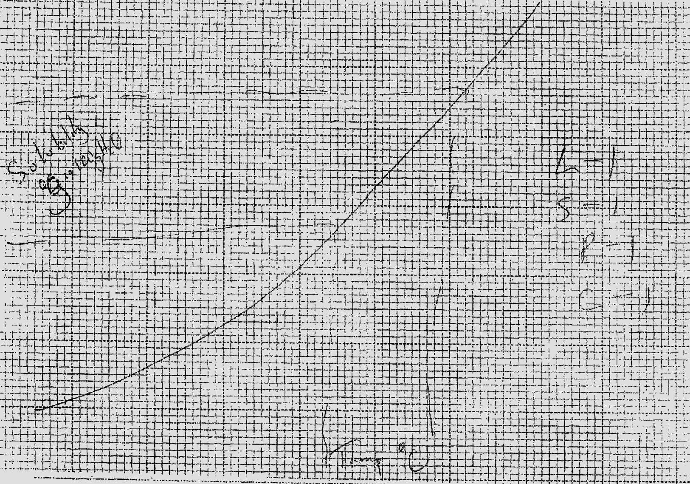

- From graph (shown)
- From graph
Procedure II
Table II
- 27.8 – 28.2 = + 0.2

- 0.3m x 25 = 0.0075mol
1000
- H₂X_{(aq)} + 2NaOH_{(aq)} Na₂X_{(aq)} + 2H₂O
2 0.0075 = 0.00375
2
- 0.00375 tilter
? 250
Answer 5g
1 mole ?

- Answer in IV = 90 + 18x
18x = Answer in IV – 90

- i)
Observation Inference
- Cracking sound - Acidic gas
- Brown fumes - NO⁻₃
- Litmus turns red
- Relights glowing splint

ii)
Observation Inference
- Dissolve - Absence of
Colourless solution coloured ions
Fe²⁺, Fe³⁺, Cu²⁺
iii)
Observation Inference
- Yellow ppt - Pb²⁺ present

iv)
Observation Inference
- White ppt dissolves - Pb²⁺ presence
On warming

v)
Observation Inference
- White ppt - Pb²⁺, Al³⁺, Zn²⁺
dissolve in excess

vi)
Observation Inference
- White ppt - Pb²⁺ confirmed
Insoluble

- a)
Observation Inference
- Dissolve to form - Polar substance
A colourless solution

b)
Observation Inference
- Prevalence - H⁺

c)
Observation Inference
- PH - Strongly acidic

d)
Observation Inference
- Pleasant small - R – COOH
Oily liquid

