CHEMISTRY – PAPER 3 SET 5

233/3
CHEMISTRY
Paper 3
CONFIDENTIAL
Time: 2¾ hours

- Solution P (KMnO₄)
- Solution Q - (Oxalic acid 0.05m)
- Solution R (Containing 4.9g of (NH₄)₂SO₄ FeSO₄ 6H₂O in 250cm³ solution).
- 50ml measuring cylinder
- 5 test tubes
- 1 boiling tube
- 250ml glass beaker
- Thermometer
- Stopwatch
- Burette
- Pipette
- Two conical flasks.
- About 1g solid B - (ZnSO₄)
- Distilled water
- About 0.5g of solid L. (Oxalic acid)
- Litmus papers
- Metallic spatula
- Means of heating
- Sodium hydroxide solution
- Ammonia solution
- Barium nitrate solution

MAKING SCHEME

1. I. - Complete table. √¹overleaf for expected values
- Correct use of decimals.√¹
- Accuracy. √¹
- Trend of values. √¹
- Correct arithmetic, I/t √¹
Table I
Temp (⁰C) | 40 | 50 | 60 | 70 | 80
Time (sec) | 74 | 43 | 22 | 11 | 7
1/t (sec-1) | 0.0135 | 0.0232 | 0.0455 | 0.0909 | 0.1428

i) – Correctly labeled axes√¹- Overleaf for graph.
- Correct scale √¹
- Correctly plotted points and curve. √¹

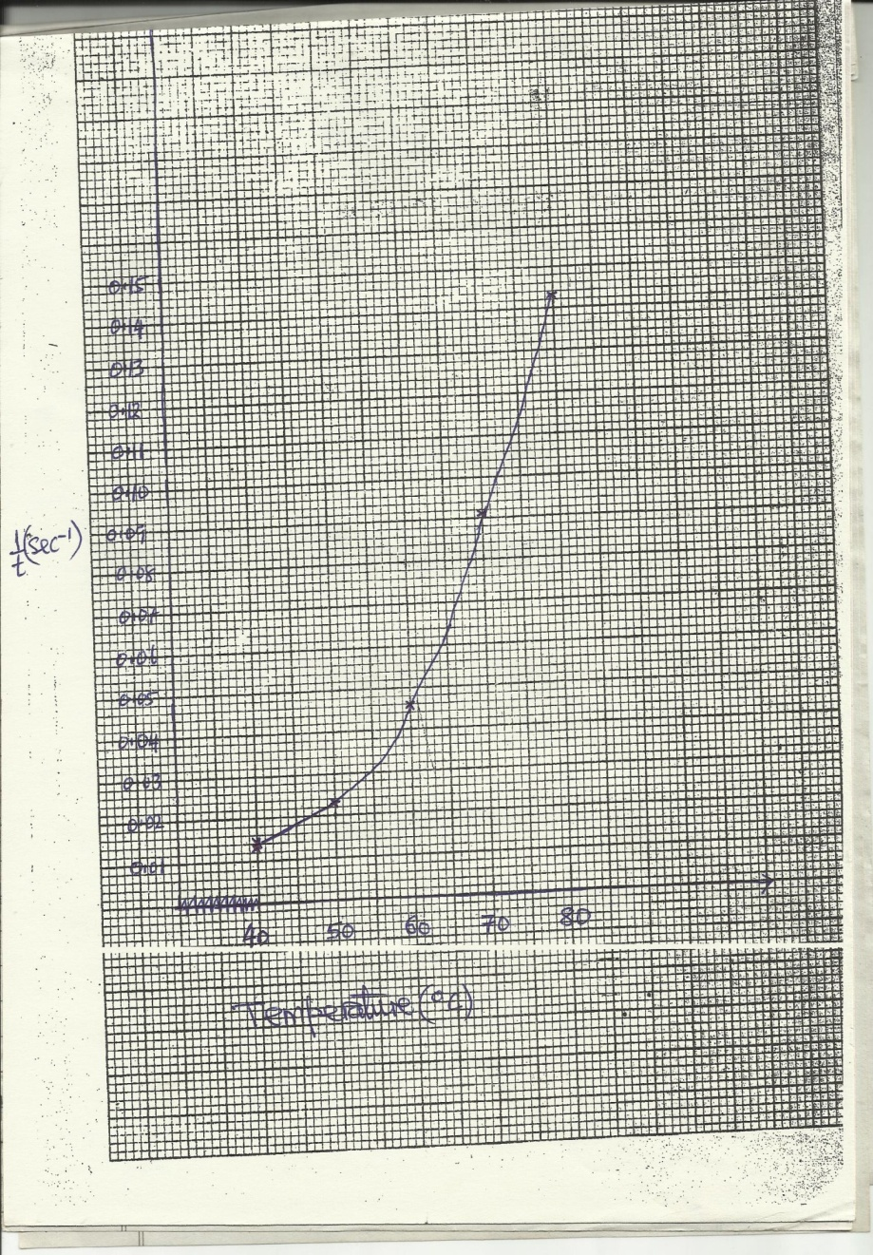

ii) I/t = 0.06√¹
t = 1__
0.06
= 16.67 seconds√¹
iii) Rate of reaction increase with increase in temperature / rate of reaction almost doubles with every 10⁰C rise in temperature.√¹
II. – Complete table √¹
- Correct use of decimals √¹
- Correct arithmetic √¹
- Accuracy (Penalise if table is inverted. Accuracy with 1.0 cm³ S.V) √¹

^{Table II}
 | I | II | III
Final burette reading (cm³) | 12.9 | 25.7 | 38.5
Initial burette reading (cm³) | 0.0 | 12.9 | 25.8
Volume of solution P used (cm³) | 12.9 | 12.8 | 12.7
i) Average titre = (12.9+12.8+12.7) cm³
3
= 12.8 cm³√¹
ii) RFM of (NH₄)₂ SO₄. FeSO₄.6H₂O = 392
Concentration = 19.6 √¹
392
= 0.05 mole dm⁻³√¹
iii) Moles of R used = 0.05x25 moles√¹
1000
= 0.00125 moles.
iv) Moles of P used = x 0.00125 moles√¹

= 0.00025 moles
v) 12.8cm3 of P 0.00025
1000cm3 of P 0.00025 x 1000 mole dm⁻³√¹
12.8
= 0.0195 mole dm⁻³√¹ Total 22 marks

2.i)
Observations | Inferences
Colourless gas that condenses on cooler parts forming a colourless liquid. √¹ | B contains water of crystallization / B is Hydrated. √¹
ii)
Observations | Inferences
Dissolves forming a colourless solution√¹ | No coloured ions in B e.g. Fe²⁺ ions,. Fe³⁺ ions or Cu²⁺ ions√¹

Observations | Inferences
Forms white precipitate soluble in excess forming a colourless solution. √¹ | Presence of Zn²⁺ ions, Pb²⁺ ions or Al³⁺ ions√¹

Observations | Inferences
No precipitate forms. √¹ | Absence of Pb²⁺ ions / presence of Zn²⁺ions or Al³⁺ ions. √¹

Observations | Inferences
Forms white precipitate soluble in excess forming a colourless solution. √¹ | Presence of Zn²⁺ ions √¹

Observations | Inferences
White precipitate is formed. √¹ | Presence of SO₄²⁻ ions√¹
Total 12 marks
3. a i)
Observations | Inferences
Solution is decolorized√¹ | C = C , - C ≡ C -
ii)
Observations | Inferences
Paper turns pink√¹ | R-COOH/H⁺

b)
Observations | Inferences
Burns with a smoky flame. √¹ | C = C , - C ≡ C -

Total 6 marks

