SET 6

233/2 PHYSICS MARKING SCHEME.

1. a) i) F ✓1

ii) Abudant in earth crust✓½ and reacts with water to form alkalines solutions ✓½

b) W is bigger than T✓1 **OR** T is shorter than W. This is because of increased nuclear charge across the period✓1

c) R ✓1and N✓1 or N✓1 and R✓1

d) Y + e Y-✓1

e) i) DCl2 ✓½

ii) W (NO3)3✓½

f) i) Ionic ✓½ / electrovalent

ii) Covalent✓½

g) Y is liquid while N✓½ is a gas. N is a molecular compound with van der waals forces while Y is a liquid with strong covalent bonds✓½

h) i) Energy required to remove an electron from an atom in gaseous form✓1

ii) The 2nd electron is being removed from a stable energy level✓1

iii) 420 + 3,100 + 4,800 = 8,320

1. I) a) i) B – CH3COO CH2 CH2 CH3

A – CH3 CH2 CH2 Na ✓1

b) i) Type – oxidation ✓1

Reagent – Acidified KMno4 / K2 Cr2 O7✓1

ii) Type – Dehydration✓1

Reagent – Conc H2SO4✓1

iii) Type – Hydrogenation ✓1

Reagent – presence of Nickel catalyst✓1

c) NaoH

d)

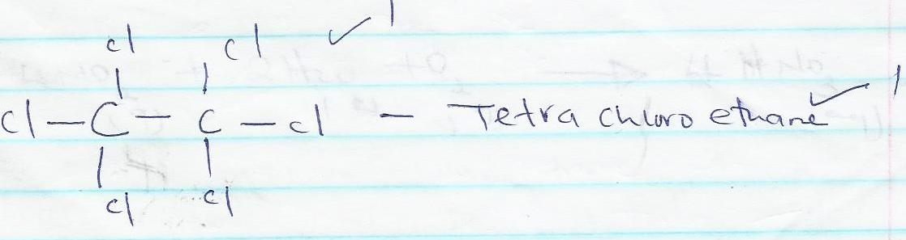

e) 2 dibromopropane✓1

f) Has a sweet smell✓1

II) i) Polythene✓½

Polychloro ethane✓½

ii)

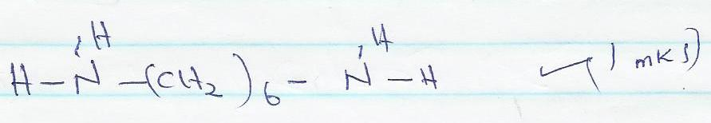

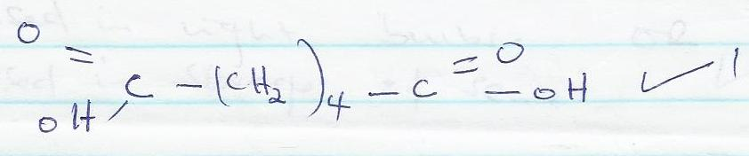

1. a) i) carbon IV oxide✓

ii) Dust particles✓

iii) Water vapour etc✓

any one

b) Heat reactants ✓1 **OR**

Cool reactants

c) 4NO2(g) + 2H2O(l) + O2(g) 4HNO3(aq) ✓1

d) W – Ammonia gas✓1

U – Water✓1

V – Nitrogen gas✓1

e) NH4NO3✓1

f) Used in light bulbs✓1 OR

Used in storage of semen

g) Mass of (NH4)2SO4 = 28 + 8 + 32 + 64 = 132 ✓½

if 28g 132g

? 6.6✓½

✓½

✓½

1. a) Solvent front ✓1

b) Y is more soluble than X ✓1 **or**

Y has a lower absorption power

c) Z is insoluble in the solvent✓1

d) i)

|  |  |  |  |  |
| --- | --- | --- | --- | --- |
| Volume |  |  |  |  |
| Pressure |  |  |  |  |
| Product | 3.0✓½ | 3.0✓½ | 3.0✓½ | 3.0✓½ |

ii) Volume is inversely proportional to pressure ✓1

e) i) Heat change when 1 mole of a compound is formed from its elements ✓1

ΔHf

ii) 2C + 3H2 + ½ O2 C2 H5 OH

O2

2O2

ΔH1

3O2

ΔH2

ΔH3

2 CO2 + 3 H2O

ΔHf + Δ H3 = 2 ΔH2 + 3H2(g)

ΔHf + Δ H1 = 3 ΔH2 – ΔH3

= (2 x 393.5) + (3x – 285.8) + 1370✓1

= -787 + -857.4 + 1370✓1

= 274.4 KJ Mol-1✓1

1. a) i) Chlorine gas✓1

ii) To maintain sodium chloride in molten form to allow ions to be mobile to conduct electricity✓1

iii) Carbon in graphite is resistant to attack by chlorine✓1

iv) To prevent chlorine from mixing with sodium to form sodium chloride✓1

b) i) To remove magnesium oxide layer on the surface ✓1

ii) Bright white flame / light or white powder

iii) a) Hydrogen gas✓1

b) concentrated sulphuric✓1

iv) Mg(s) + H2O(g) MgO(s) + H2(g) ✓1

1. I) a) element N✓½, it has the lowest reduction potential and would thus get easily oxidized at the expense of iron✓½

b) i) Eθ = E reduction – E oxidation✓½

Eθ = 0.80 – (-0.76) ✓1

Eθ = +1.56✓½

ii)

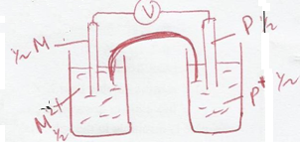

II) a) At A = oxygen gas✓½

at B = Hydrogen gas✓½

b) At electrode A

4OH-(aq) 2H2O(l) + O2 + 2e-✓1

At electrode B

2H+(aq) + 2e- H2(g) ✓1

III) CU 2+ (aq) + 2e- CU(s)

Therefore 63.5g of copper requires 193,000C

1.48g = ?

= ✓1

= 4498.2677 C✓½

Since Q = It

Then I = = ✓1 = 0.4998075

= 0.499807 5 Ampheres ✓½

1. a) The maximum amount of solute that can dissolve in 100g of water at a given temperature

b) i) Axes ✓1

Plots✓2

Curve✓1

ii) Solubility decreases as temperature increases✓1

iii) Unsaturated✓1

iv) a) increase✓1

b) 70oC = 16.0g ✓½

20oC = 140

Mass = 140 – 16g

= 124 ✓1