**SET 3**

**MARKING SCHEME**

**Chemistry paper 2**

1. (a)Magnesium Oxide (1mrk)

(b)2Mg(s) +O2(g) →2MgO(s) (1mrk)

(c) (i)sodium sulphate (1mrk) (ii)MgCO3 (1mrk)

(d)MgO (s) + H2SO4(aq)  →MgSO4(aq) + H2O(l) (1mrk)

(e)Mg2+(aq) +CO2-(aq) →MgCO3(s) (1mrk)

*(f)slaked lime(calcium hydroxide) forms white ppt (CaCO3) which finally turns to a clear solution due to formation of Ca(HCO3*)2 *(1mrk)*

*(g)Na+ ions and SO2-4 ions (1mrk)*

2 a)i) A –V

B - II

C - I

D – III (1/2 mark each)

ii) D2O3

iii) Ionic, the atom of C losses one electron to fluorine to form ionic bond.

b) i) element D.it is anon-metal thus it has no delocalized electrons (1½mks)

ii) Period 4.it has four energy levels (1½mks) 1

c)

 2mks

d) B has strong metallic bonding than A, due to the three electrons in the outermost energy

Level that contributes to electron pool. B Has higher effective nuclear charge/strong force of attraction. (2mks)

3. a)i) Zn(s) Zn2+(aq) + 2e 1mk

Pb2+(aq) + 2e- Pb(s) 1mk

ii) Zn(s) + Pb2+(aq)  Zn2+(aq) + Pb(s) 1mk

iii) Eθ = 0.76 – 0.13

= 0.63v

iv) Potassium nitrate / KNO3

b) i)

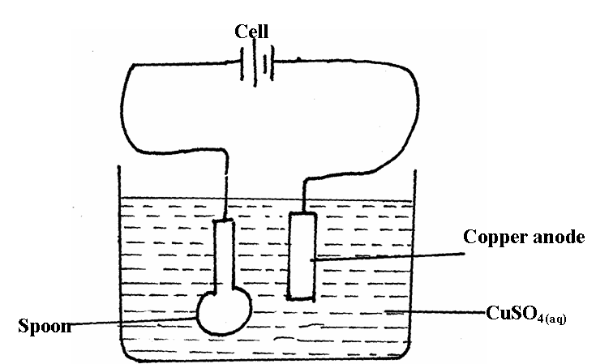

ii) Q = It

= 0.03 x 2 x 60x 60

= 216 coulombs

96500c discharge 108g

216c will deposit (216 x108/96500) g

=0.2417g of Ag (3mrks)

c) Emf = 0.76+0.8 = +1.56v✓v✓

- The reaction can occur / feasible hence cannot be stored ✓/container will corrode/eaten away (2mrks)

4. a)i) Process I – Fermentation ✓

ii) Products – Carbon (IV) oxide✓

b) Reagent – potassium manganate ( VII) or potassium chromate( VI)✓

iii) Condition – acidified / dilute acid ✓

c)i) Ethylpropanoate ✓ 1

ii) Concentrated sulphuric (VI) acid ✓ ½ warming ✓ ½

iii) Sweet smell / sweet fruity smell ✓

d)i) Nickel ✓

ii) Hydrogen gas ✓

e) Manufacture of polythene bags ✓

f) Halogenation / Bromination✓

g)i) Conc-sulphuric (VI) Acid ✓1

ii) Ethylhydrogen sulphate ✓

5(a) Energy change in converting reactant to product is the same regardless of the route by which the chemical change occurs.

3/2 O2(g)

b) Ca (s)+ C (s) CaCO3 (s)

∆H3

3/2O2(aq) ∆ H1  ∆ H2

√1

Ca O (s) + CO2 (g)

∆H3 = ∆ H1 + ∆ H2

∆ H2 = ∆H3 - ∆ H1

= - 1207 – (-635 + -394)

= - 1207 – (-1029)

= - 1207√ ½+ 1029√½

= - 178kj/mol √1

c) ∆Hr = ∑∆HBB - ∑∆HBr

= 4 x 413 + 1 x 612 + 3 x 498 – (4 x 686 x 4 x 465)√½

= 3758 – 4604√½

= - 846 kj/mol √1

d) Heat evolved = mc∆T

= 500 x 4200 x 9

1000

= 18900j √ 1

= 18.9 kj

1 mole – 380 kj

? - 18.9 kj

= 1 x 18.9

380

= 0.04497 mole √ 1

0.0497 Moles = 0.6g

1 mole = ?

= 1x 0.6

0.0497

= 12.07 √ 1

(e) Heat value is the amount of heat produced when a unit mass of fuel is completely burned in oxygen. (1mrk)

(f) (3mrks)

* Ease and rate of combustion
* Cost (1mrk each up to max of 3mrks)
* Storage and safety
* Environmental impact
* availability

6. (a) (i) P- concentrated hydrochloric acid✓1

M - Water✓1

(ii) To dry chlorine gas✓1

(iii) Anhydrous calcium oxide✓

(iv) To absorb unreacted Cl2(g)✓ ½

(v) When heated, aluminium chloride sublimes hence it is formed in vapour form and solidifies at cooler parts of apparatus✓ ½

(vi) Moles of aluminium used = 0.645

27

= 0.023889moles✓ ½

Moles chlorine used 1800 = 0.075moles✓ ½

2400

Mole ratio 0.023889: 0.075

0.023889 0.023889

1 : 3.1395✓ ½

1 : 3

E.f = AlCl3✓ ½

Mf = (E.f mass) x n

Mass 267 = (27 + 35.5 x 3)n✓ ½

267 = 133.5n

n = 267

133.5

n = 2 mf: Al2Cl6✓ ½

(b) (i) Heating

( ii) 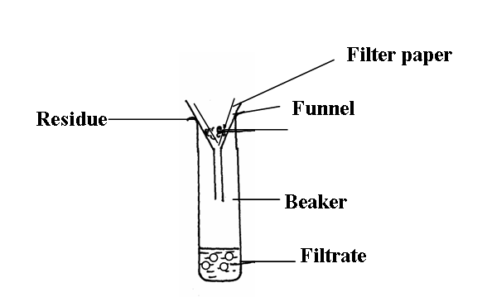

7. a)

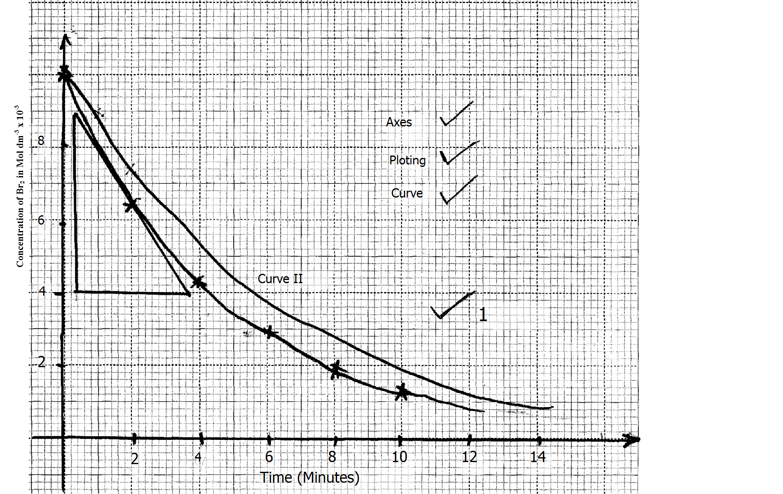

b) i) 5.2 x 10-3 Moldm-3 (Read from candidates graph) ✓ 1

ii) (8.8 – 4.0) x 10-3 ✓ 1 = 4.8 x 10-3 = - 1.412

0.4 – 3.8 - 3.4

Rate = 1.412 Mol dm-3 min-1 ✓ 1

c) The higher the concentration, the shorter the distance between the particles which leads to

a higher rate of collision, ✓ 1 hence the higher rate of reaction and vice-versa.

d) At a lower temperature, the kinetic energy of the colliding particles will reduce ✓ ½ this

reduces their speed leading to reduction in the rate of collision ✓ ½ and the rate of

reaction reduces.

**THIS IS THE LAST PRINTED PAGE.**