**233/1**

**CHEMISTRY**

**PAPER 1**

**SET 3**

**MARKING SCHEME**

1. -Does not corrode✓readily (not reactive)

- Light or low density✓

- Cheap✓

-Ductile✓ Any two (2mks)

2. –Add water to the mixture✓

- Sodium chloride dissolves where’s copper (II) oxide is insoluble✓

- Filter to obtain sodium chloride as the filtrate and leave it to cool so as to obtain sodium chloride crystals. ✓ (3mks)

3. a) Mg3N2 ✓

b) II-Mg3N2(s) +6H2O (l) 3Mg(OH)2 (aq) + 2NH3 (g) ✓

III-3PbO(s) + 2NH3(aq) 3Pb (s) + N2 (s) + 3H2O(l) ✓

4.a) X✓

b) Metallic✓

c) Z✓

5. (i) SO2(g) + NO2(g) SO3(g) + NO 9(g)

+4 +4 +6 +2

Oxidation number of S increases from +4 to +6✓ while Nitrogen decreases from +4 to +2✓ (2mks)

(ii) SO2(g) ✓

6. Precipitation ✓occurs because the solubility of salt decreases with increase in the temperature ✓(2mks)

7. Pentane: NO effervescence✓

Pentanol: Effervescence / sodium dissolve✓

(2mks)

8. KOH(aq) + HNO3(aq) KNO3(aq) + H2O(l) ✓½

R.F.M of KOH = 56✓½

Moles of HNO3 = 50 x 2 = 0.1✓½

1000

Mole ratio is 1:1✓½

Hence moles of KOH in 50cm3 = 0.1

In 100cm3 is 0.2 moles✓½

Mass of X = 0.2 x 56 = 11.2g✓½

(3mks)

9. (a) C(s) + H2O(g)  CO(g) + H2(g)✓

(b) – Reducing agent✓

- Making water gas (any other use)

10. Rate of diffusion of NH3= cm/min✓ ½

Rate of diffusion of B = $\frac{15}{4}$ cm/min✓ ½

=

RFM NH3 = 17; RFM B=?

22/4 cm3/ min =

15/4 cm3/min 17 ✓1

2 = ✓ ½

MB = 36.5689✓ ½

11. a) Butane✓

b) Hardening of oil in the manufacture of margarine✓

12. Yield increases✓ it’s an endothermic reaction increase in temperature shifts equilibrium to the right✓

13. –Add excess copper to HNO3  then filter the mixture✓½

- Add excess soluble carbonate (NA2CO3, K2CO3 ) or (NH4)2 CO3) ✓ ½ (3mks)

- Filter to obtain residue or add copper to H2SO4 and warm✓ ½

- Filter the mixture then add soluble carbonate. ✓ ½

- Heat copper in oxygen to get CuO dissolve in acid then filter. ✓ ½

- Add soluble carbonate to solution to get residue. ✓ ½

14. a) 84✓

b) a=2

b=2

15. a) Calcium: 2.8.8.2✓½

Beryllium 2.2✓½

b) Both elements are in the same group but the two valence electrons of calcium are further

          away. ✓ They are not strongly held by the nuleus, hence are readily released✓

16. Hydrogen sulphide exists as distinct molecules (H2S) with van der waals forces between them✓while water exist as molecules with intermolecular forces and hydrogen bonds forming molecules which are bulky✓

17. a) Rhombic✓or monoclinic✓1 Sulphur.

b) – For hardening rubber

- Manufacture of sulphuric acid

- As a fungicide

- In making calcium hydrogen sulphite used in bleaching.

18. Mass of water = 94.5 – 51.3 = 43.2✓½

Rmm Ba(OH)2 = 171✓½

Rmm of water = 18✓½

Ba(OH). XH2O

51.3 H2O

171 43.2✓½

18

0.3 = 1 24 = 8✓½

0.3 0.3

E. F = Ba(OH)2 . 8H2O. ✓½

19. a) (i) Concentrated HCl ✓

(ii) Concentrated H2SO4(s) ✓

b) Denser than air✓ (3marks)

20 IV, II, I, III ✓ (2mrks)

21. a) (i) NH3

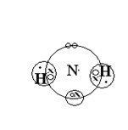



(ii) NH4+

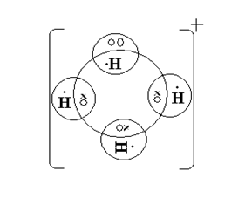

b) It has a lone pair of electrons which it uses to form a dative bond with hydrogen ions ✓

22. ∆HCH4 =( (2x – 286) + (-393)) – (-890) ✓

= -572 + - 788 + 890

= -470KJ /mol. ✓ (2marks)

23. i)

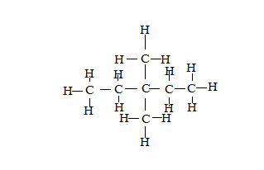

ii)

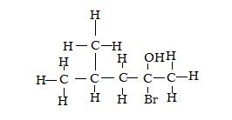✓

c)

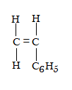✓

24. After sometime they react with oxygen and water✓ from the atmosphere that forms hydrated iron (III) oxide. ✓

25. a) They have two✓ valence electrons to conduct while group one have one✓ valence electrons

b) In solid lead bromide ions are not free but in molten lead bromide the ions are not free✓

26. R.F.M (NaCl) = 23+35.5=58.5

5.85g = 5.85 = 0.1M moles of NaCl✓½

58.5

NaCl(aq) Na+(aq) + Cl-(aq) ✓½

0.1moles 0.1mol. 0.1mol

* 1. x 6.02 x 1023 ions✓½

= 6.02 x 1022 ions✓½

27. a) 2X(s) + Cl2(g) 2XCl(s) ✓

b)

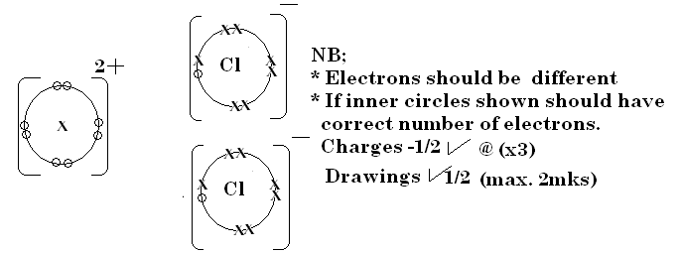

28. a) The chloride ions are more concentrated than hydroxide ions hence chloride ions are discharged with preference to hydroxide ions. ✓

b) Hydrogen✓

29. a) 2 C(s) + O2(g) 2CO(g) ✓

CuO(s) + CO(g) Cu(s) + CO2(g) ✓

b) Lime water turn white. ✓ CO2(g) is produced from reduction of CuO(s) turn the limewater white as it react with it to produce CaCO3 (white) ✓

30. a) – Sodium chloride (rock salt)

- Chile saltpeter (Sodium nitrate)

- Glauber’s salt ( sodium sulphate) Any two½ mark each

b) - Making of table salt

- Used in sodium vapour

-Used in street light

- Preparation of tetraethyl lead

- Manufacture of sodium peroxide Any two 1 mark each