**Name:** ………………………………………….…….…… **Index number**………………

**Adm No**: ……………………………………….. **Signature**: ………..................

**231/1 BIOLOGY PAPER 1(Theory)**

**TIME: 2 HOURS**

**FORM FOUR END TERM TWO EXAM -2024**

***Instructions to Candidates***

1. *Write your name and Admission number in the spaces provided above.*
2. *Sign and write the date of examination in the spaces provided above*
3. *Answer* ***ALL*** *the questions in the spaces provided below each question.*
4. *This paper consists of 30 questions only****.***
5. *Answer* ***all*** *the questions in the spaces provided.*
6. *All working* ***MUST*** *be clearly shown where necessary.*

**For Examiner’s Use Only**

|  |  |  |
| --- | --- | --- |
| **Questions** | **Max. Score** | **Candidate’s Score** |
| **1 – 30** | **80** |  |

***This paper consists of 11 printed pages. Candidates should check the question paper to ascertain that all the pages are printed as indicated and that no questions are missing.***

1. How does growth as a characteristic of living organisms differ in plants and animals? **(2marks)**

2. (a) State **two** roles of active transport in animals **(2 mark)**

.

b) Cyanide lowers the rate of active transport. Explain? **(1mark)**

3. The figure below is a diagram of a vertical section of a mammalian tooth.

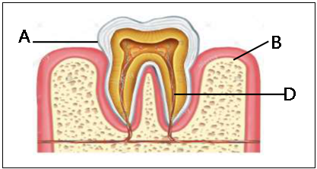

|  |  |  |
| --- | --- | --- |
| (i) | Name the parts labelled **A** and **B**. | **(2 marks)** |

(ii) State **0NE** way in which structure **D** is adapted to its functions. **(1mark)**

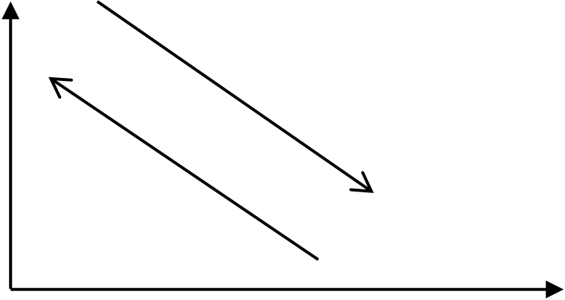4. The figure below shows % saturation of oxygen in blood in fish as water passes along the gill plate.

|  |  |  |
| --- | --- | --- |
| % | **Blood** | **Water** |
| **Saturation** |

**of oxygen**

**Distance along the gill plates**

(a) (i) Name the type of blood flow shown in the gill plate.  **(1mark**

(ii) Explain the advantage of the type of flow named in a (i) above. **(2marks)**

(b) Stateorgans in humans which display the type of flow named in a (i) above. **(1mark)**

5. The equation below shows an oxidation reaction of food substances.

**C51H98O6 + 145O2 102 CO2  + 98 H2O + energy**

a) What do you understand by the term respiratory quotient? **(1mark)**

b) Determine respiratory quotient of the oxidation of food substance. **(2marks)**

c) Identify the food substance. **(1mark)**

|  |
| --- |
|  |

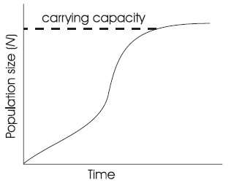6. When any one of the growth parameters such as growth in size or weight, increase in number of cells are plotted in a graph against time like below, a clear curve is obtained.

State its name**. (1mark)**

7. The embryo of a dry, fully developed seed usually passes through a period of rest after ripening period and it cannot germinate even when provided with all favorable conditions. State the significance of this. **(2marks)**

8. a) Cowpeas seeds were place in a vacuum flask and left for five days. What is the expected change in composition of gases in the flask on the sixth day? **(1mark)**

b) Give a reason for your answer in (a) above  **(1mark)**

9. Biotechnologist works day and night to curb food insecurity using the knowledge of polyploidy in genetics. Explain the economic importance of such practice? **(2marks)**

b) Define a backcross? **(1 mark)**

10. The structure below was obtained from an animal cell

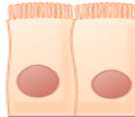

a) What is the name of the hair like structure and state its function? **(2marks)**

b) From which parts of the mammalian body are these structures found?  **(1mark)**

**11.** A student was found to have blood group B+.

a) What type of antibody is present in his plasma? **(1mark)**

b) Which antigens are present in this blood group?  **(1mark)**

12. Plants relatively have less waste to excrete than animals. Give **ONE** reasons to explain this observation,  **(1marks)**

13. State **TWO** methods by which plants get rid of their waste products. **(2marks)**

14. To estimate the population size of mosquitoes in **Banji** village that covers an area of 25km2, visiting researchers caught 400 mosquitoes which they marked and released. After 24 hours, 200 mosquitoes were caught out of which 120 had not been marked.

|  |  |  |
| --- | --- | --- |
| (a) | Suggest the sampling method described above. | **(1 mark)** |

|  |  |  |
| --- | --- | --- |
| (b) | What are the disadvantages of this method? | **(2 marks)** |

15. The table below shows stomatal distribution on leaves A and B and their surface area. Use the information to answer the questions.

|  |  |  |  |
| --- | --- | --- | --- |
|  | Leaf surface | **A** | **B** |
| Number of stomata | Upper leaf  surface | 20 | 5 |
| Lower leaf  surface | 0 | 15 |
| Surface area |  | 25 cm2 | 18cm2 |

Identify with reasons the habitats of the plant from which the leaves were obtained.

|  |  |  |
| --- | --- | --- |
| Leaf A: | Habitat*:* | **(1 mark)** |

Reason*;*  (**1** **mark**)

|  |  |  |
| --- | --- | --- |
| Leaf B: | Habitat: | (**1** **mark**) |

Reason: (**1** **mark**)

16. Name the causative agent of the following diseases. **(2 marks)**

(i) Trichomoniasis.

(ii) Gonorrhea.

17. The diagram below shows a pollen tube as it develops down the style.

Use it to answer the questions that follow;

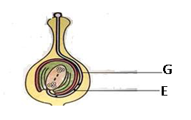

(i)Name the part labelled **G**. **(1 mark)**

(ii)State ***two*** functions of part labelled **E**. **(2 marks)**

18. (a).Define parthenocarpy. **(1 mark)**

(b)Name the plant hormone that induces fruit ripening. **(1 mark)**

19. A group of Form Three students collected a certain specimen for study as shown below. Study it carefully and use it to answer the questions that follow.

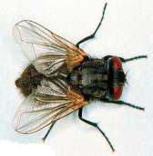

(i)Name the type of metamorphosis that the above specimen undergoes. **(1 mark)**

(ii)Give any **two** advantages of the above metamorphosis. **(2 marks)**

20. (i).Give**two** structural features in a leaf that adapts it to absorb Carbon (IV) Oxide. **(2 marks)**

(ii)Name the cell organelle in which Carbon (IV) oxide combines with water to form a complex organic compound takes place. **(1 mark)**

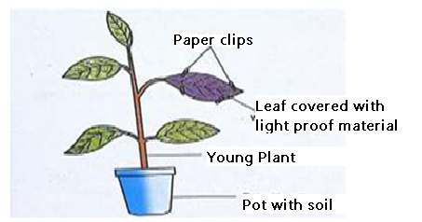21. In an experiment to investigate a factor affecting photosynthesis; leaf of a potted plant, which had been kept in the dark overnight was covered with an aluminum foil as shown in the diagram below. The set up was kept in the sunlight for three hours after which food test was carried out.

|  |  |  |
| --- | --- | --- |
| (a) | Which factor was being investigated in the experiment? | **(1 mark)** |

(b) Which food test was carried out? **(1 mark)**



|  |  |  |
| --- | --- | --- |
| (c) | State the results of the food test. | **(1 mark)** |
|  |  |  |

22. Explain how the following plant adaptations minimizes rate of transpiration. **(2marks)**

a) Sunken stomata.

b) Thick cuticle.

23. Explain how drooping of leaves on a hot sunny day is advantageous to a plant. **(2marks)**

24. Name **two** tissues in plants which are thickened with lignin. **(2marks)**

25. The diagram below shows the front view of a male reproductive system.

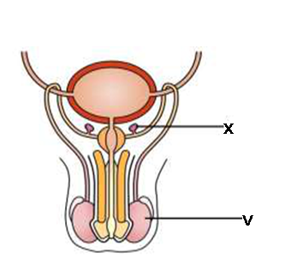

a) Give the functions of the structures labelled **X** and **V. (2marks)**

b) What is the role of Follicle Stimulating Hormone in male reproduction? **(1mark)**

26. How do the following factors hinder self-pollination in flowering plants? **(3marks)** a) Self-sterility.

b) Heterostyly.

c) Protogyny.

27. The table below shows the concentration in parts per million of sodium and iodide ions in sea water and cell sap of a plant.

|  |  |  |
| --- | --- | --- |
|  | **Sodium ions concentration** | **Iodide ions concentration** |
| **Sea water** | 326 | 39 |
| **Cell sap** | 162 | 574 |

a) i) Which of the two ions intake will be affected if the plant was sprayed with a chemical that inhibits respiration. **(1mark)**

ii) Explain your answer in 27(a) (i) above. **(1mark)**

b) An experiment was set up as shown in the diagram below.

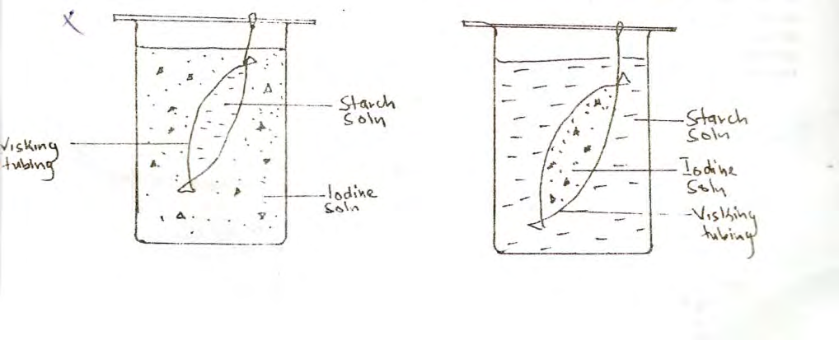

At the end of the experiment, it was observed that the starch turned blue black while the color of iodine solution in the beaker did not change. Account for this observation. **(2 marks)**

28. State the role of the following organelles: **(3 marks)**

a)Ribosomes.

b) Chloroplast.

c) Nucleus

29. A process that occurs in plants is represented by the equation below.

**C6H12O6  2C2H5OH + 2CO2 + Energy**

|  |  |  |
| --- | --- | --- |
| (Glucose) | (Ethanol) | (Carbon dioxide) |

a) Name the process. **(1 marks)**

b) State **two** economic importance of the process named in (a) above. **(2 marks)**

30. Below is a diagram of an organism.

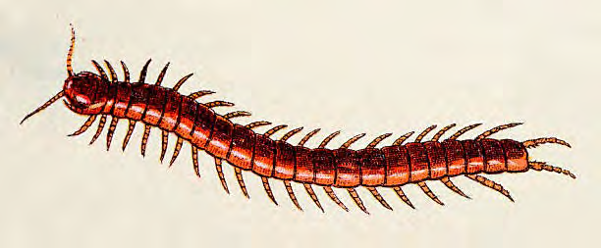

a) Identify the Class to which the organism belongs. **(1 mark)**

b) State **two** features shown on the diagram that are characteristics of this Class. **(2 mk**