**Mokasa pp3**

1.You are provided with solution X and Y, Iodine solution, Benedict’s solution, visking tubing and two pieces of thread.

(a) Using the reagents provided, carry out appropriate tests on solutions X and Y.

Ensure that droppers are not interchanged.

Iodine test

|  |  |  |  |
| --- | --- | --- | --- |
| Solution | Procedure | Observation | Conclusion |
| Solution X | To 2ml of the test substance, Add 2 drops of iodine solution; | Brown colour of iodine persist; | Starch absent; |
| Solution Y | To 2ml of the test substance, Add 2 drops of Iodine solution; | Colour changes blue-black | Starch present |

(4marks)

Benedict’s test

|  |  |  |  |
| --- | --- | --- | --- |
| Solution | Procedure | Observation | Conclusion |
| Solution X | To 2ml of the test substance, add equal amounts of Benedict’s solution and heat to boil | Colour changes from blue-green-yellow orange;brown  Acc. Any appropriate colour change | Reducing sugars present; |
| Solution Y | To 2ml of the test substance, add equal amounts of Benedict’s solution and heat to boil | Blue colour of Benedict’s solution persists; | Reducing sugars absent |

(Mark observations and conclusions as whole) (4marks)

(b) Tie one end of the visking tubing tightly with a thread. Using a dropper, place about 3ml of solution Y in the tubing and tie the open end tightly. Rinse the visking ensuring there is no leakage and immerse it in solution X in a beaker. Leave the set up to stand for about 20 minutes.

Using the contents of the visking tubing and the beaker, carry out the appropriate tests using the reagents provided.

1. Iodine test (2marks)

|  |  |  |
| --- | --- | --- |
| Contents | Observation | conclusion |
| Visking tubing | Colour turns to blue- black; | Starch present; |
| Beaker | Brown colour of iodine persists; | Starch absent; |

1. Benedict’s test (2marks)

|  |  |  |
| --- | --- | --- |
| Contents | Observation | conclusion |
| Visking tubing | Colour changes from blue to green to yellow to orange; | Reducing sugars present; |
| Beaker | Colour changes from blue to green to yellow to orange; | Reducing sugars present; |

(c) Account for the observation made in (b)ii) above in the visking tubing. (2mks)

Glucose had small molecular size;moved into visking tubing changing blue colour of Benedict’s solution to orange;

2.You are provided with the following materials and apparatus.

* Two prepared slides labelled E and K respectively containing a certain tissue obtained from the human body.
* Access to a light microscope with at least low and medium power objective lens.

Observe the prepared slides of a human tissue under medium power objective lens of the light microscope.

a) Identify with reasons the structures seen under the medium power objective of the light microscope. Draw and label the structures in the table below. (6marks)

|  |  |  |  |
| --- | --- | --- | --- |
|  | Identity | Reason | Diagram |
| E | White blood cell | Has lobed nucleus |  |
| K | Red blood cell | Lacks a nucleus  Biconcave shape |  |

b) Calculate the magnification of the image observed in the slide labelled K under low power objective lens (2marks)

magnification = eye piece lens magnification x objective lens magnification

c)Explain why the high power objective lens cannot be used with coarse adjustment knob during observation of the prepared slides above. (1mark)

Might lead to crashing of the lens and breaking of the glass slide containing specimen.

d) State the adaptations of the human structures observed in slide E to its functions (3marks)

Flexible to change their shape to engulf pathogens

Have amoeboid motion squeeze through tiny pores of capillary wall to infected tissues

Has many lysosomes to secrete lytic enzymes to digest pathogens

Lymphocytes produce respective antibodies against different pathogens

e)(i) If a slide of a complete human tissue showing all the components is prepared, which amongst the two tissues is likely to be observed in abundance. (1mark)

Red blood cell

ii) Give reason for your answer in e(i) above (1mark)

They are abundant to increase the amount of oxygen transported to the cells and carbon IV oxide away from the cells.

**3.Below are photographs of mammalian bones J and R obtained from the same region of the body. Study them and answer the questions that follows.**

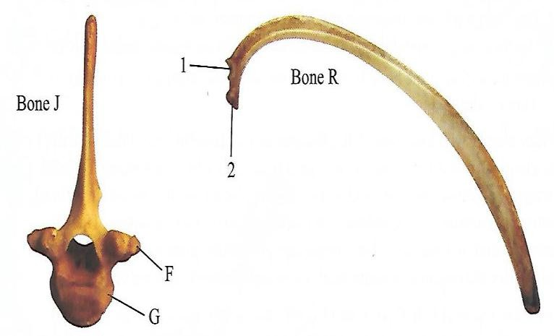

1. **Giving reasons, identify bone J and R. (4mks)**

**Bone J: Thoracic vertebra rej: vertebrae**

**Reasons: Has a long and broad neural spine**

**Has short transverse processes that bear tuberculum facets**

**Has demifacets/capitulum facets and tuberculum facets for articulation with the ribs**

**Bone R: Rib**

**Reasons: It is long, flattened and curved**

**Has tuberculum and capitulum facets for articulation with thoracic vertebrae.**

1. **(i) Name the parts labeled 1,2, and F (3mks)**
2. **Tuberculum of the rib**
3. **Capitulum of the rib**

**F- Tuberculum**

**(ii)Which of the labeled part of bone J does structures 1 and 2 on bone R articulate. (2mks)**

**1 articulate with F 2 articulate with G**

**(iii) Make a drawing to show how and bones J and R articulate (3mks)**

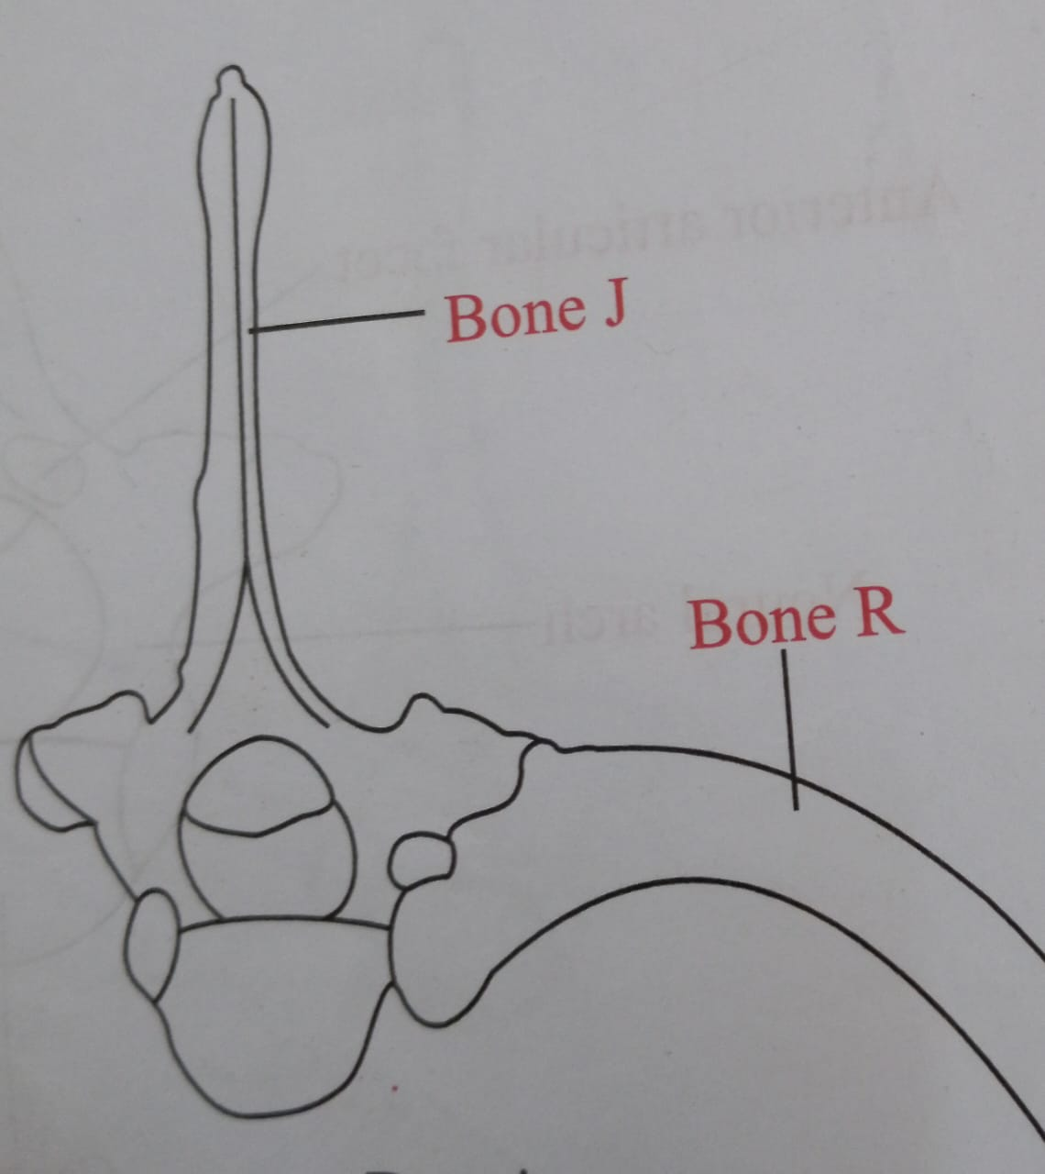

**Maximum magnification X3**