**NAME........................................................................................CLASS...............ADM………….**

**DATE……………………….SIGN………………………………SCHOOL……………………**

**231/2**

**BIOLOGY**

**PAPER 2**

**JULY 2024**

**TIME: 2 HOURS**

**MOKASA 2 EXAMINATIONS**

*(Kenya Certificate of Secondary Education)*

**BIOLOGY THEORY**

**Instructions**

Write your name, class and admission number in the space provided above.

Write the date of the examination and sign in the space provided above.

Answer ***all*** the questions in section A.Question 6 is compulsory.Answer either question 7 or 8

You may be *penalized* for wrong spelling especially technical terms.

**For Examiners Use Only**

|  |  |  |  |
| --- | --- | --- | --- |
| **Section** | **Question** | **Maximum score** | **Candidate’s score** |
| **A** | **1**  **2**  **3**  **4**  **5** | **8**  **8**  **8**  **8**  **8** |  |
| **B** | **6**  **7**  **8** | **20**  **20**  **20** |  |
| **TOTAL** |  | **80** |  |

**SECTION A (40 MARKS).Answer all questions**

1. The diagrams below show beaks of various birds. Study the diagrams and answer the questions that follow.

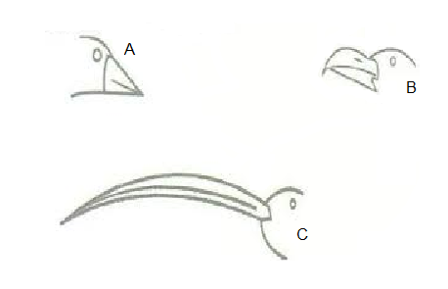

(a)Name the;

1. The type of evolution represented by the diagrams (1mark)

……………………………………………………………………………………………………………………………………………………………………………………

1. The type of structures represented by the diagrams (1mark)

…………………………………………………………………………………………..

b)i) Using Darwin’s theory of evolution, explain how the beak of bird C would have evolved

(3mks)

………………………………………………………………………………………………………………………………………………………………………………………………………………………………………………………………………………………………………………………………………………………………………………………………………………………………………………………………

1. Explain how Lamarck could have explained the evolution of beak of bird B (3mark)

……………………………………………………………………………………………………………………………………………………………………………………………………………………………………………………………………………………………………………………………………………..............................................................................................

1. The diagram below shows a growth curve of an organ from a certain organism. Study it then use it to answer the questions that follow.

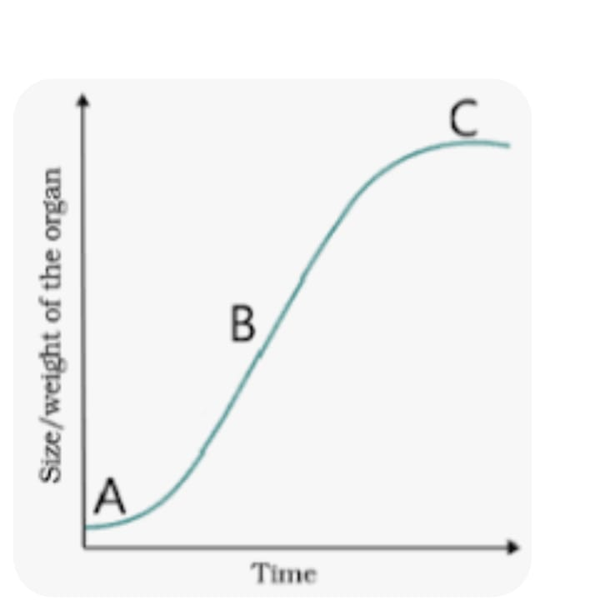

1. Identify the growth curve (1mk)

…………………………………………………………………………………………….

1. State the Phylum from which the organism belongs (1mk)

…………………………………………………………………………………………….

1. Explain the phenomenon that occurs at points

A (2mks)

………………………………………………………………………………………………………………………………………………………………………………………………………………………………………………………………………………………………………………………

B (2mks)

………………………………………………………………………………………………………………………………………………………………………………………………………………………………………………………………………………………………………………………

1. State two factors affecting growth in plants (2mks)

………………………………………………………………………………………………………………………………………………………………………………………………………………………………………………………………………………………………………………………………………………………………………………………………………………………………………………………………

3. A rhesus positive man marries a rhesus positive woman and one of their children happens to be rhesus negative.

(a) work out the possible genotypes of the two parents (1mark)

(b) the rhesus negative daughter of the above couple is married to a rhesus positive but carrier man. work out ;

(i) The phenotypes of their offspring (4marks)

1. The genotypic and phenotypic ratio of their offspring (2mark)

(c) Name the condition that the first offspring in the genetic cross in (b) above will suffer from (1mk)

…………………………………………………………………………………………………………………………………………

1. The diagram below represents a female reproductive system.

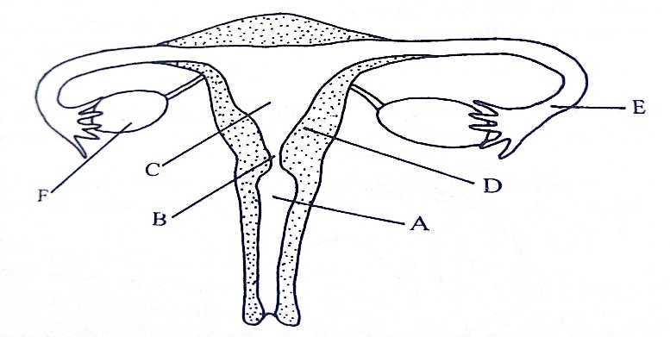

1. Name the part labelled A (1mark)

………………………………………………………………………………………………

1. Identify the letter representing the organ where fertilization takes place (1mark)

………………………………………………………………………………………………

1. Name the hormones produced by the part labelled F (2marks)

………………………………………………………………………………………………………………………………………………………………………………………………………………………………………………………………………………………………………………………

1. Explain how an ovum moves along the labelled E (2marks)

………………………………………………………………………………………………………………………………………………………………………………………………………………Explain why if the parts labelled F are removed after the fourth month, pregnancy can proceed normally. (2marks)

………………………………………………………………………………………………………………………………………………………………………………………………………………………………………………………………………………………………………………………………………………………………………………………………………………………………

1. The diagram below represents a set up during an experiment

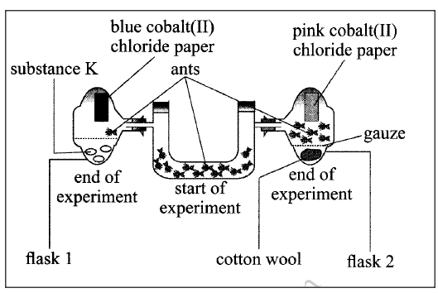

1. Name the type of response the experiment was investigating (1mark)

………………………………………………………………………………………

1. Name two other types of responses that are shown by animals in relation to stimuli

(2mks)

………………………………………………………………………………………………………………………………………………………………………………………………………………

1. State the likely identity of substance K (1mark)

………………………………………………………………………………………………

1. Explain your answer in (b(i) above (2marks)

………………………………………………………………………………………………………………………………………………………………………………………………………………………………………………………………………………………………………………………

e) Account for the observations made in flask 2 (2mks) ………………………………………………………………………………………………………………………………………………………………………………………………………………

**SECTION B (40 MARKS)**

**Answer question 6(compulsory) and either question 7 or 8**

1. The relationship between oxygen concentration and sugar consumption in isolated roots of sorghum was determined. The results are shown in the table below. The loss of sugar and potassium uptake are in arbitrary units.

% Oxygen concentration

|  |  |  |  |  |  |  |
| --- | --- | --- | --- | --- | --- | --- |
|  | 0 | 5 | 10 | 15 | 20 | 100 |
| Sugar loss | 15 | 20 | 42 | 45 | 45 | 48 |
| Potassium gain | 5 | 55 | 70 | 73 | 75 | 70 |

1. Plot graphs of sugar loss and potassium gain against percentage of oxygen concentration in the same axis. (8mks) 
2. Name the process by which potassium is taken in by root hairs. Give reasons for your answer.

Process: (1mk)

………………………………………………………………………………

Reasons. (1mk)

……………………………………………………………………………………………………………………………………………………………….

1. Account for the sugar loss and potassium gain at:
   1. 0% oxygen concentration. (2mks)

………………………………………………………………………………………………………………………………………………………………………………………………………………………………………………………………………

* 1. Between 5% and 20% oxygen concentration. (2mks)

1. ………………………………………………………………………………………………………………………………………………………………………………………………………………………………………………………………………………………………………………………………………………………………………………………………

d) Apart from oxygen concentration, give **two** other factors that are necessary for the above process. (2mks)

………………………………………………………………………………………………………………………………………………………………………………………………………………………………………………………………………………………

e) State **two** ways in which you can stop the above process from taking place. (2mks)

…………………………………………………………………………………………….……………………………………………………………………………………………

f)Name **two** main areas in the mammalian body where the above process is involved. (2mks )

………………………………………………………………………………………………………………………………………………………………………………………………………………………………………………………………………………………………………………………………

7a) Describe the causes and effects of water pollution (10mks)

b) State the adaptations of the ileum to its functions (10mks)

8a) Describe the economic importance of plant excretory products (10mks)

b) Describe the mechanism of gaseous exchange in terrestrial insects (10mks)

……………………………………………………………………………………………………………………………………………………………………………………………………………………………………………………………………………………………………………………………………………………………………………………………………………………………………………………………………………………………………………………………………………………………………………………………………………………………………………………………………………………………………………………………………………………………………………………………………………………………………………………………………………………………………………………………………………………………………………………………………………………………………………………………………………………………………………………………………………………………………………………………………………………………………………………………………………………………………………………………………………………………………………………………………………………………………………………………………………………………………………………………………………………………………………………………………………………………………………………………………………………………………………………………………………………………………………………………………………………………………………………………………………………………………………………………………………………………………………………………………………………………………………………………………………………………………………………………………………………………………………………………………………………………………………………………………………………………………………………………………………………………………………………………………………………………………………………………………………………………………………………………………………………………………………………………………………………………………………………………………………………………………………………………………………………………………………………………………………………………………………………………………………………………………………………………………………………………………………………………………………………………………………………………………………………………………………………………………………………………………………………………………………………………………………………………………………………………………………………………………………………………………………………………………………………………………………………………………………………………………………………………………………………………………………………………………………………………………………………………………………………………………………………………………………………………………………………………………………………………………………………………………………………………………………………………………………………………………………………………………………………………………………………………………………………………………………………………………………………………………………………………………………………………………………………………………………………………………………………………………………………………………………………………………………………………………………………………………………………………………………………………………………………………………………………………………………………………………………………………………………………………………………………………………………………………………………………………………………………………………………………………………………………………………………………………………………………………………………………………………………………………………………………………………………………………………………………………………………………………………………………………………………………………………………………………………………………………………………………………………………………………………………………………………………………………………………………………………………………………………………………………………………………………………………………………………………………………………………………………………………………………………………………………………………………………………………………………………………………………………………………………………………………………………………………………………………………………………………………………………………………………………………………………………………………………………………………………………………………………………………………………………………………………………………………………………………………………