**MOKASA II, 2024**

**BIOLOGY PAPER 2 – MARKING SCHEME**

1. The diagrams below show beaks of various birds. study the diagrams and answer the questions that follow.

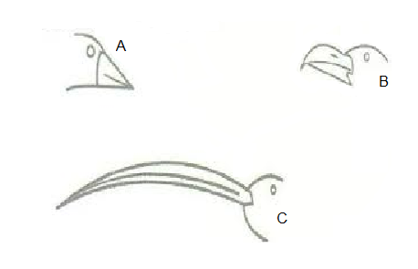

(i)Name the;

1. The type of evolution represented by the diagrams (1mark)

Divergent evolution

1. The type of structures represented by the diagrams (mark)

Homologous

ii) Using Darwin’s theory of evolution, explain how the beak of bird C would have evolved (3marks)

There were variations in beaks and those with beak C was well adapted; to the environment conferring them an advantage were able to compete favorably; reached sexual maturity and passed on the advantageous trait to next generation;

iii) Explain how Lamarck could have explained the evolution of beak of bird B (3marks)

The environment demanded the need for a broad sharp beak B; due to continuous use of the beak, it developed to adapt it to its habitat, the acquired trait (broad sharp beak) was passed on to offsprings over several generations leading to emergence of new species with beak B only.

1. The diagram below shows a growth curve of an organ from a certain organism. Study it then use it to answer the questions that follow.

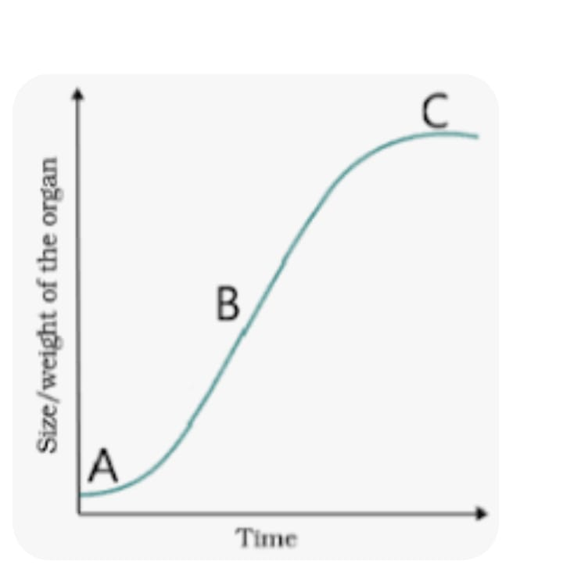

1. Identify the growth curve (1mk)

Sigmoid;

1. State the Phylum from which the organism belongs (1mk)

Chordata;

1. Explain the phenomenon that occurs at points

A (2mks)

Lag phase; slow growth of organ as the organism is still adjusting to environment;limited resources e.g nutrients; slow cell division; (max 2)

B (2mks)

Exponential/log phase; rapid growth rate as organ cells are fully adjusted to environment; sufficient nutrients supply; limited competition; max 2

1. State two factors affecting growth in plants (2mks)

Growth hormones;

Sufficient Oxygen supply;

Availability of water; Optimum temperature; light intensity; (first 2)

3. A rhesus positive man marries a rhesus positive woman and one of their children happens to be rhesus negative.

(a) work out the possible genotypes of the two parents (1mark)

Rh+ Rh_

(b) the rhesus negative daughter of the above couple is married to a rhesus positive but carrier man. work out ;

(i)the phenotypes of their offsprings (4marks)

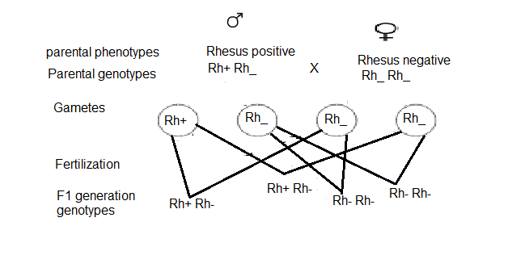

1. The genotypic and phenotypic ratio of their offspring (2mark)

(c) name the condition that the first offspring in the genetic cross in (b) above will suffer from.(1mark)

Haemolytic disease of the newborn/Erythroblastosis foetalis

1. The diagram below represents a female reproductive system.

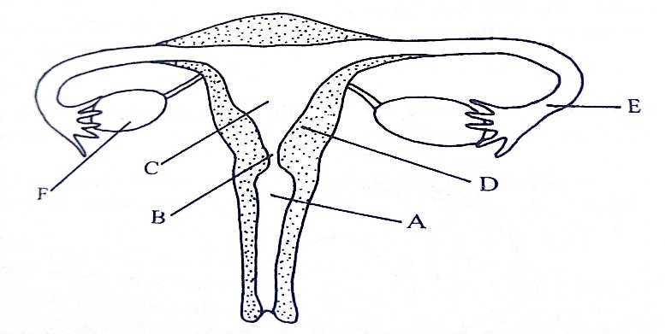

1. Name the part labelled A (1mark)

Vagina;

1. Identify the letter representing the organ where fertilization takes place (1mark)

E;

1. Name the hormones produced by the part labelled F (2marks)

Oestrogen;

Progesterone;

1. Explain how an ovum moves along the part labelled E (2marks)

Movement is aided by cilia; which wafts ovum;

Muscular contractions of smooth muscles;brings peristaltic movement;

1. Explain why if the parts labelled F are removed after the fourth month, pregnancy can proceed normally. (2marks)

Placenta is fully developed; hence secretes progesterone hormone (which maintains pregnancy);

1. The diagram below represents a set up during an experiment

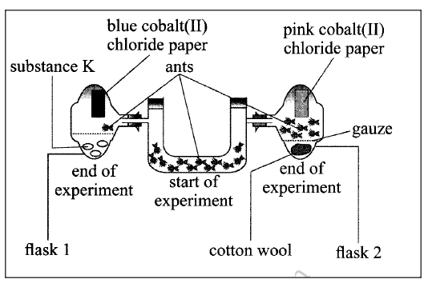

1. Name the type of response the experiment was investigating (1mark)

Positive hydrotaxis/ acc negative chemotaxis

b) Name two other types of responses that are shown by animals in relation to stimuli (2mars)

Rheotaxis

Osmotaxis

1. State the likely identity of substance K (1mark)

Silica gel

1. Explain your answer in (b(i) above (2marks)

It absorbed moisture/water providing an unsuitable condition to the ants, hence migrated to flask 2.

(b)account for the observations made in flask 2 (2marks)

Presence of moisture provided a suitable habitat for ants hence more ants move towards flask 2

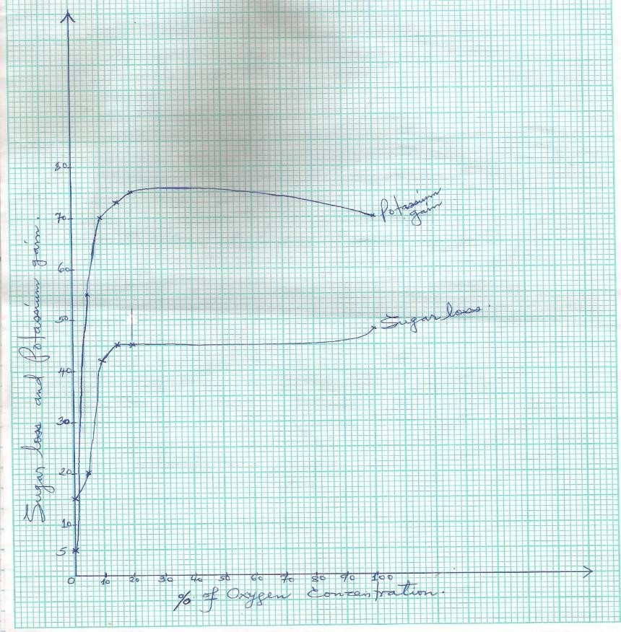

1. Plotting the points - @ curve 1mk = 2mk

Joining the points - @ curve 1mk = 2mk

Labeling of X and Y axes - @ ½mk = 1mk

Scale on X and Y axes, @ 2mk = 2mk

Identify/labeling the curves @ ½mk = 1mk

Total 8mks

1. Process; Active transport; = 1mk

Reasons: Movement of materials occur against a concentration gradient; the process requires

energy; as a result of oxidation of sugar / glucose being consumed by use of oxygen; 3mks

1. (i) Rate of active transport slow ; low oxygen concentration leads to less potassium

ions absorbed. owtte 2mks

(ii) Rate of active transport is high; the, higher the oxygen concentration, the more the

potassium ions absorbed; 2mks

1. - Glucose concentration;
   * Optimum Temperature; 2mks
2. - Increase in temperature beyond optmum;
   * Introducing enzyme inhibitors; 2mks
3. - Kidney tubule;
   * Ileum;
4. (a)Describe the causes and effects of water pollution 10mks

***Lead;***

***Pollutant from pipes and tanks made of lead; When ingested by animals, it accumulates in the kidneys, liver bones and brain causing poor mental development; lead also blocks stomata in plants leading to limited photosynthesis in plants making them retarded;***

***Agrochemicals;***

***Inorganic fertilizers contain phosphates and nitrates; which causes eutrophication; and subsequent increased demand in biological oxygen demand in aquatic ecosystems;***

***Pesticides contain heavy metals like copper and mercury; that affect the respiratory activities of aquatic organisms; They also contain non-biodegradable cfcs; which accumulates along the food chains; becoming toxic at higher trophic levels;***

***Oil spillage;***

***From oil tankers accidents; offshore oil rigs and refineries and damaged warships; forms a layer on the water surface reducing oxygen supply; leading to death of aquatic organisms; it also clogs respiratory surfaces of aquatic organisms leading to their death; it also clogs the feathers of birds preventing them from flying; coats and blocks the stomata of plants limiting photosynthesis; reduces light penetration into water limiting photosynthesis in aquatic plants;***

***Mercury;***

***Mercury is a product released from industries that manufacture other chemicals like vinyl plastics; from combustion of coal; and petroleum; methane; Bacteria convert the mercury to methylmercury; which kills organisms; it also accumulates along the food chain eventually reaching man; and accumulating in the kidney, liver and brain resulting in mental retardation in children; mercury also interferes with melanin formation ;leading to development of skin cancer; blindness and death;***

***Domestic effluents;***

***Untreated sewage from urban areas discharged into water bodies; contains disease causing micro-organisms; such as Salmonella typhi, virus and bacteria which causes water borne diseases such as cholera; Domestic effluents also contains detergents which are broken down to phosphate and nitrates which are then added into the water bodies causing algal bloom;(eutrophication) and increased biological oxygen demand in aquatic ecosystems;***

***Industrial effluents***

***Industrial waste discharged into water bodies contain toxic compounds such as mercury arsenic kills aquatic organisms such as fish directly; They may also lead to eutrophication; and increased biological oxygen demand in the aquatic environment indirectly killing aquatic organisms; such compounds also enter the food chain and accumulate to lethal levels in higher organisms in the food chains;***

***Soil erosion/Siltation;***

***Makes water turbid; and unfit for human consumption; silt reduces light penetration reducing the rate of photosynthesis in aquatic organism; silt also clogs respiratory surfaces interfering with gaseous exchange; and photosynthesis;***

***Heat***

***Hot water discharged from factories directly into water bodies reduces the amount of dissolved gases such as oxygen for respiration such as oxygen respiration; and carbon (IV) oxide for photosynthesis; thus, limiting the two processes; The heat may also directly kill aquatic organisms; heat also raises the respiratory rates to abnormal levels causing malfunctioning of organisms;***

7b). State the adaptations of ileum to its function 10marks

**Dense network of capillaries**; to transport blood; for efficient transport of absorbed food;

presence of lacteals; for absorption of fatty acids and glycerol molecules into lymphatic system

**Presence of enzymes**: Lipase; for digestion of lipids into fatty acids and glycerol; maltase; for digestion of maltose to glucose molecules; peptidase; for breakdown of peptides into amino acids; sucrase; for digestion of sucrose into glucose and fructose; lactase; for digestion of lactose into glucose and galactose;

**Goblet cells**; produce mucus; to lubricate the walls of the ileum; for smooth flow of food; coats the walls of ileum to prevent digestion by peptidase  
enzyme;

**Highly-coiled**; to reduce speed of food flow; for maximum digestion; and absorption;

**Highly folded** to increase the surface area for complete digestion of food; and maximum absorption of digested food

Long to give more time for maximum digestion and maximum absorption of digested food.

Numerous villi and **Microvilli** on the surface of the villus further increase surface area for faster absorption of nutrients

The epithelium of the villus is **one cell thick** to provide a short distance for faster absorption to happen by diffusion and active transport

Well supplied with a **network of blood capillaries** that transport glucose and amino acids away from the small intestine in the blood,and to maintain a steep diffusion gradient

Has crypt of Lieberkühn to secrete succus entericus

Has Brunner’s gland to secrete alkaline fluid that provide suitable PH for enzyme activity

8a) **Describe the economic importance of plant excretory products (12mks)**

• caffeine from tea and coffee is used in medicine and as a stimulant which is harmful to humans

• quinine used for treating malaria

• cocaine derived from leaves of cocoa plant used as a stimulant by addicts or as a local anesthesia, also causes damage to the brain, may cause addiction if not well used and is an illegal drug

• Tannins derived from barks of acacia (wattle bark) trees are used to make ink and tanning (softening) of leather.

• Nicotine got from leaves of tobacco plant stimulates the central nervous, may cause addiction if much is used or consumed. It is used to make cigarettes, cigars and is poisonous. It is a precursor of lung cancer

• Cannabis sativa(bhang) is used to make drugs

• Gum derived from glues is used for sticking substances and making certain jellies

• Rubber, a product of latex, got from rubber plant is sued to make tyres and synthetic fibres

• Morphine from opium poppy plant is a narcotic and illegal drug as it causes addiction

• Khat and miraa are used as stimulants

• Colchicines used in inducing polyploidy, cancer therapy, treatment of gouts in small quantities

• Papain used as meat tenderizer

8**b) Describe the mechanism of gaseous exchange in terrestrial insects (8mks)**

• air in the atmosphere contains oxygen

• air is drawn into the body of the insect through the spiracles due to movement of abdominal muscles

• these movements cause the opening of spiracles

• air moves through the trachea to tracheoles

• oxygen moves from the tracheoles into body cells by diffusion due to concentration gradient

• carbon iv oxide in the tissues diffuses into tracheoles due to concentration gradient

• From tracheoles carbon IV oxide moves into trachea and out through the spiracles into the air.