MOKASA

PAPER 1

1.The diagram shows the percentage of tongue rollers and non-rollers in a human population.

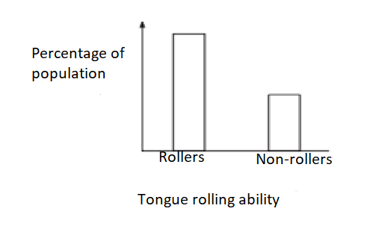

(i)what name is given to this type of variation? (1mk)

Discontinuous variation

(ii) Give two features of the above named type of variation (2mks)

Not influenced by environmental conditions

Clearly defined /distinct differences/no intermediate forms

Determined by one or two genes

2. Study the genetic cross illustrated below and answer the questions that follow.

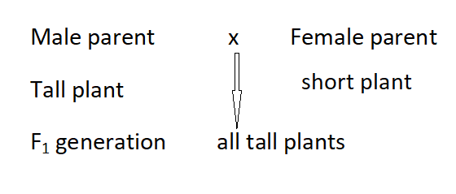

When F1 was selfed 1064 plants were counted. State the ;

(i) Genotypic ratio of F2 plants (1mk)

1TT;2Tt;1tt

(ii) Number off tall plants and short plants in F2 generation (1mk)

Tall plants

3/4x1064=798

Short plants

1/4x1064=266

3 Name one example of a characteristic in man transmitted by multiple alleles. (1mk)

ABO blood groups

4. It is known that weight lifting exercises in men causes muscles to grow bigger. However,the children of such men are not born with big bulging muscles. Explain (2mk)

Changes in the phenotype which do not affect the genotype/gametes; cannot be inherited;

5. State two features of nerves which increases the speed of nerve impulse transmission along them (2mks)

Presence of myelin sheath to insulate axon

Presence of nodes of ranvier to propagate nerve impulses

6. Name the tough fibrous band of connective tissue that holds the bones together at a moveable joint (1mk)

Ligament

7. The diagram below shows the human brain.

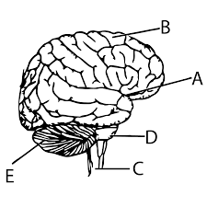

Give the significance of the folds on the surface of the part labeled E (1mk)

Increase surface area for attachment of nerves

Which labeled parts of the brain are involved in the following activities (2mks)

1. Gasping for air after holding breath for sometime

D

(b) Ability to memorize and recite a poem during music festivals

B

8. Explain what causes the tendrils of a pea plant to coil around stems of other plants (3mks)

Contact; causes lateral diffusion/migration of auxins to side away from contact; higher concentration of auxins at side away from contact stimulates rapid/faster cell elongation; leading to coiling around the stem.

9. State two structural differences between biceps muscles and muscles in the arteries in a human being. (2mks)

|  |  |
| --- | --- |
| Biceps (skeletal | Smooth muscle(arteries |
| Has cross striations | Lacks cross striations |
| multinucleated | Uninucleated |

10. Plants with non woody stems have various devices of getting support. State three methods by which this is achieved. (3mks)

Twinning/coiling

Thorns/hooks/spines

Turgidity of parenchyma cells

11. The diagram below illustrates the results obtained in an experiment done to investigate a certain factor that affects the process of osmosis.

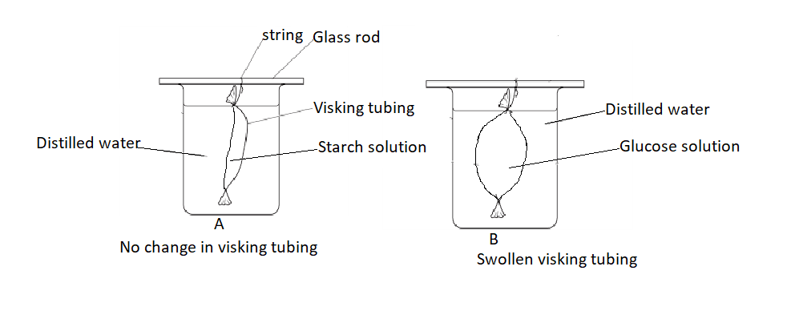

(a) Account for the results in set up;

(i) A (2mks)

Starch is osmotically inactive; hence does not develop osmotic pressure and water does not move from the beaker into the visking tubing; hence the visking tubing has no observable change.

(ii) B (2mks)

Glucose in the visking tubing is osmotically active; develops osmotic pressure and distilled water moves from the beaker into the visking tubing by osmosis making it swell/increase in contents.