**BUSINESS STUDIES**

**PAPER 1**

**MARKING SCHEME**

1. **Define the following terms as used in Business Studies. (4 mks)**
2. **Economics**

It refers to the study of how human beings strive to satisfy their unlimited wants using the limited / scarce resources.

1. **Entrepreneurship**

It refers to the process of identifying business opportunity and acquiring necessary resources to maximize the profit.

1. **Opportunity cost**

This is the value of the best next alternative forgone when acquiring or when a choice has been made.

1. **Scale of preference**

It is a list of wants showing the order in which they are satisfied from the most urgent to the least urgent.

1. **Highlight four reasons why food is an important basic need. (4 mks)**
2. It reduces the effects of hunger.
3. It is a source of important minerals for body building
4. Protects the body against diseases
5. Provides the body with warmth.
6. **Outline four importance of a warehouse to a consumer. (4 mks)**
7. It facilitates steady supply of goods by storing surplus goods and releasing them during times of shortages.
8. May help them in stabilizing prices as supply becomes continuous.
9. Some goods when stored improve in quality to the advantage of consumer.
10. It can create employment opportunities to consumers
11. Enables the consumers to check on quality of goods before they buy.
12. **Outline four requirements for one to start a limited liability company as one of the forms of business units. (4 mks)**
13. Memorandum of Association.
14. Article of association.
15. List of directors (Public companies a must)
16. Declaration of compliance (signed by at least one director)
17. Statement of share capital showing the total amount of capital that the company wishes to raise and its division into shares.
18. **Highlight four factors a firm must take into account when deciding on the product(s) to produce. (4 mks)**
19. Profitability of the venture
20. Level of competition
21. Availability of resources
22. Government policy
23. Extent of demand / market
24. Cost of production
25. **Highlight four ways in which entrepreneurs can observe ethics in the management of their business. (4 mks)**
26. By having zero tolerance to corruption in business dealings.
27. By practicing fair business practices with competitors
28. By providing quality goods and services
29. By compliance with the country’s laws and regulations.
30. By offering fair prices on goods and services to avoid consumer exploitation.
31. By not discriminating of employees in terms of gender, religion, ethnicity and race.
32. By eliminating use of unfair means of achieving business objectives such as boarding and selling of counterfeit goods.
33. **The following information was extracted from the books of Dawida business enterprise for the year ended 30th June 2000.**

**Capital as at 30th June, 2000 640,000**

**Capital as at 1st July 1999 420,000**

**Drawing for the year 180,000**

**Net profit for the year 140,000**

**Determine the additional capital during the year. (4 mks)**

Additional capital = closing capital – opening capital – profit + drawings

I = 640,000 – 420,000 – 140,000 + 180,000

I = 640,000 – 560,000 + 180,000

I = 640,000 + 180,000 – 560,000

I = 820,000 – 560,000

I = 260,000

Additional capital = 260,000/=

1. **Highlight four ways through which one can convey verbal communication.(4 mks)**
2. When the sender wants to convince and persuade the recipient.
3. When distance between the sender and the recipient is not long.
4. When the message is to be delivered accurately.
5. When immediate feedback is required.
6. When the message to be communicated is confidential.
7. Where the message is urgent and required quick communication.
8. **Below is a demand and supply curve.**

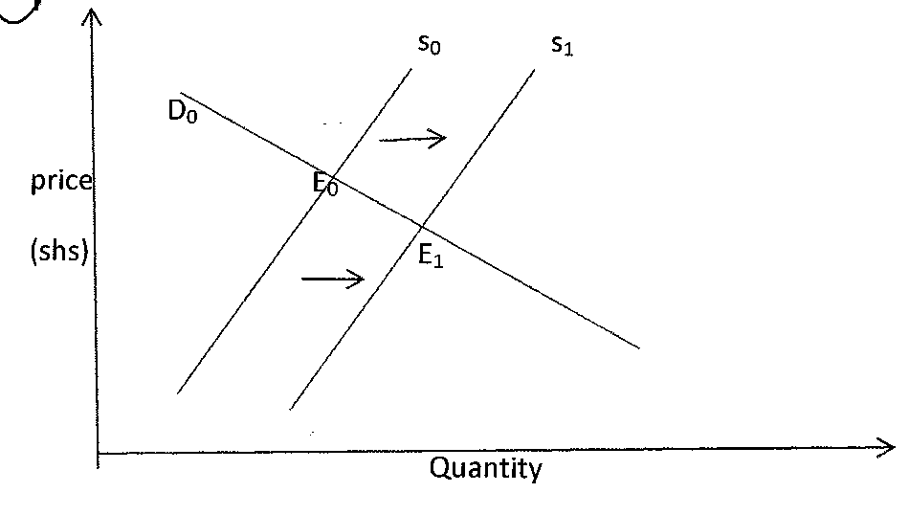

**Highlight the factors that may have led to the above behavior. (4 mks)**

1. Reduction in the cost of production.
2. Improvement in the state of technology
3. Decrease in prices of other related commodities.
4. Favourable government policies like reduction in taxes.
5. Conducive climatic conditions.
6. **Outline four circumstances under which a trader can issue a credit note to a customer.**

**(4 mks)**

1. Where the customer returns goods due to wrong order.
2. If customer returned empty cases / containers which were earlier included in pricing.
3. If there was a price overcharge in the invoice.
4. If items some were included in the invoice yet were not actually delivered.
5. **Give the difference between: (4 mks)**
6. **Double and co-insurance**

It is where an insured takes the same insurance policy / insures the same subject matter against the same risk with more than one insurance company. Whereas co-insurance is whereby one insurance company invites other insurers to insure with them the same property against the same risk.

1. **Premiums and surrender value**

Premium is the specified amount of money paid at regular intervals by the insured to the insurer in exchange for cover against losses arising from an insured risk. Whereas surrender payment of the premium before the policy matures, is an amount less than the amount of premium already paid.

1. **Highlight four advantages of indirect tax. (4 mks)**
2. It is where tax payment is voluntary.
3. Can be used selecting to achieve a given objective.
4. Not possible to evade.
5. It is flexible
6. More revenue can be raised (board based)
7. It is convenient.
8. It stimulates efforts.
9. **Highlight four ways in which a legal-political environment can impact negatively on entrepreneurs. (4 mks)**
10. Lack of political stability in the country scares away investors.
11. Government policies like high taxation discourages investors.
12. Requirements for one to start a given business may be costly.
13. Procedures to be used to acquire relevant documents may be lengthy and tiresome.
14. Lack of political goodwill to support entrepreneurs in a country’s government.
15. **Highlight four duties of commercial attaches in trade promotion. (4 mks)**
16. Publish and advertise their country’s exports in business journals and magazines.
17. Select buyers, agents and distributors of the home country’s exports.
18. Explore and identify new markets for more exports opportunities.
19. Research and analyze markets for exports from their home countries.
20. Keep statistics of products such as volume s, packaging sizes and methods of manufacturing.
21. Assist sales missions from home countries by organizing educational tours for them.
22. Inform traders in their home countries of standards required for exports.
23. **Identify the book of original entry in which the following transactions can be recorded. (4 mks)**

|  |  |
| --- | --- |
| **Transaction** | **Book of Original Entry** |
| **Paid salaries by cheque** | Cash payment journal |
| **returned goods to a supplier** | Purchase returns journal |
| **Sold goods on credit** | Sales journal |
| **Bought delivery van on credit** | General journal |

1. **Outline three leakages in a circular flow of income. (3 mks)**
2. Savings
3. Imports
4. Taxes
5. **Outline four advantages of using celebrities in product promotion. (4 mks)**
6. They help in increasing recognition.
7. They influence consumer purchases.
8. Build awareness
9. Attract new users / customers.
10. Breathe life into failing brand.
11. Help people in remembering advertisement.
12. Makes people believe that the products contributes to superstar stats.
13. Helps the product in getting a better position in the market.
14. Build brand equity
15. Helps the product in getting a better position in the market.
16. **Distinguish between the following terms of sales as used in international trade. (4 mks)**
17. **Free on rail (FOR)**

Price quoted includes expenses for transporting the goods up to the nearest railway station. The buyer meets railway charges and all other expenses.

1. **Free on board (FOB)**

Price quoted includes the movement of goods up to when they are in the ship. The buyer meets all the other expenses.

1. **In bond**

Price quoted includes all the expenses up to handling the goods into the exporters bonded warehouse. The buyer / importer meets all other charges such as duty and storage.

1. **On nearest offer (ONO)**

The exporter is willing to accept the quoted price or any other nearest to the quoted one.

1. **Kenya is planning to extend her pipeline transport. State four advantages of pipeline transport to the country. (4 mks)**
2. It is economically in labour / requires minimal manpower.
3. Environmentally friendly since it is free of noise and smoke.
4. Allows for continuous flow of goods being transported.
5. Pipeline can be constructed even where it is difficult to construct roads such as rugged terrains.
6. Has reduced damage on roads by tankers.
7. Reduced delay occasioned by congestion on roads due to tankers
8. Maintenance costs are low since it relies on gravitational force and booster stations.
9. Not affected by adverse weather conditions.
10. Has helped to reduce accidents caused by tankers on roads.
11. **Outline four emerging issues in office management. (4 mks)**
12. Use of computers in data processing, storing information and for communication.
13. Adopting of open or landscape office layouts.
14. The development of customer care departments in organizations to ensure customer satisfaction.
15. Provision of cell phone to employees to ensure that they carryout office activities even while away from working stations.
16. Traditional procedures and routines are becoming outdated and employees in management does work that could have otherwise have been done by clerks and typist.
17. Identification badges
18. CCTV security systems
19. **Kiburu carried out the following transactions during the month of February, 2105.**

**February 1: Started business by depositing sh 220,000 in business bank account.**

**7: Bought good on credit from Miyogo sh 72,000.**

**8: Paid rent by cheque sh 20,000**

**16: Sold goods to Kamula on credit sh 50,000**

**Required; Post the above transaction in the relevant ledger accounts.**

Dr Capital A/c Cr Dr Bank a/c Cr

|  |  |  |  |  |
| --- | --- | --- | --- | --- |
|  | 1.5.15 bank 220,000 ✓ |  | 1.5.15 capital 20,000✓ | 8.5.15 rent 20,000✓ |

Dr Purcahse A/c Cr Dr Miyogo a/c Cr

|  |  |  |  |  |
| --- | --- | --- | --- | --- |
| 7.5.15 Miyogo 72,000✓ |  |  |  | 7.5.15 Purchases 72,000✓ |

Dr Sales A/c Cr Dr Kamula a/c Cr

|  |  |  |  |  |
| --- | --- | --- | --- | --- |
|  | 16.5.15 Kamau 50,000 ✓ |  | 16.5.15 Sales 50,000✓ |  |

Dr Rent A/c Cr

|  |  |  |  |
| --- | --- | --- | --- |
| 8.5.15 ban 20,000✓ |  |  | @✓ = ½ mark total 4 marks |

1. **Highlight four features of perfect competition market. (4 mks)**
2. Uniformity of buyers and sellers.
3. Perfect mobility of factors of production.
4. There is no government interference or intervention.
5. Large number of buyers and sellers.
6. There is freedom of entry and exit into the industry.
7. Both buyers and sellers have perfect knowledge of what is happening in the market.
8. There is excess demand or excessive supply.

**23. Mention whether the following transactions have an increase, decrease or no effect on the assets, capital and liabilities of a business. (4 mks)**

|  |  |  |  |  |
| --- | --- | --- | --- | --- |
|  | **Transaction** | **Assets** | **Capital** | **Liabilities** |
| **(a)** | **Bought premises on credit** | Increase | No Effect | Increase |
| **(b)** | **Took stock of goods and donated to a local dispensary** | Decrease | Decrease | No Effect |
| **(c)** | **Withdrew money from bank for office use** | No effect | No effect | No effect |
| **(d)** | **Sold furniture receiving cash** | No effect | No effect | No effect |

1. **The following information relates to Liston traders for the period ended 31st March 2012.**

**Opening stock Sh 40,000**

**Sales Sh 100,000**

**Closing stock 25% on cost of sales**

**Mark-up 25%**

**By clearly calculating gross profit and purchases, prepare a trading account**

1. **Gross profit (1 mk)**

Mark up = ¼ , margin = 1/5, gross profit = 1/5, 100,000 = sh 20,000

1. **Purchases for the year (2 mks)**

C.O.S. = Sales – G.P. 100,000 – 20,000 = Sh 80,000

Purchase = C.O.S. + closing stock – opening stock

= 80,000 + 20,000 – 40,000

= Sh 60,000

Trading a/c

For the period ended 31st March 2012

|  |  |
| --- | --- |
| Opening stock 40,000✓ | sales 100,000✓ |
| Add purchases 60,000✓ |  |
| Less closing stock 20,000✓ |  |
| Gross profit c/d 20,000✓ |  |
| 100,000 | 100,000 |

Gross profit b/d 20,000 ✓ @ tick ½ mark = 3 mks