MANGU HIGH SCHOOL
BIOLOGY
PAPER 2
231/02
MARKING SCHEME

1. a) Oxygen(as a factor necessary for germination)
b) Absorbs oxygen
c) Anaerobic respiration
d) Glucose Ethanol ₊ Carbon(IV) oxide +Energy

e) Alcohol when in high concentration is poisons to plant tissues;
f) Suitable temperature
Moisture / water
Seed viability
Enzymes
Hormone

2. a (i) Homologous structures (1 mark)

(ii) Divergent evolution (1 mark)

b) (i) Structures that have ceased to be functional and have been reduced in size. ( 1 mark)

(ii) – Tail of a human being.
- Appendix (1 mark)

c) In the bacteria population some become resistant to antibiotics due to mutation; those that do not have this characteristic are destroyed by antibiotics; the resistant ones multiply and eventually all bacterial become resistant; and are no longer affected by antibiotics.

d) The present day continents formed one large single land mass; the land broke up into parts which drifted from one another forming the present day continents; these isolated animals from one common ancestry hence forming new species. (2 marks)
3. a)It’s a phenomenon or process whereby fertilization occurs inside the body of a
female organism. (1mk)

b) - Pregnant animals are vulnerable to predators.
- Too demanding to the mother in terms of nutrients.
- Pose health risks to pregnant animals. (2mk)

c) - Secret the hormone progesterone.
- Medium for gaseous exchange
- Medium for supplying nutrients to the foetus
- Medium for hemoring wastes products from the foetus.

d) i) Oestrogen- Healing and repair of uterrine wall after menstruation.
- Stimulate the secretion of LH by the pitutary gland.
ii) Luteinizing hormone- Causes ovulation
- Stimulate curpus luteum to secret progesterone homone
iii) –Causes graafian follicle to develop from primary follicle
- Stimulate ovary to secret oestrogen. (3mks)
4. (a) Animalia Rej Animal
(b) Centrally located nucleus;
-Absence of cell wall;
-Many small vacuole; ( 1st 2)
(c) On the diagram ( not else where)
A – Golgi bodies/apparatus
B - Cytoplasm
C - Cell/plasma membrane
(d) D – Site for protein synthesis;
E- control activities of the cell
Store genetic materials
5. a) Genes located on the same chromosome and are always transmitted together;
b) (i) X^{h}X^{h};
(ii) Parental genotype X^{H}X^{h} X X^{H}Y;

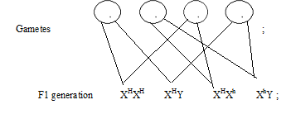

Phenotypic ratio 3 normal: 1 haemophiliac;
NB-Crossing sign must be present
-Circles must be complete
-Fusion lines should not converge or penetrate the gamete.
Accept use of a punnet square
(iii) Males lack corresponding allele on the Y chromosome; therefore they cannot be carriers; OWTTE

6. (a)
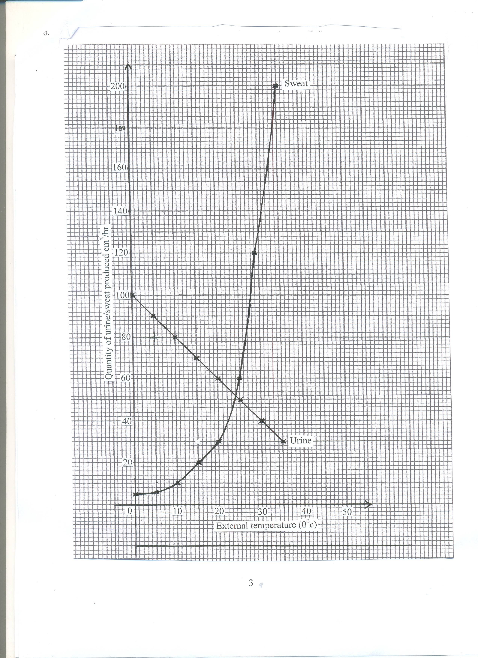
(b) 24⁰c; (1mk)

(c) Sweat production increases with increase in temperature; because high temperatures increase evaporation rate; hence more sweat is converted to vapour; (drawing latent heat from body causing cooling) (3mks)

(d) An increase in temperature decreases amount of urine produced; this is due to increased sweating which raises osmotic pressure of blood; A lot of water is then reabsorbed into the kidney tubules; resulting in production of less urine (3mks)

(e) (i) Cells lining tubules contain numerous mitochondria; to provide energy for active transport,
- Glomerular capillaries have numerous tiny pores for ultrafiltration; (allow small molecular weight substances to pass through and not proteins and blood cells)
- Inner surface of epithelium cells of tubules have numerous micro villi; to increase surface area for reabsorption;
- Tubule well supplied with blood capillaries; for transport
- Proximal and distal tubules are coiled; to reduce speed of flow of filtrate; and increase S.A for reabsorption;
- Thin epithelial lining; for faster passage of substances;
Mark 4 correctly explained answers (max 4 mks)
(ii) Excretion – Elimination of metabolic waste products from body/or separation and removal of metabolic waste products; (1mk)
Egestion – removal of undigested materials from the gut through the anus; (1mk)

7. Herbivores
- Have horny pad (on the upper jaw); against which grass is cut by lower incisors;
- Have long tongue; that turn food/move it for grinding;
- Have diastema; (a gap between front and back teeth) to allow food to be turned . in the mouth;
- Jaws can move side by side; to enable grinding of food;
- Teeth (Molars and premolars) have large cusps; for crushing/grindingvegetation;
10 marks
Carnivores
- Have well developed leg muscles; that facilitate fast movement;
- Have strong jaws and sharp teeth; to grasp their prey;
- Incisors are chisel – shaped; to seize prey/grip/ strip flesh from bones
- Have long/conical/curved canines; to kill/tear flesh;
- have carnassial teeth (that have smooth sides/sharp edges)’ to slice through flesh/crush bones;
- Jaws are attached to powerful muscles; that facilitate their up and down movement/grasping prey;
12 marks max 10 mks

8 (a) (i) It serves to cool the leaves especially during hot environment;
      - It provides a mechanism through which mineral salts are transported in the plants;
      - Allows loss of excess water from the plants;

  - Root pressure: This is the force which push water from the root to the stem.
Cohesion and adhesion force
Cohesion force – force which attracts water molecules together maintaining a continuous column
of water preventing the break of water column.
Adhesion force – water molecules cling to the sides of the xylem vessels wall.
Capillary force – The forces of adhesion and cohesion are the basis of capillarity the rise of liquids in
capillary tubes.
Transpiration pull – as water evaporates from the cells on the exposed parts of plants, water molecules
are drawn from the adjacent cells. Eventually those cells that are adjacent to the xylem vessels draw
water from them by osmosis.

  - The guard cells have chloroplasts; in presence of light; photosynthesis occur in the guard cells of stomata; producing sugar in guard cells; This increases the osmotic pressure of guard cells; water is drawn from the neighbouring cells by osmosis; causing turgidity of guard cells; the inner walls of the guard cells which are thicker than outer wall stretch more causing the guard cells to bulge outwards; stomata open.
In absence of light, no photosynthesis in guard cells; sugar in guard cells is converted into starch; osmotic pressure lowers; guard cell lose water to adjacent epidermal cells by osmosis; become flaccid; the inner
walls of guard cells shrink; the thicker wall reduces; this closes this stomata.

