NAME _______________________________________________ADM NO. _______________
STREAM _____________________
DATE________________________ CANDIDATE’S SIGN ____________________________


BIOLOGY 231/1
OCT/NOVEMBER
2 HOURS
FORM 4

MANGU HIGH SCHOOL TRAIL 2 MOCK 2021
KENYA CERTIFICATE OF SECONDARY EDUCATION (KCSE)

INSTRUCTIONS TO CANDIDATES
- Write your name, admission number, school and stream in the spaces provided above.
- Answer all the questions in the spaces provided.

FOR EXAMINERS USE ONLY
QUESTIONS | MAXIMUM SCORES | CANDIDATE’S SCORE
1 – 31 | 80

1. Define the term Entomology. (1mk)
_________________________________________________________________________________________________________________________________________________
2. What is meant by the term Natural Selection. (2mks)
___________________________________________________________________________________________________________________________________________________________________________________________________________________________
3. The diagram below shows regions of a root-tip
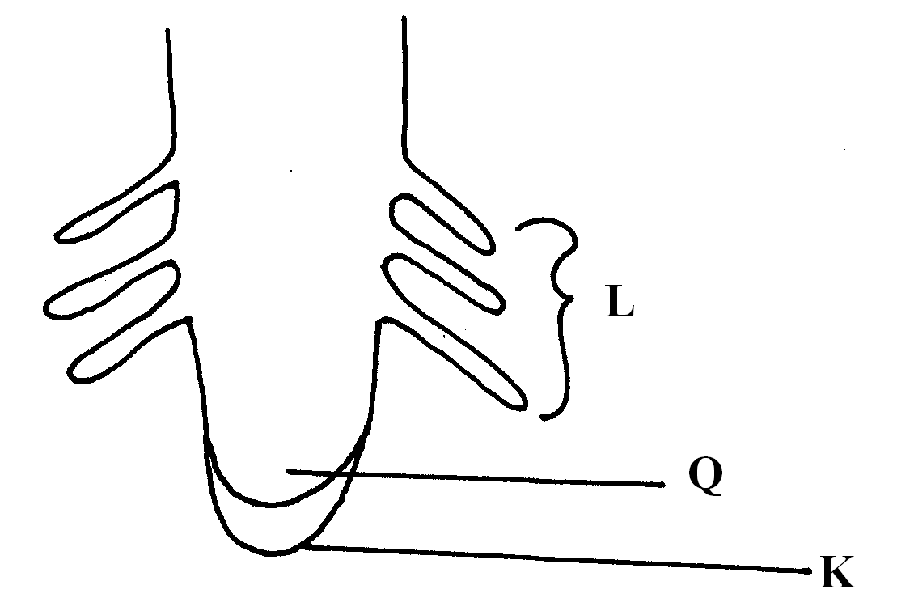
a) What is the function of the part labeled K. (1mk)
______________________________________________________________
b) Name the region labeled L. (1mk)
______________________________________________________________
c) Give ONE characteristics of the cells in the part labeled Q. (1mks)
______________________________________________________________
4. The organelle below is important in the process of Nutrition.
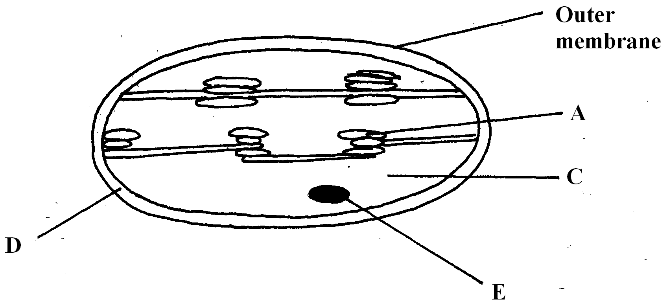
a) Identify the organelle. (1mk)
______________________________________________________________
b) Name the part labeled C. (1mk)
______________________________________________________________
c) Identify the structure within the organelle that would make the leaf to be variegated. (1mk)
___________________________________________________________________
5. A Rhinocerous in a game park was found to be infested with ticks. State the trophic level
occupied by Ticks (2mks)
_______________________________________________________________________
6. State the causative agent of the following diseases. (2mks)
a) Typhoid
________________________________________________________________________
b) Pneumonia
________________________________________________________________________
7. A student estimating a cell size of an onion epidermal cells observed the following on
The microscope field of view using a transparent ruler.
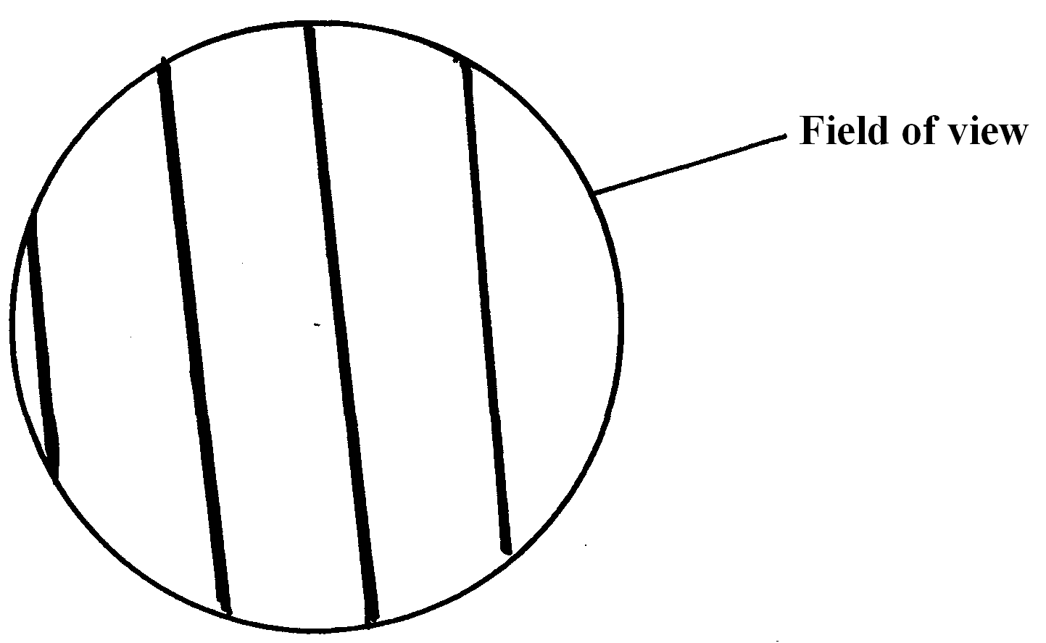
The student identified 20 cells across the field of view. Calculate the size of the cell in
Micrometers (show your working) (3mks)

- Name the tissues whose cells are thickened with:
- Cellulose and pectin. ……………………………………….……………. (1mk)

- Lignin. …………………………………………………………..………… (1mk)

- The diagram below represents a fern.

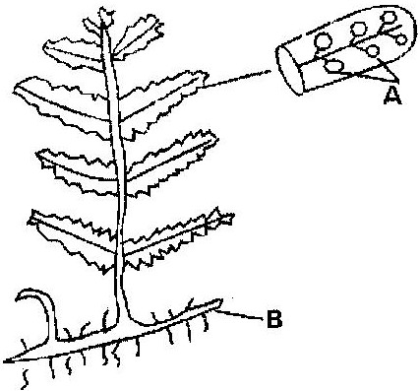

(a) Name Parts labeled A and B. (2mk)
A ……………………………………………………………………………………..
B ……………………………………………………………………………………….
(b) To which division does the plant belong? (1mk)
………………………………………………………………………………………………..
- Explain how the following factors hinder self-pollination in plants:
(i) Protogyny (1mk)
………………………………………………………………………………………………………………………………………………………………………………………………
(ii) Dioecism (1mk) ………………………………………………………………………………………………………………………………………………………………………………………………
- Explain the likely effect on humans and other organisms of untreated sewage discharged into water body that supplies water for domestic use. (3mk)
………………………………………………………………………………………………………………………………………………………………………………………………………………………………………………………………………………………………………………………………………………………………………………………………
- State TWO differences between osmosis and active transport. (2mk)
………………………………………………………………………………………………………………………………………………………………………………………………………………………………………………………………………………………………………………………………………………………………………………………………
- The diagram below illustrates part of a nephron from a mammalian kidney.
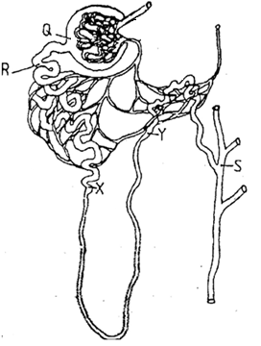

a) Name the fluid found in the part labeled Q. (1mk)
……………………………………………………………………………………
b) Identify the process responsible for the formation of the fluid named in (a) above. (1mk)
………………………………………………………………………………………
c) Which two hormones exert their effect in the nephron? (2mk)
………………………………………………………………………………………………………………………………………………………………………………………………………………………………………………………………………
- State TWO characteristics of members of kingdom Monera that are not found in other kingdoms.
(2mk)
………………………………………………………………………………………………………………………………………………………………………………………………………………………………………………………………………………………………………………………………………………………………………………………………………………………………………………………………………………………………
- What is meant by the following biological terms?
- Crenation (1mk)
………………………………………………………………………………………………
……………………………………………………………………………………………….
ii) Haemolysis (1mk)
…………………………………………………………………………………………….
…………………………………………………………………………………………….
- The diagram below shows a stage during fertilization in flowering plant.

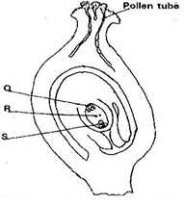
a) Name the parts labeled Q, R, and S. (3 mk)

Q ……………………………………………………………………………………

R …………………………………………………………………………………..

S ……………………………………………………………………………………

b) State the function of the pollen tube. (1 mk)
………………………………………………………………………………………………
………………………………………………………………………………………………
………………………………………………………………………………………………
- An experiment was set to investigate a certain aspect of response. A seedling was put on a horizontal position as shown in figure M below. After 24 hours, the set up was as shown in figure N.

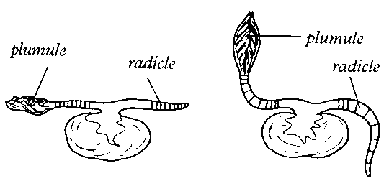
M
N

a) Name the response exhibited. (1mk)
…………………………………………………………………………………………………
b) Explain the curvature of the shoot upwards. (3mk ……………………………………………………………………………………………………………………………………………………………………………………………………………………………………………………………………………………………………………………………………………………………………………………………………………………………………………………………………………………………………………
- The paddles of whales and the fins of fish adapt these organisms to aquatic habitats.
a) Name the evolutionary process that may have given rise to these structures. (1mk)
……………………………………………………………………………………………
……………………………………………………………………………………………
b) What is the name given to such structures? (1mk)
………………………………………………………………………………………………
………………………………………………………………………………………………
c) Give ONE examples of vestigial organs in man. (1mk)
……………………………………………………………………………………………
……………………………………………………………………………………………
- A group of Form four students set up an experiment to investigate a biological process using termites. They used a small box in which a portion was covered with black paper and had moist soil. The open part had dry soil. Termites were placed inside in open area of the box.
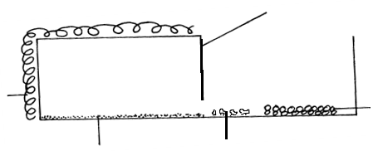
Moist soil Termites
Black
paper
Dry
soil
Dark area
Lit area
card
board

a) Predict what happened to the termites after 30 minutes. (1mk)
………………………………………………………………………………...
b) What form of response is exhibited by termites? (1mk)
……………………………………………………………………………….
- State one biological significance of the above response to termites.(1mk)
………………………………………………………………………………...
………………………………………………………………………………
- The diagram below represents an experimental set up to investigate a certain scientific concept. The potted plant was first destarched by keeping it in dark for four days.
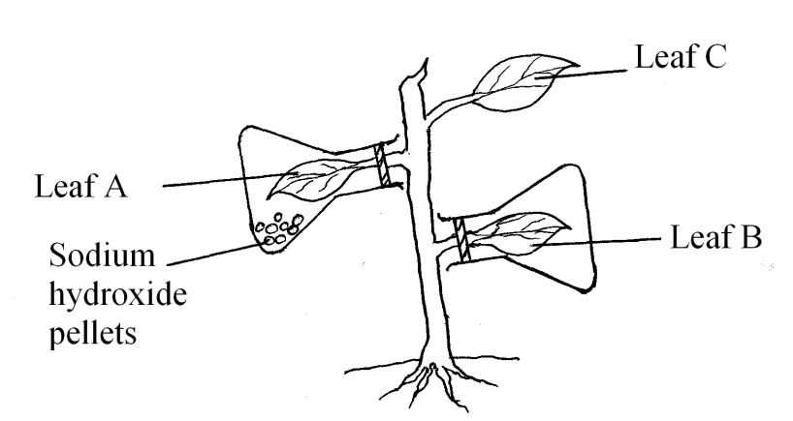
The set up was then placed in sunlight for five hours and leaves were tested for starch. a) What scientific concept was being investigated? (1mk ................................................................................................................................................
................................................................................................................................................
b) i) Give the results likely to be obtained after starch test for A and B.
A and B.
A ………………………………………………………………………… (1mk)
B ………………………………………………………………………… (1mk)
ii) Account for the results in leaf A in b (i) above. (1mk)
…………………………………………………………………………………..
……………………………………………………………………………………
…………………………………………………………………………………
c) Why was leaf C included in the set-up? (1mk)
………………………………………………………………………………………
21) Explain why a pregnant woman excretes less urea compared to a woman who is not- pregnant. (2mk)
................................................................................................................................................
................................................................................................................................................
...............................................................................................................................................
- a) Outline the main features of Lamarckian theory of evolution. (2mk)
………………………………………………………………………………………………………………………………………………………………………………………………………………………………………………………………………………………………………………………………………………………………………………………………
b) In view of modern genetics, explain why Lamarck’s theory is unacceptable. (1mk)
………………………………………………………………………………………………………………………………………………………………………………………………………………………………………………………………………………………………
c) Name one factor in nature that increases the process of evolution. (1mk)
……………………………………………………………………………………………
23. Explain why fresh water Protozoa like amoeba do not burst when placed in distilled water. (2mks)
………………………………………………………………………………………………………………………………………………………………………………………………………………………………………………………………………………………………
24. The equation below shows an oxidation reaction of flow food substance
5C₅₁H₉₈O₆ + 145O₂ 102CO₂ + 98H₂O + Energy
- Determine respiratory quotient of the oxidation of the food substance above.(2mks
………………………………………………………………………………………………………………………………………………………………………………
(b) Identify the food substance (1mk)
………………………………………………………………………………………………………………………………………………………………………………
25. Give the one aspect of dichogamy in flowers (1mk)
……………………………………………………………………………………
………………………………………………………………………………………………………………………………………………………………………………………………
………………………………………………………………………………………………
26. The table below shows the concentration of important plant nutrients
Ion | Concentration in pond water (ppm) | Concentration in cell sap (ppm)
Chloride | 200 | 50
Potassium | 1 | 15
Name the process by which the above ions could have been taken up by the plants
(i) Potassium ………………………………………………………………… (1mk)
(ii) Chloride……………………………………………………………………..(1mk)
27. In an experiment Drosophila melanogaster (fruit flies) with broad abdomens were crossed with those having narrow abdomens. All the offspring (F1 generation) from the crosses had broad abdomens. Using A to denote the genes for abdomen size,
(a) Give the genotypes of the parents (2mks)
………………………………………………………………………………………………
………………………………………………………………………………………………
(b) If 150 fruit flies had narrow abdomens in the second filial generation (F2) how many fruit flies with broad abdomens were in the same generation (show your working) (2mks)
………………………………………………………………………………………………
………………………………………………………………………………………………
28. Give a reason why two species in an ecosystem cannot occupy the same niche. (1mk)
………………………………………………………………………………………………
………………………………………………………………………………………………
29. A person was found to pass out large volume of dilute urine frequently. Name the:
(a) Disease the person was suffering from? (1mk)
………………………………………………………………………………………………
………………………………………………………………………………………………
(b) Hormone that was deficient (1mk)
………………………………………………………………………………………………
………………………………………………………………………………………………
30. Identify the processes X and Y and the unknown product Z in the chemical equations below;
[i] Glucose + Galactose X Lactose + Z (2mks)
X ______________________________________________________________________
Z ______________________________________________________________________
[ii] G + water Y Glucose + Fructose (2mks)
Y ____________________________________________________________________

KENYA CERTIFICATE OF SECONDARY EDUCATION (KCSE)
BIOLOGY 231/1
MARKING SCHEME
FORM 4

1. Study of insects;
2. Where natural environment selects organisms with advantageous characteristics and allow them to survive; (to maturity and reproduce) and weeds out organisms with disadvantageous characteristics;
3. a) Protect the apical menstem of the root;
b) Region / Zone of cell differentiation;
c) Dense cytoplasm; prominent Nucleus;
Thin cell walls; No vacuoles;
4. a) Chloroplast;
b) Stroma;
c) A/grana/granum;
5. Secondary consumer / third trophic level / second consumer level;
6. a) Salmonella typhi;
b) Streptococcus pneumonial; / Pneumococcus sp;
7. Field of view = 4mm
Field of view = 4 x 1000 = 4000 um;
Size of cell = $\frac{\text{Field} \text{of} \text{view}}{\text{Number} \text{of} \text{cells}}$
=$\frac{\text{4000}}{\text{20}}$; = 200Um;

- Collenchyma;
- Sclerenchyma;
9. (a)
A – Sori; rej. sorus

B – Rhizome;
(b) Pteridophyta;
10. (i) Protogyny (1mk)
Stigma matures earlier and is ready to receive pollen grains before the anthers are ready;
(ii) Dioecism (1mk)
Male and female gametes occur in separate plants;
11. Contains disease – causing micro-organisms which may cause outbreak of water borne diseases; faecal material is broken down by saprophytes leading to depletion of dissolved oxygen thus suffocation of aquatic organisms; breakdown of matter releases nutrients which enrich the water resulting in eutrophication;

12. Osmosis involves movement of water /solvent molecules, active transport involves movement of solute molecules; osmosis does not require energy, active transport requires energy; in osmosis molecules move along a concentration gradient, in active transport molecules move against a concentration gradient;

a) Glomerular filtrate;
b) Ultra-filtration / pressure filtration;
c) Antidiuretic hormone / vasopressin; Aldosterone; (rej wrong spelling)
- Nucleus lack nuclear membrane / organelles not membrane bound; nucleus not organized; mitochondria absent / most organelles absent; cell wall made of mycoprotein;

- Shrinking of red blood cells/ animal cells as a result of water loss by osmosis (when placed in hypertonic solution);
ii) Bursting of red blood cells as a result of uptake of water by osmosis (when placed in hypotonic solution);
- a)
Q – Antipodal cell(s);
R – Polar nucleus / body;
S – Functional egg cell;
b) pathway through which male nuclei reach the embryo sac / improves efficiency of fertilization; its tip produce lytic enzyme which dissolves the embryo sac wall to allow entry of male nuclei;
- a) Geotropism;
b) Gravity causes high concentration of auxins on the lower part of the shoot; this causes faster elongation of cells on the lower part compared to the upper part; making the shoot to curve upwards;

18. a) Convergent evolution;
b) Analogous structures;
c) Coccyx; appendix;

19. a) Moved to the dark area;
b) Negative phototaxis / positive hydrotaxis
- To escape predation; to reduce dessication;

20. a) Photosynthesis;
b) i) A – Negative test / starch absent;
B – Positive test / starch present; (
- Sodium hydroxide absorbed all the Carbon (IV) Oxide hence no photosynthesis;
c) Control experiment;
21. Amino acids are used in the formation of foetal tissues; thus has less excess
to be eliminated;
22.a) Use and disuse of structures / when structures are not used for a long time they shrink and when used they develop properly; transmission of physically acquired characteristics / physically acquired characteristics are passed on to the offspring;
b) phynotypically / physically acquired characteristics which do not affect the genes cannot be inherited;
c) Natural selection; cross- breeding; mutation;
23. Fresh water Protozoa take in water by osmosis; the excess water is then actively pumped into the contractile vacuole which discharges the water to the outside;
24. (a) $R\text{.}Q=\frac{{\text{CO}}_{2} \text{produced} }{O_{2} \text{used} \text{up}}=\frac{\text{102}}{\text{145}}=0\text{.}7;$
(b) Fat / Lipid;
25. - Protogyny
- Protandry

26. (i) Active transport;
(ii) Diffusion;
27. (a) AA; aa;
(b) 150 x 4 = 600;
¾ x 600 = 450;
28. Due to stiff competition for available resources which leads to elimination / exclusion;
29. (a) Diabetes inspidus;
(b) Antidiuretic hormone (ADH);
30. (i) X – Condensation
Z – Water
(ii) Y – Hydrolysis

