**Name:………………………………………….………………….Class:…………Adm No:…….**

**BIOLOGY**

**FORM 2 TERM OPENER EXAM-AUGUST**

**TIME: 1HR 30MINS**

**INSTRUCTIONS.**

**Answer all the questions in the spaces provided.**

1. State the function of the following organelles. (2mks)
2. Lysosomes
3. Ribosomes
4. A student observed a row of 16 epidermal cells in a microscopic field that was 8mm in diameter. Calculate the average length of one cell in micrometres. Show your working. (3mks)
5. A student drew a 6cm diagram of a plant flower if the actual length of the flower was 12cm. calculate the magnification of the drawing made by the student. Show your working. (3mks)
6. State three factors that affect the rate of diffusion. (3mks)
7. An experiment was set-up in a laboratory as shown below.

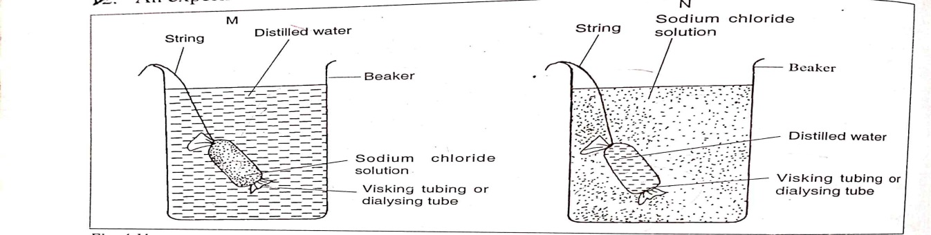

1. What will happen to visking tubing in M and N after two hours. (2mks)
2. Explain the observations made in M. (2mks)
3. What does visking tubing represent in a living organism? (1mk)
4. Distinguish between autotrophism and heterotrophism modes of nutrition. (2mks)
5. State three properties of monosaccharides. (3mks)
6. The equation below shows formation of a disaccharide.

Glucose + Glucose process p Q + water

1. Name process P. (1mk)
2. Product Q. (1mk)
3. Other than product Q named above name other two examples of disaccharides. (2mks)
4. List four factors which affect enzyme controlled reaction. (4mks)
5. Name two nutrients that are absorbed without being digested by the enzymes in humans. (2mks)
6. List three types of salivary glands. (3mks)
7. Give two roles of saliva in the process of digestion. (2mks)
8. Differentiate between homodonts and heterodonts. (2mks)
9. The diagram below represents the lower jaw of a mammal.

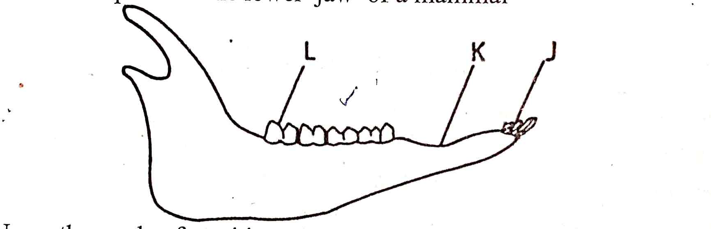

1. Name the mode of nutrition of the animal whose jaw is shown above. (1mk)
2. Mode of feeding. (1mk)
3. Give a reason for your answer in (b) above. (1mk)
4. Diet of the animal. (1mk)
5. Name the toothless gap labeled K. (1mk)
6. Name the substance that is responsible for hardening of teeth. (1mk)
7. State the roles of the structures found within a tooth:
8. Blood vessels. (1mk)
9. Nerves. (1mk)
10. List two major types of dental diseases. (2mks)
11. Give two roles played by bile salts in the process of digestion. (2mks)
12. Explain five ways in which the illume is adapted to its functions. (5mks)
13. The following is a dental formula of a certain mammal.

I0/3 C0/1 Pm3/3 m3/3

1. Calculate the total number of teeth of the mammal. (2mks)
2. Give the likely mode of feeding. (1mk)
3. Give a reason for your answer in (ii) above. (1mk)
4. Name the disease in humans caused by deficiency the following: (5mks)
5. Vitamin A
6. Vitamin D
7. Vitamin C
8. Iodine
9. Iron

b. State one function of water in the diet. (1mk)

c. State five factors that determine energy requirements in human beings. (5mks)