Term 2 - 2022
BIOLOGY
(QUESTION PAPER II) FORM FOUR
TIME:2 HOURS
Name: …………………………………………………………. Adm No: ………………. School: ……………………………………………………….. Class: …………………..
Signature: …………………………………………………….. Date: ……………………
Instructions to candidate
- Write your name, school, index number in the space provided at the top of the paper.
- Sign and write the date of examination in the space provided above.
- This paper consists of two sections, A and B.
- Answer all the questions in section A in the spaces provided.
- In section B answer question 6 (compulsory) and either question 7 or 8 in the answer booklet provided.
- Candidates should check the question paper to ascertain that all the pages are printed as indicated and that no questions are missing.
- Candidates should answer the questions in English.
For Examiner’s Use Only
Section | Question | Maximum  Score | Candidate’s Score
A | 1 | 8
A | 2 | 8
A | 3 | 8
A | 4 | 8
A | 5 | 8
B | 6 | 20
B | 7 | 20
B | 8 | 20
 |  | 80
SECTION A (40 marks)
1. a) Using the diagrams below, construct a dichotomous key that can be used to identify the leaves. (2mks)
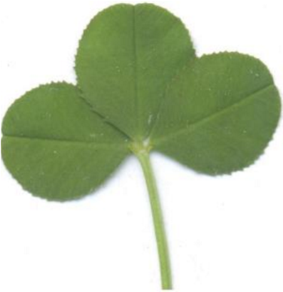 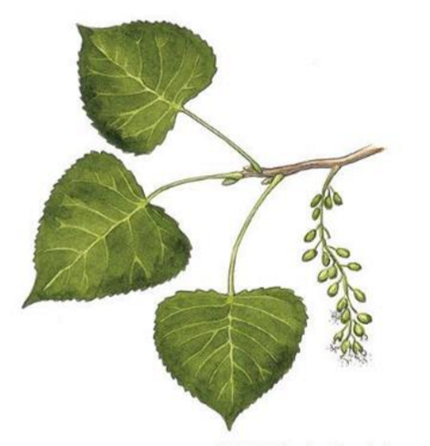COTTON WOOD
WHITE CLOVER
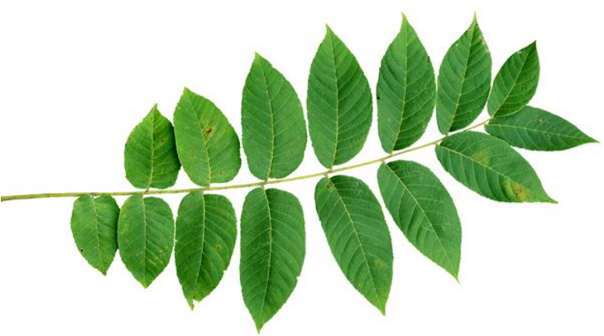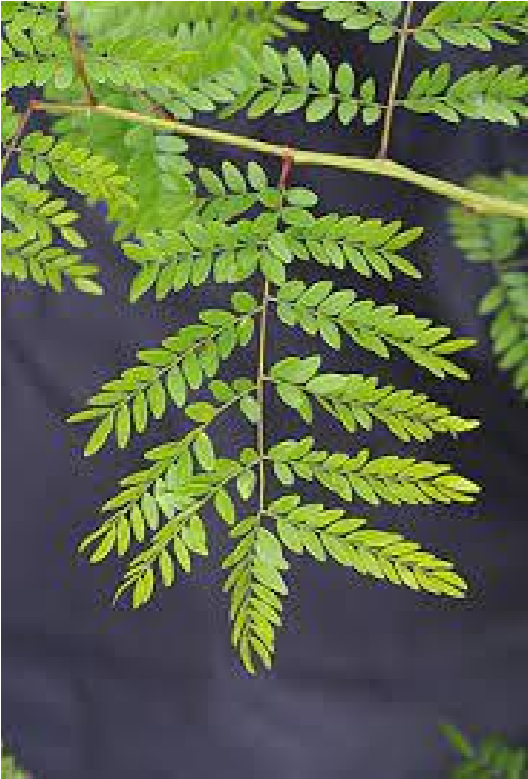
HONEY LOCUST
……………………………………………………………………………………………………………..
……………………………………………………………………………………………………………..
……………………………………………………………………………………………………………..
……………………………………………………………………………………………………………..
………………………………………………………………………………………………………………
………………………………………………………………………………………………………………
………………………………………………………………………………………………………………
b) State two reasons for classifying living organisms (2mks)
……………………………………………………………………………………………………………….
……………………………………………………………………………………………………………….
2. The diagram below is a cross section through a part of human ileum.
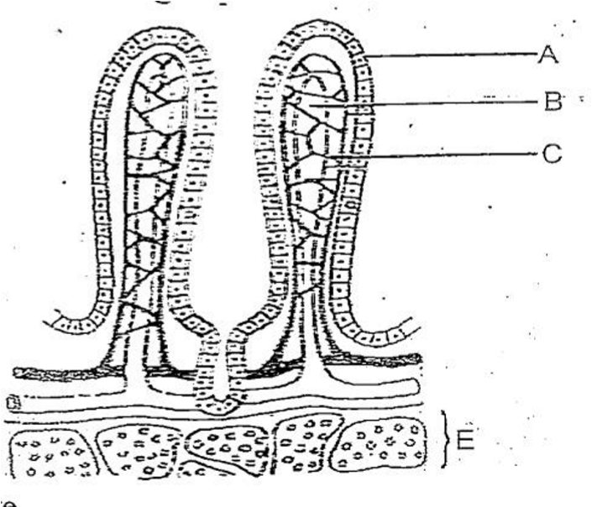
(a)(i) Identify the structure drawn above (1 mark)
………………………………………………………………………………………………………
(ii) Sate the significance of the structure shown above. (1 mark)
………………………………………………………………………………………………………
(b) Name the parts labelled A, B and C (3 marks)
A…………………………………………………………………………………………………….
B……………………………………………………………………………………………………
C……………………………………………………………………………………………………
(c)Give the functions of the part labelled B and C (2 marks)
B…………………………………………………………………………………………………….
C……………………………………………………………………………………………………..
(d) Name the cell organelle more abundant in goblet cells. (1 mark)
………………………………………………………………………………………………………………
- a) In human, premature baldness is controlled by a gene on the Y chromosome. Using B to represent the gene for baldness, work out a cross between a bald man and his wife . (4mks)
  - i) What is the probability of their daughters being bald? (1mk)
………………………………………………………………………………………………… ii) Give a reason for your answer. (1mk)
………………………………………………………………………………………………
………………………………………………………………………………………………
  - Name one trait in human beings that is determined by multiple allele. (1mk)
………………………………………………………………………………………………
  - Name one genetic disorder affecting the red blood cells. (1mk)
………………………………………………………………………………………………
- Study the diagram below and answer the following questions.
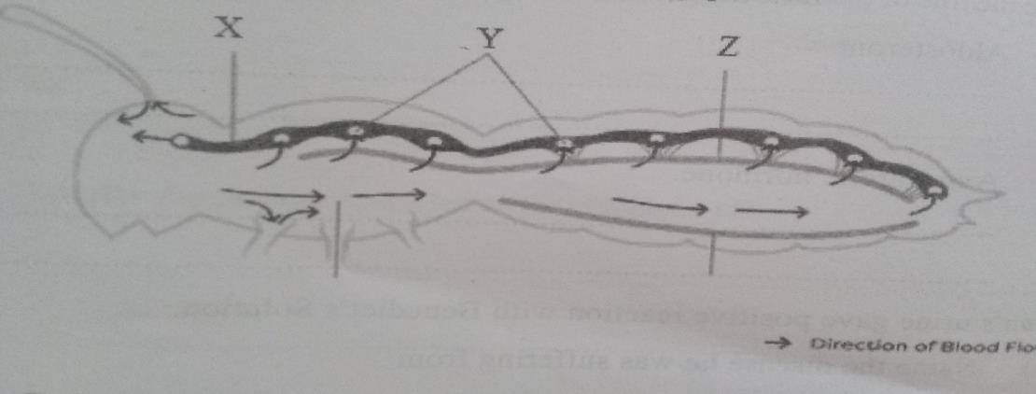
(a) i) Identify the type of circulatory system shown in diagram above. (1mk)
…………………………………………………………………………………………………
ii) Give a reason for your answer in (a)i) above. (1mk)
………………………………………………………………………………………………….
………………………………………………………………………………………………….
    - Name the parts labelled X, Y and Z. (3mks)
X…………………………………………………………………………………………
Y…………………………………………………………………………………………
Z…………………………………………………………………………………………
    - Explain the disadvantage of having the above circulatory system in the animals. (2mks)
…………………………………………………………………………………………………
………………………………………………………………………………………………….
    - Explain why amoeba lack a circulatory system. (1mk)
…………………………………………………………………………………………………
…………………………………………………………………………………………………
- An experiment was carried out to find out the concentration of ions in the cell sap of an aquatic plant and that of the pond water in which they were found.
 | Concentration in
Ions | Cell sap | Pond water
Na⁺ | 50 | 1.2
K+ | 49 | 0.5
Mg2+ | 11 | 3.0
Ca2+ | 13 | 1.3
Cl- | 101 | 1.3
SO₄2- | 13 | 0.67
(a)(i) Name the process by which the aquatic plant absorbs ions from pond water. (1 mk)
…………………………………………………………………………………………………….
(ii) State the four roles of the process you have named in (a)(i) above in a mammalian body. (4 mks)
………………………………………………………………………………………………………………
………………………………………………………………………………………………………………
………………………………………………………………………………………………………………
………………………………………………………………………………………………………………
……………………………………………………………………………………………………………..
- Name the cell structure that allows passage of ions in and out of the cell. (1mk)
………………………………………………………………………………………………………..
- How can the rate of uptake of ions by the aquatic plant be increased. (2mks)
………………………………………………………………………………………………………………
………………………………………………………………………………………………………………
……………………………………………………………………………………………………………….
SECTION B (40 marks)
Answer question 6 (compulsory ) and either question 7 or 8 in the spaces provided after question 8.
6.The glucose level in mg per 100cm³ of blood was determined in two person Y and Z. Both had stayed for six hours without taking food. They were fed on equal amount of glucose at the start of the experiment .The amount of glucose in their blood was determined at intervals .The results are shown in the table below.
Times in minutes | Glucose level in blood in mg /100cm³
Times in minutes | Y | Z
0 | 85 | 78
20 | 105 | 110
30 | 105 | 110
45 | 130 | 170
60 | 100 | 195
80 | 93 | 190
100 | 90 | 140
120 | 90 | 130
140 | 88 | 120
  - On the grid provided, plot graphs of glucose levels in blood against time on the same axes. (7 mks )
Page 7 of 12 Biology Paper 2
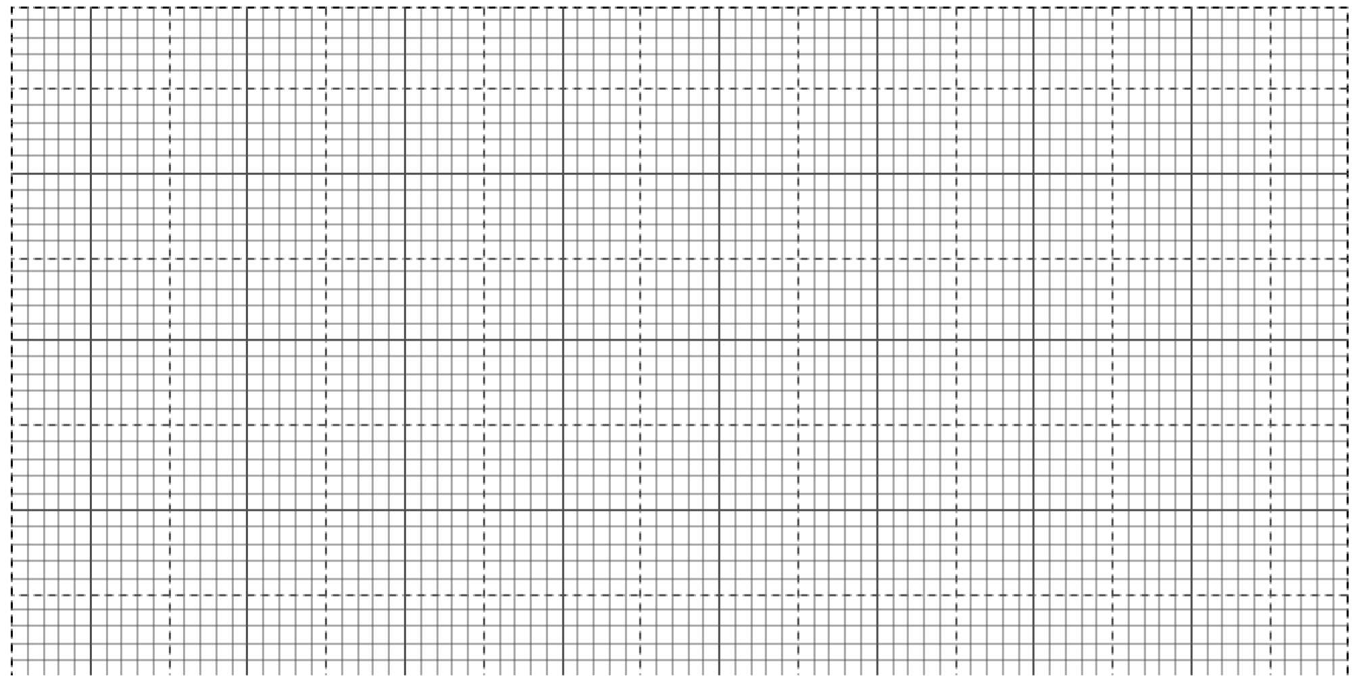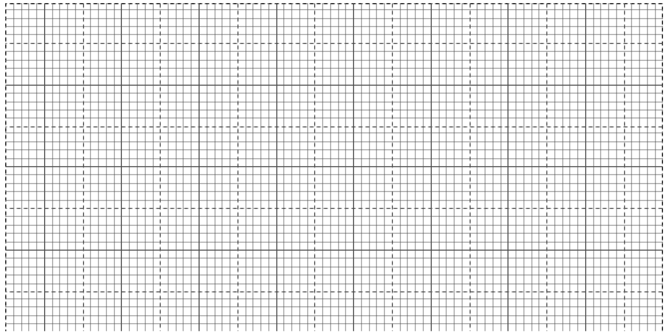
  - What was the concentration of glucose in the blood of Y and Z at the 50th minute? (2 mks )
Y...................................................................................................................................
Z...................................................................................................................................
  - Account for the level of glucose in present Y
of 12 Biology Paper 2
      - During the first 45 minutes. (2mks)
......................................................................................................................................................................... ......................................................................................................................................................................... .........................................................................................................................................................................
................................................................................................................
      - After 45th minute to the end. (4mks)
.........................................................................................................................................................................
.........................................................................................................................................................................
......................................................................................................................................................................... ......................................................................................................................................................................... .........................................................................................................................................................................
......................................................................................................................................................................... .........................................................................................................................................................................
........................................................
    - Account for the decrease in glucose level person Z after 60 minutes. (2mk)
......................................................................................................................................................................... ......................................................................................................................................................................... ......................................................................................................................................................................... ......................................................................................................................................................................... ......................................................................................................................................................................... ....................................................................................
    - Low blood sugar level in harmful to the body . Explain. (3mks)
......................................................................................................................................................................... ......................................................................................................................................................................... ......................................................................................................................................................................... .........................................................................................................................................................................
...................................................................................................
- (a) (i) Give four modes of expressing food relationship in an ecosystem. (4 marks)
(ii) Explain how food as a factor regulate the population of animals in an ecosystem.( 8 marks)
of 12 Biology Paper 2
(b)How are desert plants adapted to conserving water? (8 marks)
- Describe the structure and functions of various organelles in a mature animal cell. (20mks)
………………………………………………………………………………………………………………
………………………………………………………………………………………………………………
………………………………………………………………………………………………………………
………………………………………………………………………………………………………………
………………………………………………………………………………………………………………
………………………………………………………………………………………………………………
………………………………………………………………………………………………………………
………………………………………………………………………………………………………………
………………………………………………………………………………………………………………
………………………………………………………………………………………………………………
………………………………………………………………………………………………………………
……………………………………………………………………………………………………………… ……………………………………………………………………………………………………………… ………………………………………………………………………………………………………………
………………………………………………………………………………………………………………
………………………………………………………………………………………………………………
………………………………………………………………………………………………………………
……………………………………………………………………………………………………………… ……………………………………………………………………………………………………………… ………………………………………………………………………………………………………………
………………………………………………………………………………………………………………
………………………………………………………………………………………………………………
………………………………………………………………………………………………………………
……………………………………………………………………………………………………………… ……………………………………………………………………………………………………………… ………………………………………………………………………………………………………………
………………………………………………………………………………………………………………
………………………………………………………………………………………………………………
………………………………………………………………………………………………………………
……………………………………………………………………………………………………………… ……………………………………………………………………………………………………………… ………………………………………………………………………………………………………………
………………………………………………………………………………………………………………
………………………………………………………………………………………………………………
………………………………………………………………………………………………………………
……………………………………………………………………………………………………………… ……………………………………………………………………………………………………………… ………………………………………………………………………………………………………………
………………………………………………………………………………………………………………
………………………………………………………………………………………………………………
………………………………………………………………………………………………………………
……………………………………………………………………………………………………………… ……………………………………………………………………………………………………………… ………………………………………………………………………………………………………………
………………………………………………………………………………………………………………
………………………………………………………………………………………………………………
………………………………………………………………………………………………………………
……………………………………………………………………………………………………………… ……………………………………………………………………………………………………………… ………………………………………………………………………………………………………………
………………………………………………………………………………………………………………
………………………………………………………………………………………………………………
………………………………………………………………………………………………………………
……………………………………………………………………………………………………………… ……………………………………………………………………………………………………………… ………………………………………………………………………………………………………………
………………………………………………………………………………………………………………
………………………………………………………………………………………………………………
………………………………………………………………………………………………………………
……………………………………………………………………………………………………………… ……………………………………………………………………………………………………………… ………………………………………………………………………………………………………………
………………………………………………………………………………………………………………
……………………………………………………………………………………………………………… ………………………………………………………………………………………………………………
………………………………………………………………………………………………………………
………………………………………………………………………………………………………………
.........................................................................................................................................................................
......................................................................................................................................................................... .........................................................................................................................................................................
......................................................................................................................................................................... .........................................................................................................................................................................
......................................................................................................................................................................... ......................................................................................................................................................................... ......................................................................................................................................................................... .........................................................................................................................................................................
.........................................................................................................................................................................
.........................................................................................................................................................................
.........................................................................................................................................................................
......................................................................................................................................................................... ......................................................................................................................................................................... ......................................................................................................................................................................... .........................................................................................................................................................................
......................................................................................................................................................................... .........................................................................................................................................................................
.........................................................................................................................................................................
......................................................................................................................................................................... .........................................................................................................................................................................
.........................................................................................................................................................................
.............................................................................................................................................................

