**Name: ………………………………………….................... Index No………………………. Signature: …………………….. Date: ……………………………**

**231/3**

**Biology Practical**

**1 ¾ hours**

**INTRUCTIONS TO CANDIDATES**

* Write your **Name** and **Index Number** in the spaces provided above.
* **Sign** and write the **date** of examination in the spaces provided above.
* Answer **all** the questions in this paper.
* You are supposed to spend the first **15 minutes** of the **1 ¾ hours** allowed for this paper reading the whole paper carefully before commencing your work.
* Answers **must** be written in the spaces provided on the question paper.
* Additional pages must not be inserted.
* Candidates may be **penalized** for recording irrelevant information and for incorrect spelling especially of **technical terms**.
* Answers **must** be written in English only.

**For Examiner’s use only**

| Question | Maximum score | Candidate’s  score |
| --- | --- | --- |
| 1 | 15 |  |
| 2 | 11 |  |
| 3 | 14 |  |
| Total | 40 |  |

This paper consists of 7 printed pages. Candidates should check the question paper to ensure that all the pages are printed as indicated and no question is missing.

1. You are provided with photographs labelled **S** and **T.**

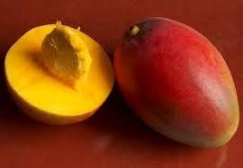 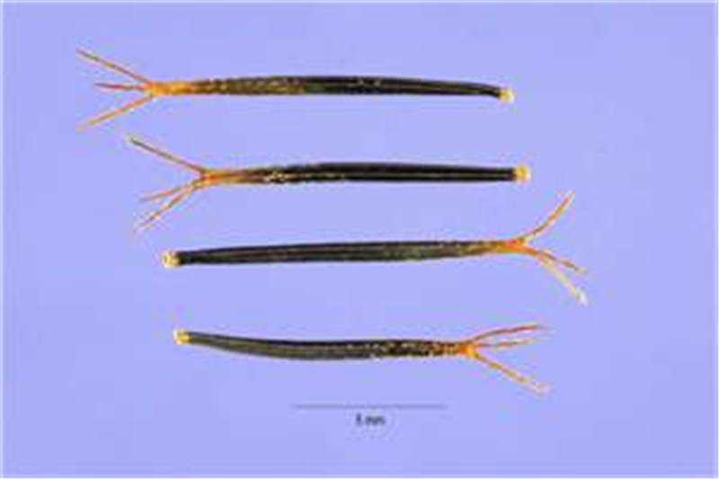

1. With reason, identify the type of fruit each specimen belongs.
2. Specimen **S**: (1 mark)

………………………………………………………………………………………………

Reason: (1 mark)

………………………………………………………………………………………………

1. Specimen **T**: (1 mark)

……………………………………………………………………………………………… Reason: (1 mark)

………………………………………………………………………………………………

1. State **three** differences between specimens **S** and **T**. (3 marks)

………………………………………………………………………………………………………………………………………………………………………………………………………………………………………………………………………………………………………………………………………………………………………………………………

1. With reasons, state the mode of dispersal of each specimen:
2. Specimen **S**: (1 mark)

………………………………………………………………………………………………

Reason: (1 mark)

………………………………………………………………………………………………

1. Specimen **T**: (1 mark)

……………………………………………………………………………………………… Reason: (1 mark)

………………………………………………………………………………………………

1. You are provided with photographs of specimens labelled **P**, **Q**, **R**, **S** and **T**. Examine them carefully.

 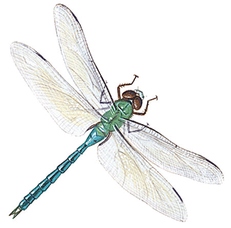



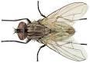 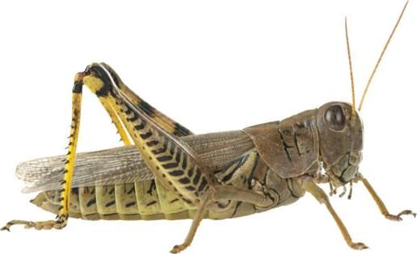 



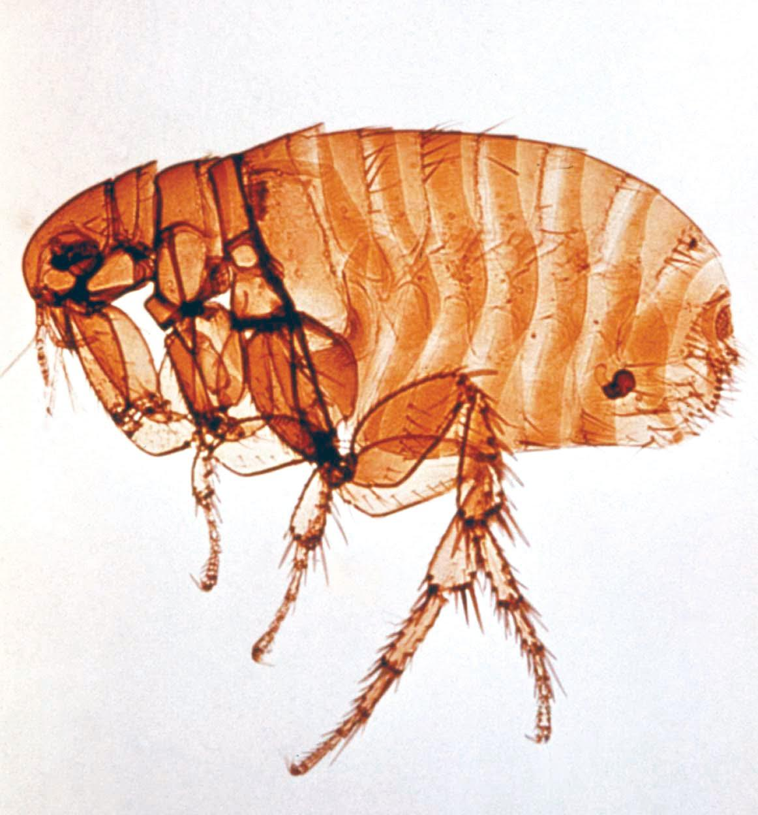

(a) Use the dichotomous key provided below to answer the questions that follow

1 a Wings present……………………………………………….Go to 2

b Wings absent………………………………………………..Go to 7

2 a One pair of wings…………………………………………...Housefly

b Two pairs of wings …………………………………….......Go to 3

3 a Wings membranous ………………………………………..Go to 4

b Hind wings only membranous……………………………....Go to 6

4 a Long and thin abdomen…………………………………......Dragon fly

b Medium sized abdomen…………………………………......Go to 5

5 a Wings peckled….....................................................................Butterfly

b Wings not peckled …………………………………………..Bee

6 a Forewings shell-like……………………………………........Beetle

b Fore wings hand……………………….………………........Grasshopper

7 a Body laterally flattened…..……………………………........Louse

b Body horizontally flattened…………………..………..........Flea

1. Use the dichotomous key provided to identify each of the specimens. (5 marks)

Specimen Steps followed Identity

**P**…………………….. ……………………

**Q**…………………….. ……………………

**R** …………………….. ……………………

**S** …………………….. …………………….

**T** …………………….. …………………….

1. (i) State the class to which the specimens belong. (1mark)

…………………………………………………………………………………………………………

(ii) Give a reason for your answer in (b)(i) above. (1mark)

…………………………………………...………………………………………………………………

……………………………………………...……………………………………………………………

1. Give **two** observable similarities and **three** observable differences between specimens **S** and **T**.
2. Observable similarities. (2marks)

…………………………………………..………………………………………………………………

………………………………………………………………….……………………………………….

1. Observable differences. (3 marks)

........................................................................................................................................................................................................................................................................................................................................................................................................................................................................................................

(d)(i) Identify the type of habitat specimen **S** is likely to be found living. (1mark)

…………………………………………..………………………………………………………………

(ii) Give a reason for your answer in (d) (i) above. (1mark)

………………………………………………………………….………………………………………

…………………………………………..………………………………………………………………

………………………………………………………………….………………………………………