**SET 10**

***FORM 4***

**231/3**

**BIOLOGY PAPER 3**

**MARKING SCHEME**

|  |  |  |  |
| --- | --- | --- | --- |
| **Food Substance** | **Procedure** | **Observations** | **Conclusion** |
| Reducing sugar | To Q add Benedict’s solution and heat to boil/ heat | Blue colour of Benedict’s solution retained | Reducing sugar absent |
| Non-reducing sugar | To Q add dilute Hydrochloric acid and heat to boil; cool; add sodium hydrogen carbonate(until fizzling stops); add Benedict’s solution; heat to boil. | From blue to green to yellow to orange/brown  ***N:BSequence of colours must be correct*** | Non reducing sugar present |
| Protein | To Q add sodium hydroxide solution then add copper(II) sulphate solution (in drops); | Purple colour appears | Protein present |
|  | ***N.B spellings of chemicals, in all the procedures must be correct*** |  |  |

1. a) **Specimen M** –lumbar vertebra

**Reasons**

* Wide/large centrum, **rej** thick
* Long transverse process
* Presence of metapophysis and anapophysis and hypapophysis in rabbit

**Specimen N**- Cervical vertebra

**Reasons**

* Pointed/short/small neural spine
* Presence of vertebraterial canal
* Branched transverse process/ forked/ short transverse process.

b) - Presence of neural canal for passage of spinal cord

- Neural spine for muscle attachment

- Transverse process for muscle attachment

- Facets for articulation with other vertebrae

- Vertebraterial canal for passage of blood vessels

c)

|  |  |
| --- | --- |
| **M** | **N** |
| * Vertebraterial canal absent | * Vertebraterial canal present |
| * Long transverse process | * Short transverse process |
| * Metapophysis/ Anapophysis | * Absence of metapophysis and Anapophysis |
| * Cervical ribs absent | * Cervical ribs present |
| * Narrow neural canal | * Neural canal wide |

d)

Drawing mark = (1 mark)

* Outline be continuous
* Centrum be bean shaped

max1

Labelling = (2 marks)

* Label line should touch structure
* No arrows

= $\frac{Labels}{2}$ then max 2

**Total 3 marks**

*Neural spine*

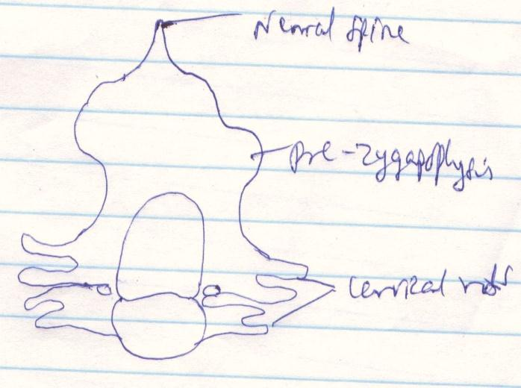

*Pre-zygapophysis*

*Cervical rods*

1. a) I Animals –Hooks for attaching on fur or cloth (**rej attack)**

III Self explosive mechanism – lines of weakness

- Lines of dehiscent

- sutures **(rej satures)**

IV Wind – wing like projection to increase surface area for buoyancy

b) III – marginal placentation

V – Basal placentation

VI – Axile placentation/ central placentation.

c) N – Remains of calyx

P – Fruit

Q – Fruit stalk/ pedicel

d) Increases surface area for buoyancy.

e) Has lines of weakness/lines of dehiscent/

***CONFIDENTIALS***

***To each candidate provide;***

**QUESTION 1**

* 4ml of benedict’s solution
* 2ml of dilute hydrochloric acid, labelled X
* 2ml of 1% copper (II) sulphate solution, labelled M
* 2ml of 10% sodium hydroxide, labelled M
* 6ml of dilute sodium hydrogen carbonate, labelled Y
* 6ml of Q (a mixture of sucrose(10%) and egg albumen (10%) labelled Q)
* Source of heat
* test tube holder
* White tile
* Means of labelling
* Test tube rack
* A dropper
* 10ml measuring cylinder
* 4 test tubes
* Means of timing

**QUESTION 2**

* Lumbar vertebra
* Cervical vertebra labelled N