SET4
BIOLOGY MARKING SCHEMES
PAPER 1
- Ability to respond to stimuli.
- (a)(i) Arachnida (ii) simple eyes.
- Chordata.
- (i) Mitochondria. (ii) Chlorophyll.
- (a) Organic compounds made of carbon, hydrogen and oxygen elements with oxygen being in lower proportion than of carbohydrates, and may have other elements like phosphorus;
(b)(i) Inert/ un-reactive; (ii) Insoluble in water, but readily soluble in organic solvents to form emulsions and suspensions; (iii) Fats readily changed into oils when heated while oils are readily solidified into fats when exposed to low temperature;
- (a) For continuity/ perpetuation of life;
- Plants take in carbon (IV) oxide and give out oxygen during the day, but at night they take in oxygen and give out carbon (IV) oxide, while animals take in oxygen and give out carbon (IV) oxide throughout;
- (a) Hypertonic solution; (b) Osmosis;
- Amoebaosis (Amoebic dysentery); cholera.
- U:Water;V:Oxygen gas; W:Hydrogen ions;
- (a)(i) Beri beri; (ii) Pellagra; (iii) Pernicious anaemia;
- Increases bulkiness of food in the alimentary canal to enhance peristalsis/ firm grip along lining of the canal;
- X: Glucose; Y: Fructose; [acc. vice versa]
- Camouflaged skin to skip notice by predator; prey mimicry/ assuming taste of another organism non-palatable to the predator; prey showing confrontational behaviour against the predator; prey running very fast and in zigzag movement to avoid being caught by predator;
- Photosynthesis reactions regulated by many enzymes; these enzymes require optimum temperature to act best; the increase in temperature increases the rate of photosynthesis up to optimum temperature, beyond which the enzymes get denatured to lower the rate;
- Nitrogen fixation by the bacteria/ Rhiziobia found in root nodules of leguminous plants; Direct fixation by free-living bacteria in the soil; fixation by algae like Chlorella and Nostoc;
- (a) B: Selective reabsorption of glucose and amino acid; C: Reabsorption of water;
- Aldosterone hormone;
- Bowman’s capsule;
- If total magnification = eye piece lens magnification X objective lens magnification;
Then objective lens magnification = 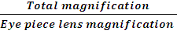;
= ;
= X40;
- (a) The observable differences amongst individuals;
- Deletion; inversion; Translation; Duplication;[mark 1st 3]
- (a) Marginal; (b) Has lines of weakness/ sutures through which it splits open to scatter the seeds;
- (a) Metaphase; (b) (i) Animal; (ii) Presence of centrioles; (c) The part labelled label J/Spindle fibre;
- Ethanol used in brewing industries; Carbon (IV) oxide in baking industries/ soft drinks industries; Energy for industrial processes;
- Stomata; Lenticels; Cuticle; [mark 1st 2]
- (a) (i) Refracts light rays; Protection of inner part of the eye against mechanical damage; Secretes humour; [mark 1st one] (ii) Concentrates the rods for colour vision and visual acuity; (b) Using of diverging/ convex lenses;
- Ecology; Entomology (dealing with biological control); Botany (to know more about the plant); Morphology; Anatomy; [mark 1st 2]
- (i) One male gamete nucleus fuses with functional egg nucleus to form a diploid zygote, while the other fuses with the polar nuclei to form triploid primary endosperm nucleus;
- Has impermeable casparian strip to water that makes water to pass through the cell actively hence creating necessary root pressure required to force the water into the xylem and up the plant;
- (i) Guttation is the process by which plants lose excess water to the atmosphere in liquid form through hydathodes in the leaves while transpiration is the process by which plants lose excess water to the atmosphere in gaseous/ vapour form;
- Morphology is the scientific study of external structures of living organisms while anatomy is the scientific study of internal structures of living organisms;
- Stimulate rapid cell division and cell elongation in dwarf varieties of certain plants; Fruit formation; Induce parthenocarpy; Promote formation of side branches from lateral buds; Break dormancy in buds and seeds; Inhibit sprouting of adventitious roots from stem cuttings Reduces leaf fall; [mark 1st 3]
- (a) Hypogeal; (b) The epicotyl elongates faster than the hypocotyl; making the plumule to grow out of the coleoptiles and forms the first foliage leaf; the remains of seed and seed coat remains underground;

Bryophytes | Spermatophytes
Non-vascular | Vascular;
Reproduce by use of spores | Reproduce by use of seeds;
Have rhizoids | Have roots;
No clearly defined stems and leaves | Clearly defined stems and leaves;
Clear alternation of generation with gametophyte generation being dominant | No clear alternation of generation;
[mark 1st 3]
- (a) changes in genetic constitution of an individual that interferes with base sequence in DNA molecule; (b) Colour blindness; Sickle cell anaemia; Albinism; [mark 1st 2]
- (i) Acts as pace maker during heart beating; (ii) Prevents back flow of blood from right ventricle to right atrium;
- Affects availability of mineral salts; affects the soil microorganisms involved in recycling of water; determines the types of plants to grow in the soil; differentiate between the two types of immunity in mammals.

BIO PAPER 2
- (a) (i) Species A; (ii) The rate of multiplication of in species A is faster than of species B;
(b) (i) Number reproducing is more / suitable environmental conditions/ food/ space/
resources were not limiting ; hence population increased rapidly/ exponentially;
(ii) Population has become stagnant; as birth rate equals death rate/ due to limiting or
shortage of resources;
- Inter-specific competition;
- They have different food requirements hence do not compete;
- “R” represents dominant gene for red colour and “r” represents recessive gene for white colour.

♀ ♂
Parental phenotypes Red-flowered plants White-flowered plants
Parental genotypes RR X rr ;

Gametes R R r r ;

Fusion ;
Offspring genotypes Rr Rr Rr Rr;
- Phenotypic ratio: Red-flowered plants: pink-flowered plants: white-flowered plants
1 : 2 : 1
Genotypic ratio: RR : Rr : rr
1 : 2 : 1
- A case of partial dominance where gene “R” is partially dominant over gene “r”;
- (a) R: Humerus; T: Scapula; (b) Ball-and-socket joint;
- Flattened supra scapulae to increase surface area for attachment of muscles; Spine to increase surface area for attachment of muscles; Glenoid cavity for articulation with the ball of humerus; Acromion process for articulation with clavicle bone; Metacromion and coracoid processes for increasing surface area for attachment of muscles; [mark 1st 2]
- Pentadactyl design;
- Reflects common ancestry/ similar embryonic origin;
- (a)
Artery | Vein
Wider lumen | Narrower lumen;
Thick muscular walls | Thin muscular walls;
Absence of valves | Presence of valves;

- Walls made up of endothelium cells or only one-cell thick to facilitate exchange of materials across the capillary wall; Numerous to be close to each other; Pores between capillary walls to enable cells (leucocytes) to squeeze through into the tissue fluid; [mark 1st 2]

- (i) Transfer of blood from donor/ blood bank to a recipient’s bloodstream;
- After transfusion, the anti b antibodies in the patient plasma reacted with B antigen of the donor; causing haemagglutination/ clumping of donor’s red blood cells;
- (a) K: Buccal cavity; N: Nare/ Nostril; (b) L: Sensitivity/ tasting of food; M: Gaseous exchange;
- During strenuous exercise;
- Highly vascularised/well supplied with blood capillaries for absorption and transportation of gases; Thin lining to facilitate diffusion of gases across; Moist to dissolve gases to enable them to diffuse across; [mark 1st 2]
- (a)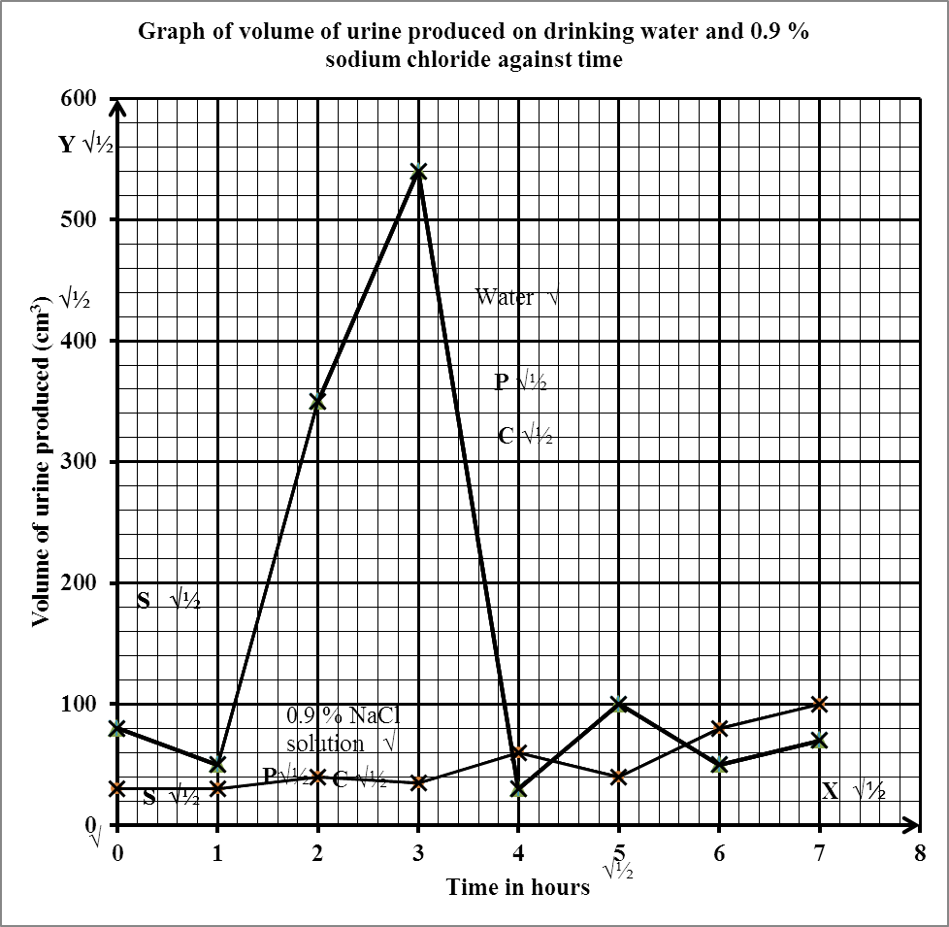
Axes: 1
Labelling of axes: 1
Suitable scale: 1
Origin: 1
Plotting: 1
Curve: 1
Labelling of curves: 2
Tot al: 8 marks

- 425 cm³± 1 cm³
- Large amount of urine produced;
Less ADH; produced (by pituitary glands) hence less/ no reabsorption of water into the blood stream;
- 0.9 % NaCl solution is isotonic to the body fluids; hence no change in osmotic pressure of the body fluids; the volume of the urine produced is constant;
- A condition in which large/ copious amounts of urine is produced ; due to lack of ADH;
- Insulin is a protein; hence would be digested (into amino acids) if taken orally;
- (a)
Nervous system | Hormonal system
Nerve impulse evoke response | Chemical substance/ hormone evoke a response;
Impulse transmitted through nerves | Chemical substance /hormone transmitted through blood;
Response immediate | Response slow;
Effects rapid and short-lived | Effects long-lasting;
Location of the response confined to effectors | Location of the response wide-spread;
[5 marks]
- Immediately after menstruation; the pituitary gland is stimulated to secrete follicle stimulating hormone (FSH); which stimulates the ovary leading to start of development of a new Graafian follicle; its high concentration stimulates follicle cells of the ovary; to secrete oestogen hormone; Oestrogen hormone brings about healing and repair of uterine wall; and its high concentration stimulates pituitary gland; to secrete Luteinising hormone (LH); LH brings about ovulation; causes the reorganization of remnants of Graafian follicle into corpus luteum; and stimulates this corpus luteum to secrete progesterone hormone; high concentration of LH inhibits secretion of oestrogen; Progesterone hormone leads to proliferation of uterine in readiness for implantation; When conception occurs, the progesterone hormone maintains pregnancy up to birth; and inhibits production of FSH; If no conception, progesterone level falls drastically leading to menstruation; [max 15 marks]
- (a) Plants adapted to grow in arid ad semi arid habitats; by possessing specific
characteristic features;
- - Roots extensively developed to provide large surface area for water absorption;
- Roots superficial; to enable plants to utilize the rain water from short showers;
- Roots grow deep/ long roots; to reach water table/ source deep in the ground;
- Succulent/ fleshy stem/ stem possession of water storage tissue; to store water for future use/ to enable them to survive drought;
- Possession of waxy thick cuticle; to reduce transpiration rate;
- Hairy leaves; to trap water vapour increasing humidity around the leaf lowering rate of transpiration;
- Reduced leaf surface/ spines/ scales/ leaves modified into needle-like to minimise surface area directly exposed to sunlight to lower rate of transpiration;
- Sunken stomata/ modified stomata/ reduced number of stomata; to minimise surface area directly exposed to sunlight to lower rate of transpiration;
- Reversed stomatal rhythm to minimise rate of transpiration; Rolled leaves/ folded leaves / shading leaves; to minimise surface area directly exposed to sunlight to lower rate of transpiration;
- Short life cycles/ quick growth after rains; to make use of available water quickly;

Rej. flowering alone. Rej. long, short roots alone. [max 9 features each with its importance, 18 marks]

BIO PAPER 3
- (a) and (b)
Test tube | Observations at the start of experiment (a) | Observations at the end of experiment (b)
1 | Blue black/ black/ blue/ dark blue colour; Rej. brick red. | Blue black/ black/ blue/ dark blue colour; Rej. brick red.
2 | Blue black/ black/ blue/ dark blue colour; Rej. brick red/ traces of blue black. | Brown/ yellow/ orange/ retains colour of iodine solution/ no change in colour/ traces of blue black/ reddish brown; Rej. remains the same colour/ no colour change/ no change/ red.
3 | Blue black/ black/ blue/ dark blue colour; Rej. brick red/ traces of blue black. | Brown/ yellow/ orange/ retains colour of iodine solution/ no change in colour/ traces of blue black/ reddish brown; Rej. remains the same colour/ no colour change/ no change/ red.
- Test tube 2: Green / yellow; Rej. orange
Test tube 3: Orange/ brown; Rej. yellow/ green
- Control experiment;
- Starch was converted/ digested / broken down/ hydrolysed/ into simple sugars/ maltose/ glucose in the test tubes 2 and 3; Starch was not converted/ digested / broken down/ hydrolysed/ into simple sugars/ maltose/ glucose due to lack of NaCl and solution L; There is more sugar in test tube 3 than in test tube 2 due to higher concentration of NaCl in test tube 3; NaCl accelerates digestion of starch; [OR: In test tube 1, starch was converted to sugars due to lack of solution L and NaCl; In test tube 2 starch was converted to less simple sugars by solution L due to the concentration of NaCl. In test tube 3, starch was converted more simple sugars by solution L. Due to higher concentration of NaCl, conversion of starch to sugars is accelerated;]
- Enzyme diastase/ amylase/ ptyalin; Acc. organic catalyst. Rej. Maltase;
- Most suitable temperature/ optimum temperature / best temperature / enzyme work best/ favourable for enzyme activity; Rej. specified temperature, starch reduced.
- (a) (i) Drupe; Fleshy mesocarp and horny endocarp; (ii) Cypsela; Remains of the style;

S | T
Bigger in size | Smaller in size;
Fleshy mesocarp and horn endocarp | Hard pericarp;
Green | Black;
No persistent calyx | Persistent calyx with hooks;
[mark 1st 3]
- (i) Animals; Fleshy mesocarp/ brightly coloured to attract animals;
(ii) Animals; Hooks to enable it to adhere/ stick onto the skin of passing animal;
- (a)
Specimen Steps Identity
P: 1a, 3a, 4b, 5a; Butterfly;
Q: 1a, 2b, 3a, 4a; Dragon fly;
R: 1a, 2a; House fly
S: 1a, 2b, 3b, 6b; Grasshopper;
T: 1b, 7b; Flea;
[10/2 = 5 marks]
- (i) Insecta; (ii) Three body parts; 3 pairs of legs; [mark 1st one]
- (i) Both have walking legs; Both have antennae; Both have segmented bodies; [mark 1st 2]
(ii)
S | T
Bigger in size | Smaller in size;
Yellowish brown/yellowish green body colour | Brownish red body colour;
Has wings for flight | No wings;
Pointed tip of abdomen | Rounded tip of abdomen;
[mark 1st 3]
- (i) Terrestrial; (ii) Has legs for walking;

CONFIDENTIAL
- Solution L: Diastase enzyme
- Starch solution
- 0.1 % Sodium chloride solution
- 14 % Sodium chloride solution
- 3 test tubes on a rack
- 3 labels
- 10 ml measuring cylinder
- White tile
- Iodine solution
- water bath maintained at 37 º C
- Benedict’s solution
- Source of heat
- Wire gauze and tripod stand
- Dropper
- Hot water bath

