- Area of a triangle

1. The sides of a triangle are in the ratio 3:5:6. If its perimeter is 56 cm, use the Heroes formula to find its area (4mks)
2. The figure below is a triangle XYZ. ZY = 13.4cm, XY = 5cm and angle xyz = 57.7º
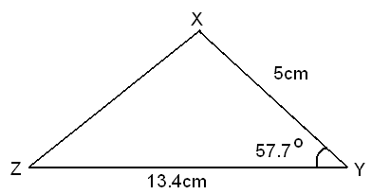

Calculate
  - Length XZ. (3mks)
  - Angle XZY. (2 mks)
  - If a perpendicular is dropped from point X to cut ZY at M, Find the ratio MY:ZM. (3 mks)
  - Find the area of triangle XYZ. (2 mks)
3. The figure below represents a triangular plot ABC. The lengths of AB = 50m, AC = 80m
B
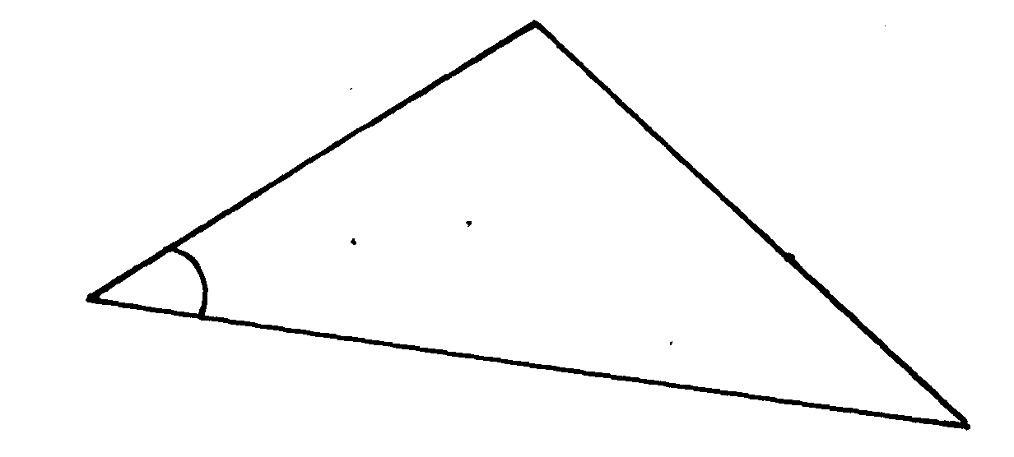
and angle BAC =30º
50m
30º
A

80m

C
(a) Find the length of BC to 2 s.f
(b) Find the area of the plot in hectares
(c) The plot is fenced using 4 strands of barbed wire. The length of one roll of barbed
wire is 600m and it costs shs.4000. Calculate;
(i) The length of fencing wire required
(ii) The number of complete rolls to be bought
(iii) The cost of the rolls

