Air and combustion

1. The set-up below was used to prepare a sample of oxygen gas. Study it and answer
the questions that follow.
H₂O₂
MnO₂

(i) Complete the diagram to show how Oxygen can be collected
(ii) Write a chemical equation of the reaction to produce oxygen

2. Air was passed through several reagents as shown below:
Concentrated sodium hydroxide solution
Air
Excess copper turnings hydroxide solution
Escaping
gases
Excess heated magnesium powder

(a) Write an equation for the reaction which takes place in the chamber containing
Magnesium powder
(b) Name one gas which escapes from the chamber containing magnesium powder.
Give a reason for your answer

3. (a) What is rust?
(b) Give two methods that can be used to prevent rusting
(c) Name one substance which speeds up the rusting process

4. 3.0g of clean magnesium ribbon 8.0g of clean copper metal were burnt separately in
equal volume of air and both metals reacted completely with air;
a) State and explain where there was greater change in volume of air
Mg =24 Cu = 64
b) Write an equation for the reaction between dilute sulphuric acid and product of burnt copper

5. Oxygen is obtained on large scale by the fractional distillation of air as shown on the flow
chart bellow.

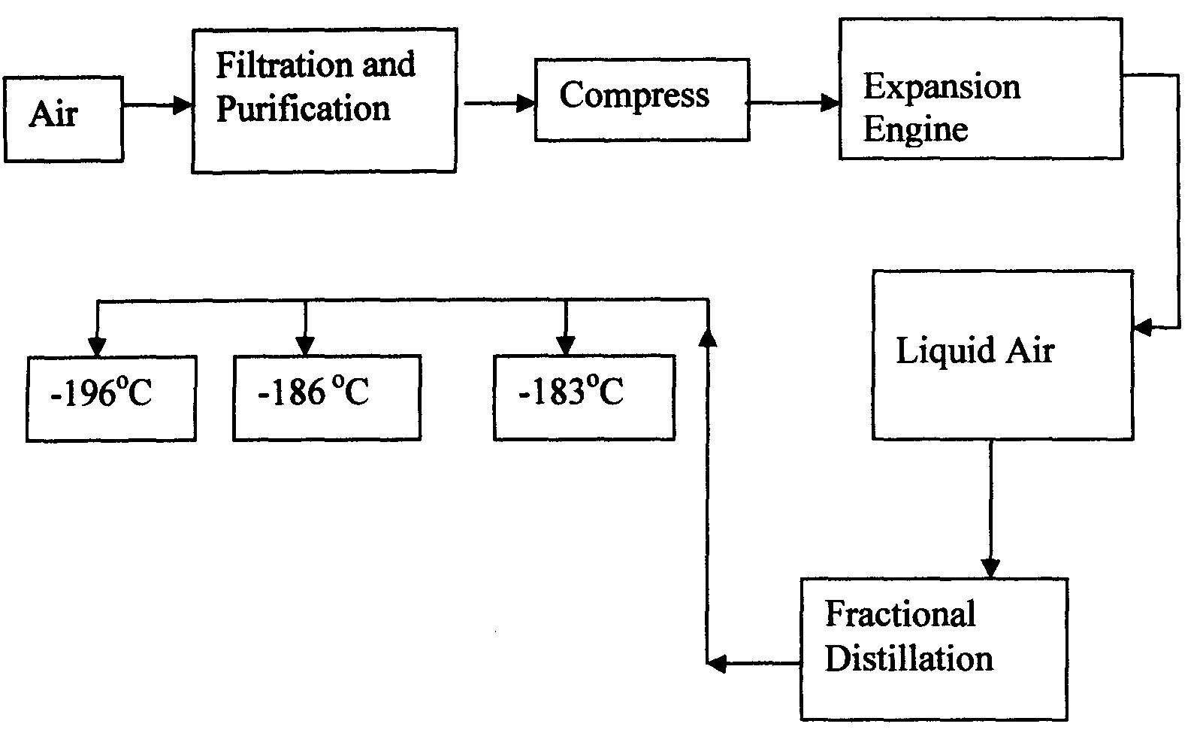

a) Identify the substance that is removed at the filtration stage
b) Explain why Carbon (IV) oxide and water are removed before liquefaction of air
c) Identify the component that is collected at -186°C

6. The set-up below was used to study some properties of air.
Moist iron wool
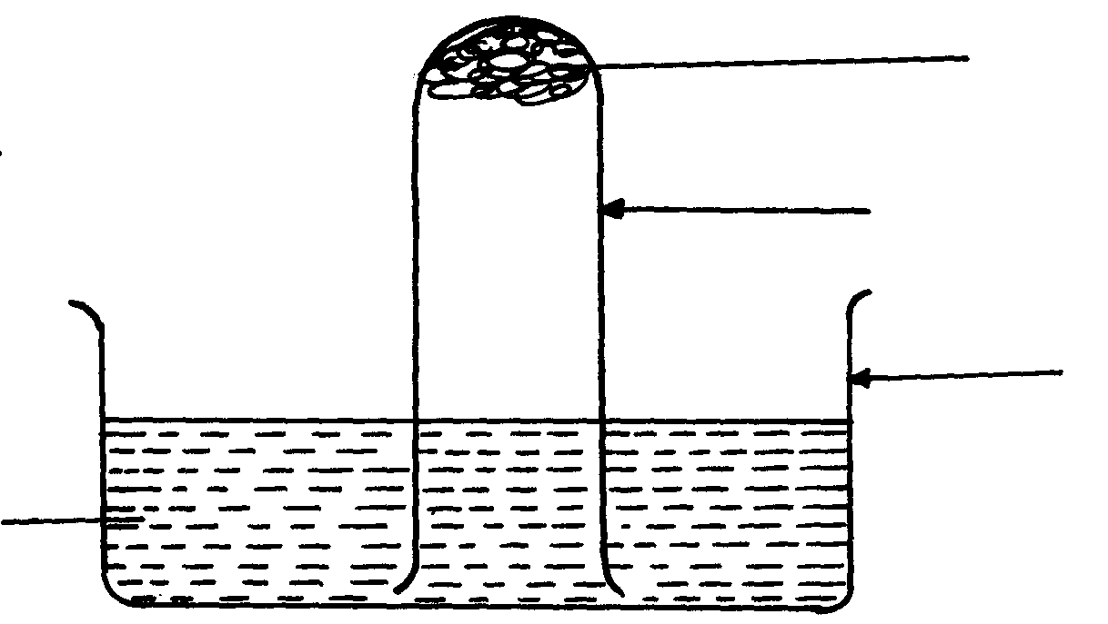
Test tube

Beaker

Water

State and explain two observations that would be made at the end of the experiment
7. A form two student in an attempt to stop rusting put copper and Zinc in contact with iron
as shown:-
Iron
Zinc
Copper
(i)
(ii)

(a) State whether rusting occurred after one week if the set-ups were left out
(b) Explain your answer in (a) above

8. In an experiment, a piece of magnesium ribbon was cleaned with steel wool. 2.4g of
the clean magnesium ribbon was placed in a crucible and completely burnt in oxygen.
After cooling the product weighed 4.0g
a) Explain why it is necessary to clean magnesium ribbon
b) What observation was made in the crucible after burning magnesium ribbon?
c) Why was there an increase in mass?
d) Write an equation for the major chemical reaction which took place in the crucible
e) The product in the crucible was shaken with water and filtered. State and explain the
observation which was made when red and blue litmus paper were dropped into the filtrate

9. In an experiment a gas jar containing some damp iron fillings was inverted in a water trough
containing some water as shown in the diagram below. The set-up was left un-disturbed for three
days. Study it and answer the questions that follow:
Water Trough
Inverted gas jar
Damp iron fillings
Water

(a) Why were the iron filings moistened?
b) State and explain the observation made after three days.
(c) State two conclusions made from the experiment.
d) Draw a labelled set-up of apparatus for the laboratory preparation of oxygen using
Sodium Peroxide
(e) State two uses of oxygen
10. In an experiment, a piece of magnesium ribbon was cleaned with steel wool. 2.4g of the clean
magnesium ribbon was placed in a crucible and completely burnt in oxygen. After cooling the
product weighed 4.0g
a) Explain why it is necessary to clean magnesium ribbon
b) What observation was made in the crucible after burning magnesium ribbon?
c) Why was there an increase in mass?
d) Write an equation for the major chemical reaction which took place in the crucible
e) The product in the crucible was shaken with water and filtered. State and explain the
observation which was made when red and blue litmus paper were dropped into the filtrate

11. The set-up below was used to collect gas F produced by the reaction between sodium
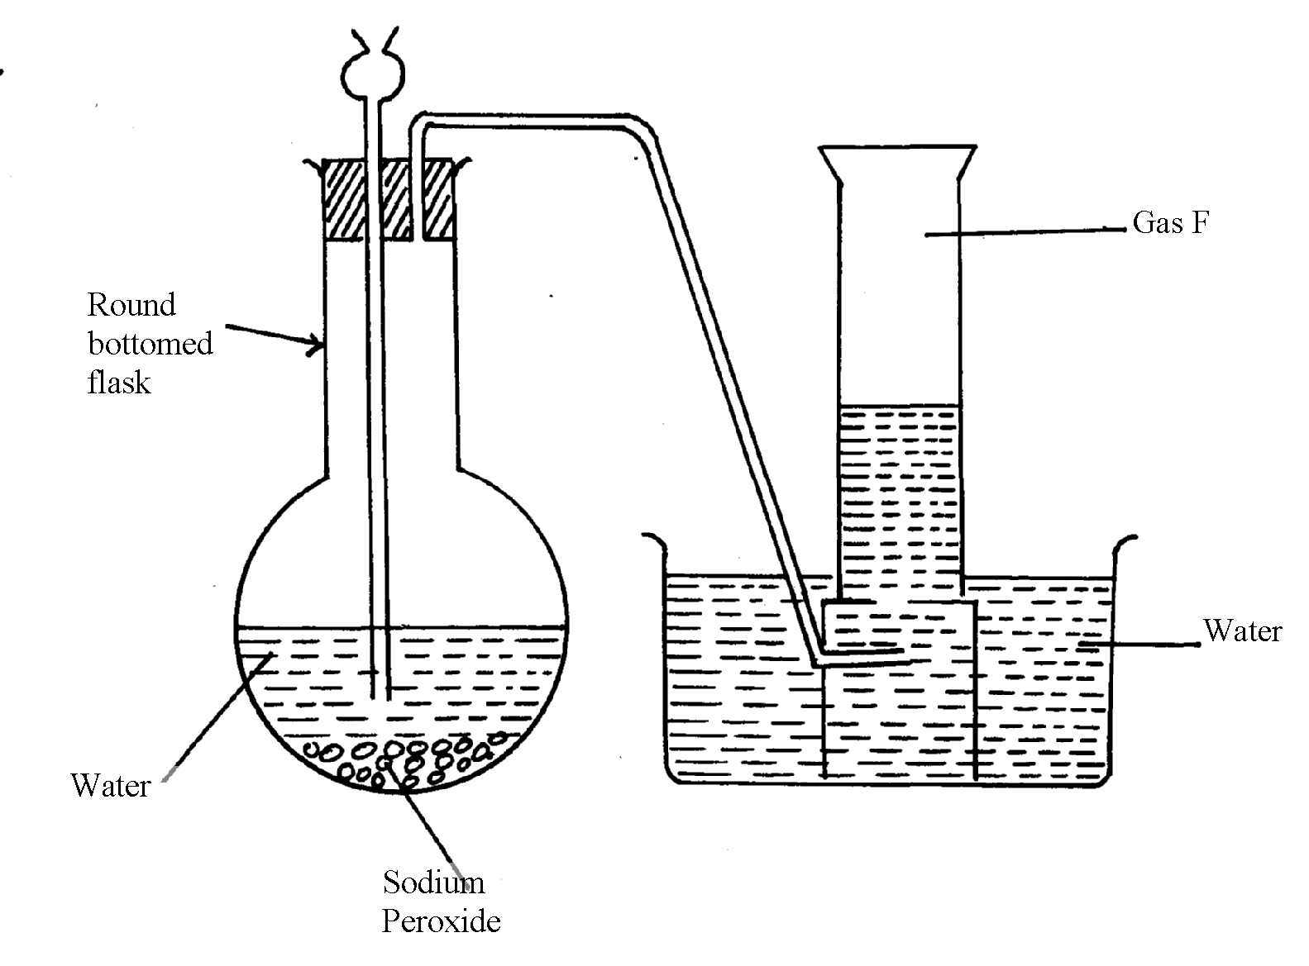
peroxide and water

(i) Name gas F……………………………………………………………………………
(ii) At the end of the experiment, the solution in the round bottomed flask was found to be
a strong base. Explain why this was so
(iii) Which property of gas F makes it be collected by the method used in the set-up?
(iv) Give one industrial use of gas F

12. . The set-up below was used to investigate properties of the components of air:
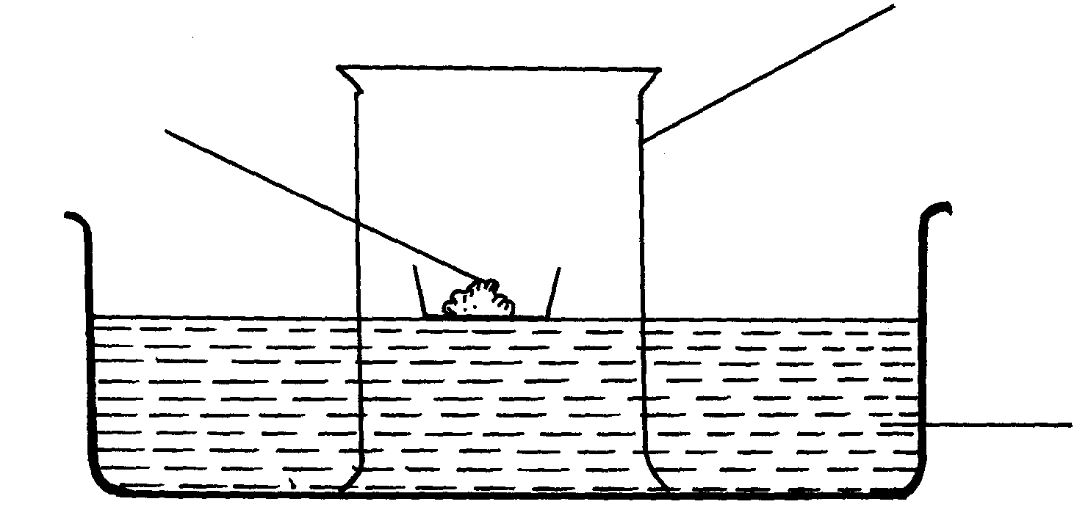
Phosphorous
Gas jar
Water

(i) State two observations made during the experiment
(ii) Write two chemical equations for the reactions which occurred
(iii) The experiment was repeated using burning magnesium in place of phosphorous.
There was greater rise of water than in the first case. Explain this observation
(iv) After the two experiments, the water in each trough was tested using blue and red litmus
papers. State and explain the observations of each case.
(a) Phosphorous experiment
b) magnesium experiment
(v) Briefly explain how a sample of nitrogen gas can be isolated from air in the laboratory
13. (a) A group of students burnt a piece of Mg ribbon in air and its ash collected in a Petri dish.
The ash was found to comprise of magnesium Oxide and Magnesium nitride
(i) Write an equation for the reaction leading to formation of the magnesium nitride
(ii) A little water was added to the products in the Petri dish. State and explain the
observation made.
(iii) A piece of blue litmus paper was dipped into the solution formed in (b) above.
State the observation made.
14. A form one class carried out an experiment to determine the active part of air. The diagram
below shows the set-up of the experiment and also the observation made.
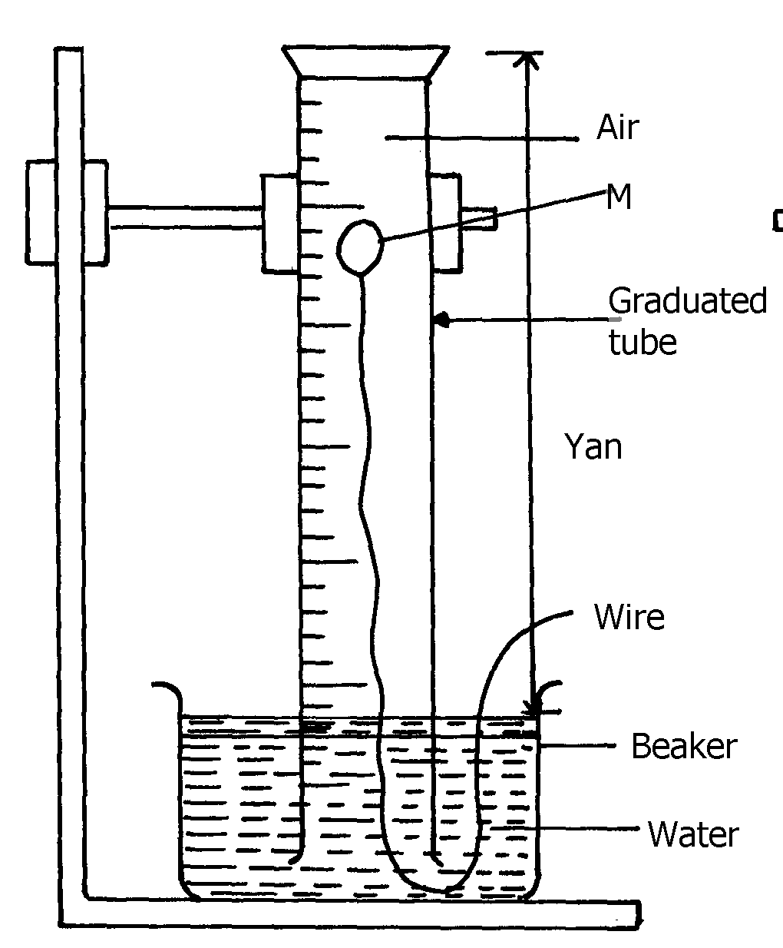
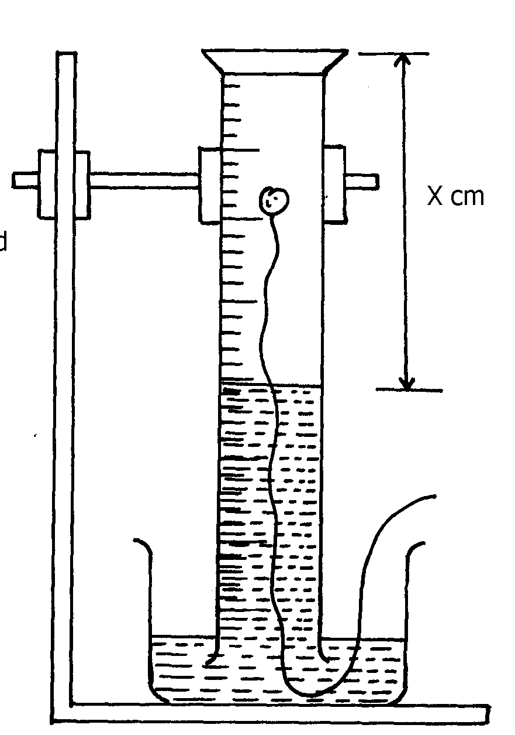
(i) At the beginning (ii) observation at the end of the experiment

Ycm
Solid A
Air

(a) (i) Identify substance M ..................................................................................
(ii) State two reasons for the suitability of substance M for this experiment
(b) Write the equation for the reaction of substance M and the active part of air
(c) (i) Using the letters Y and X write an expression for the percentage of the active part of air
(ii) The expression in (c)(i) above gives lower value than the expected. Explain
(d) (i) Explain the observation made when litmus paper is dipped into the beaker at the end of the
experiment
(ii) Name the active part of air ................................................................................................
(iii) Suggest another method that can be used to determine the active part of air
15. A piece of phosphorous was burnt in excess air. The product obtained was shaken with a small
amount of hot water to make a solution
i) Write an equation for the burning of phosphorus in excess air
ii) The solution obtained in (b) above as found to have pH of 2. Give reasons for this
observation

16. Study the set-up below and answer the questions that follow:-
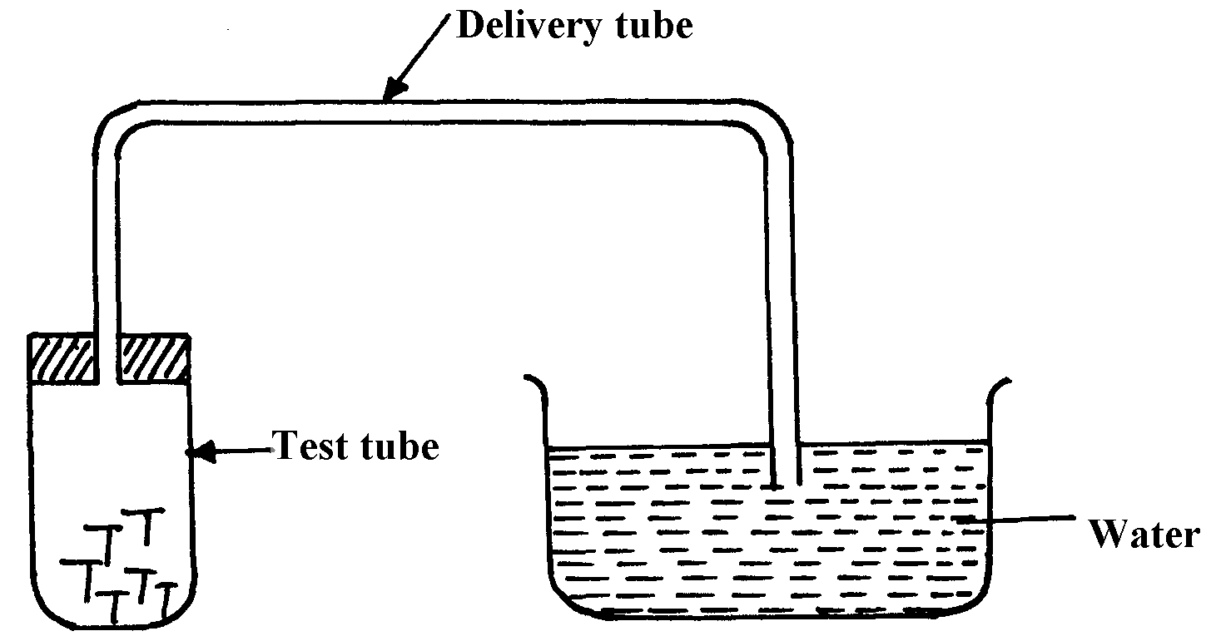

Iron nails

(a) State two observations that would be made after one week. Explain
(b) Write the equation of the reaction taking place in the test-tube
17. Fe₃O₄ and FeO are oxides of iron which can be produced in the laboratory
(a) Write chemical equation for the reaction which can be used to produce each of the oxides
(b) Wire an ionic equation for the reaction between the oxide, Fe₃O₄ and a dilute acid.

18. Below is a list of oxides.
MgO, N₂O, K₂O, CaO ans Al₂O₃
Select:-
a) A neutral oxide.
b) A highly water soluble basic oxide.
c) An oxide which can react with both sodium hydroxide solution and dilute hydrochloric acid.

19. The diagram below shows students set-up for the preparation and collection of oxygen gas
X
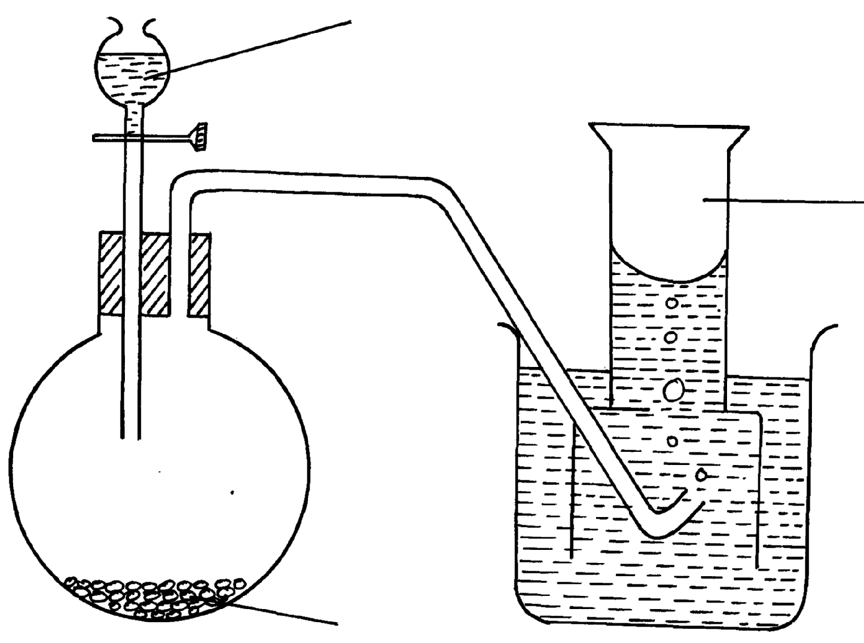

Oxygen gas

Sodium peroxide

(a) Name substance X used
(b) Write an equation to show the reaction of sodium peroxide with the substance named in 1(a)

