Air and combustion

1.
Oxygen
Water

2. a) 3 M_{g} + N_{2 g} ________ M_{g 3} N_{2 g}
b) Argon
- It is inert

3. a) Rust is hydrated iron (III) Oxide
b) - Electroplating
- Painting
- Oiling
- Galvanization
c) - Salts
- Acids

4. a) Moles of copper ⁸/₆₄ = 0.125 moles of Mg ³/₂₄ = 0.125Mg reacts with both O2 and N2 gases in
the air while copper reacts with )2 only
There is greater change in the reaction with copper and smaller change in reaction with Mg

b) CUO_{(g)} + H₂SO_{4(q)} ___________ CUSO_{4(aq)} + H₂O_{(l)}
Balanced
Chemical symbols correct
State symbols correct

5. a) Dust particles
b) They readily solidify hence may block the pipes
c) Argon

6. - Water rose up the test-tube to occupy the space of active air ^{√½} which has been
used in resting. ^{√½}
- Iron wool turned reddish – brown ^{√½} due formation of red-oxide of iron ^{√½} which is rust.

7. a )i)rusting occurred√ ½
ii) No rusting√ ½
b) In (i) iron is more reactive than copper hence undergoes corrosion√1
in (ii) zinc is more reactive than iron hence undergoes corrosion in place of iron√1

8. a) To remove any magnesium oxide coating from the surface of magnesium// To remove any
oxide film on it

b) White solid which is magnesium oxide

c) Increase in mass was due to oxygen which combined with magnesium

d) 2Mg(s) + O_{2(g)} _______ 2MgO(s)
Penalize ½ for wrong or missing state symbols

e) The filtrate is magnesium hydroxide which is an alkaline
Red litmus paper changed blue, but blue litmus paper remained blue

9. (a) So that they may stick to the gas Jar to prevent them from falling into water when the
gas jar is inverted
(b) Iron filings turned to reddish brown because they reacted with oxygen in presence
of moisture to form rust.
- The level of water inside the gas jar rise so as to occupy the volume initially occupied
by part of air used up for rusting
(c) - Air is made up of two parts; - the active part that is necessary for rusting and the inactive
part that is not used for rusting
- oxygen is the active part of air

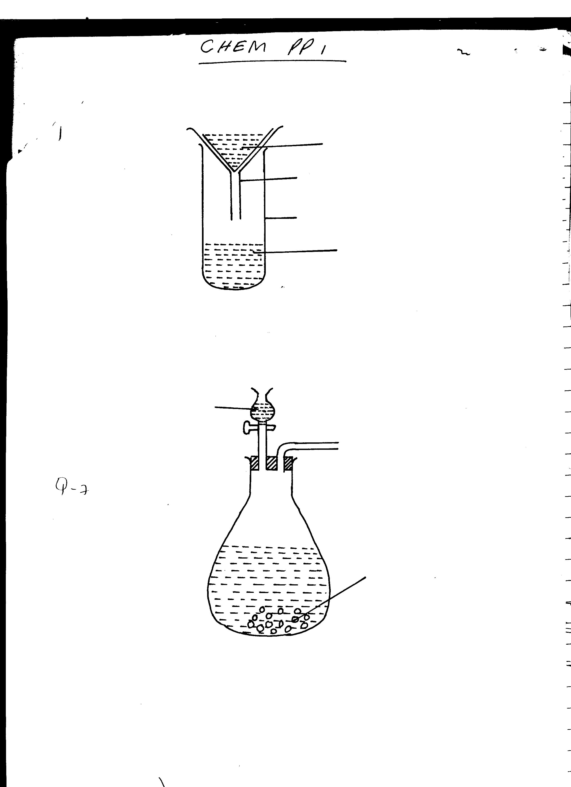
Water
Sodium Peroxide
Oxygen
(d)

- Neat diagram-
- correct method of collection
(e) - For cutting and welding metals
- Rocket fuel
- Mountain climbing
- Sea diving
- Used in explosions (any two)
10. a) To remove any magnesium oxide coating from the surface of magnesium// To remove any
oxide film on it

b) White solid which is magnesium oxide

c) Increase in mass was due to oxygen which combined with magnesium

d) 2Mg(s) + O2(g) _______ 2MgO_{(s)}
Penalize ½ for wrong or missing state symbols

e) The filtrate is magnesium hydroxide which is an alkaline
Red litmus paper changed blue, but blue litmus paper remained blue

11. (i) Oxygen
(ii) Sodium hydroxide is a strong base
(iii) Slightly soluble in water
12. (i) White fumes form in the gas jar which disappear after sometime.
- The level of water rises in the gas jar.
(ii) P_{(s)} + O_{2(g)} P₂O5_{(s)}
P₂O_{(s)} + 3H₂O_{(l)} 2H₄PO_{4(aq)}
(iii) Magnesium react with oxygen and nitrogen hence greater of fraction of air is used.
(iv) (a) Blue litmus changed to red as remained red. The solution was acid due to phosphoric
(b) Red litmus changed to blue as blue remained blue due to formation of basic magnesium
hydroxide ammonia solution.
(v) – Pass air over conc. KOH / NaOH to absorb CO₂
- Pass the remaining gases over hot copper solid which reacts with oxygen.
- Collect the remaining gas over water. The gas is mainly nitrogen.
13. a) i) 3Mg(s) + N₂(g) Mg₃N₂(s) √1
ii) Gas with√1 choking irritating smell.
Mg₃N₂ reacts with water to form ammonia √1 gas.
iii) It remains blue. √½ Ammonia gas is alkaline. √½
14. (a) (i) Phosphorous
(ii) - Do not react with water when being inserted into the tube
- reacts with oxygen when exposed to air.
(b) 4P(s) + 3O_{2(g)} 2P₂O_{3(s)}
or 4P(s) + SO_{2(g)} 2P₂O_{5(s)}

(c) (i) Y – X x 100
y
(ii) – Wrong reading of volume
- Phosphorous can go off before complete combustion
(d) (i) – Red litmus paper no effect
- Blue litmus paper turns red due to formation of phosphoric acid/phosphorous (V) Oxide whish is an acidic oxide
(ii) – Oxygen
(iii) – Burning of candle
- Use of pyrogallol
- Rusting of iron fillings
15. i) P_{4(g)} + 5O_{2(g)} ______________ 2P₂O_{5(s)}
// P_{4(s)} + 3O_{2(g)} ____________ 2P₂O_{3(g)} Anyone √ 1 mark

ii) Phosphorous (v) or (iii) oxide formed is an acidic Oxide which dissolves in water to
form a strong acidic solution of phosphoric acid whose PH is 2

16. (a) – Iron nails turns brown.
 ½
- Water rises up the delivery tube/water level drops in the trough ( any ½mk)
Explanation: Oxygen has been used up in rusting of iron nails hence water rises up to take
 1
the place of oxygen
 1
(b) 4Fe_{(s) +} 3O_{2(g)} + 2H₂O_{(l)} 2Fe₂O₃.2H₂O_{(s)}
(accept a balanced chemical equation)

17. a) FeCO₃ _{(s)} Fe O_{(s)} + CO_{2(g)}
Fe(s) + 4 H₂O_{(g)} Fe O₄ _{(s)} + 4H_{2 (g)}
Or
2 Fe_{(s)} + 20₂(_{g)} Fe₃ O_{4(s)}
b) Fe₃O_{4(s)} + 8H⁺ _{(aq)} 4H₂O _{(l)} + 2 Fe³⁺_{(aq)} + Fe²⁺_{(aq)}

18. a) N₂O 1 (Nitrogen (I) oxide) – Denitrogen Oxide.
b) K₂O 1 (Potassium oxide)
c) Al₂O₃ (Aluminium oxide)

19. a) water √1
b) 2Na₂O_{2(S)} + 2H₂o _{(L)} 4NaOH _{(aq)} + _{O2(g)} √1 mk
Penalize ½ - wrong missing state symbols

