Acids, bases and salts
1. Study the reaction below and answer the questions that follow
NH₃ _{(g)} + H₂O _{(l)} NH₄⁺ _{(aq)} + OH⁻_{(aq)}
(a) Define the term acid
(b) Identify an acid in the above reaction
(c) Explain your answers in (b) above
2. A student mixed equal volumes of Ethanol and butanoic acid. He added a few drops of
concentrated Sulphuric (VI) acid and warmed the mixture
(i) Name and write the formula of the main products
Name………………………………….
Formula……………………………………..
(ii) Which homologous series does the product named in (i) above belong?

3. A sample of water from a village in Trans Mara East District was divided into equal portions
and each mixed with equal volume of soap solution. The observations made are tabulated below:

Sample of water | Treatment before adding soap | Observations made on shaking with soap
I | Boiled | Lather form immediately
II | No treatment | Slight lather form slowly
III | Treatment with washing soda | Lather formed immediately

(a) What type of hardness is present in water from the village. Explain
(b) State one advantage of hard water
4. The solubility of Iron (II) Sulphate crystals are 22ºC is 15.65g per 100g of water. Calculate
the mass of iron(II) sulphate crystals in 45g of saturated solution at the sae temperature

5. Hardness of water may be removed by either boiling or addition of chemicals:
(a) Write an equation to show how boiling removes hardness of water
(b) Name two chemicals that are used to remove hardness of water

6. State one advantage of drinking hard water rather than soft water.

7 Given this reaction;
RNH₂ + H₂O RNH₃⁺ +OH⁻
a) Identify the acid in the forward reaction .Explain
b) Dilute nitric acid can react with a solution of sodium carbonate. Write an ionic equation
for the reaction

8. Magnesium hydrogen carbonate is responsible for the temporary hardness of water.
This type of hardness can be removed by addition of ammonia solution
(a) Describe how temporarily hard water is formed

(b) Write an equation to show the softening of temporarily hard water by the addition
of aqueous ammonium solution

K
³⁹
¹⁹

9. When 2M potassium hydroxide solution was added to solution R, a white precipitate T was
formed which dissolved in excess potassium hydroxide solution to form solution L. solution
R forms a white precipitate with sodium chloride solution:
(a) Identify the cation in solution R ......................................................................
(b) Name precipitate T ..............................................................................
(c) Write the molecular formula of the compound in solution L

10. Below is a table showing the solubilities of salts Q and R at different temperatures.
Temperature ºC |  | 0 | 10 | 20 | 30 | 40 | 50
Solubilities in grammes per 100g of water | Salt Q | 3.0 | 5.0 | 7.4 | 10.0 | 14.0 | 19.0
Solubilities in grammes per 100g of water | Salt R | 15.0 | 17.0 | 20.7 | 25.7 | 28.7 | 33.0

(a) Define the term “Solubility of salt”
(b) If both salts Q and R are present in 100cm³ of saturated solution at 50ºC, what will
be the total mass of crystals formed if the solution was cooled to 20ºC?

11. The following results were obtained during an experiment to determine the solubility of potassium
chlorate(V)in water at 30ºC.
Mass of evaporating dish =15.86g
Mass of evaporating dish + saturated solution at 30ºC = 26.8g
Mass of evaporation dish +solid potassium chlorate (v) after evaporation to dryness=16.86g
Calculate the mass of the saturated solution containing 60.0g of water at 30ºC
12. (a) What is meant by the term solubility of salts?
(b) Calculate the solubility of salt given that 15g of the salt can saturate 25cm³ of water
(c) The table below gives the solubility of salt X in grams per 100g of water at different
temperatures
Temp ºC | 10 | 20 | 30 | 40 | 50 | 60 | 70 | 80 | 90 | 100
Solubility (g/100g) water | 5.0 | 7.5 | 10.5 | 14.0 | 18.5 | 24.0 | 30.0 | 38.0 | 46.0 | 50.1

(i) Plot a solubility curve for salt X (solubility in g /100g water Y- axis) (temp ºC (X –axis)
(ii) What is meant by the points plotted in (i) above?..................................................................
(iii) From your graph determine the solubility of salt X at the following temperatures
I 44ºC ………………………………………….
II 62ºC ………………………………………. .
(iv) What mass of crystals of the salt will be formed if the solution was cooled from
62ºC to 44ºC
(v) Name two areas where knowledge of solubility curves is applied
13. You are given a mixture of Lead (II) Chloride, Iodine, ammonium chloride and sodium chloride.
Explain how you would separate all the four solids using methylbenzene, a source of heat and
water
14. (a) The table below shows the solubility of potassium chlorate at different temperatures

Temperature (ºC ) | 10º | 20º | 30º | 40º | 50º | 60º | 70º
Solubility g/100g water | 27 | 30 | 36 | 55 | 80 | 110 | 140
(i) Plot a graph of solubilities of potassium chlorate against temperature
(ii) Using your graph:
(I) Determine the solubility of potassium chlorate at 47ºC
(II) Determine the concentration in moles per litre of potassium chlorate at 47ºC
(K= 39, Cl = 35.5, O= 16) density of solution = 1g/cm³
(III) Determine the mass of potassium chlorate that would crystallize if the solution
is cooled from 62ºC to 45ºC
(b) In an experiment to determine the solubility of sodium hydroxide, 25cm³ of a saturated
solution of sodium hydroxide weighing 28g was diluted in a volumetric flask and the
volume made to 250cm³ mark. 20cm³ of this reacted completely with 25cm³ of 0.2M
hydrochloric acid according to the equation.
NaOH_{(aq)} + HCl_{(aq)} NaCl_{(aq)} + H₂O_{(l)}

Calculate:
(i) The number of moles of hyrdrochloric acid used
(ii) The number of moles of sodium hydroxide in 20cm³
(iii) The moles of sodium hydroxide in 250cm³ of solution
(iv) The mass in grams of sodium hydroxide in 250cm³ of solution
(v) The solubility of sodium hydroxide in g/100g water
15. a) Define the term solubility of a substance
b) The table below shows the solubilities of two salts L and M at different temperatures.

Temperature(ºC) |  | 10 | 20 | 30 | 40 | 50
Solubility in g/100g  of water. | L | 11.0 | 14.0 | 20.1 | 28.0 | 36.0
Solubility in g/100g  of water. | M | 15.0 | 17.0 | 19.0 | 21.2 | 25.0
i) Name the method that can be used to separate the two salts
ii) Plot on the same axes a graph of solubilities of L and M against temperature
iii) From the graph determine:-
The temperature at which solubilities are equal
The solubility at the temperature mentioned above
iv) If the relative formula mass of M is 132, determine the concentration of M in moles per litre
in (iii) II above

16. The graph below shows the changes in conductivity when 50cm³ of 0.1M Nitric (V) acid
is titrated with potassium hydroxide (curve I) and when 50cm³ of 0.1M methanoic acid is
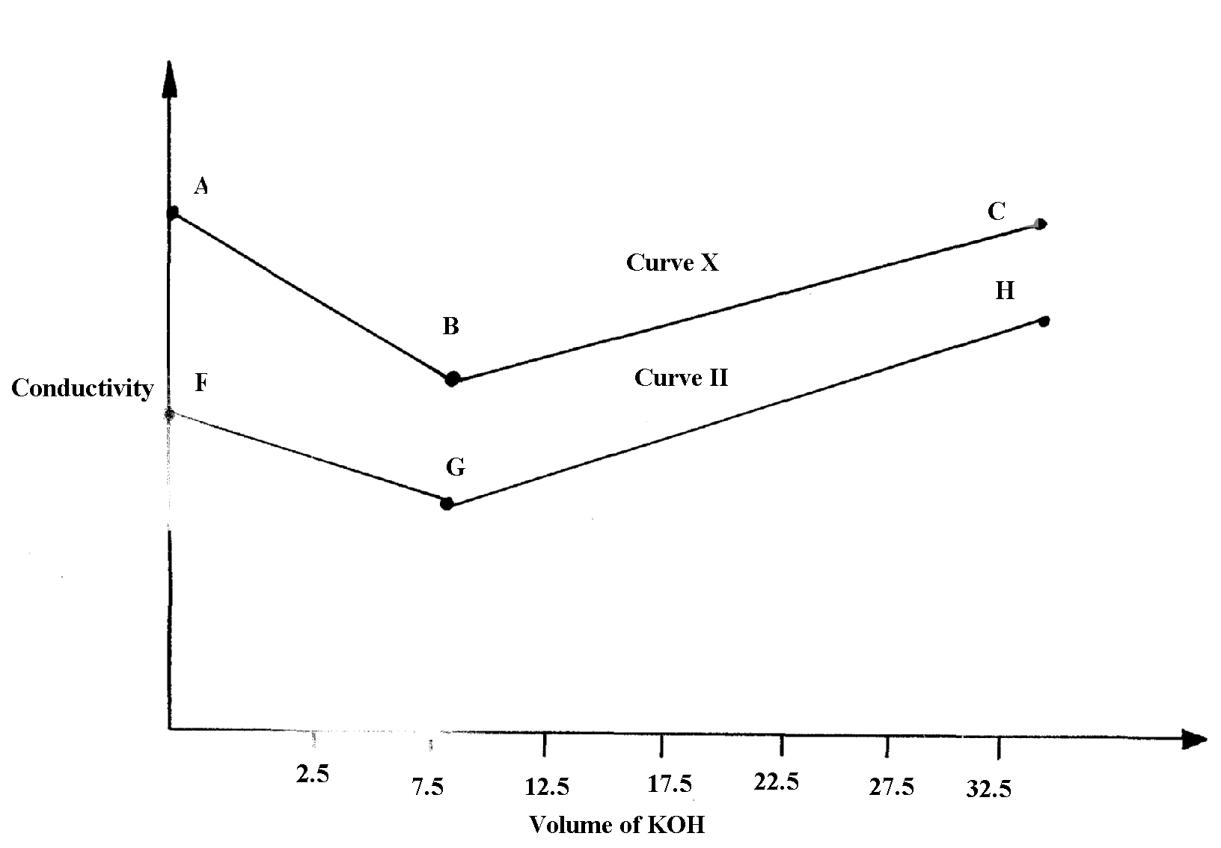
reacted with the same potassium hydroxide solution (curve II)

I

0

(a) (i) Explain the changes in conductivity in the regions:
AB…………… BC………………………………………………….
(ii) Using curve (I), explain why the conductivity does not have a value of zero
at end-point
(iii) Calculate the concentration of KOH with reference to curve II
(iv) Explain why the two curves shows different trends in conductivity
(b) 50cm³ of 0.1M methanoic acid was reacted with 20cm³ of a solution of sodium
carbonate of unknown concentration. Work out the concentration of the carbonate

17. The flow charts below show an analysis of a mixture R that contains two salts. Study the
analysis and answer the questions that follow:-
(a)
Mixture R
Step I
Residue
Two metallic oxides, H₂O_{(g),} CO_{2(g),} NO_{2(g),} O_{2(g)}
Step II
Add HCl_{(aq)}

Add HCl(aq)
Colourless solution
Add excess NaOH_{(aq)} to a portion of X

Filtrate X
Step III
Add excess NH₃ _{(aq)}

to a portion of X
Colourless solution

(i) State:-
(I) The condition in step I
(II) The process in step II
(ii) A small portion of mixture R is added to dilute nitric (V) acid in a test-tube. What would be
observed?
(iii) Write an equation for the reaction between the cation in filtrate X and sodium hydroxide
solution
(iv) Explain how water vapour in step I could be identified
Mixture R
Step IV
Add water
then filter

Add HCl(aq)
Residue U
Filtrate W

Step VI
Colourless solution
Step V
Add H₂SO_{4(aq)}
Add excess NH_{3(aq)}
to apportion of Z
Add excess NaOH_{(aq)}
to a portion of Z
Solution Z + CO₂
White precipitate
(b)

(i) State and explain the conclusion that can be made from step IV only
(ii) Name the anion present in residue U. Explain

(iii) From the flow chart in (a) and (b);
(I) Write the formulae of cations present in mixture R

18. a) Define the term solubility of a substance.
b) The table below shows the solubilities of two salts L and M at different temperatures.

Temperature (ºC) | Type of salt | 10 | 20 | 30 | 40 | 50
Solubility g/100g of water | L | 11.0 | 14.0 | 20.1 | 28.0 | 36.0
Solubility g/100g of water | M | 15.0 | 17.0 | 19.0 | 21.2 | 25.0

(i) Name the method that can be used to separate the two salts.
(ii) Plot on the same axes a graph of solubilities of L and M against temperature
(iii) From the graph, determine:
I. The temperatures at which solubilities are equal
II. The solubility at the temperature mentioned above (iv) If the relative formula mass of M is 132, determine the concentration of
M in moles per litre in (iii) II above.
v) A solution contains 38g of L and 22g of M at 50°C. Calculate the total mass of crystals
obtained in cooling this solution to 30°C.

19. a) Define:
(i) A saturated solution.
(ii) Solubility of a solute.
b) In an experiment to determine solubility of sodium chloride, 10.0 cm³ of a saturated solution of
sodium chloride weighing 10.70g were placed in a volumetric flask and diluted to a total of 500
cm³. 25.0 cm³ of the diluted solution of sodium chloride reacted completely with 24.0 cm³ of
0.1M silver nitrate solution. The equation for the reaction is
AgNO₃(_{aq}) + NaCl (_{aq}) AgCl (_{s}) + NaNO₃ (_{aq})
I. Calculate;
(i) Moles of silver nitrate in 24.0 cm³ of solution.
(ii) Moles of NaCl in 25.0 cm³ of solution.
(iii) Moles of NaCl in 500 cm³ of solution.
(iv) Mass of NaCl in 10.0 cm³ of saturated sodium chloride (Na = 23, Cl = 35.5)
(v) Mass of water in 10.0cm³ of saturated solution.
(vi) The solubility of NaCl in g/100g of waters.

20. Describe how you would prepare a dry sample of crystals of potassium sulphate starting with
100cm³ of 1M sulphuric (VI) acid.
21. The table shows solubility of potassium chlorate V
Temp (ºC) | 45ºC | 80º
Solubility | 39 | 63
(a) Calculate the mass of solute and solvent in 90g of the saturated solution of the salt at 45ºC
(b) A solution of the salt in 100g water contains 63g at 95ºC. At what temperature will the
solution start forming crystals when cooled
22. Two samples of hard water C and D were boiled. When tested with drops of soap, sample
D formed lather easily while C did not:-
(a) Name the possible salt that caused hardness in sample D
(b) Explain how distillation can remove hardness in sample C
(c) Give one advantage of hard water
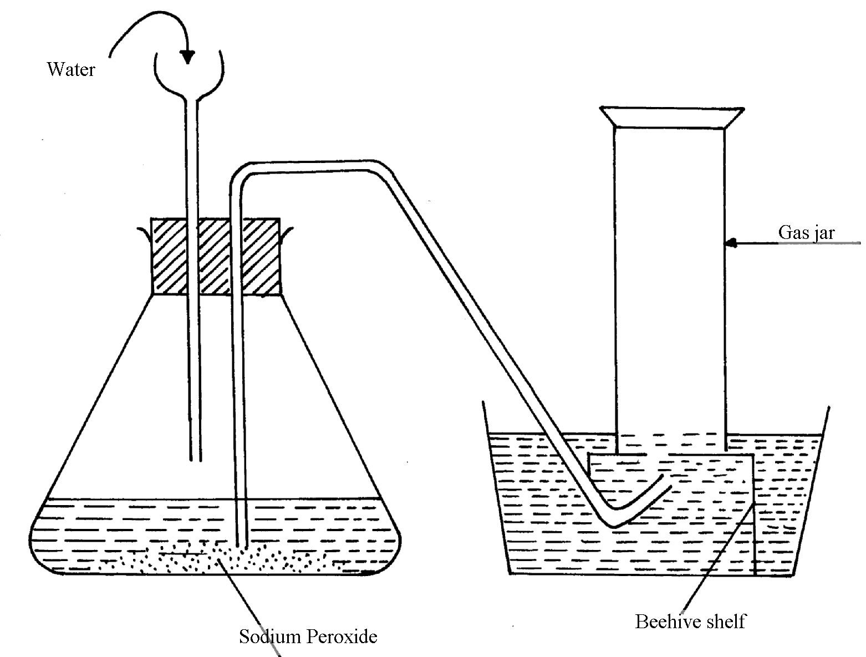
23. A student attempted to prepare a gas using the set-up below. She could not collect any gas

(a) Give two reasons why no gas was collected
(b) Which gas did the student intend to prepare?
24. Water from a town in Kenya is suspected to contain chloride ions but not sulphate ions.
(a) Describe how the presence of chloride ions in the water can be shown
(b) State one advantage of drinking hard water rather than soft water
25. Study the following tests and observation and answer the questions that follow:-
 | TEST | OBSERVATION
I | - Add few drops of acqueous ammonia to copper (II) nitrate solution | - Light blue precipitate is formed
II | - Add excess of ammonia to copper (II) nitrate | - Deep blue solution
III | - Add cold dilute hydrochloric acid to substance E1 and warm gently | - Gas evolved, smells of rotten eggs and blackens lead acetate paper
Identify:-
(a) Substance responsible for:
I. Light blue precipitate…………………………………………………………………
II. Deep blue solution …………………………………………………………….
(b) Gas evolved in test III above …………………………………………………………

26. (i) What is meant by the term solubility of salts?
(ii) Calculate the solubility of a salt given that 15g of the salt can saturate 25cm³ of water.
27. (a) Draw a well labeled diagram to show how to prepare an acqueous solution of hydrogen
chloride gas
(b) Name one other gas whose aqueous solution can be prepared in the same way
28. In an experiment to determine the solubility of solid Y in water at 30ºC the following results
were obtained; *MAT
Mass of empty evaporating dish = 26.2g
Mass of evaporating dish + saturated solution = 42.4g
Mass of evaporating dish + dry solid Y = 30.4g
(a) Use the data to calculate the solubility of solid Y at 30ºC
(b) State one application of solubility curves and values

29. Study the table below showing the solubility of substance K at various temperatures
Temperature (ºC ) | Solubility (g/100g water)
0  30  70  100 | 30  24  19  14

(a) What would happen if a sample of a saturated solution of the substance at 30ºC is
heated to 70ºC. Explain.
(b) What is the most likely state of substance K..................................................................
30. In the equilibrium given below:-
Fe³⁺_{(aq) +} SCN_{(aq)} [Fe(SCN)]²⁺ _{(aq)}
Brown Red
What would be observed when Iron (III) Chloride is added to the equilibrium mixture. Explain
31. Sodium Carbonate Decahydrate crystals were left exposed on a watch glass for two days.
a) State the observations made on the crystals after two days.
b) Name the property of salts investigated in the above experiment

32. The label on a bottle of mineral; water had the information below.
Ions present | Concentration (g/litre)
Ca²⁺  Mg²⁺  Na+  K+  SO₄  HCO₃ | 0.10  0.20  0.01  0.01  0.14  0.26
²⁻
⁻

(a) Name the compound that causes temporary hardness in the mineral water.
(b) Using an equation, describe how the water can be made soft by adding sodium
carbonate solution.
(c) Give one advantage of drinking mineral water such as the one above

33. A solution of hydrogen chloride gas in methylbenzene has no effect on calcium carbonate.
A solution of hydrogen chloride in water reacts with calcium carbonate to produce a gas. Explain
34 (i) Is concentrated sulphuric acid a weak acid or a strong acid?
(ii) Explain your answer in (i) above.
35. When water reacts with potassium metal the hydrogen produced ignites explosively
on the surface of water.
(i) What causes this ignition?
(ii) Write an equation to show how this ignition occurs
36. In an experiment, soap solution was added to three samples of water. The results below
show the volume of soap solution required to lather with 500cm3 of each water sample
before and after boiling
 | Sample 1 | Sample 2 | Sample3
Volume of soap used before water boiled | 26.0 | 14.0 | 4.0
Volume of soap after water boiled | 26.0 | 4.0 | 4.0
(i) Which water samples are likely to be soft?
(ii) Explain the change in volume of soap solution used in sample 2
1
37. How does the pH value of 0.25M KOH_{(aq)} compare with that of 0.25M ammonia solution

